Story Board

Site Map
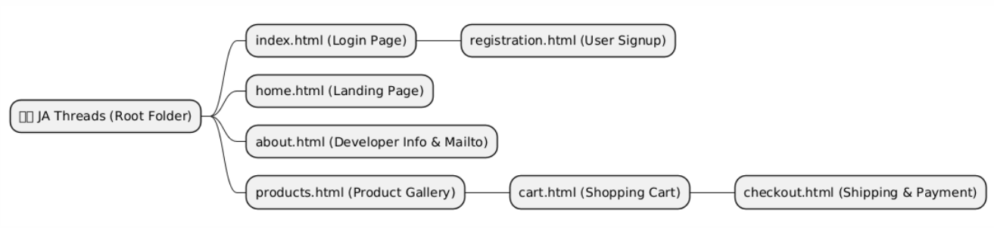

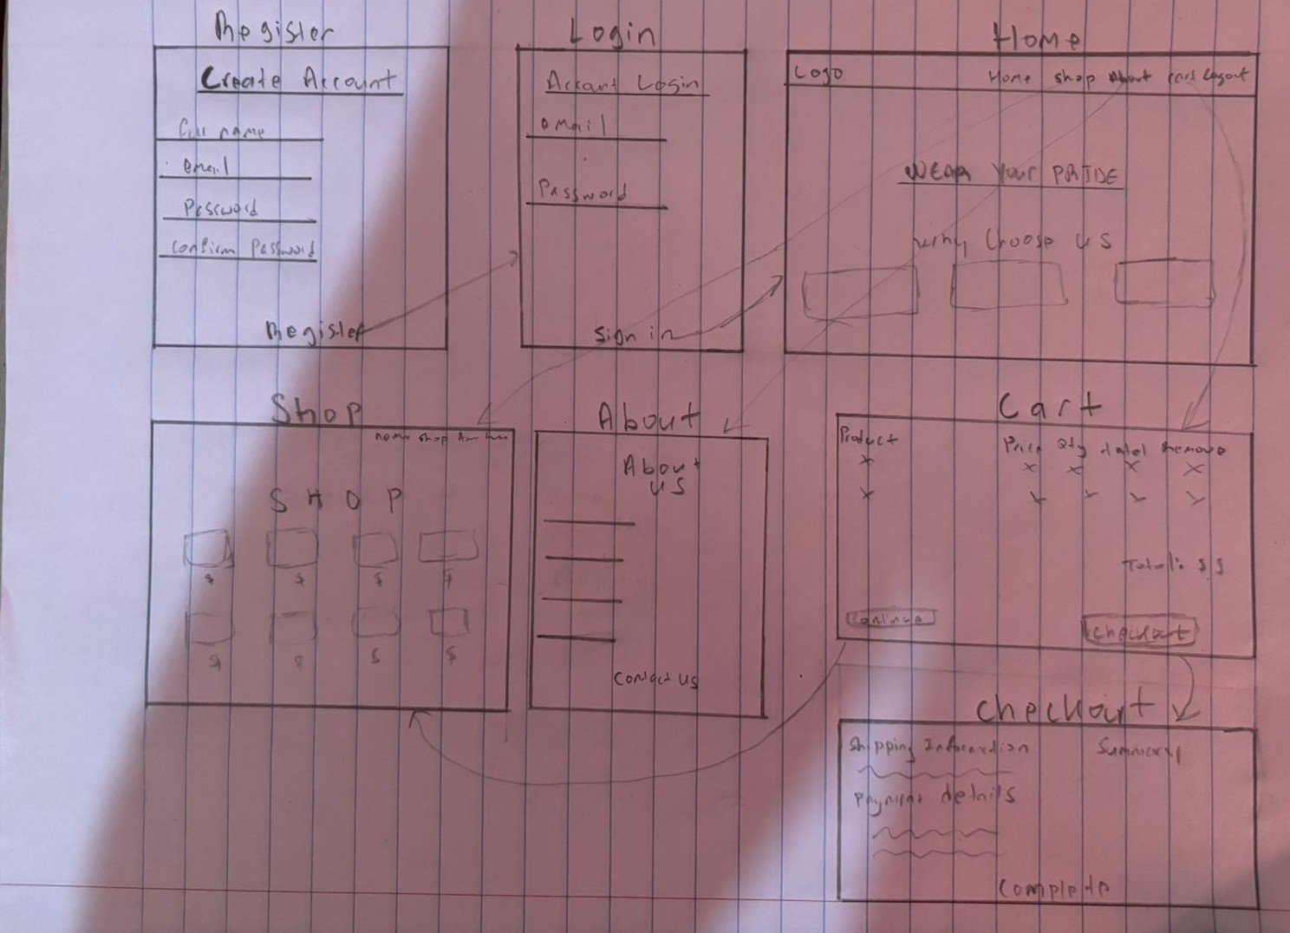

Page Descriptions
- Login (index.html): The primary entry point where users authenticate. It features a clean form for existing customers to access their accounts.
- Registration (registration.html): A data-capture page for new users to join the platform, collecting essential details like Name, and Email.
- Home (home.html): The brand's landing hub. It highlights the "Wear Your Pride" mission statement and provides quick navigation to the shop and company values.
- Products (products.html): The e-commerce core featuring a responsive grid of apparel. Each item displays a high-quality image, price, and unique cultural description.
- About Us (about.html): A transparency page containing the developer’s academic details, the project's background, and a direct mailto link for inquiries.
- Cart (cart.html): A functional summary page where users review selected items, adjust quantities, and see a real-time breakdown of sub-totals and GCT (tax).
- Checkout (checkout.html): The final transactional stage. It validates shipping addresses and payment details before confirming the order.

Business Identity
- Logo The JA Threads logo features a hand-drawn heart filled with the Jamaican national flag. The bold black outline and "X" saltire symbolize a deep "love for country," blending traditional heritage with a modern, artistic streetwear aesthetic.
- Business Description: JA Threads is a for-profit e-commerce venture specializing in premium, culture-inspired apparel. We bridge the gap between traditional Jamaican heritage and modern streetwear, providing high-quality garments for those who want to represent the island with style.
- Slogan: Heritage in Every Stitch.
- Mission Statement: To provide premium Jamaican branded apparel designed for the bold and the irie.
- Vision Statement: To become the global leader in authentic Caribbean-inspired fashion, making island culture accessible and wearable for everyone, everywhere.

iii. Color Palette Justification
Our palette uses the iconic colors of the Jamaican flag to trigger immediate brand recognition and cultural emotional responses:
- Gold (#FFB81C): In marketing, gold represents excellence, optimism, and warmth. It draws the eye to call-to-action buttons (like "Shop Now") and suggests a high-value, premium product.
- Green (#007749): Symbolizes growth, vitality, and the lush Jamaican landscape. It provides a sense of balance and trust, making the user feel secure during the checkout process.
- Black (#000000): Represents strength, elegance, and power. Used as a primary background/text color, it provides a high-contrast, modern aesthetic that makes the vibrant gold and green "pop."
iv. Intended Audience
The target audience consists of Young Adults (ages 18–35), specifically:
- The Jamaican Diaspora: Individuals living abroad (USA, UK, Canada) looking for a tangible connection to their roots.
- Culture Enthusiasts: Fans of Reggae and Dancehall culture who value authentic, artistically designed streetwear.
- Tourists: Visitors seeking a high-quality alternative to generic souvenir shop merchandise.

References
Amazon. (n.d.). Yellow Jamaican athletic performance tee [Photograph]. https://www.amazon.com/images/I/71JQkDohNRL.UL1500.jpg
Jamaica One Love. (n.d.). Jamaican unisex designer t-shirt [Photograph]. https://jamaicaonelove.com/products/jamaican-unisex-designer-t-shirt
Jamaica One Love. (n.d.). T-shirt collection [Photograph]. https://jamaicaonelove.com/collections/t-shirts
Purple Print House. (n.d.). Jamaica t-shirt for men [Photograph]. https://www.purpleprinthouse.com/shop/clothing/graphic-t-shirts/mens-graphic-t-shirts/jamaica-t-shirt-men/
Sun Island Jamaica. (n.d.). Men’s Jamaica performance t-shirt [Photograph]. https://www.sunislandjamaica.com/product/mens-jamaica-performance-t-shirt/
Sweet Jamaica Shopping. (n.d.). Men's Jamaica 1962 printed cotton t-shirt - green [Photograph]. https://sweetjamaicashopping.com/products/mens-jamaica-1962-printed-cotton-t-shirt-green
TeePublic. (n.d.). Jamaica t-shirt collection [Photograph]. https://www.teepublic.com/t-shirts/jamaica
VectorStock. (n.d.). Jamaican flag heart logo vector [Graphic]. https://www.vectorstock.com/royalty-free-vector/jamaican-flag-heart-logo-vector-35731643

