University of Technology
School of Computing and Information Technology
CIT2011 – Web Programming

Group Assignment

Richardo White (2103123)
Donnyl Williams (2307274)
Michalia Williams (2405331)

Tutor: Mrs. Badhika
Desktop Storyboard
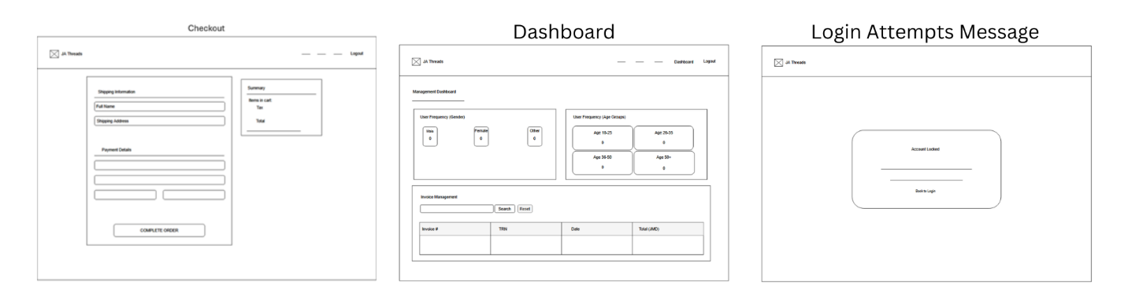
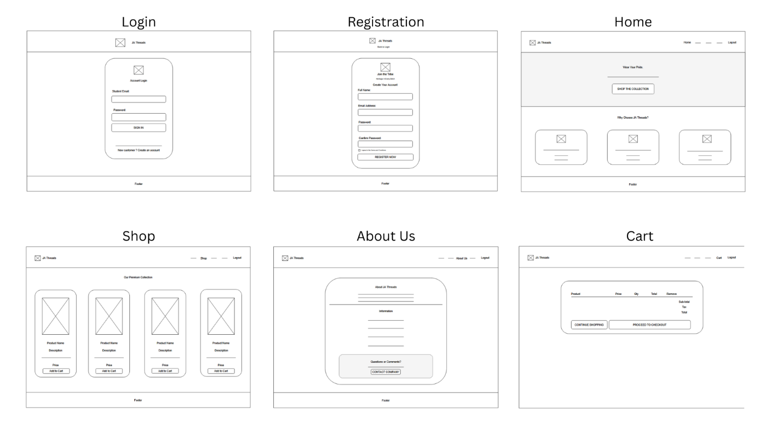
Mobile Storyboard
