CSCI4795 Spring 2020 Cloud Computing PA#1

Name: ______________Richard Red___________________

UGA Student ID: ______811634716____________________

**Instructions: Fill in your answers to the 4 questions and SUBMIT A PDF to eLC**

1. [Step #24] Cut-and-paste a browser screen of your Web site showing health plans. You must replace this sample screenshot with your own (7” wide). If you were unable to complete this part, remove the screen shot and explain how far you were able to get and describe the problem (which you were unable to debug). To receive full credit, your name must be shown in the top of the Web page.

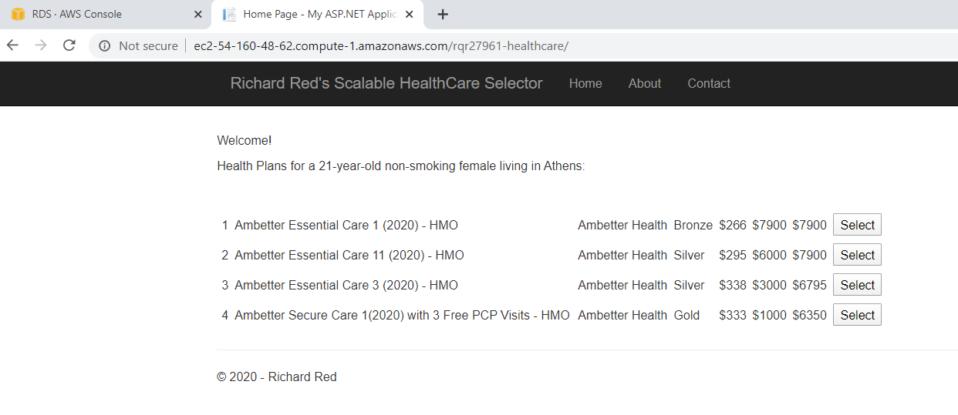

1. [Step #26] Cut-and-paste a browser screen showing SQL Server Management Studio showing the “Top 200 rows” in the “Registrations” table after Emily Charlton has registered. If you were unable to complete this part, explain how far you were able to get and describe the problem (which you were unable to debug).

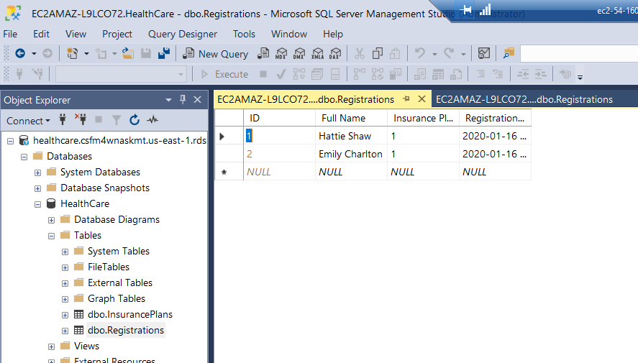

(After also registering ‘Hattie Shaw’)

1. Cut-and-paste a browser screen of your AWS Web Console (Services → RDS 🡪 Databases (left)) at the end of the assignment. To receive full credit, your name must be shown in upper right of the Web page.

(it was in ‘Deleting’ status for a while but now it’s just empty): 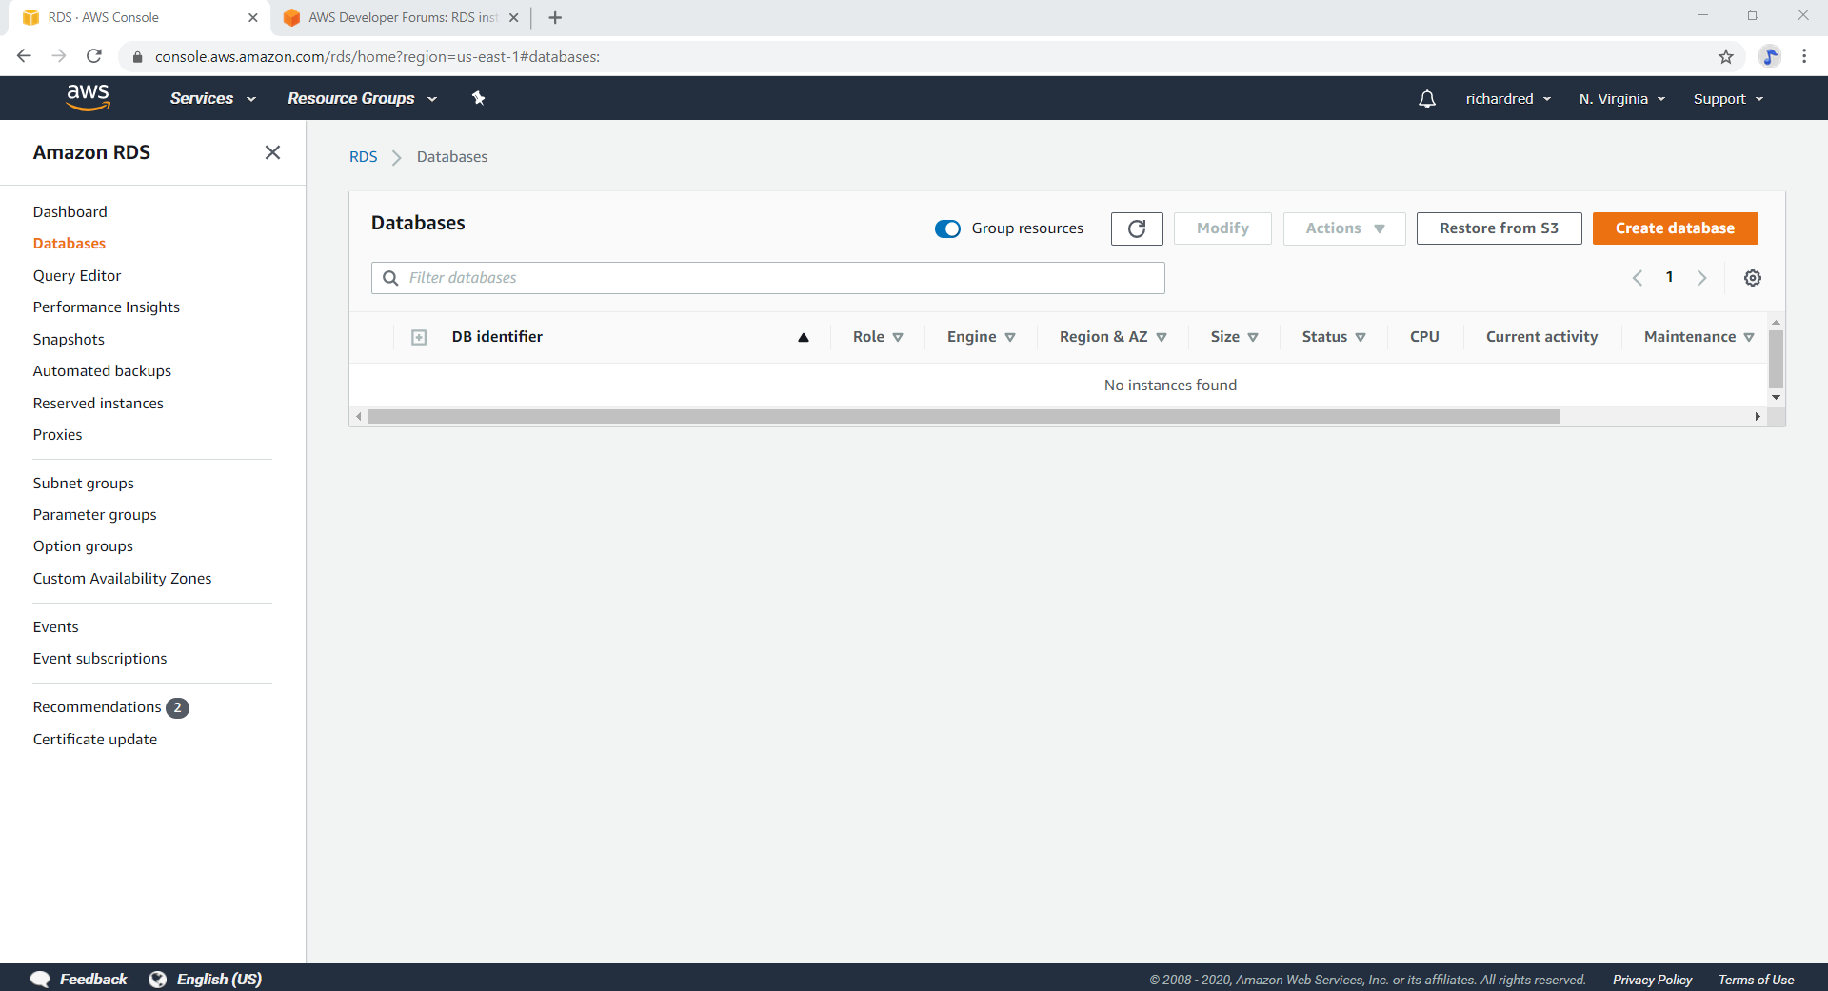

1. Cut-and-paste a browser screen of your AWS Web Console (Services → EC2) at the end of the assignment. To receive full credit, your name must be shown in upper right of the Web page.

