The Ravine Fire, the Gospers Mountain fire. Environmental effects. Contribute to mass air pollution.

Table of content

* Introduction
* Methods
* Discussion
* Conclusion

Abstract:

Air pollution causes climate change, causing wildfires from the droughts. Kangaroo lost approximately half of the inhabitable land in the form of vegetation for wildlife and many animals` lives were lost. Emissions carried by the air parcel were dispersed. Several directions, including 6000 km South towards Antarctica, and Eastbound 6487 km crossed over New Zealand and beyond. Forest fires will continue to be the result of air pollution, and the ultimate solution will be immediate International response to the emergency state of the planet.

Introduction:

During 2019 and beginning of 2020 the Gospers Mountain Fire destroyed 81% of the Blue Mountains World Heritage Area and 48% of Kangaroo was burned by the Ravine Fire. The 2019-2020 wildfires generated 700 million tons of carbon dioxide. The bushfires burned more than 46 million acres, at least, 3500 homes and thousands of other buildings. It was a huge hit for ecology and human being across Australia and for the World.

Due to deterioration from air pollution, fires start happening more all over the Earth. Increase of temperature causes drought, which is the catalyst of fires. A lot of people are endangered. Anthropogenic effects on the habitat of animals are destructive, and many animals are dying.

The objective of this report is to document widespread destruction of the habitat on Kangaroo Island and bring awareness about the effects of air pollution on the biosphere.

Methods:

To represent satellite images of interest area Google Earth Engine will be used as main engine. Write about co2 emission tool, some more pictures, code, then represent some more images from external resource

Satellite images from area Google Earth Engine processed by Code Editor with JavaScript, for images of the catastrophe. Sentinel-2 was used in this problem. To represent an air parcel trajectory, HYSPLIT models from the National Oceanic Atmospheric Administration were used. Air Quality Indexes were provided by World Air Quality Index website using historical data.

Results:

Figure 1 shows processing of sentinel-2A images, I created Differed Normalized Burn Ratio to represent the area where fires were likely located on Kangaroo Island.(From QGIS)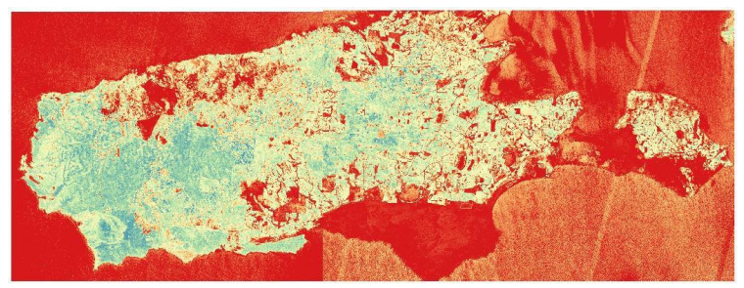

The 2019-2020 bushfires on Kangaroo Island, Australia were the greatest in the recorded history. 47.3% of the Kangaroo island was burned. A billion animals may have died. Almost 100,000 sheep were killed in bushfires on Kangaroo Island. Levels of CO2 in the atmosphere were 417 ppm in May, with the mean CO2 level for 2020 forecast to be 414.2 ± 0.6ppm. Mean CO2 would exceed the 2019 average by 2.74 ± 0.57 ppm. Increasing level of CO2 causes to increasing of greenhouse effect. Climate change includes increased mean temperatures. Since 1910, mean temperatures have been exceeded by 3 C. In Figure 2, plots A&B represent mean temperatures increase.

The emissions from wildfires affect clouds, regionally and globally. As precipitation has decreased and drought has increased, the mean temperatures rise. All of this creates the stage for more devastating fire each year.

Earth Engine Code was also used to create NDVI and NBR indexes. (Include Google earth engine code and images)

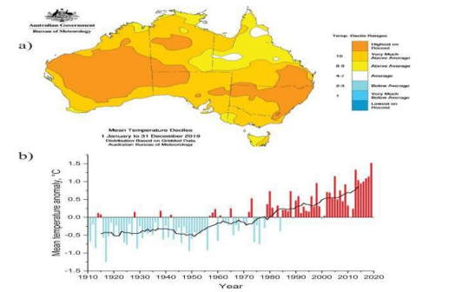

6487 km to the east green parcel of air. Figure 3 is Hysplit showing a blue parcel of air went from 1500 meters to approx. 6000 meters on the Southern course toward Antarctica.

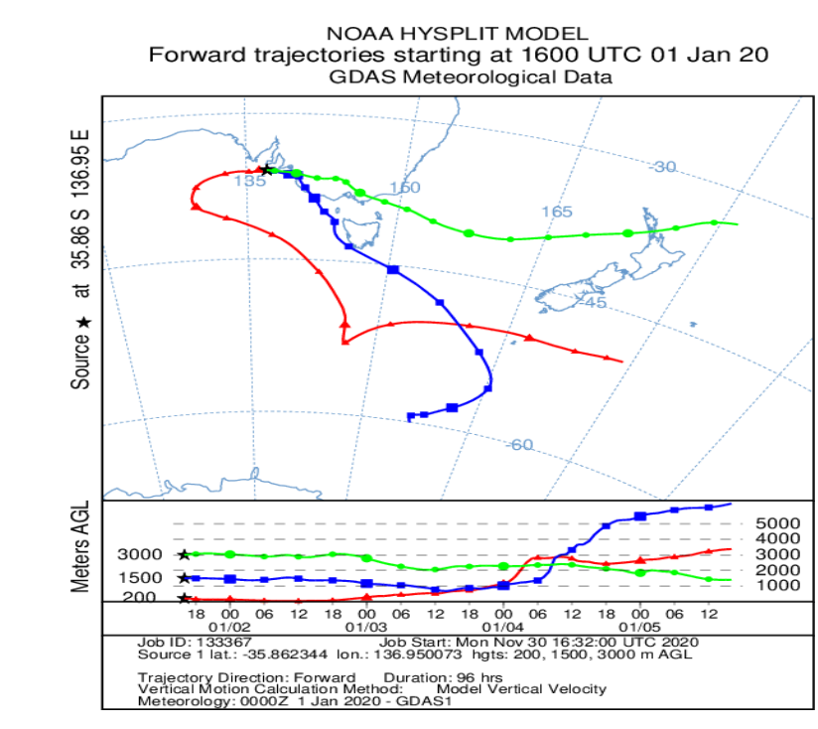

Discussion:

Habitat including vegetation needs restoration, and the process will take years to restore. Fires on mainland Australia, were larger than the Kangaroo Island fire. However, ecological destruction did not suffer as many animal deaths due to having land to escape the fires. Action should be taken immediately air pollution. The nations surrounding this area, including all other countries globally should also improve the national environmental laws to encourage the improvement of the atmosphere.

Conclusion:

Air pollution from humans causes rapid climate change, which provides increasing of the global mean temperature. The droughts caused by warmer temperatures provokes more wildfires. The emissions from the fires affects the atmosphere negatively. International Policies should be refined for addressing the current state of emergency and ban biologically inconsiderate fuel sources.