**QUESTION NUMBER :1**

SELECT orders.orderNumber,products.productName,customers.customerName,payments.amount,payments.checkNumber

FROM orders

INNER JOIN orderdetails

ON orders.orderNumber = orderdetails.orderNumber

INNER JOIN products

ON orderdetails.productCode = products.productCode

INNER JOIN customers

ON orders.customerNumber = customers.customerNumber

INNER JOIN payments

ON payments.customerNumber = customers.customerNumber

WHERE orders.orderNumber=10100;

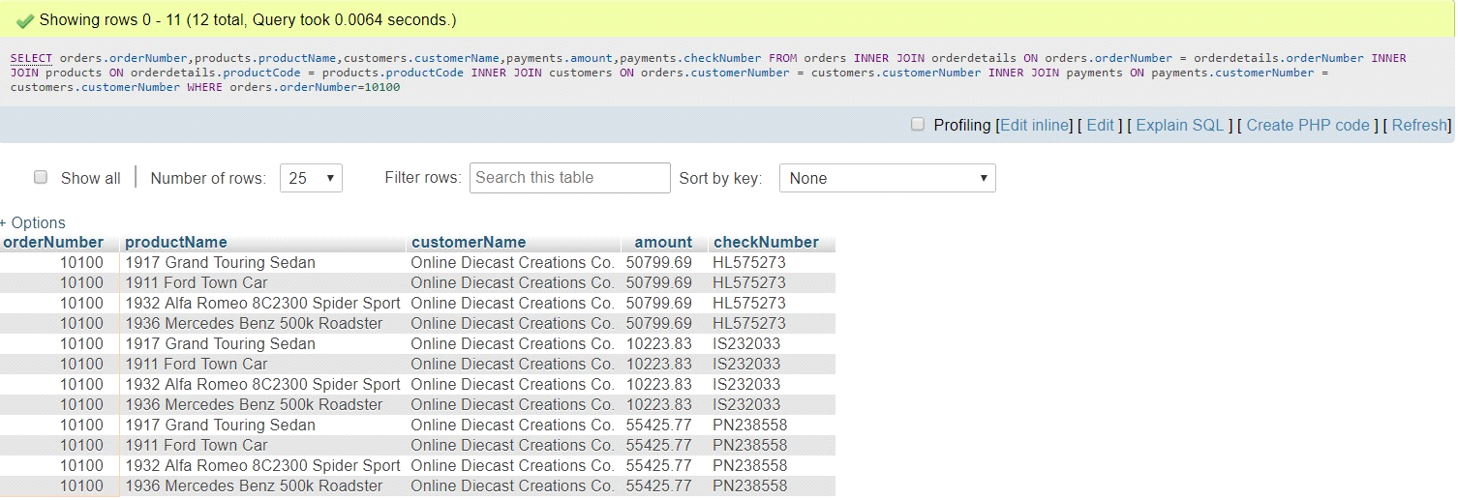

**QUESTION NUMBER :2**

SELECT orders.orderNumber,SUM(payments.amount) AS total_paid_amount_for_the_order_10100

FROM orders

INNER JOIN orderdetails

ON orders.orderNumber = orderdetails.orderNumber

INNER JOIN products

ON orderdetails.productCode = products.productCode

INNER JOIN customers

ON orders.customerNumber = customers.customerNumber

INNER JOIN payments

ON payments.customerNumber = customers.customerNumber

WHERE orders.orderNumber=10100;

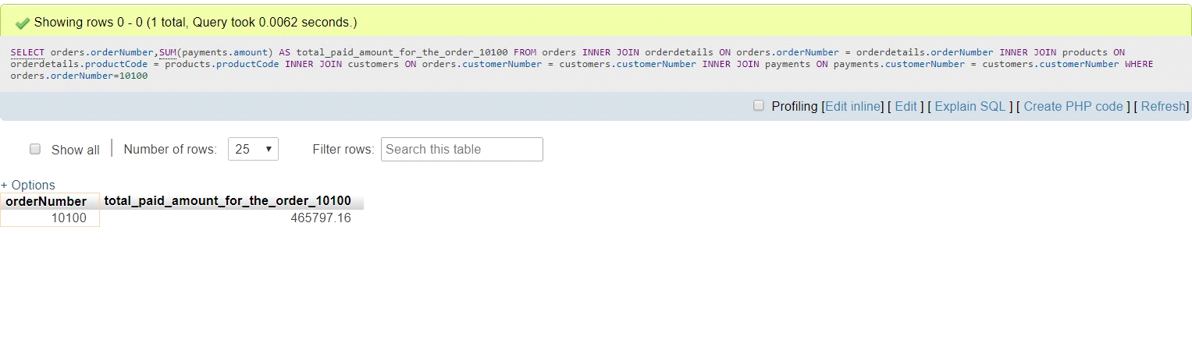

**QUESTION NUMBER :3**

SELECT DISTINCT orders.orderNumber,payments.checkNumber

FROM orders

INNER JOIN orderdetails

ON orders.orderNumber = orderdetails.orderNumber

INNER JOIN products

ON orderdetails.productCode = products.productCode

INNER JOIN customers

ON orders.customerNumber = customers.customerNumber

INNER JOIN payments

ON payments.customerNumber = customers.customerNumber

WHERE orders.orderNumber=10100;

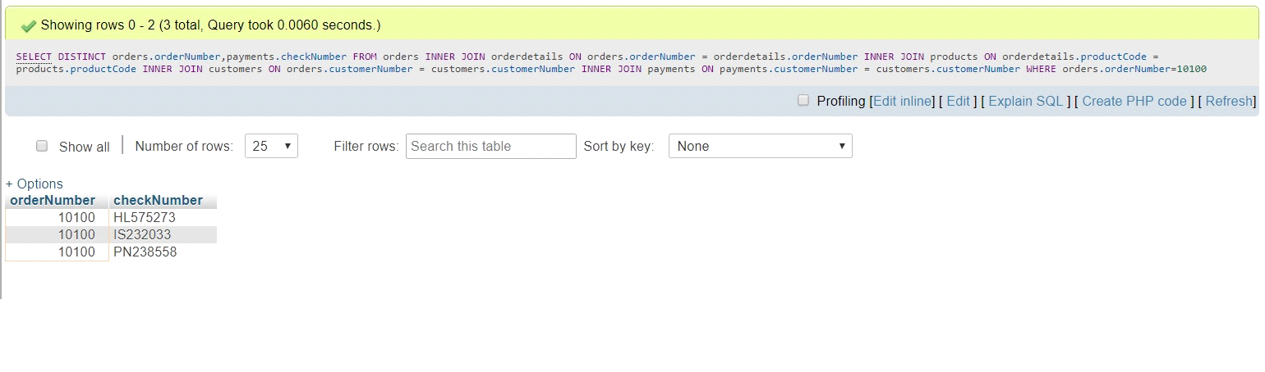

**QUESTION NUMBER :4**

SELECT MIN(quantityInStock) AS min_value_in_quantityInStock,MAX(quantityInStock) AS max_value_in_quantityInStock FROM products;

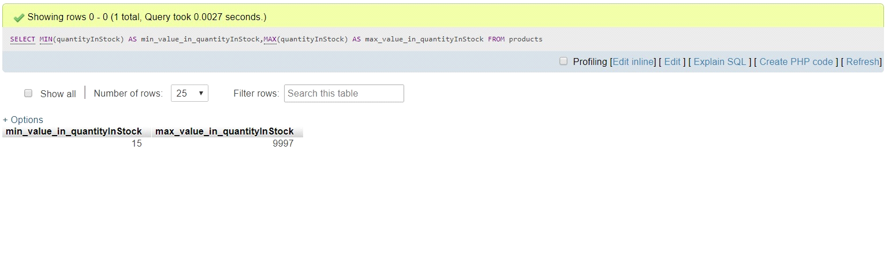

**QUESTION NUMBER :5**

SELECT products.productCode,products.productLine,productLines.htmlDescription

FROM `products`

INNER JOIN productlines

ON products.productLine=productlines.productLine

WHERE products.productLine=(SELECT productLine FROM productlines WHERE productLine='Classic Cars')

AND (productCode='S12_3380'OR productCode='S12_3891' OR productCode='S12_3990') ;

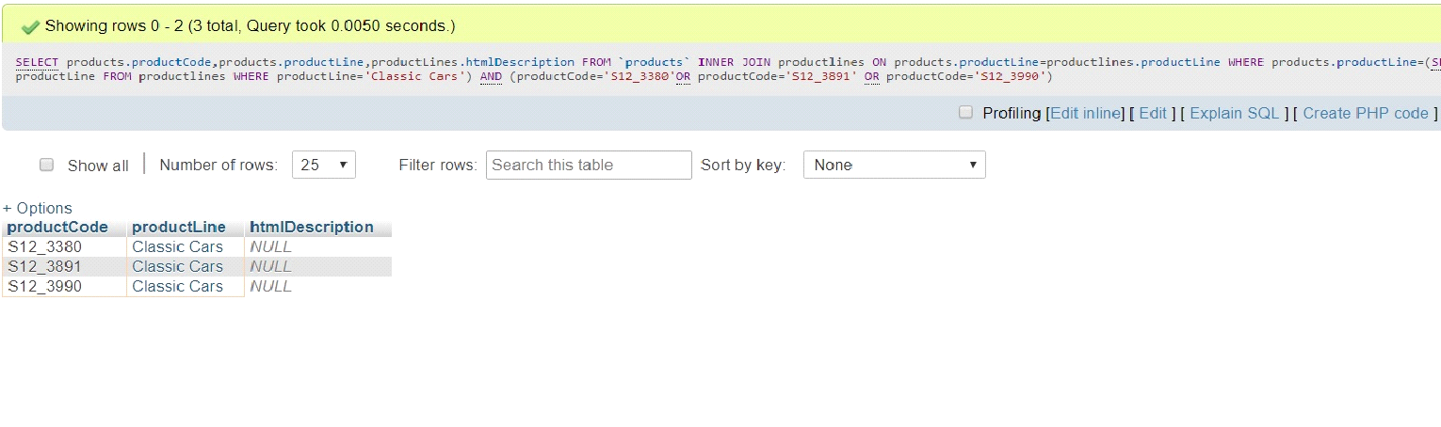

**QUESTION NUMBER :6**

SELECT COUNT(*) FROM productLines WHERE htmlDescription=NULL;

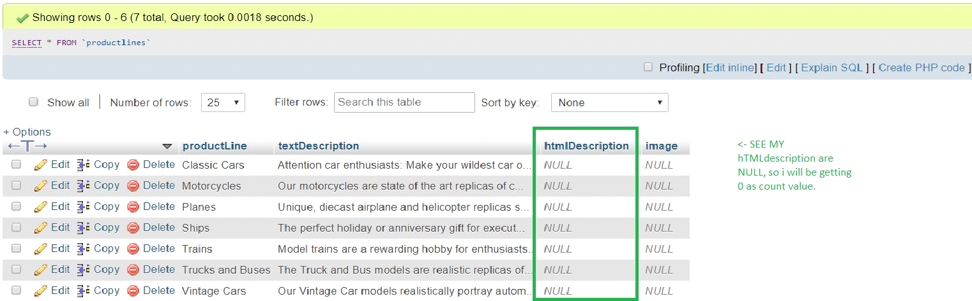

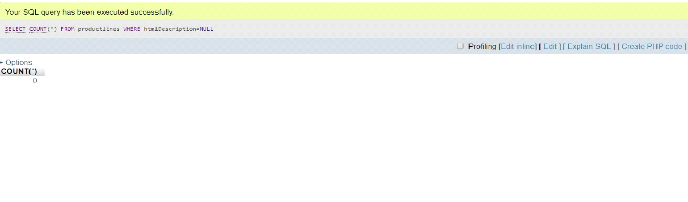

**QUESTION NUMBER :7**

SELECT DATE_FORMAT('2019-07-18 12:49:24' ,'%d %b %a') AS output;

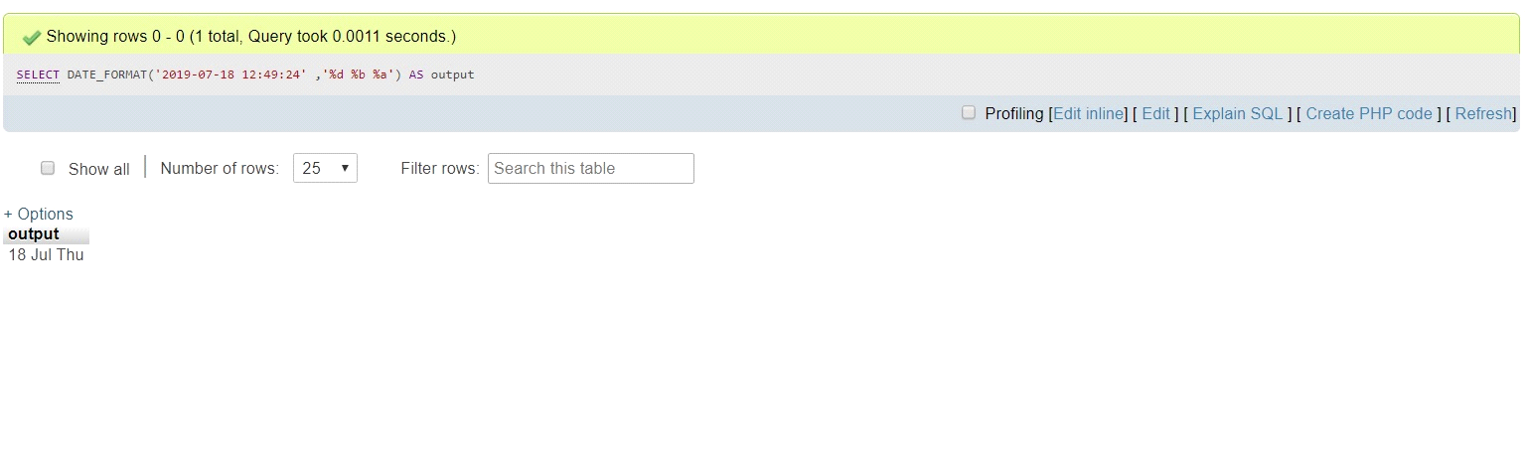

**QUESTION NUMBER :8**

SELECT amount FROM payments ORDER BY amount DESC LIMIT 2,1

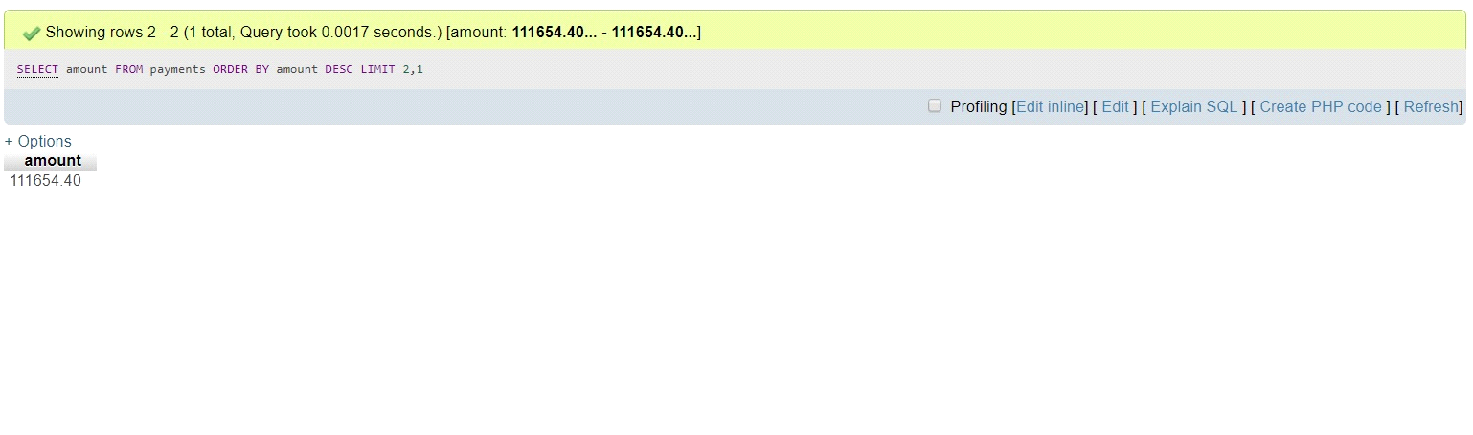

**QUESTION NUMBER :9**

SELECT contactFirstName FROM customers WHERE contactFirstName LIKE 'C%a '

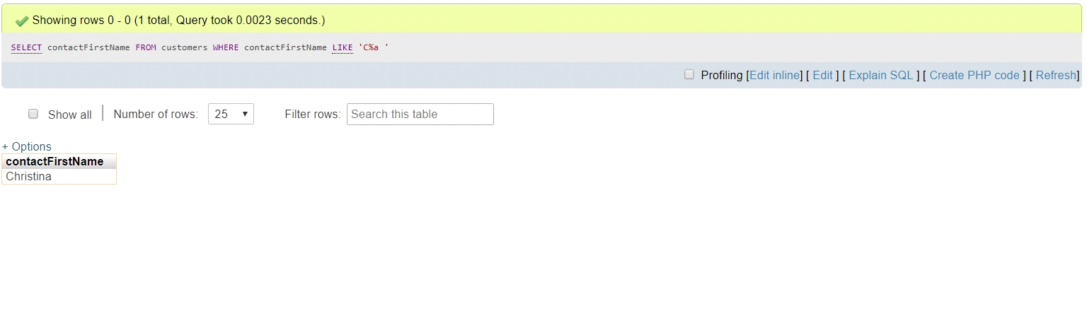

**QUESTION NUMBER :10**

SELECT productLines.productLine,productLines.textDescription,productLines.htmlDescription,productLines.image

FROM `productlines`

INNER JOIN products

ON products.productLine = productlines.productLine

WHERE productLines.productLine <> products.productLine;

