IDEX OPEN CHALLENGE SUBMISSION

Annexure-4
Supporting evidence and screenshots checklist
CIN | PAN | TAN
U62011AP2025PTC120239 | ABQCS7152R | VPNS31351F

Applicant Entity | Contact
Syntriass Labs Private Limited | kattanaga5555@gmail.com
12-50, SLV Market, 12 Ward, Dharmavaram, Ananthapur - 515671, Andhra Pradesh, India | +91 88864 68060

Supporting Evidence and Screenshots

Company Identification Details
Field | Details
Legal Entity Name | Syntriass Labs Private Limited
CIN | U62011AP2025PTC120239
PAN | ABQCS7152R
TAN | VPNS31351F
Registered Office | 12-50, SLV Market, 12 Ward, Dharmavaram, Ananthapur - 515671, Andhra Pradesh, India
Contact Email | kattanaga5555@gmail.com
Contact Phone | +91 88864 68060
GitHub Repository | https://github.com/richardrich999888-rgb/NEXUS
Submission Date | 17 May 2026

1. Applicant Resume Format
Field | Details
Applicant | K. Naga Sri Ganesh
Role | Founder / Inventor
Company | Syntriass Labs Private Limited
Relevant Focus | Governed autonomy, execution control, autonomous systems security, cryptographic audit, defence proposal development
Current Project | NEXUS governed-autonomy stack
Problem 1 Product | NEXUS Guard: governed execution layer for unauthorized autonomous action prevention

Relevant Experience
- Development of NEXUS execution-control, governance, proof, audit, and safety components.
- Design of pre-execution guard interfaces for autonomous software systems.
- Preparation of defence-focused evidence packages for iDEX-style evaluation.
- Software prototype validation using Rust and Python test suites.

2. Prototype Evidence List
Evidence Item | Current Status | Notes
NEXUS Guard concept package | Prepared | Located under docs/idex-open-challenge-2026/01-nexus-guard/.
ExecutionGuard source path | Available | nexus-executor/src/guard.rs.
Composite guard source path | Available | nexus-executor/src/guards/composite.rs.
Executor source path | Available | nexus-executor/src/executor.rs.
Red-team execution test | Available | cargo test -p nexus-executor --test red_team_execution -- --nocapture.
Shared test report | Available | docs/IDEX_PRE_SUBMISSION_TEST_REPORT.md.
Defence capability audit | Available | docs/DEFENCE_CAPABILITY_AUDIT.md.
iDEX package evidence file | Available | docs/idex-open-challenge-2026/01-nexus-guard/evidence.md.
GitHub repository | Available | https://github.com/richardrich999888-rgb/NEXUS.

3. Architecture Screenshots List
Screenshots generated for this Annexure from the local repository and current test output:
Screenshot | Purpose
ExecutionGuard interface | Shows mandatory guard contract before protected execution.
Composite first-deny-wins flow | Shows that any guard denial blocks execution.
Red-team test output | Shows unauthorized execution denial tests.
ETK audit evidence flow diagram | Shows allowed execution evidence generation.
TELOS consequence-budget trace | Shows consequence accounting for high-impact actions.
NEXUS Guard dashboard mock/screen | Shows blocked actions, reason codes, and audit review.

4. Demo Evidence List
Demo Step | Evidence To Capture
Start NEXUS Guard demo runtime | Terminal output or dashboard screenshot showing runtime ready.
Submit unauthorized protected action | Request payload and policy context.
Show guard denial | Denial reason, guard name, and blocked execution status.
Verify no success proof/cache | Output showing no success artifact for denied path.
Submit authorized protected action | Request payload with valid authority and policy context.
Show allowed execution | Execution result and ETK-compatible audit record.
Show TELOS consequence update | Consequence tier and remaining budget trace.
Export evidence packet | Audit or replay file generated for evaluator review.

5. Technical Validation Material

Required Pre-Submission Test Command
cargo test -p nexus-executor --test red_team_execution -- --nocapture

Recorded Pre-Submission Evidence
The shared test report records NEXUS execution red-team validation as passing at software-subsystem level. The command should be rerun immediately before portal upload and the latest output should be added to this Annexure as screenshot or terminal capture.

Validation Scope
Validation Area | Status
Unauthorized execution denial | Software test evidence available
No success proof/cache on denied path | Software test evidence available
Allowed execution audit evidence | Prototype evidence path available
TELOS consequence accounting | Supporting module evidence available
Hardware-in-loop validation | Proposed work, not claimed completed
Field deployment | Not claimed

6. Future Deployment Scope
Phase | Scope
Lab Evaluation | Run red-team denial demos against simulated autonomous actions and tool calls.
Integration Pilot | Wrap selected mission software, agent tool router, or robot command path with NEXUS Guard.
Edge / On-Premise Trial | Deploy local guard runtime, policy bundle, and audit store without external cloud dependency.
Hardware-in-Loop Validation | Connect to target robotic or cyber-physical testbed and measure latency, denial reliability, and evidence integrity.
Operational Hardening | Add service-specific policy packs, secure key custody, monitoring, and evaluator-approved deployment procedures.

7. Readiness and Caveats
- Current readiness should be stated as software subsystem TRL 3-4.
- No physical military hardware validation is claimed in the current package.
- No operational deployment claim is made.
- Human approval, command policy, and service-specific safety rules must be integrated before operational use.
- Latency, resilience, and hardware-in-loop testing are part of the proposed iDEX work.

8. Evidence Checklist Before Portal Upload
Item | Status
Insert final contact and signatory details | Pending final review
Rerun red-team execution test | Pending final pre-upload run
Capture screenshots of source paths and test output | Pending
Export Annexure files to PDF under portal size limits | Pending
Add dashboard/demo screenshots if available | Pending
Conduct legal/export-control/security review | Pending
Confirm portal challenge title and category | Pending

Evidence Page 5 - Evidence Register Overview
This Annexure is structured to mirror the AIRON evidence-packet format by reserving page-level slots for source evidence, test evidence, demo evidence, screenshots, validation plans, and readiness caveats.
Evidence categories:
- Source code screenshots.
- Test command screenshots.
- Terminal output screenshots.
- Runtime demo screenshots.
- Audit export screenshots.
- Deployment and API screenshots.
- Readiness and caveat statements.
Status: repository reference screenshot embedded; final portal pass should confirm the link is still accessible.
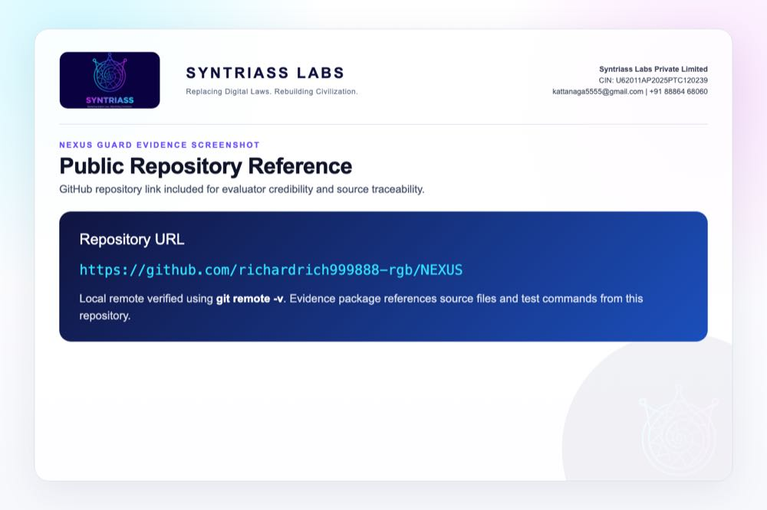
GitHub repository reference for evaluator source traceability

Evidence Page 6 - ExecutionGuard Interface
Evidence source: nexus-executor/src/guard.rs
Purpose: show the frozen guard contract used for pre-execution authorization.
Expected capture:
- ExecutionGuard trait.
- check(&self, pcu: &PCU, ctx: &ExecutionContext).
- GuardDecision return path.
- File path visible in editor or terminal.
Status: source evidence available; screenshot embedded.
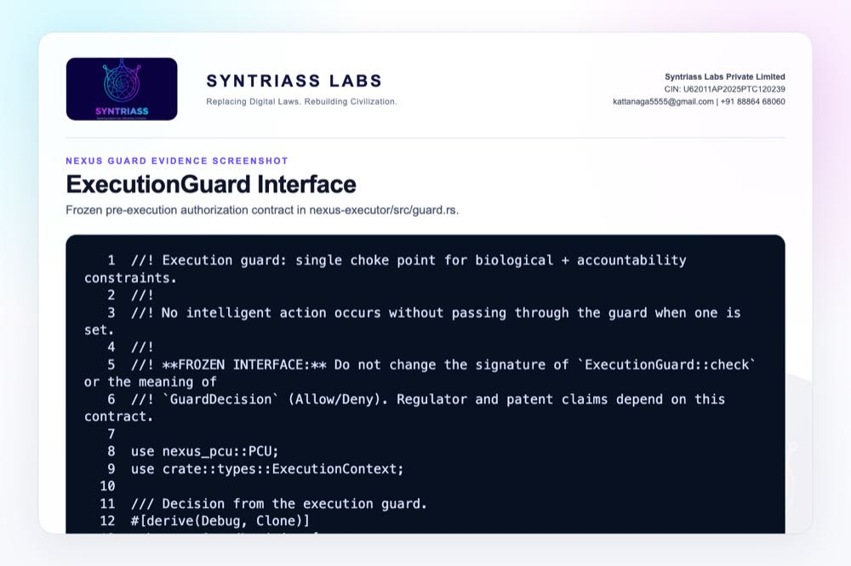
ExecutionGuard source interface screenshot

Evidence Page 7 - Composite First-Deny-Wins Guard
Evidence source: nexus-executor/src/guards/composite.rs
Purpose: show that layered guards block execution when any guard returns Deny.
Expected capture:
- Guard iteration.
- GuardDecision::Allow continuation.
- GuardDecision::Deny(reason) early return.
- File path visible.
Status: source evidence available; screenshot embedded.
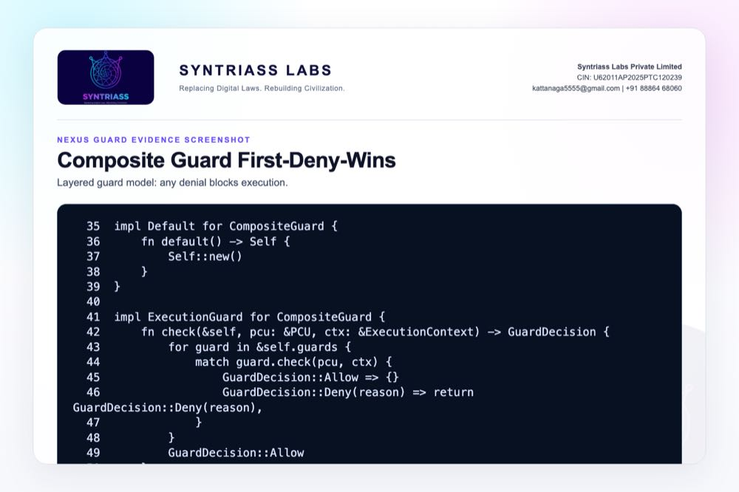
Composite guard first-deny-wins source screenshot

Evidence Page 8 - Execution Engine Path
Evidence source: nexus-executor/src/executor.rs
Purpose: show where guarded execution connects to the execution engine.
Expected capture:
- Request intake.
- Guard check before execution.
- Execution or denial branch.
- Proof/cache behavior if visible in source.
Status: source evidence available; screenshot embedded.
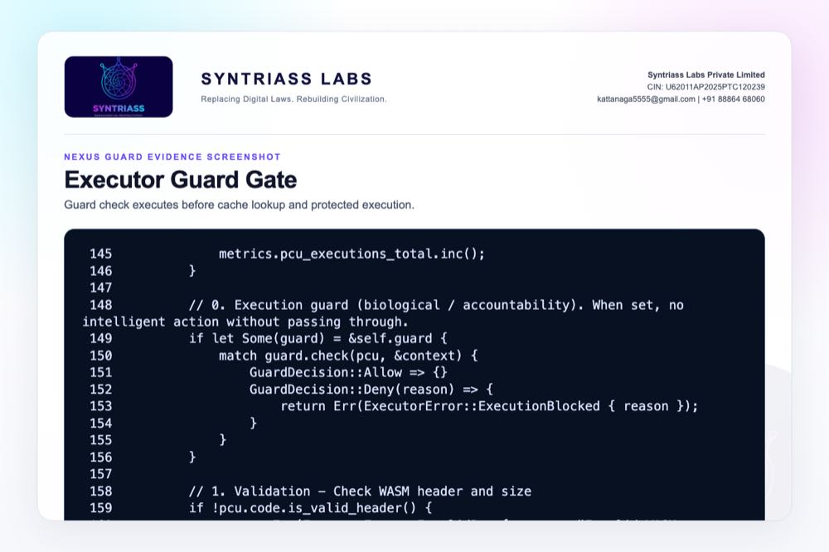
Executor guard gate source screenshot

Evidence Page 9 - Red-Team Test File
Evidence source: nexus-executor/tests/red_team_execution.rs
Purpose: show that explicit bypass/denial-path tests exist.
Expected capture:
- Test names.
- Unauthorized execution cases.
- Denied path expectations.
- No proof/cache expectation if present.
Status: test source available; screenshot embedded.
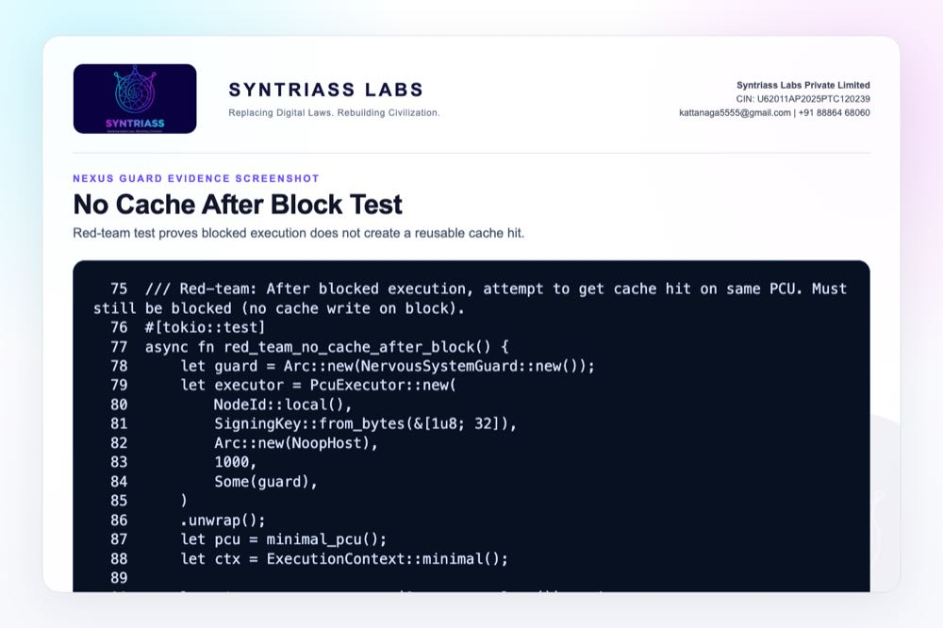
No-cache-after-block red-team source screenshot

Evidence Page 10 - Red-Team Test Command
Required command before portal upload:
cargo test -p nexus-executor --test red_team_execution -- --nocapture
Expected capture:
- Command visible in terminal.
- Passing test count.
- Any denial-path diagnostic output.
- Timestamped terminal or saved log.
Current status: rerun completed on 17 May 2026; screenshot embedded below.
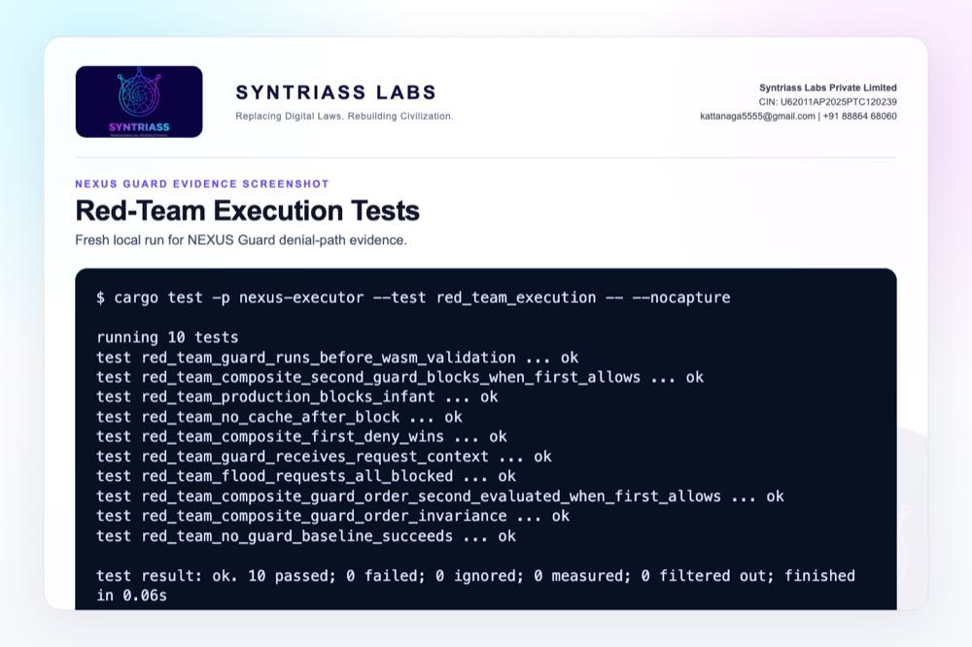
Fresh red-team execution test output screenshot

Evidence Page 11 - Red-Team Test Output
Screenshot to insert after rerun: terminal output from the red-team execution command.
Acceptance evidence:
- Tests pass.
- Unauthorized execution is denied.
- Denied path does not create a success proof.
- Denied path does not create a success cache artifact.
Status: rerun completed on 17 May 2026; screenshot embedded below.
Final rerun completed on 17 May 2026. Result: 10 passed, 0 failed.

Fresh red-team execution test output screenshot

Evidence Page 12 - ETK Audit Evidence Path
Purpose: show the offline audit verification path used by the Execution Truth Kernel (ETK).
Status: source evidence embedded. This page supports the claim that allowed execution evidence can be verified locally from proof, event, policy, and public-key artifacts.
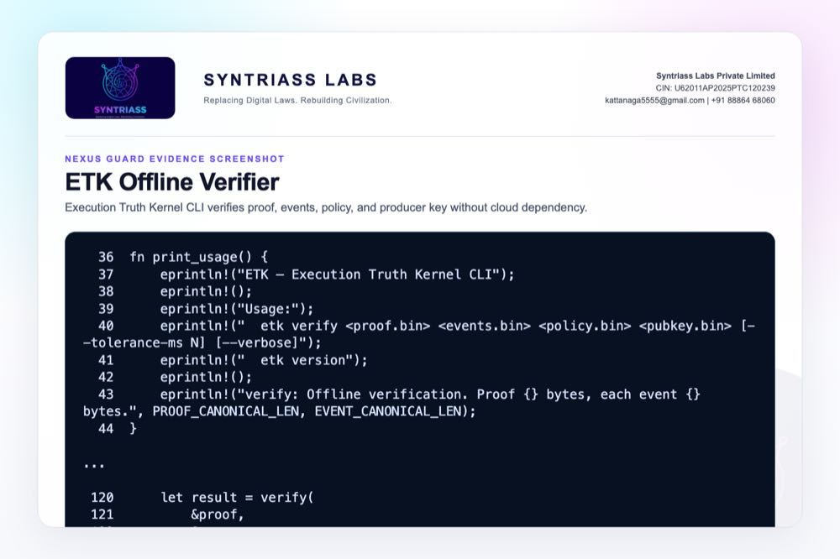
ETK offline verifier source screenshot

Evidence Page 13 - TELOS Consequence Accounting
Purpose: show the consequence-tier and entropy-budget mechanism proposed for high-impact action friction.
Status: source evidence embedded. The evidence is software-level only; operational tuning and hardware validation remain proposed iDEX work.
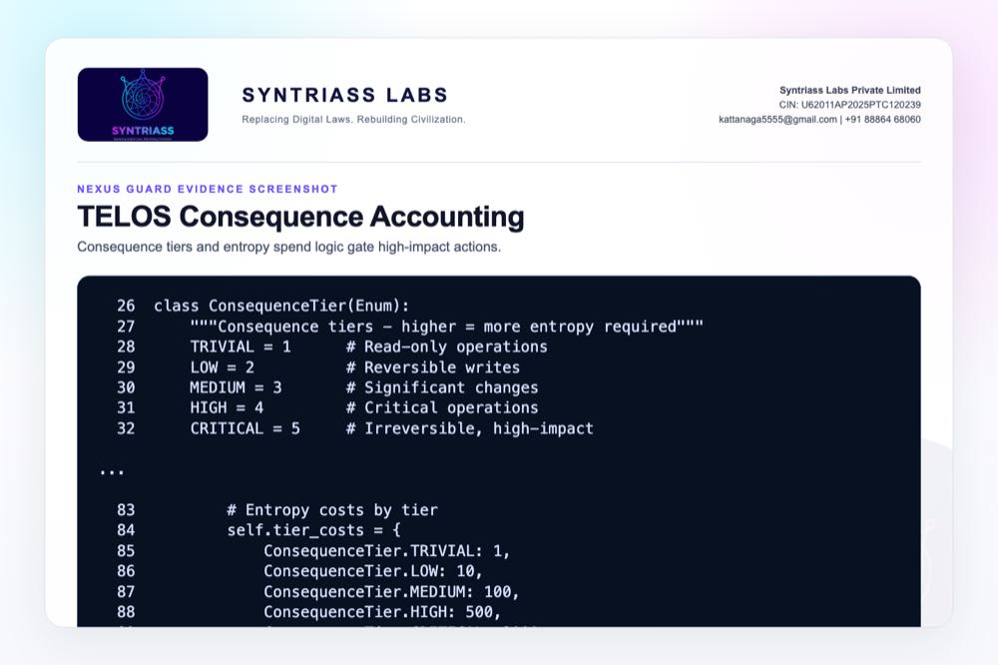
TELOS consequence accounting screenshot

Evidence Page 14 - Guarded Request Schema
Purpose: show the execution context available to the guard decision: inputs, identity, resource limits, request ID, and risk metadata.
Status: source evidence embedded.
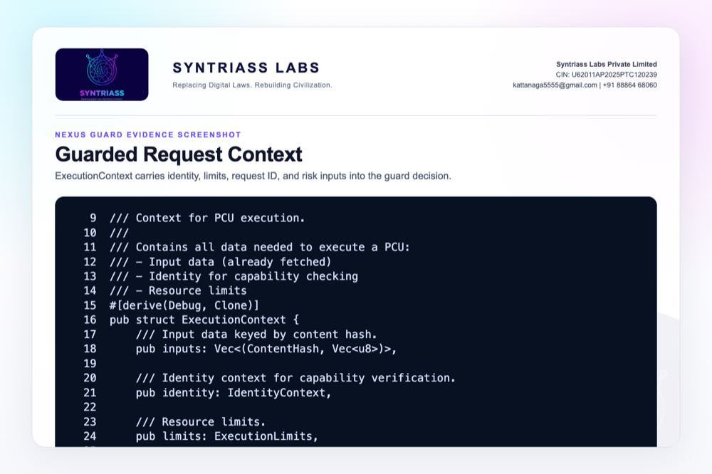
Guarded request context screenshot

Evidence Page 15 - Denial Reason Codes
Purpose: show that denial, identity failure, proof failure, and cache failure are typed program outcomes rather than silent failures.
Status: source evidence embedded.
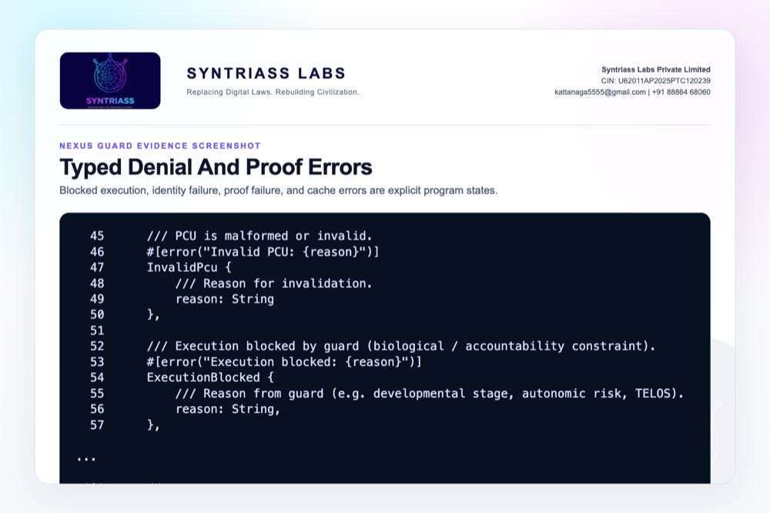
Typed denial and proof error screenshot

Evidence Page 16 - No Success Proof On Deny
Purpose: show that blocked execution returns an error path instead of a successful execution response/proof path.
Status: integration-test evidence embedded.
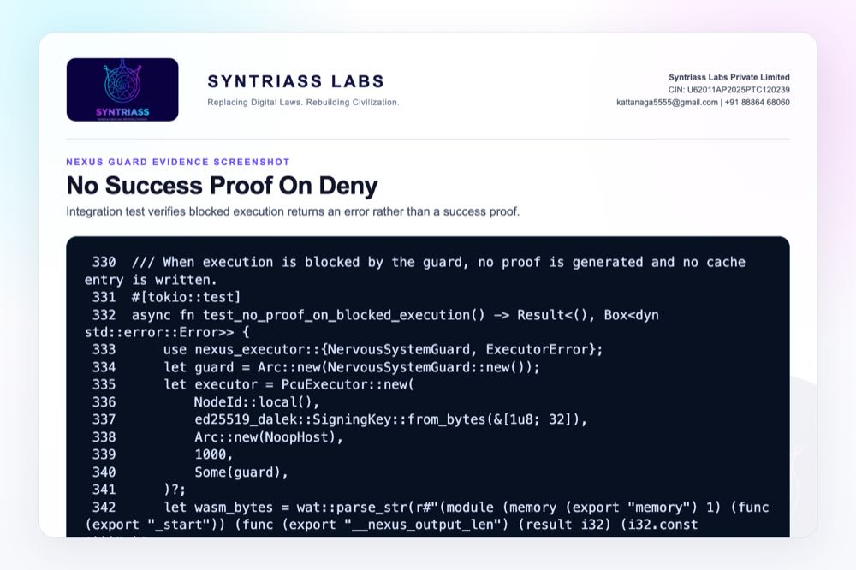
No success proof on denied execution test screenshot

Evidence Page 17 - No Cache Artifact On Deny
Purpose: show that a denied request does not create a cache artifact that could later be served as a successful result.
Status: red-team test evidence embedded.
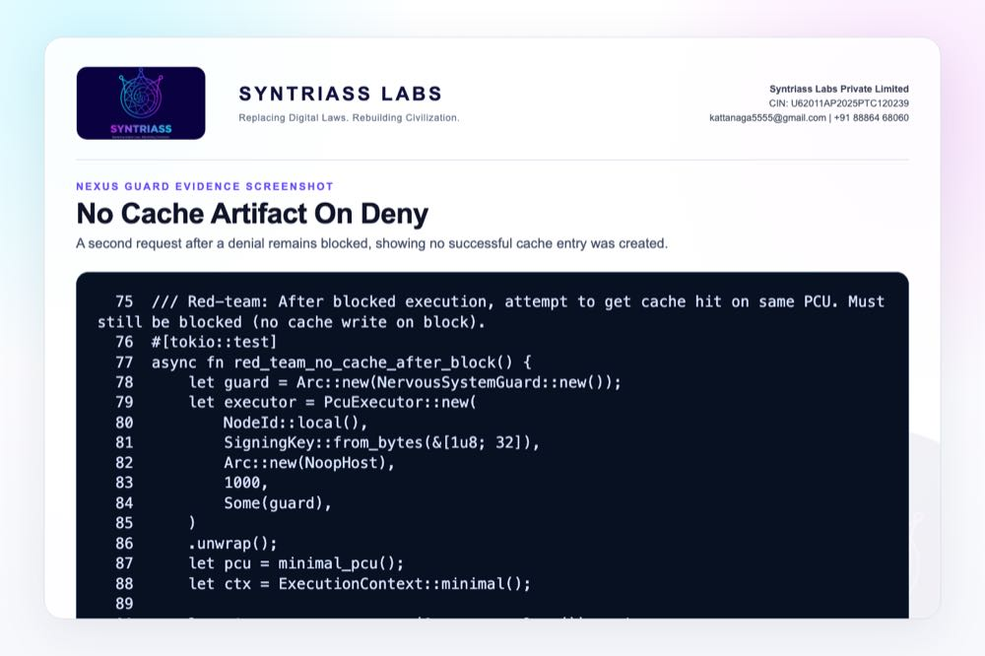
No cache artifact on denied execution test screenshot

Evidence Page 18 - Allowed Execution Audit Record
Purpose: show the contrast between denied and allowed paths: only the successful branch generates a proof, writes cache, and returns ExecutionResponse.
Status: source evidence embedded.
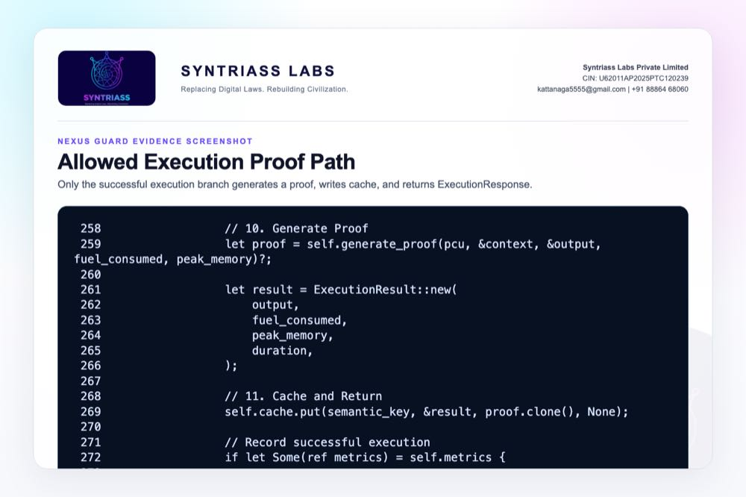
Allowed execution proof and cache path screenshot

Evidence Page 19 - Unauthorized Action Demo
Purpose: show repeated unauthorized execution attempts remain blocked under the guard.
Status: red-team source evidence embedded; terminal output for the full test run is included on Evidence Page 10.
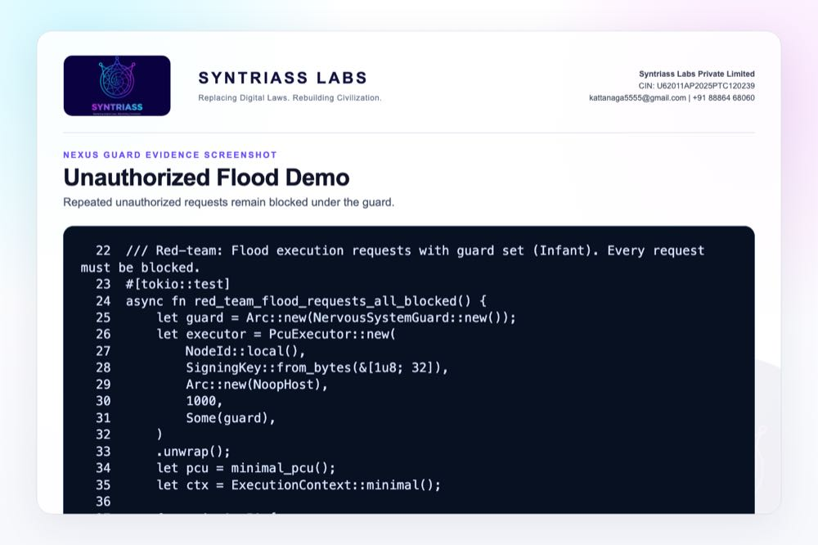
Unauthorized action flood denial screenshot

Evidence Page 20 - Authorized Action Demo
Purpose: show baseline execution with a signed identity when no guard constraint is installed, and clarify why production must use the guarded builder.
Status: red-team baseline evidence embedded. This page is a control case, not a claim that unguarded operation is acceptable for deployment.
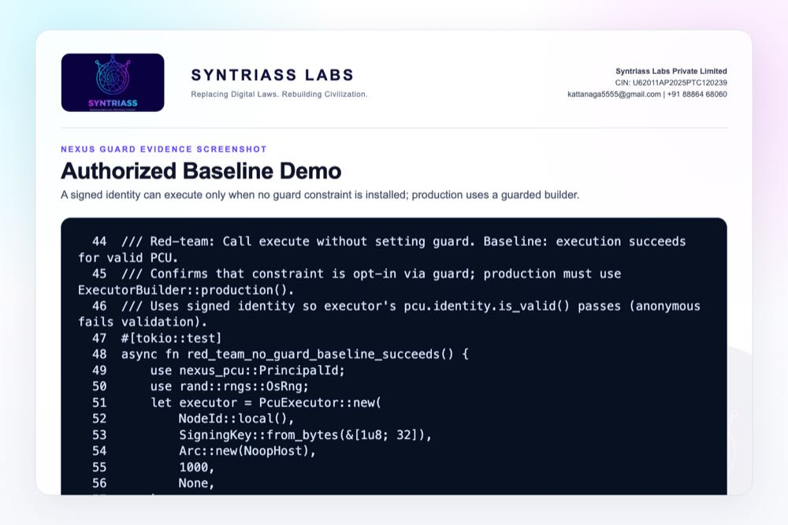
Authorized baseline execution screenshot

Evidence Page 21 - Replay Attempt Demo
Purpose: show current adversarial replay/cache behavior coverage and document the remaining work for nonce-level replay rejection.
Status: adversarial source evidence embedded; nonce replay hardening remains part of the iDEX prototype plan.
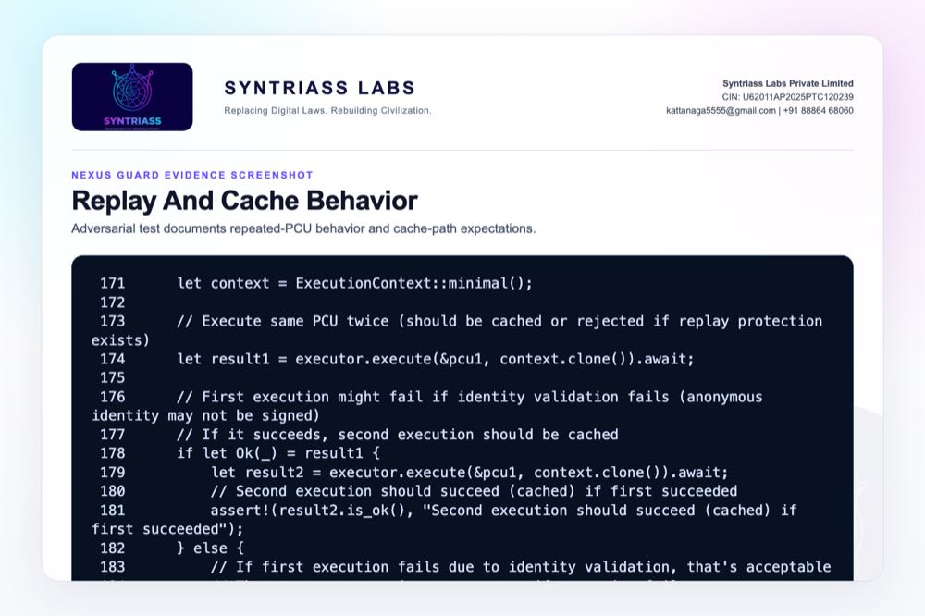
Replay and cache behavior test screenshot

Evidence Page 22 - Policy Bypass Demo
Purpose: show that malformed or adversarial execution payloads cannot bypass the guard by failing later validation.
Status: red-team source evidence embedded.
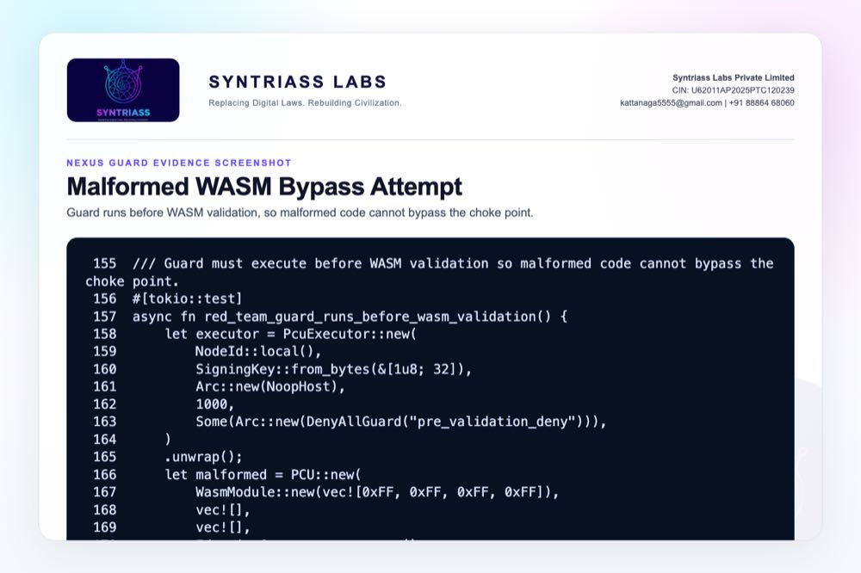
Malformed WASM bypass attempt screenshot

Evidence Page 23 - Consequence Budget Demo
Purpose: show the concrete spend() path used for consequence-aware budget gating.
Status: source evidence embedded; mission-specific consequence thresholds are proposed for iDEX prototype calibration.
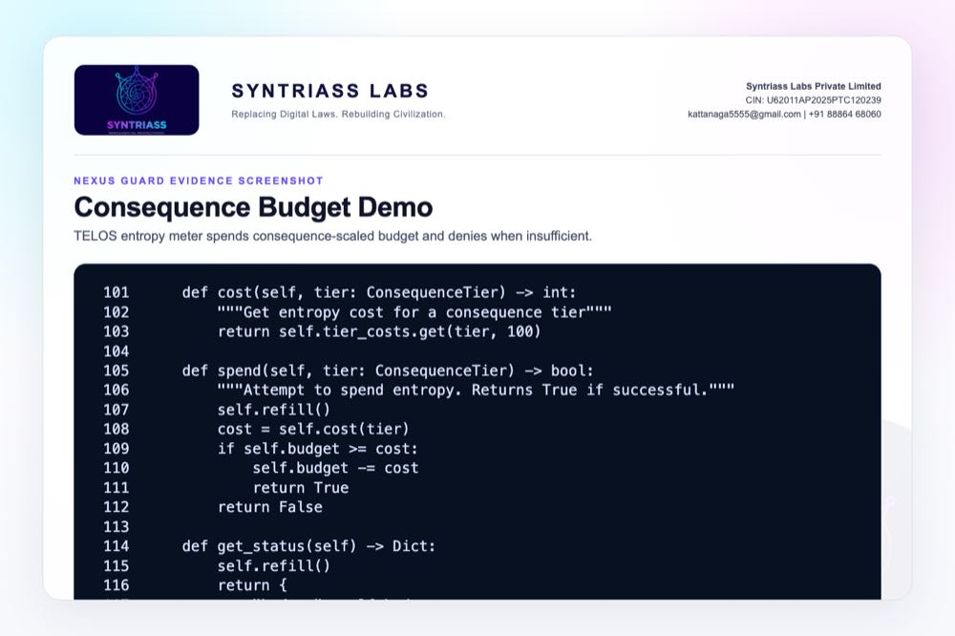
Consequence budget spend path screenshot

Evidence Page 24 - Console Summary View
Purpose: provide an evaluator-facing summary card of the current software evidence state.
Status: generated from current repository/test evidence. A full web dashboard is not claimed in this phase.
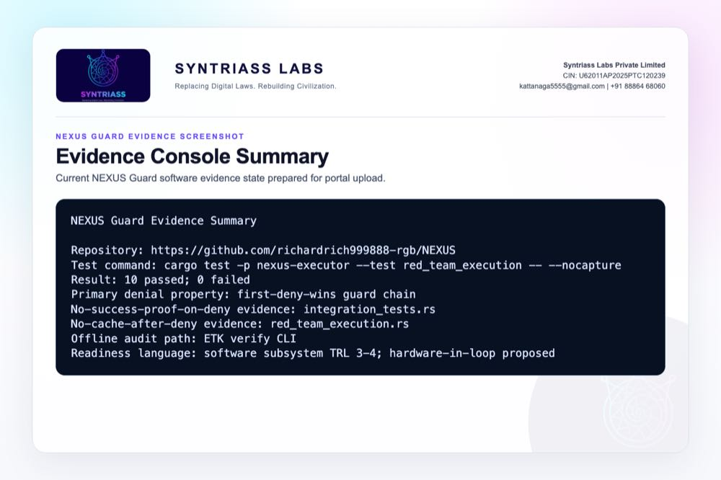
NEXUS Guard evidence console summary screenshot

Evidence Page 25 - Audit Export File
Purpose: show the execution proof schema for allowed executions: PCU hash, input hashes, output hash, identity hash, executor node, timestamp, resource use, and attestation.
Status: source evidence embedded.
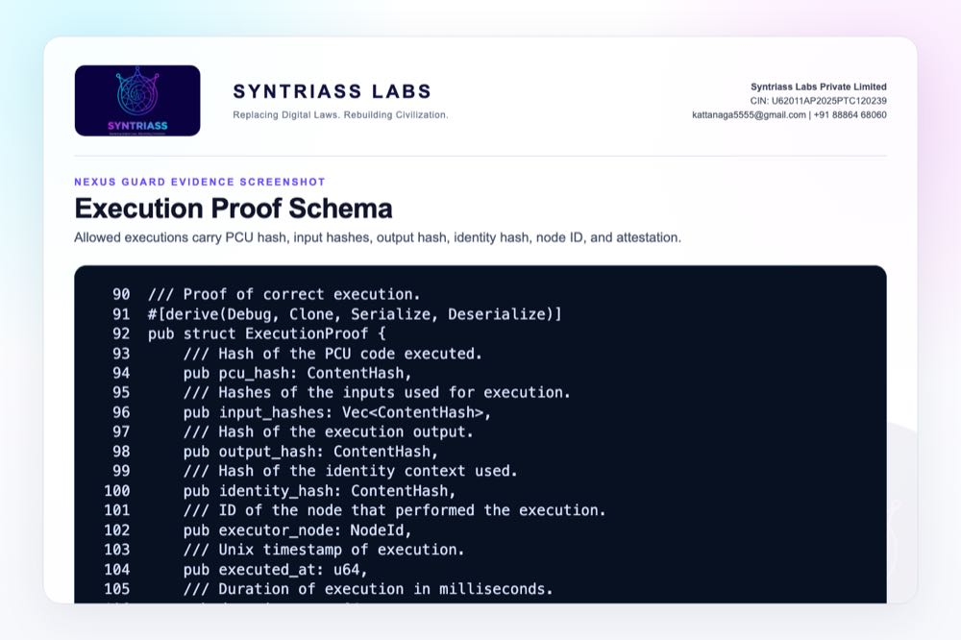
Execution proof schema screenshot

Evidence Page 26 - Offline Review Workflow
Purpose: show that review can be performed locally using ETK CLI artifacts and regulator-grade build checks.
Status: documentation evidence embedded.
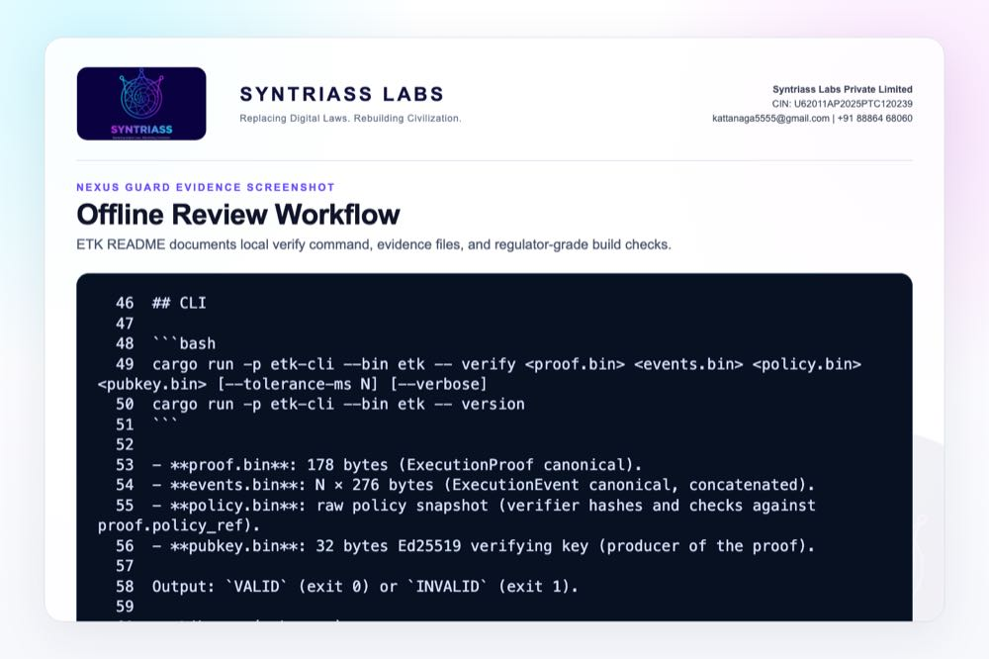
Offline review workflow screenshot

Evidence Page 27 - Deployment Artifact
Purpose: show the executor deployment profile and hardware-attestation feature flags.
Status: source evidence embedded. SGX/SEV/TrustZone use remains a prototype integration step, not a field-validated claim.
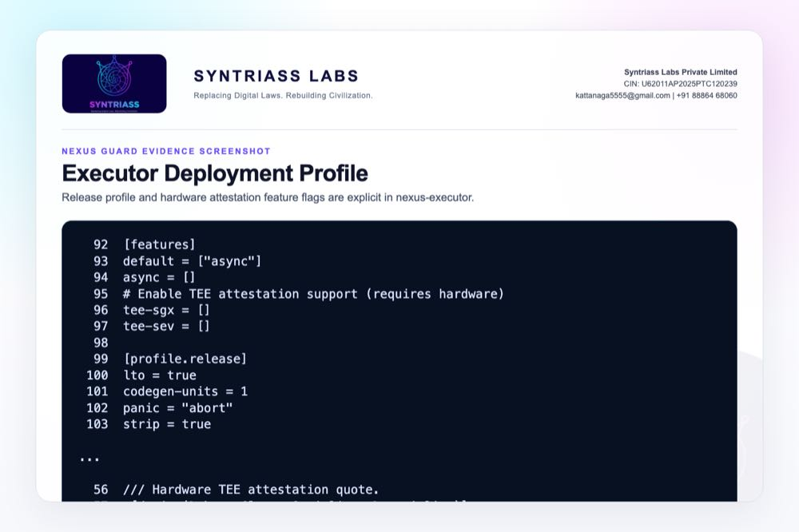
Executor deployment profile screenshot

Evidence Page 28 - API Contract
Purpose: show the code-level integration contract exported to applications and robotics/simulation adapters.
Status: source evidence embedded.
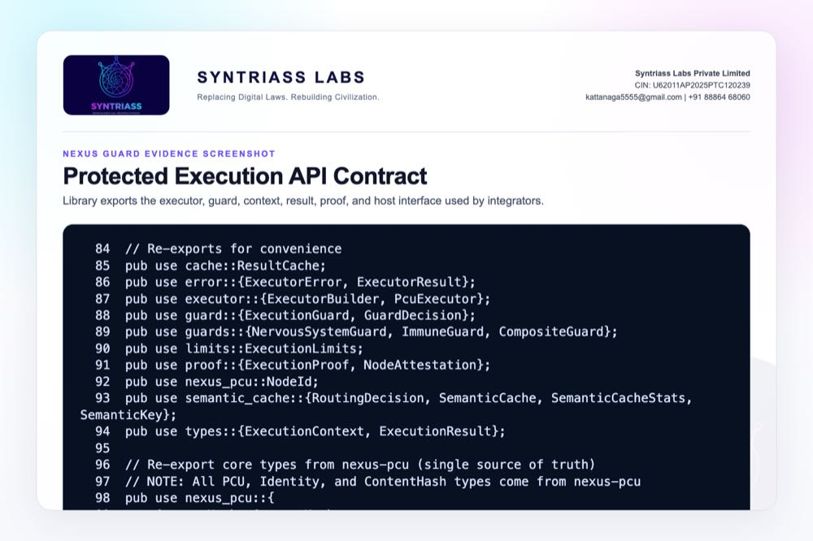
Protected execution API contract screenshot

Evidence Page 29 - Reviewer Repository Map
Public repository:
- https://github.com/richardrich999888-rgb/NEXUS
Primary proposal package location inside the repository:
- docs/idex-open-challenge-2026/01-nexus-guard/final_4_documents/
Primary source modules for this application:
- nexus-executor/src/guard.rs - frozen pre-execution guard interface.
- nexus-executor/src/guards/composite.rs - first-deny-wins guard composition.
- nexus-executor/src/executor.rs - guard-before-cache-before-execution path.
- nexus-executor/src/types.rs - guarded request context and execution response types.
- nexus-executor/src/error.rs - typed denial, proof, identity, and cache errors.
- nexus-executor/src/proof.rs - execution proof and node attestation schema.
How to review quickly:
- Open the GitHub repository.
- Navigate to the file paths above.
- Compare the code with Evidence Pages 6-28.
- Run the test command on Evidence Page 10.

Evidence Page 30 - Claim To File Location Map
This page maps the main NEXUS Guard claims to exact repository evidence.
Claim | Repository location | Evidence page
Guard interface exists | nexus-executor/src/guard.rs | Page 6
First-deny-wins is implemented | nexus-executor/src/guards/composite.rs | Page 7
Guard runs before cache/execution | nexus-executor/src/executor.rs | Page 8
Red-team denial tests exist | nexus-executor/tests/red_team_execution.rs | Pages 9-11
No cache after deny | nexus-executor/tests/red_team_execution.rs | Page 17
No success proof on deny | nexus-executor/tests/integration_tests.rs | Page 16
Allowed path creates proof/cache | nexus-executor/src/executor.rs | Page 18
ETK offline review path exists | etk/crates/etk-cli/src/main.rs, etk/README.md | Pages 12, 26
TELOS consequence budget exists | agp-core/src/telos/membrane.py | Pages 13, 23
Proof schema exists | nexus-executor/src/proof.rs | Page 25
Reviewer note: these are software-subsystem evidence locations, not field deployment evidence.

Evidence Page 31 - Test And Command Locations
Primary executed test command:
cargo test -p nexus-executor --test red_team_execution -- --nocapture
Test file locations:
- nexus-executor/tests/red_team_execution.rs
- nexus-executor/tests/integration_tests.rs
- nexus-executor/tests/adversarial.rs
Recorded output artifact:
- docs/idex-open-challenge-2026/01-nexus-guard/final_4_documents/evidence_assets/nexus_guard_red_team_test_output.txt
Current recorded result:
- 10 passed; 0 failed
- Fresh local run date: 17 May 2026
Additional relevant test commands for later iDEX prototype stages:
- cargo test -p nexus-executor --test integration_tests
- cargo test -p nexus-executor --test adversarial
- cargo test -p telos-protocol

Evidence Page 32 - Generated Artifact Locations
Final PDF artifacts:
- docs/idex-open-challenge-2026/01-nexus-guard/final_4_documents/01_SYNTRIASS_NEXUS_Guard_Annexure_1_Applicant_Details_and_Solution_Summary.pdf
- docs/idex-open-challenge-2026/01-nexus-guard/final_4_documents/02_SYNTRIASS_NEXUS_Guard_Annexure_2_Technical_Architecture.pdf
- docs/idex-open-challenge-2026/01-nexus-guard/final_4_documents/03_SYNTRIASS_NEXUS_Guard_Annexure_3_Advantages_and_Competencies.pdf
- docs/idex-open-challenge-2026/01-nexus-guard/final_4_documents/04_SYNTRIASS_NEXUS_Guard_Annexure_4_Supporting_Evidence_and_Screenshots.pdf
Word artifacts:
- Same directory as above, with .docx extension.
Evidence screenshot folder:
- docs/idex-open-challenge-2026/01-nexus-guard/final_4_documents/evidence_assets/
Build scripts:
- docs/idex-open-challenge-2026/01-nexus-guard/final_4_documents/generate_nexus_guard_evidence_screenshots.mjs
- docs/idex-open-challenge-2026/01-nexus-guard/final_4_documents/build_syntriass_letterhead_problem1.mjs
File-size status:
- Annexure 4 PDF: under 5 MB after compressed evidence embedding.

Evidence Page 33 - Screenshot Artifact Index
Screenshot artifacts embedded in this Annexure:
- evidence_assets/01_github_repository.jpg - public repository link.
- evidence_assets/02_red_team_test_output.jpg - red-team test output.
- evidence_assets/03_execution_guard_interface.jpg - guard trait.
- evidence_assets/04_composite_first_deny_wins.jpg - composite deny path.
- evidence_assets/05_executor_guard_gate.jpg - executor guard gate.
- evidence_assets/06_no_cache_after_block_test.jpg - no cache after block.
- evidence_assets/07_etk_offline_verifier.jpg - ETK CLI verifier.
- evidence_assets/08_telos_entropy_accounting.jpg - consequence tiers.
- evidence_assets/09_guarded_request_schema.jpg - request context.
- evidence_assets/10_denial_reason_codes.jpg - typed errors.
- evidence_assets/11_no_success_proof_on_deny.jpg - no proof on denied path.
- evidence_assets/12_no_cache_artifact_on_deny.jpg - denied path cache check.
- evidence_assets/13_allowed_execution_audit_record.jpg - allowed proof/cache branch.
- evidence_assets/14_unauthorized_action_demo.jpg - unauthorized flood denial.
- evidence_assets/15_authorized_action_demo.jpg - baseline signed execution.
- evidence_assets/16_replay_attempt_demo.jpg - replay/cache behavior.
- evidence_assets/17_policy_bypass_demo.jpg - malformed WASM bypass denial.
- evidence_assets/18_consequence_budget_demo.jpg - budget spend path.
- evidence_assets/19_console_summary_view.jpg - evidence summary.
- evidence_assets/20_execution_proof_schema.jpg - proof schema.
- evidence_assets/21_offline_review_workflow.jpg - ETK review workflow.
- evidence_assets/22_deployment_profile.jpg - deployment/attestation profile.
- evidence_assets/23_api_contract.jpg - library API contract.
All screenshots are generated artifacts, not hand-edited screenshots.

Evidence Page 34 - Threat Model To Evidence Map
Threat-driven review map:
- Unauthorized execution: red_team_flood_requests_all_blocked, Evidence Page 19.
- Unguarded baseline risk: red_team_no_guard_baseline_succeeds, Evidence Page 20.
- Cache-after-deny risk: red_team_no_cache_after_block, Evidence Page 17.
- First-deny-wins bypass: red_team_composite_first_deny_wins, Evidence Page 7.
- Malformed payload bypass: red_team_guard_runs_before_wasm_validation, Evidence Page 22.
- Request-context manipulation: red_team_guard_receives_request_context, nexus-executor/src/types.rs.
- Proof forgery risk: nexus-executor/src/proof.rs, Evidence Page 25.
- Offline audit tampering risk: etk/crates/etk-cli/src/main.rs, Evidence Page 12.
Prototype-stage gaps still to validate:
- Hardware-in-loop command denial.
- Mission-specific replay nonce enforcement.
- Latency under robotics/cyber-physical workloads.
- Key custody and rotation procedure.

Evidence Page 35 - Prototype Work Package Locations
The following repository locations anchor the proposed iDEX prototype work:
- Guarded execution kernel: nexus-executor/
- PCU identity/proof primitives: nexus-pcu/
- Offline audit verifier: etk/
- Consequence membrane: agp-core/src/telos/
- Robotics/OS future adapter area: agp-core/src/os/
- ROS2 test area: agp-core/tests/test_ros2.py
- RTOS test area: agp-core/tests/test_rtos.py
- Resource controller test area: agp-core/tests/test_resources.py
- Production deployment references: nexus-executor/Cargo.toml, docker-compose.prod.yml, k8s/
Planned validation outputs during iDEX:
- Hardware-in-loop denial report.
- Latency characterization report.
- Replay/nonce hardening test report.
- Guarded ROS2 or API adapter demo.
- ETK-compatible audit export bundle.

Evidence Page 36 - Panel Review Checklist
Suggested reviewer checklist:
- Confirm GitHub repository link on Evidence Page 5.
- Open nexus-executor/src/guard.rs and verify the ExecutionGuard trait.
- Open nexus-executor/src/guards/composite.rs and verify first-deny-wins logic.
- Open nexus-executor/src/executor.rs and verify guard check occurs before cache lookup and execution.
- Open nexus-executor/tests/red_team_execution.rs and inspect the bypass tests.
- Run cargo test -p nexus-executor --test red_team_execution -- --nocapture.
- Compare the terminal result with evidence_assets/nexus_guard_red_team_test_output.txt.
- Open nexus-executor/src/proof.rs and verify allowed execution proof fields.
- Open etk/README.md and verify offline audit workflow.
Final upload checks completed for this document:
- Annexure 4 page count: 37.
- Annexure 4 PDF size: under 5 MB.
- All evidence pages after page 11 contain either embedded source/test evidence or reviewer-navigation material.

Evidence Page 37 - Declaration, Caveats, And Repository Coordinates
Declaration:
NEXUS Guard is submitted as a software-subsystem prototype for governed autonomous execution evaluation.
Repository coordinates:
- Public repository: https://github.com/richardrich999888-rgb/NEXUS
- Proposal folder: docs/idex-open-challenge-2026/01-nexus-guard/
- Final documents: docs/idex-open-challenge-2026/01-nexus-guard/final_4_documents/
- Evidence assets: docs/idex-open-challenge-2026/01-nexus-guard/final_4_documents/evidence_assets/
- Test output: docs/idex-open-challenge-2026/01-nexus-guard/final_4_documents/evidence_assets/nexus_guard_red_team_test_output.txt
Caveats:
- No physical military hardware validation is claimed.
- No field deployment is claimed.
- No autonomous operational authority is requested.
- Human approval, command policy, and service-specific safety rules must be integrated before operational use.
- Software evidence supports prototype review and iDEX-funded validation planning.

