IDEX OPEN CHALLENGE SUBMISSION

Annexure-4
Supporting evidence, screenshots, repository locations, and artifact map
CIN | PAN | TAN
U62011AP2025PTC120239 | ABQCS7152R | VPNS31351F

Applicant Entity | Contact
Syntriass Labs Private Limited | kattanaga5555@gmail.com
12-50, SLV Market, 12 Ward, Dharmavaram, Ananthapur - 515671, Andhra Pradesh, India | +91 88864 68060

Supporting Evidence and Screenshots

Company Identification Details
Field | Details
Legal Entity Name | Syntriass Labs Private Limited
CIN | U62011AP2025PTC120239
PAN | ABQCS7152R
TAN | VPNS31351F
Registered Office | 12-50, SLV Market, 12 Ward, Dharmavaram, Ananthapur - 515671, Andhra Pradesh, India
Contact Email | kattanaga5555@gmail.com
Contact Phone | +91 88864 68060
GitHub Repository | https://github.com/richardrich999888-rgb/NEXUS
Submission Date | 17 May 2026

1. Applicant Resume Format
Applicant: K. Naga Sri Ganesh
Company: Syntriass Labs Private Limited
Role: Founder / Inventor
Relevant focus: governed autonomy, multi-agent immune systems, execution assurance, reputation systems, and defence-oriented autonomy validation.

2. Prototype Evidence List
Evidence Item | Repository / Artifact Location
Source module | multi-asi-immune/src/
Test suite | multi-asi-immune/tests/
Fresh test output | docs/idex-open-challenge-2026/02-bioshield-swarm/final_4_documents/evidence_assets/bioshield_swarm_test_output.txt
Evidence screenshots | docs/idex-open-challenge-2026/02-bioshield-swarm/final_4_documents/evidence_assets/
Final documents | docs/idex-open-challenge-2026/02-bioshield-swarm/final_4_documents/

3. Validation Scope
Current validation is software-subsystem validation. The evidence supports Rust module correctness and simulation-level behavior for identity, reputation, defection, threat memory, and threat propagation. It does not claim physical drone testing, tactical radio testing, EW range validation, or operational deployment.

4. Test Command and Recorded Result
Primary command:
cargo test -p multi-asi-immune -- --nocapture
Fresh local result:
- 68 Rust tests passed.
- 0 failed.
- 1 doc-test ignored.
- Run date: 17 May 2026.
Test categories:
- Library unit tests.
- Defection tests.
- Identity tests.
- Integration tests.
- Reputation tests.
- Threat propagation tests.

5. Evidence Checklist
- Source screenshots embedded.
- Test output screenshot embedded.
- GitHub repository link embedded.
- File locations and artifact locations listed.
- Claims phrased as software-subsystem evidence, not field qualification.
- Hardware-in-loop validation listed as proposed work.

Evidence Page 5 - Public Repository Reference
Purpose: give panel reviewers a direct path to inspect the source repository.
Status: GitHub repository reference embedded.
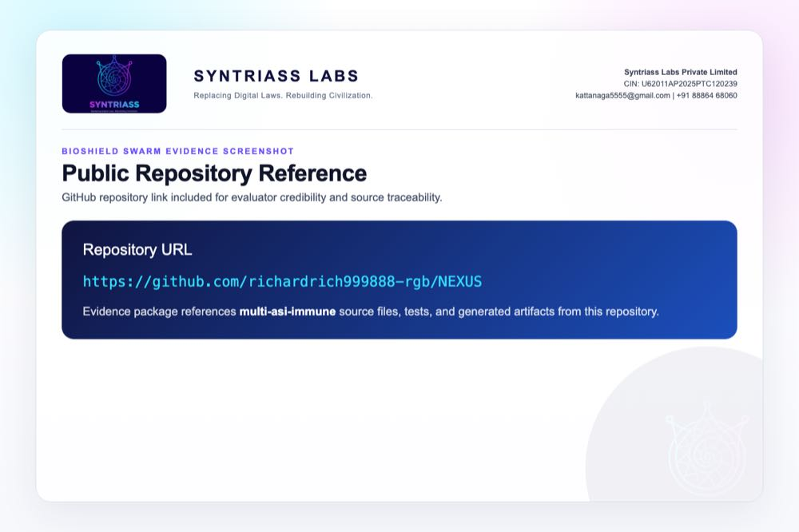
GitHub repository reference for BioShield Swarm

Evidence Page 6 - Fresh Test Output
Purpose: show that the BioShield Swarm Rust test suite was run locally before proposal packaging.
Status: test output screenshot embedded.
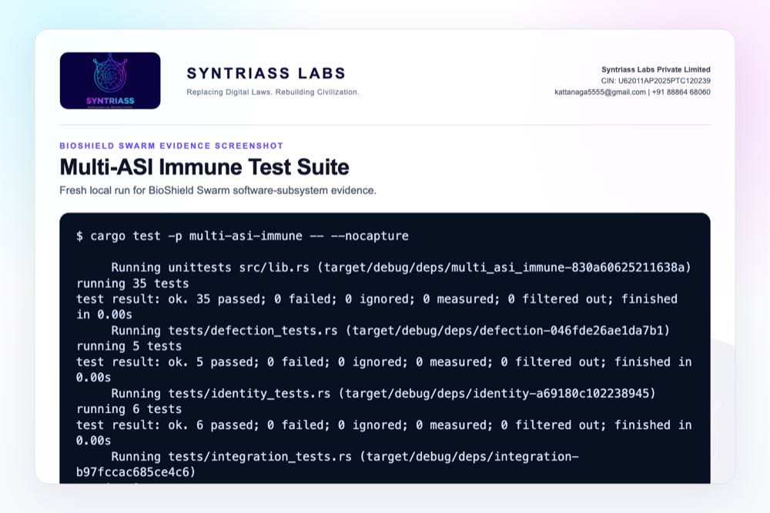
BioShield Swarm test output screenshot

Evidence Page 7 - Threat Categories
Evidence source: multi-asi-immune/src/threat/pattern.rs
Purpose: show the implemented threat categories and severity model.
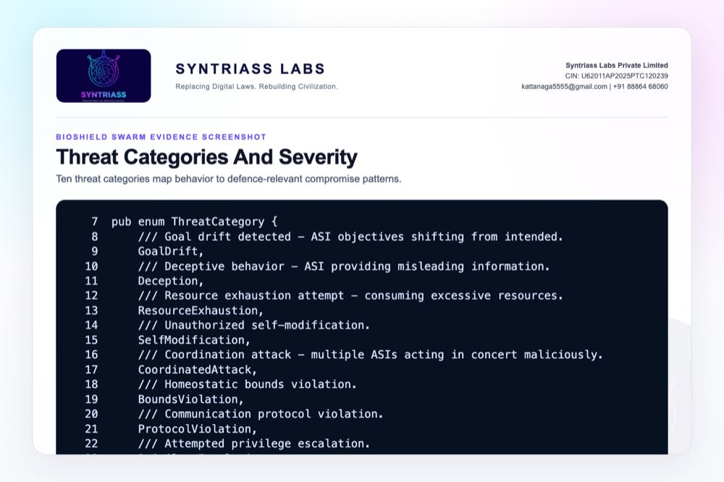
Threat categories and severity source screenshot

Evidence Page 8 - Defection Types
Evidence source: multi-asi-immune/src/enforcement/defection.rs
Purpose: show the observable defection categories used for rogue-node scoring.
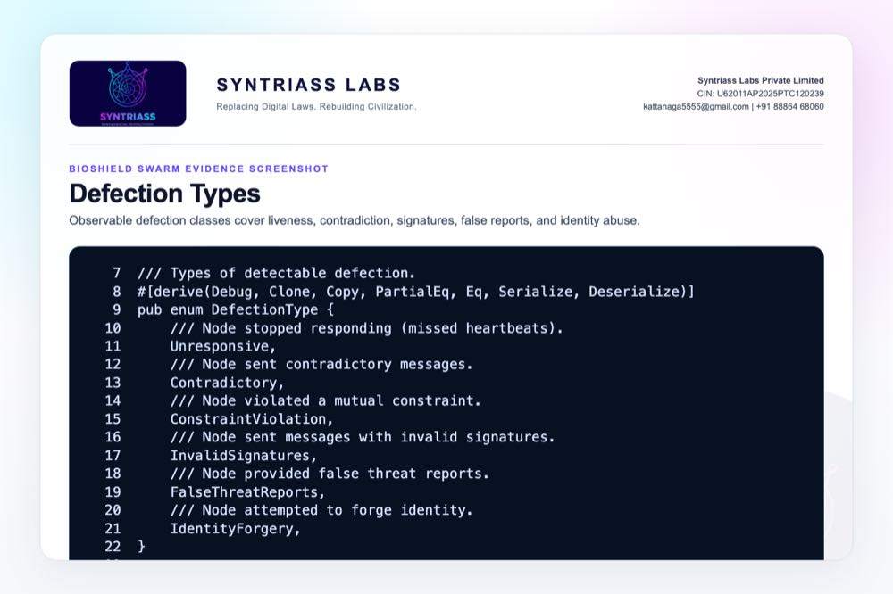
Defection types source screenshot

Evidence Page 9 - Isolation Logic
Evidence source: multi-asi-immune/src/enforcement/defection.rs
Purpose: show cumulative severity and isolation threshold logic.
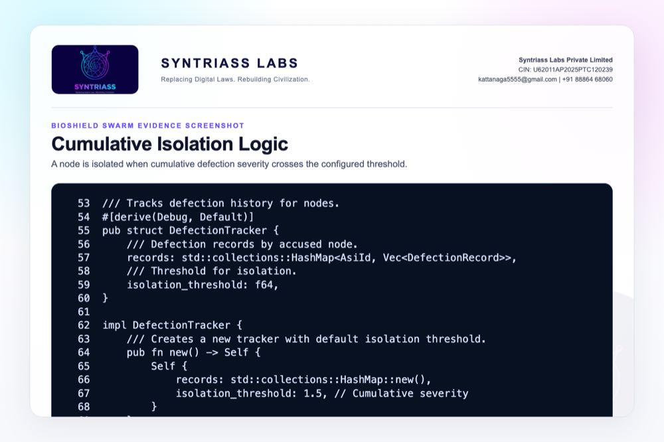
Cumulative isolation logic screenshot

Evidence Page 10 - Identity Sign and Verify
Evidence source: multi-asi-immune/src/identity/keypair.rs
Purpose: show identity generation, public identity, signing, and signature verification.
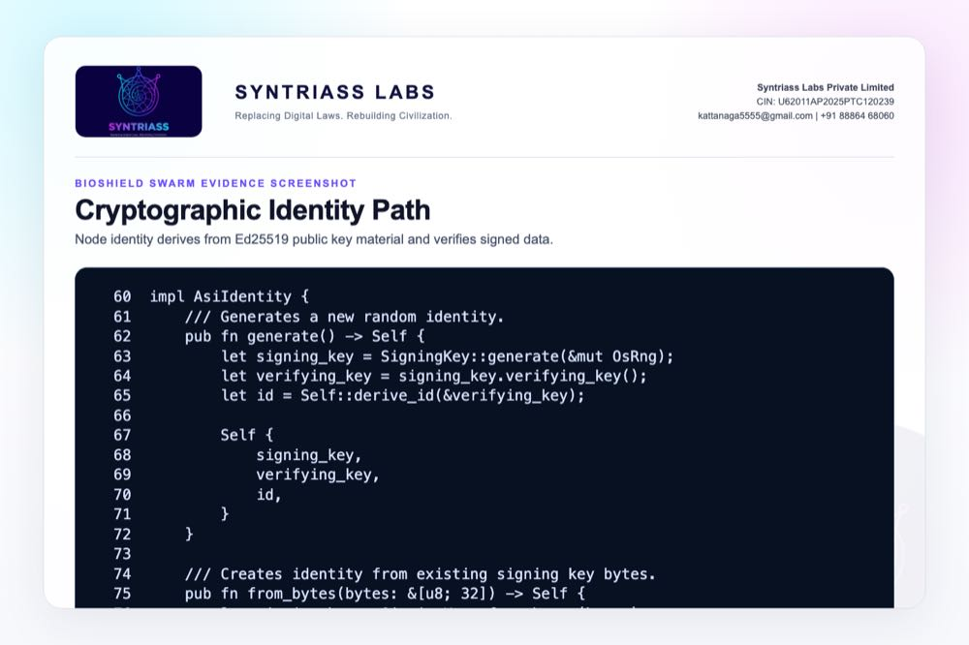
Cryptographic identity path screenshot

Evidence Page 11 - Reputation Decay
Evidence source: multi-asi-immune/src/reputation/score.rs
Purpose: show bounded, decaying reputation and suspicious-node detection.
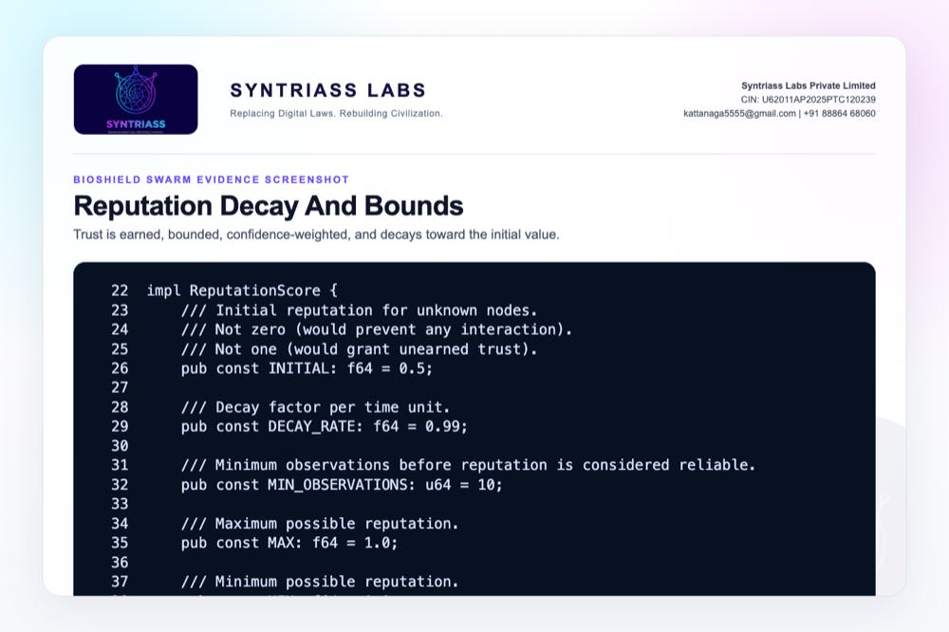
Reputation decay and bounds screenshot

Evidence Page 12 - Threat Memory
Evidence source: multi-asi-immune/src/threat/memory.rs
Purpose: show duplicate rejection, reporter reputation filtering, confidence aggregation, and new-threat storage.
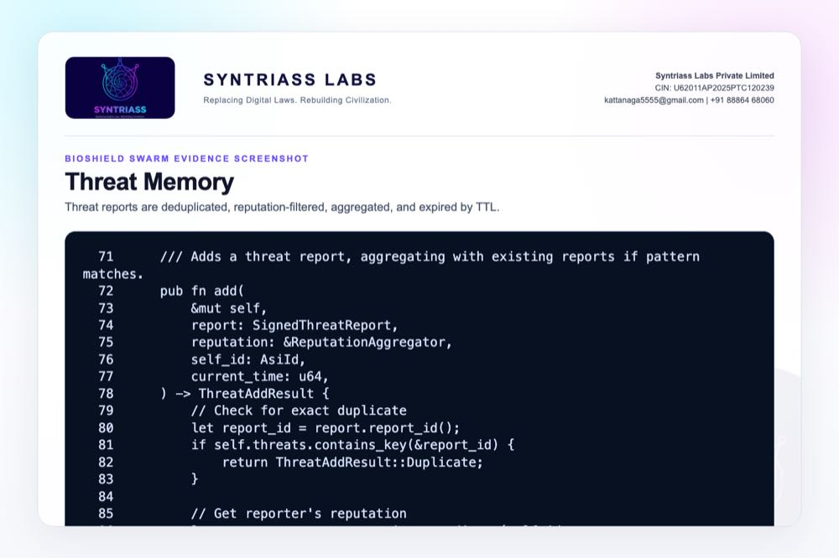
Threat memory source screenshot

Evidence Page 13 - Signed Threat Report
Evidence source: multi-asi-immune/src/threat/signature.rs
Purpose: show signed reports binding pattern, reporter, confidence, timestamp, and signature.
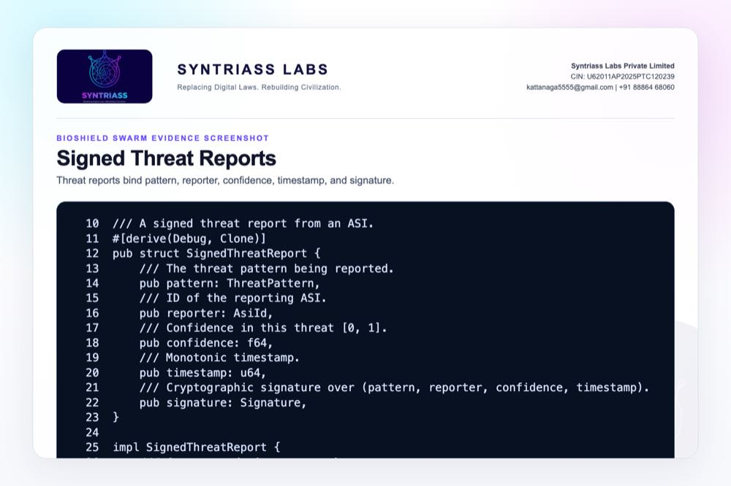
Signed threat report source screenshot

Evidence Page 14 - Node Execution Gate
Evidence source: multi-asi-immune/src/node/state.rs
Purpose: show that isolated or low-reputation principals can be denied by node policy.
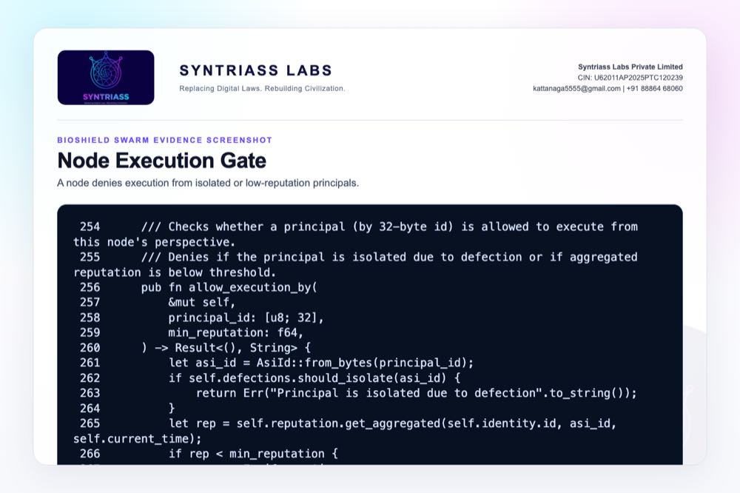
Node execution gate screenshot

Evidence Page 15 - Threat Gossip Path
Evidence source: multi-asi-immune/src/node/state.rs
Purpose: show verified threat reports being stored and broadcast to peers.
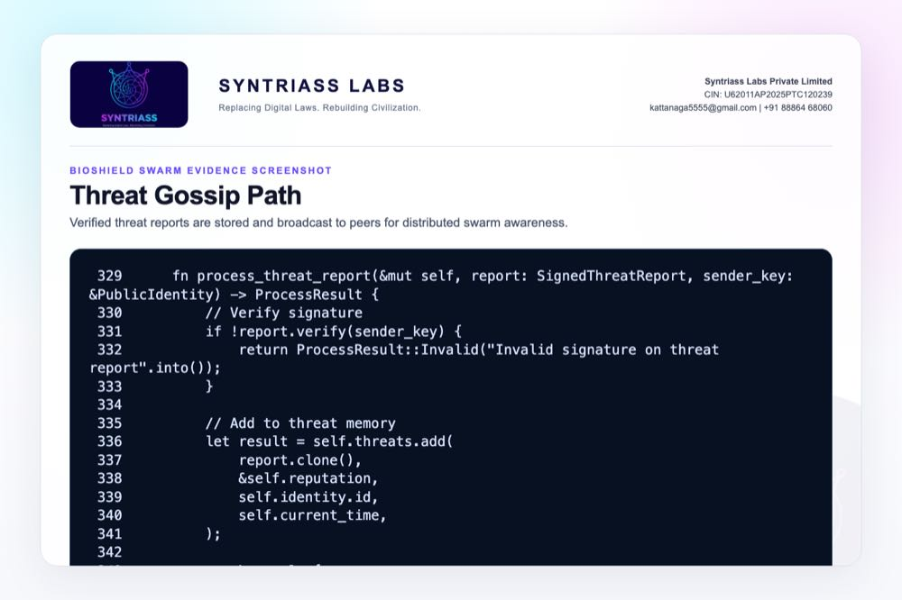
Threat gossip source screenshot

Evidence Page 16 - Swarm Protocol Messages
Evidence source: multi-asi-immune/src/protocol/message.rs
Purpose: show handshake, threat report, heartbeat, attestation, constraint, and accusation message types.
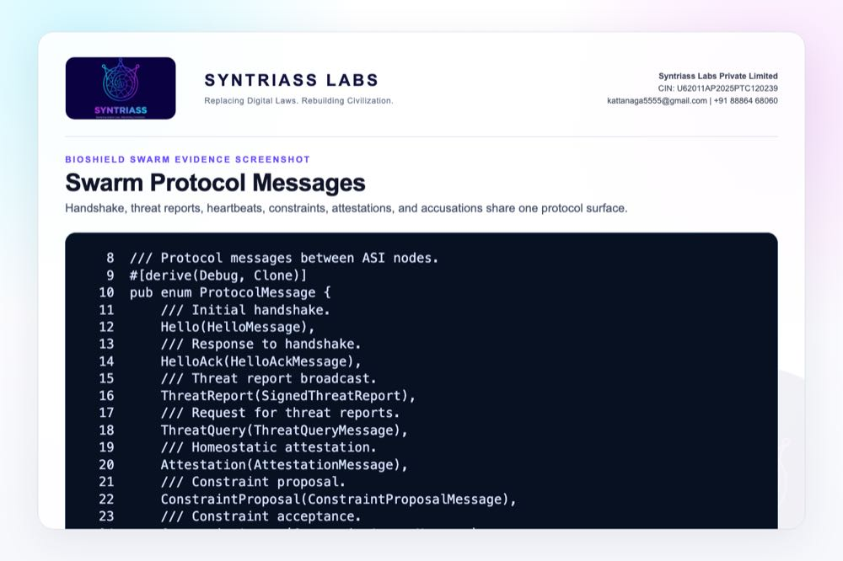
Swarm protocol messages screenshot

Evidence Page 17 - Constraint Actions
Evidence source: multi-asi-immune/src/protocol/message.rs
Purpose: show graded response actions including reduce cooperation, increase caution, broadcast warning, and isolate.
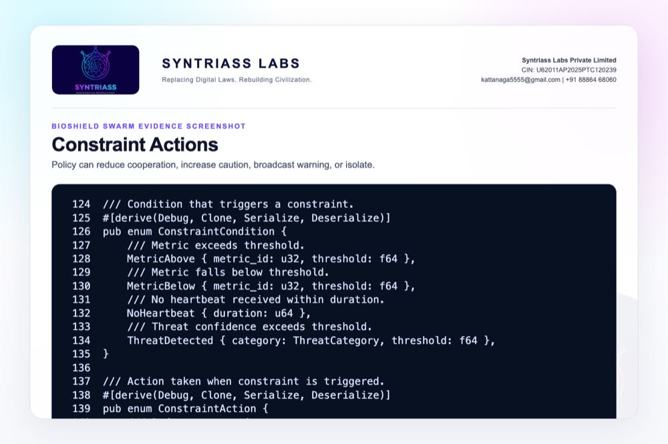
Constraint actions screenshot

Evidence Page 18 - Network Health Assessment
Evidence source: multi-asi-immune/src/node/state.rs
Purpose: show active, suspicious, isolated, active-threat, and active-constraint summary fields.
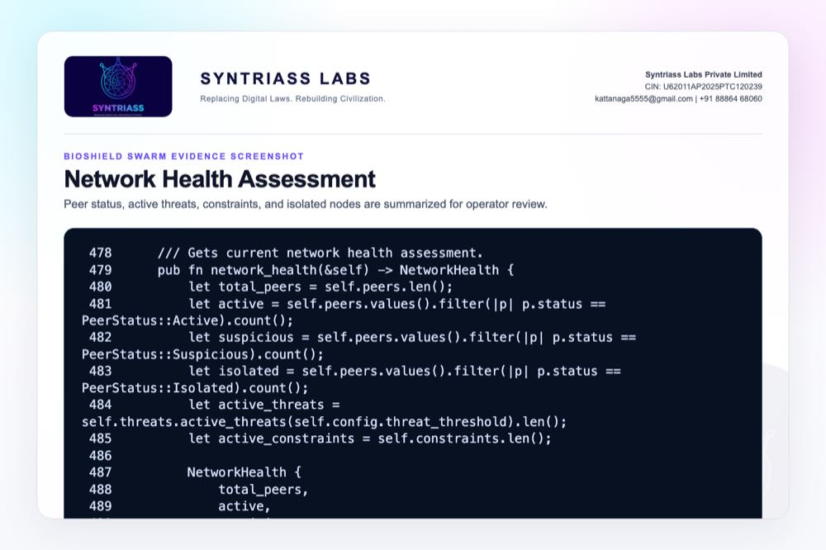
Network health assessment screenshot

Evidence Page 19 - Homeostatic Safety Constraints
Evidence source: multi-asi-immune/src/integration/homeostasis_bridge.rs
Purpose: show safety constraints derived from stress, caution, urgency, wellbeing, and cooperation state.
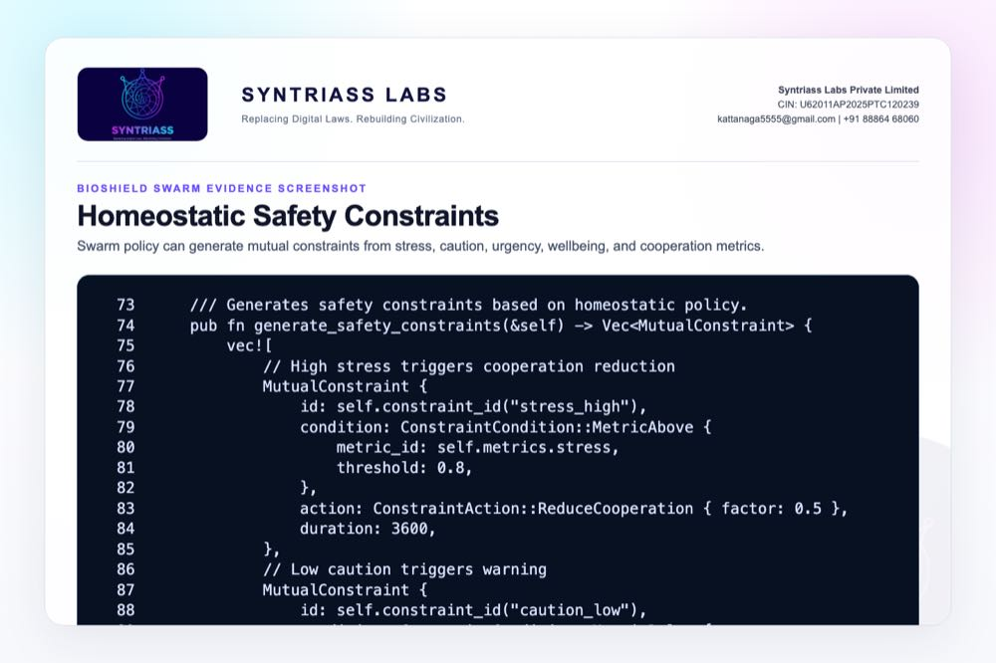
Homeostatic safety constraints screenshot

Evidence Page 20 - Threat Propagation Test
Evidence source: multi-asi-immune/tests/integration_tests.rs
Purpose: show that threat reporting propagates through peer processing and gossip.
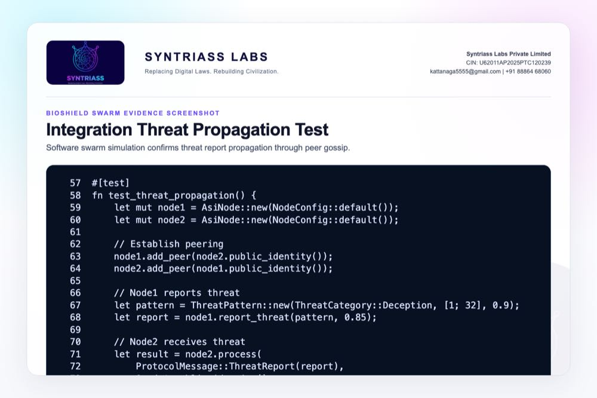
Integration threat propagation test screenshot

Evidence Page 21 - Full Protocol Flow Test
Evidence source: multi-asi-immune/tests/integration_tests.rs
Purpose: show a three-node flow for coordinated-attack reporting and propagation.
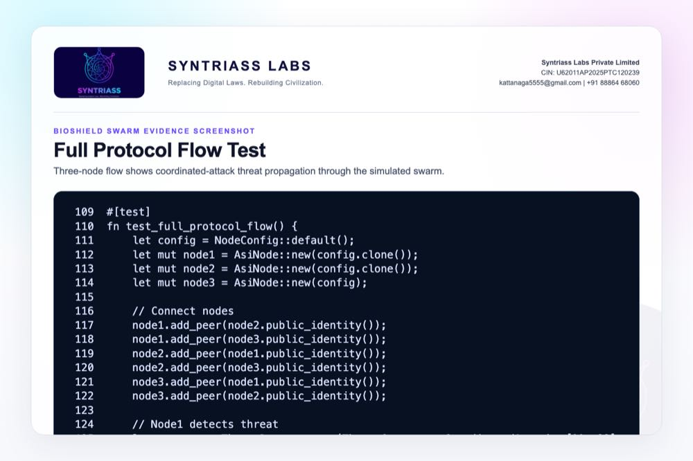
Full protocol flow test screenshot

Evidence Page 22 - Defection Isolation Test
Evidence source: multi-asi-immune/tests/defection_tests.rs
Purpose: show test-level evidence for isolation threshold behavior.
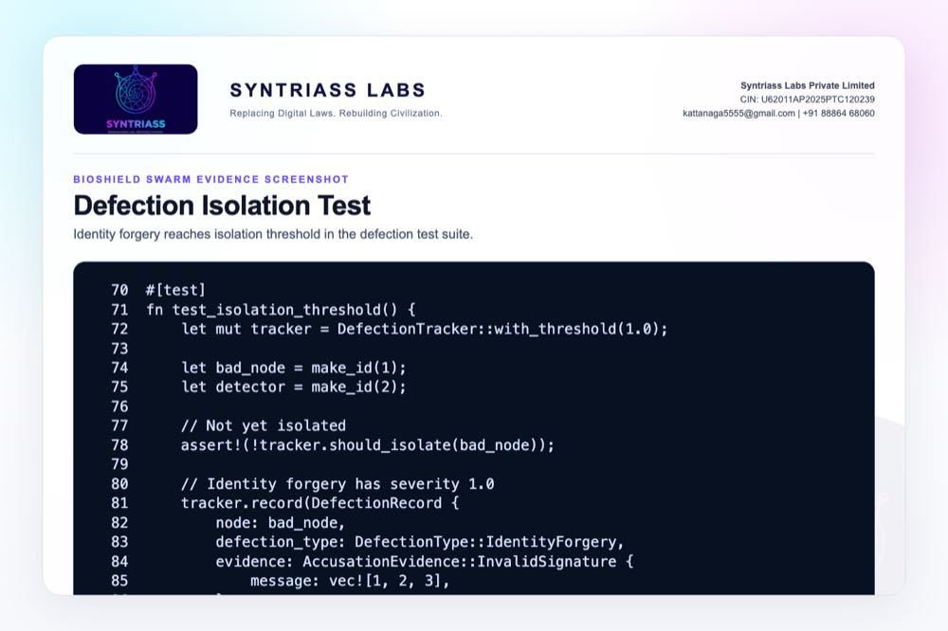
Defection isolation test screenshot

Evidence Page 23 - Identity Verification Tests
Evidence source: multi-asi-immune/tests/identity_tests.rs
Purpose: show correct signature verification and wrong-identity or modified-message failure.
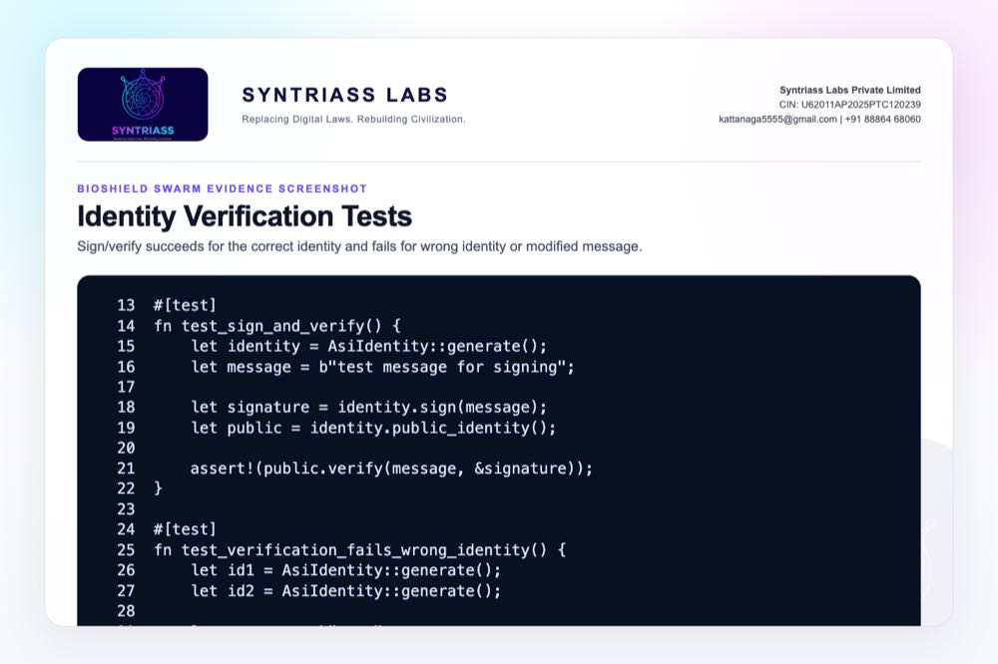
Identity verification tests screenshot

Evidence Page 24 - Reputation Behavior Tests
Evidence source: multi-asi-immune/tests/reputation_tests.rs
Purpose: show positive behavior, negative behavior, and decay tests.
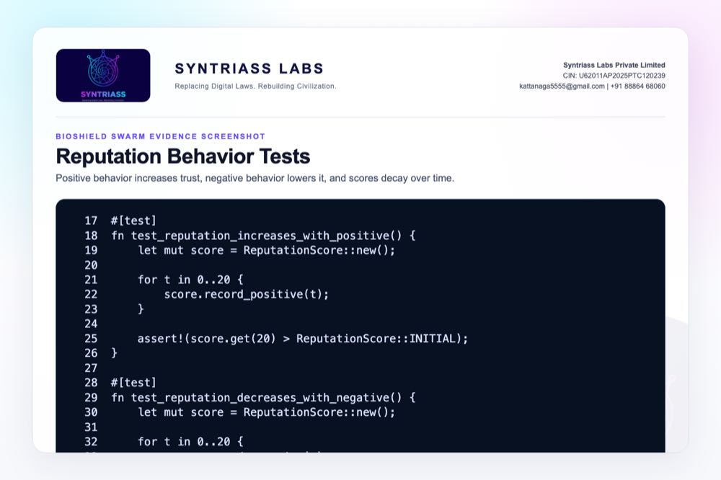
Reputation behavior tests screenshot

Evidence Page 25 - Threat Memory Tests
Evidence source: multi-asi-immune/tests/threat_propagation_tests.rs
Purpose: show threat memory add, duplicate rejection, and multi-reporter confirmation.
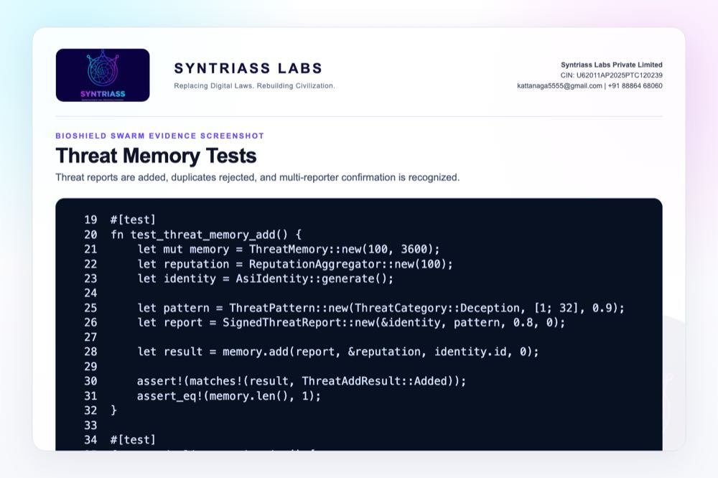
Threat memory tests screenshot

Evidence Page 26 - Package and Test Manifest
Evidence source: multi-asi-immune/Cargo.toml
Purpose: show crate dependencies and named test targets.
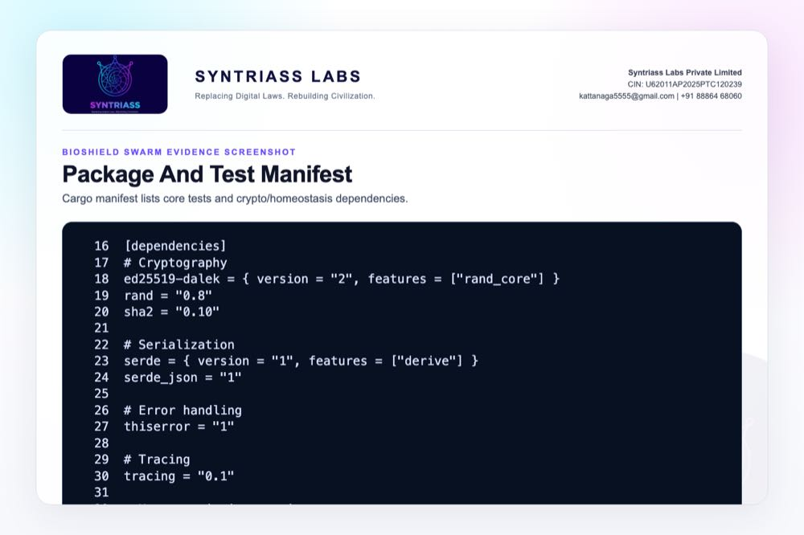
Package and test manifest screenshot

Evidence Page 27 - Public API Exports
Evidence source: multi-asi-immune/src/lib.rs
Purpose: show the public API surface exported for integration.
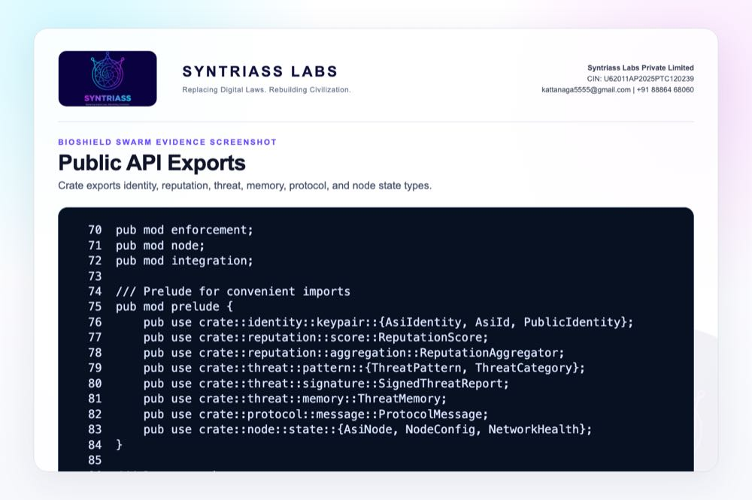
Public API exports screenshot

Evidence Page 28 - Reviewer Repository Map
Public repository:
- https://github.com/richardrich999888-rgb/NEXUS
Primary proposal package:
- docs/idex-open-challenge-2026/02-bioshield-swarm/final_4_documents/
Primary source modules:
- multi-asi-immune/src/identity/keypair.rs
- multi-asi-immune/src/reputation/score.rs
- multi-asi-immune/src/reputation/aggregation.rs
- multi-asi-immune/src/threat/pattern.rs
- multi-asi-immune/src/threat/signature.rs
- multi-asi-immune/src/threat/memory.rs
- multi-asi-immune/src/enforcement/defection.rs
- multi-asi-immune/src/node/state.rs
- multi-asi-immune/src/protocol/message.rs
How to review quickly:
- Open the repository.
- Navigate to multi-asi-immune/.
- Compare source files with Evidence Pages 7-27.
- Run the command on Evidence Page 6.

Evidence Page 29 - Claim To File Location Map
Claim | Repository location | Evidence page
Threat categories are implemented | multi-asi-immune/src/threat/pattern.rs | Page 7
Defection classes are implemented | multi-asi-immune/src/enforcement/defection.rs | Page 8
Isolation threshold exists | multi-asi-immune/src/enforcement/defection.rs | Page 9
Identity signing and verification exist | multi-asi-immune/src/identity/keypair.rs | Page 10
Reputation decays over time | multi-asi-immune/src/reputation/score.rs | Page 11
Threat memory stores and deduplicates reports | multi-asi-immune/src/threat/memory.rs | Page 12
Signed threat reports exist | multi-asi-immune/src/threat/signature.rs | Page 13
Node policy can deny isolated/low-trust principals | multi-asi-immune/src/node/state.rs | Page 14
Verified threats can be broadcast | multi-asi-immune/src/node/state.rs | Page 15
Tests validate core behavior | multi-asi-immune/tests/ | Pages 20-25
Reviewer note: these are software-subsystem evidence locations, not physical field qualification evidence.

Evidence Page 30 - Test And Command Locations
Primary executed test command:
cargo test -p multi-asi-immune -- --nocapture
Test file locations:
- multi-asi-immune/tests/identity_tests.rs
- multi-asi-immune/tests/reputation_tests.rs
- multi-asi-immune/tests/defection_tests.rs
- multi-asi-immune/tests/threat_propagation_tests.rs
- multi-asi-immune/tests/integration_tests.rs
Recorded output artifact:
- docs/idex-open-challenge-2026/02-bioshield-swarm/final_4_documents/evidence_assets/bioshield_swarm_test_output.txt
Current recorded result:
- 68 Rust tests passed; 0 failed; 1 doc-test ignored
- Fresh local run date: 17 May 2026

Evidence Page 31 - Generated Artifact Locations
Final PDF artifacts:
- docs/idex-open-challenge-2026/02-bioshield-swarm/final_4_documents/01_SYNTRIASS_BioShield_Swarm_Annexure_1_Applicant_Details_and_Solution_Summary.pdf
- docs/idex-open-challenge-2026/02-bioshield-swarm/final_4_documents/02_SYNTRIASS_BioShield_Swarm_Annexure_2_Technical_Architecture.pdf
- docs/idex-open-challenge-2026/02-bioshield-swarm/final_4_documents/03_SYNTRIASS_BioShield_Swarm_Annexure_3_Advantages_and_Competencies.pdf
- docs/idex-open-challenge-2026/02-bioshield-swarm/final_4_documents/04_SYNTRIASS_BioShield_Swarm_Annexure_4_Supporting_Evidence_and_Screenshots.pdf
Word artifacts:
- Same directory as above, with .docx extension.
Evidence screenshot folder:
- docs/idex-open-challenge-2026/02-bioshield-swarm/final_4_documents/evidence_assets/
Build scripts:
- generate_bioshield_swarm_evidence_screenshots.mjs
- build_syntriass_letterhead_problem2.mjs

Evidence Page 32 - Screenshot Artifact Index
Screenshot artifacts embedded in this Annexure:
- evidence_assets/01_github_repository.jpg
- evidence_assets/02_test_output.jpg
- evidence_assets/03_threat_categories.jpg
- evidence_assets/04_defection_types.jpg
- evidence_assets/05_isolation_logic.jpg
- evidence_assets/06_identity_sign_verify.jpg
- evidence_assets/07_reputation_decay.jpg
- evidence_assets/08_threat_memory_add.jpg
- evidence_assets/09_signed_threat_report.jpg
- evidence_assets/10_node_execution_gate.jpg
- evidence_assets/11_threat_gossip.jpg
- evidence_assets/12_protocol_messages.jpg
- evidence_assets/13_constraint_actions.jpg
- evidence_assets/14_network_health.jpg
- evidence_assets/15_homeostasis_bridge.jpg
- evidence_assets/16_integration_threat_propagation.jpg
- evidence_assets/17_full_protocol_flow.jpg
- evidence_assets/18_defection_tests.jpg
- evidence_assets/19_identity_tests.jpg
- evidence_assets/20_reputation_tests.jpg
- evidence_assets/21_threat_memory_tests.jpg
- evidence_assets/22_package_manifest.jpg
- evidence_assets/23_api_exports.jpg
All screenshots are generated artifacts from local source/test output.

Evidence Page 33 - Threat Model To Evidence Map
Threat / Failure Mode | Evidence Location
Identity spoofing | Pages 10 and 23
Invalid signature | Pages 13 and 23
False threat reporting | Pages 12, 13, 25
Contradictory messages | Pages 8, 9, 22
Missed heartbeat / liveness loss | Pages 8, 16
Low reputation / bad actor | Pages 11, 14, 24
Threat propagation | Pages 15, 20, 21
Quarantine / isolation | Pages 9, 14, 17, 22
Degraded node ambiguity | Proposed iDEX calibration work
EW or radio-link stress | Proposed iDEX simulation work
Prototype-stage gaps still to validate:
- Hardware-in-loop drone or robot node testing.
- EW packet-loss and spoofing simulation.
- Mission-specific threshold calibration.
- Operator revalidation workflow.

Evidence Page 34 - Prototype Work Package Locations
Repository anchors for proposed iDEX prototype work:
- Swarm immune module: multi-asi-immune/
- Identity and signing: multi-asi-immune/src/identity/
- Threat category engine: multi-asi-immune/src/threat/pattern.rs
- Threat report signatures: multi-asi-immune/src/threat/signature.rs
- Threat memory: multi-asi-immune/src/threat/memory.rs
- Reputation: multi-asi-immune/src/reputation/
- Defection tracking: multi-asi-immune/src/enforcement/
- Node processing and health: multi-asi-immune/src/node/
- Protocol messages: multi-asi-immune/src/protocol/
- Homeostatic integration: multi-asi-immune/src/integration/
Planned validation outputs during iDEX:
- Compromised-node simulation report.
- False-positive and false-negative analysis.
- Threshold calibration report.
- Quarantine/revalidation demo.
- Hardware-in-loop validation plan.

Evidence Page 35 - Panel Review Checklist
Suggested reviewer checklist:
- Confirm GitHub repository link on Evidence Page 5.
- Open multi-asi-immune/src/threat/pattern.rs and inspect threat categories.
- Open multi-asi-immune/src/enforcement/defection.rs and inspect severity/isolation logic.
- Open multi-asi-immune/src/identity/keypair.rs and inspect signing/verification.
- Open multi-asi-immune/src/reputation/score.rs and inspect decay behavior.
- Open multi-asi-immune/src/threat/memory.rs and inspect duplicate rejection and confidence aggregation.
- Open multi-asi-immune/tests/ and inspect identity, reputation, defection, threat propagation, and integration tests.
- Run cargo test -p multi-asi-immune -- --nocapture.
- Compare the terminal result with evidence_assets/bioshield_swarm_test_output.txt.
Upload checks for this document:
- Annexure 4 page count target: 37.
- Annexure 4 PDF size target: under 5 MB.
- Evidence pages contain source/test screenshots or reviewer navigation material.

Evidence Page 36 - Readiness Statement And Caveats
Current readiness:
- Software subsystem TRL 3-4.
- Rust module and test evidence available.
- Software simulation evidence available.
- Physical military hardware validation not claimed.
- EW/radio-link simulation not yet claimed.
- Operational deployment not claimed.
Caveats:
- Thresholds require mission-specific tuning.
- Degraded-but-benign nodes require careful policy treatment.
- Quarantine must be integrated with command policy and human review.
- Hardware-in-loop testing is required before higher readiness claims.
- The iDEX prototype should evaluate latency, false-positive rate, false-negative rate, and recovery/revalidation behavior.

Evidence Page 37 - Declaration And Repository Coordinates
Declaration:
BioShield Swarm is submitted as a software-subsystem prototype for governed multi-agent swarm integrity evaluation.
Repository coordinates:
- Public repository: https://github.com/richardrich999888-rgb/NEXUS
- Proposal folder: docs/idex-open-challenge-2026/02-bioshield-swarm/
- Final documents: docs/idex-open-challenge-2026/02-bioshield-swarm/final_4_documents/
- Evidence assets: docs/idex-open-challenge-2026/02-bioshield-swarm/final_4_documents/evidence_assets/
- Test output: docs/idex-open-challenge-2026/02-bioshield-swarm/final_4_documents/evidence_assets/bioshield_swarm_test_output.txt
Submission caveat:
- The package is prepared for prototype review and iDEX-funded validation planning.
- No field deployment, weapons integration, or autonomous operational authority is claimed.
- Human approval, mission policy, and service-specific safety rules remain required for operational use.

