IDEX OPEN CHALLENGE SUBMISSION

Annexure-4
Supporting evidence, screenshots, repository locations, and artifact map
CIN | PAN | TAN
U62011AP2025PTC120239 | ABQCS7152R | VPNS31351F

Applicant Entity | Contact
Syntriass Labs Private Limited | kattanaga5555@gmail.com
12-50, SLV Market, 12 Ward, Dharmavaram, Ananthapur - 515671, Andhra Pradesh, India | +91 88864 68060

Supporting Evidence and Screenshots

Company Identification Details
Field | Details
Legal Entity Name | Syntriass Labs Private Limited
CIN | U62011AP2025PTC120239
PAN | ABQCS7152R
TAN | VPNS31351F
Registered Office | 12-50, SLV Market, 12 Ward, Dharmavaram, Ananthapur - 515671, Andhra Pradesh, India
Contact Email | kattanaga5555@gmail.com
Contact Phone | +91 88864 68060
GitHub Repository | https://github.com/richardrich999888-rgb/NEXUS
Submission Date | 17 May 2026

1. Applicant Resume Format
Applicant: K. Naga Sri Ganesh
Company: Syntriass Labs Private Limited
Role: Founder / Inventor
Relevant focus: governed autonomy, robotic operating layers, AGP governance, RTOS scheduling, ROS2 simulation, safety interlocks, and defence-oriented autonomy validation.

2. Prototype Evidence List
Evidence Item | Repository / Artifact Location
Source modules | agp-core/src/os/, nexus-rtos-core/src/lib.rs
Test suite | agp-core/tests/test_rtos.py, test_ros2.py, test_resources.py, test_production.py
Rust RTOS test | cargo test -p nexus-rtos-core -- --nocapture
Portability check | cargo check -p nexus-rtos-core --target wasm32-unknown-unknown
Fresh Python test output | docs/idex-open-challenge-2026/03-agp-os-robotics-safety-layer/final_4_documents/evidence_assets/agp_os_robotics_test_output.txt
Fresh Rust RTOS output | docs/idex-open-challenge-2026/03-agp-os-robotics-safety-layer/final_4_documents/evidence_assets/nexus_rtos_core_test_output.txt
Evidence screenshots | docs/idex-open-challenge-2026/03-agp-os-robotics-safety-layer/final_4_documents/evidence_assets/
Final documents | docs/idex-open-challenge-2026/03-agp-os-robotics-safety-layer/final_4_documents/

3. Validation Scope
Current validation is software-subsystem validation. The evidence supports simulation-level ROS2 bridge behavior, RTOS scheduler behavior, resource-denial behavior, production adapter safety checks, and Rust no_std RTOS core checks. It does not claim physical robot testing, military-grade hardware timing, environmental qualification, ROS2 field deployment, or operational authority.

4. Test Commands and Recorded Results
Primary commands:
agp-core/.venv/bin/python agp-core/tests/test_rtos.py
agp-core/.venv/bin/python agp-core/tests/test_ros2.py
agp-core/.venv/bin/python agp-core/tests/test_resources.py
agp-core/.venv/bin/python agp-core/tests/test_production.py
cargo test -p nexus-rtos-core -- --nocapture
cargo check -p nexus-rtos-core --target wasm32-unknown-unknown
Fresh local results:
- RTOS scheduler: 8 passed, 0 failed.
- ROS2 bridge: 16 passed, 0 failed.
- Resource controller: 12 passed, 0 failed.
- Production ROS2 adapter: 22 passed, 0 failed.
- Rust RTOS core: 4 passed, 0 failed.
- Rust wasm32-unknown-unknown check: passed.
- Run date: 17 May 2026.

5. Evidence Checklist
- Source screenshots embedded.
- Test output screenshot embedded.
- GitHub repository link embedded.
- File locations and artifact locations listed.
- Claims phrased as software-subsystem evidence, not field qualification.
- Hardware-in-loop validation listed as proposed work.

Evidence Page 5 - Public Repository Reference
Purpose: give panel reviewers a direct path to inspect the source repository.
Status: GitHub repository reference embedded.
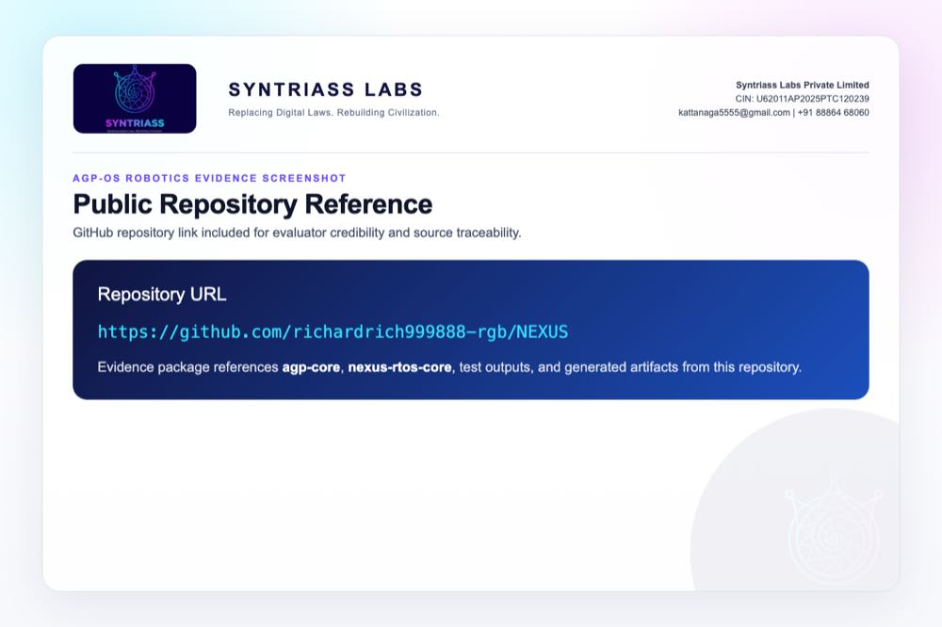
GitHub repository reference for AGP-OS Robotics

Evidence Page 6 - Fresh Test Output
Purpose: show that AGP-OS Robotics tests were run locally before proposal packaging.
Status: test output screenshot embedded.
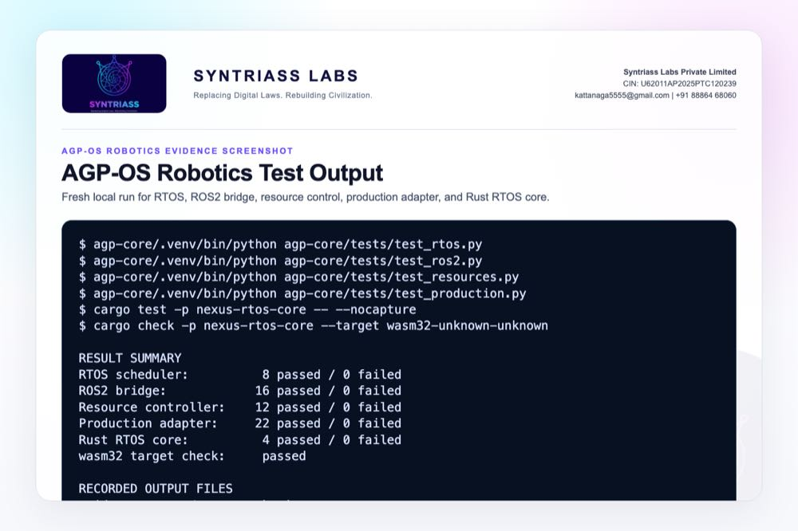
AGP-OS Robotics test output screenshot

Evidence Page 7 - RTOS Priority Classes
Evidence source: agp-core/src/os/rtos/scheduler.py
Purpose: show implemented critical, high, normal, low, and idle task priority classes.
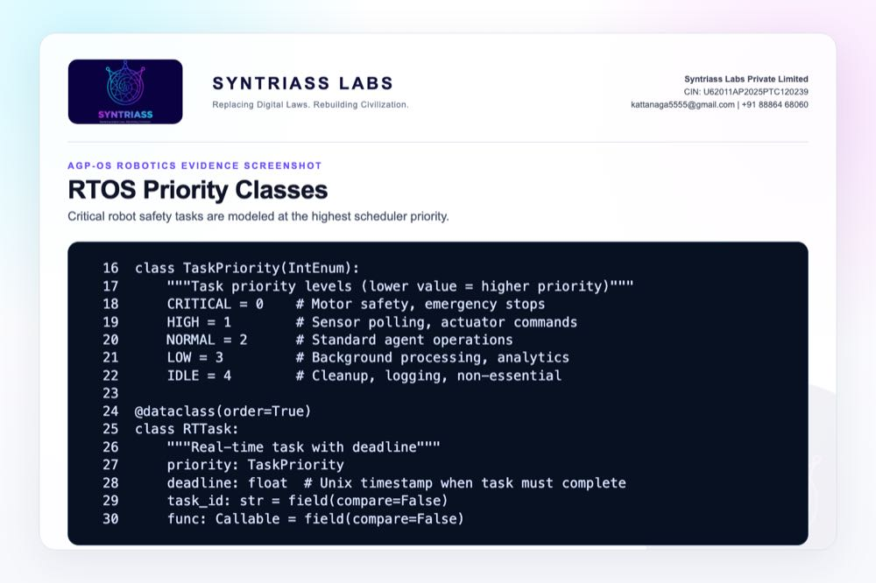
RTOS priority classes screenshot

Evidence Page 8 - RTOS Dispatch and Deadline Logic
Evidence source: agp-core/src/os/rtos/scheduler.py
Purpose: show scheduler dispatch, task execution, and deadline-miss accounting.
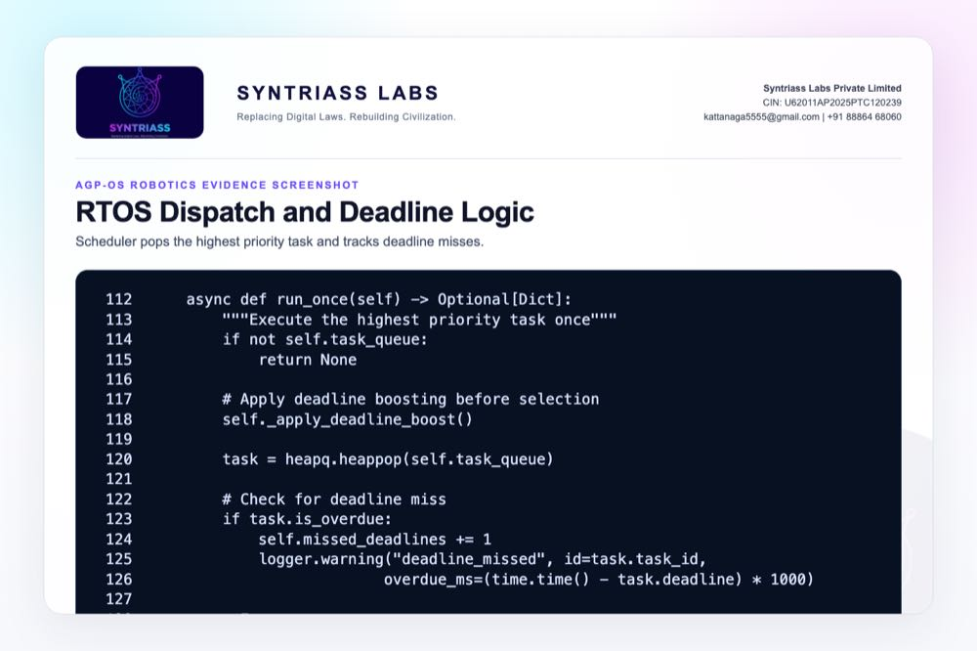
RTOS dispatch and deadline logic screenshot

Evidence Page 9 - ROS2 Message and Robot State Model
Evidence source: agp-core/src/os/ros2/bridge.py
Purpose: show common ROS2 message classes and simulated robot state structure.
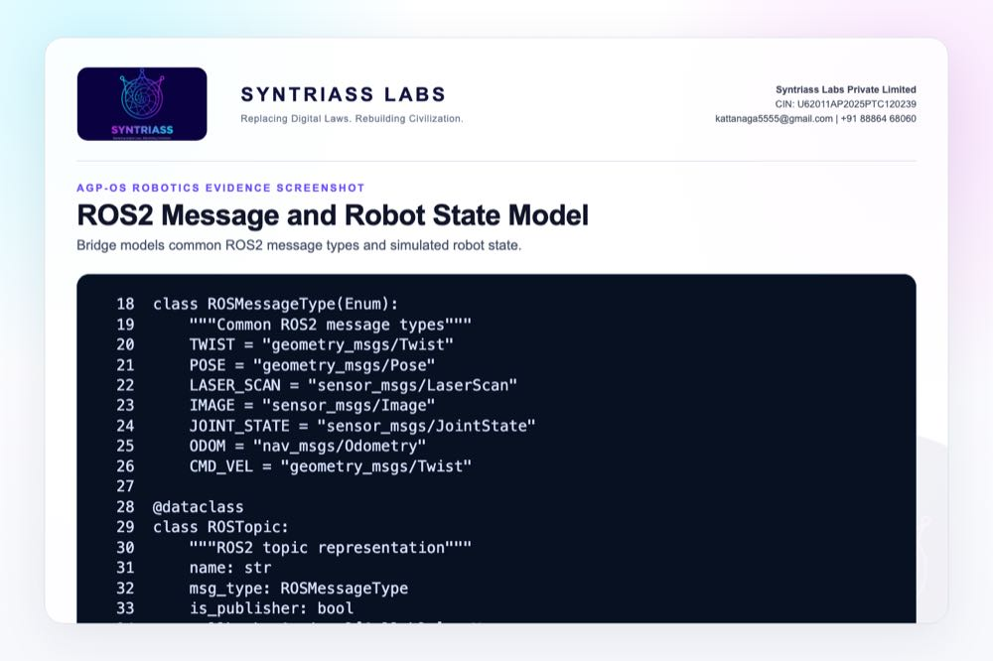
ROS2 message and robot state model screenshot

Evidence Page 10 - ROS2 Topic Publish Flow
Evidence source: agp-core/src/os/ros2/bridge.py
Purpose: show publisher validation and simulated command processing.
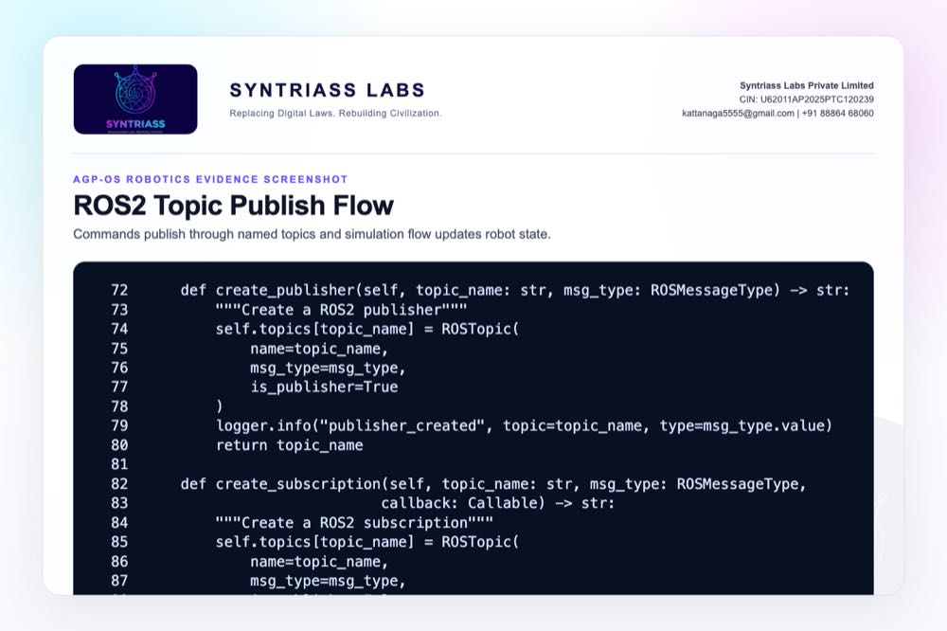
ROS2 topic publish flow screenshot

Evidence Page 11 - ROS2 Robot Spawn and Agent Linking
Evidence source: agp-core/src/os/ros2/bridge.py
Purpose: show robot spawn path, standard topic creation, and AGP agent linkage.
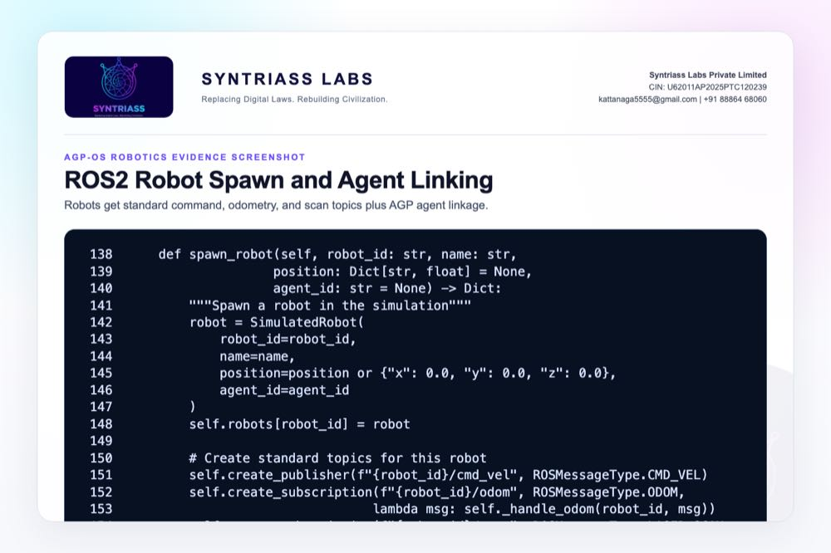
ROS2 robot spawn and agent linking screenshot

Evidence Page 12 - ROS2 Sensor Injection and Statistics
Evidence source: agp-core/src/os/ros2/bridge.py
Purpose: show simulated sensor injection and bridge statistics.
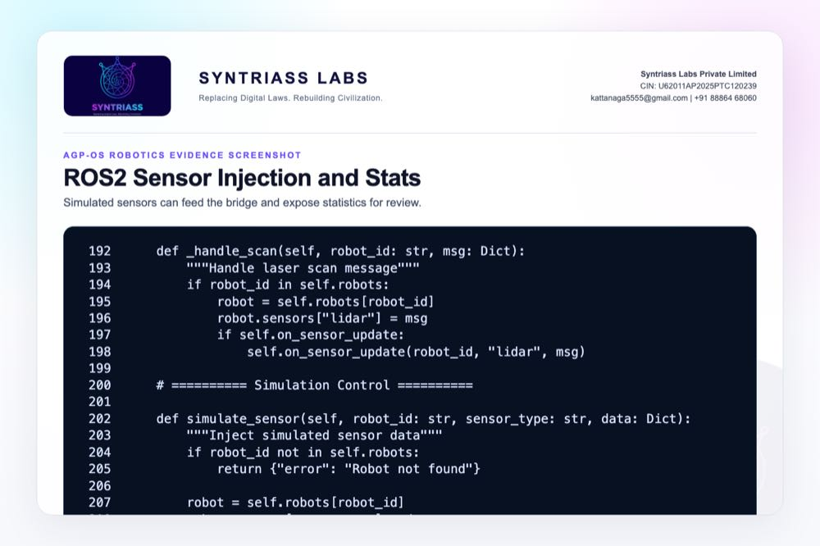
ROS2 sensor injection and statistics screenshot

Evidence Page 13 - Resource Quota Model
Evidence source: agp-core/src/os/resources/controller.py
Purpose: show memory, tokens, CPU, I/O, and priority fields.
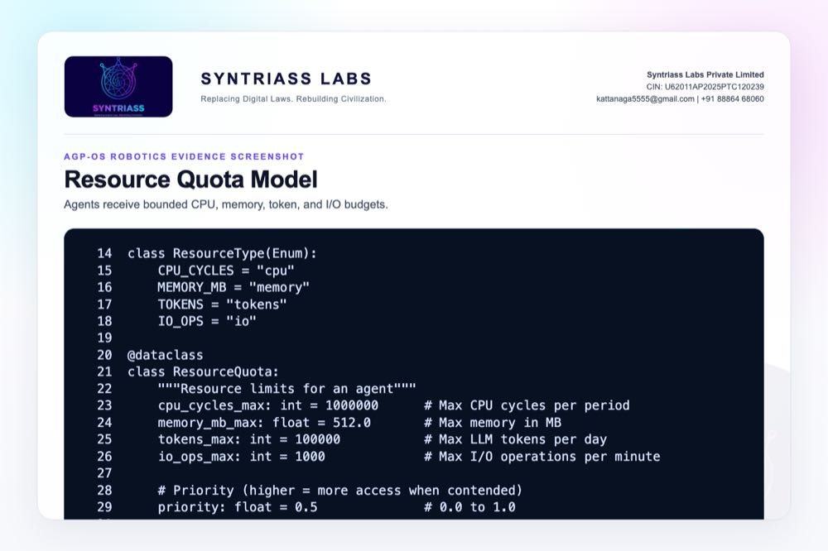
Resource quota model screenshot

Evidence Page 14 - Resource Grant and Denial Path
Evidence source: agp-core/src/os/resources/controller.py
Purpose: show explicit grant and denial logic for over-quota requests.
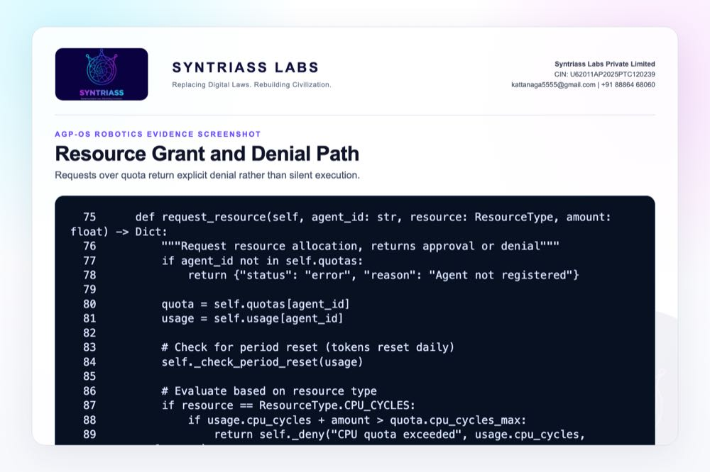
Resource grant and denial path screenshot

Evidence Page 15 - Resource Usage and System Status
Evidence source: agp-core/src/os/resources/controller.py
Purpose: show reviewer-visible usage and system-level resource status.
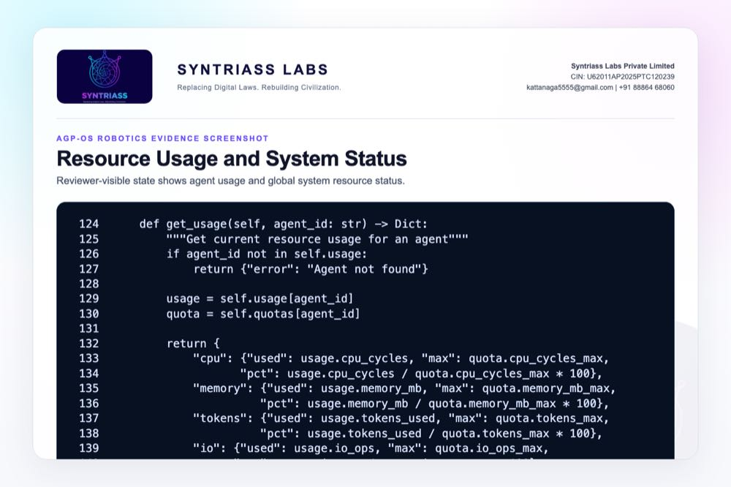
Resource usage and system status screenshot

Evidence Page 16 - HAL Device and Safety Thresholds
Evidence source: agp-core/src/os/hal/hal.py
Purpose: show sensor, actuator, status, and safety threshold structures.
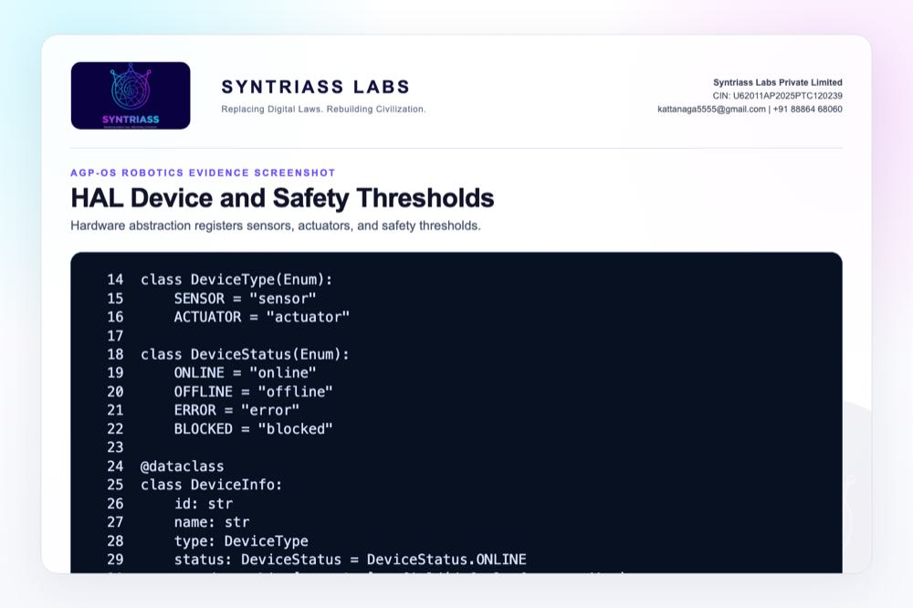
HAL device and safety thresholds screenshot

Evidence Page 17 - HAL Safety Interlock
Evidence source: agp-core/src/os/hal/hal.py
Purpose: show low-alignment actuator block and velocity cap behavior.
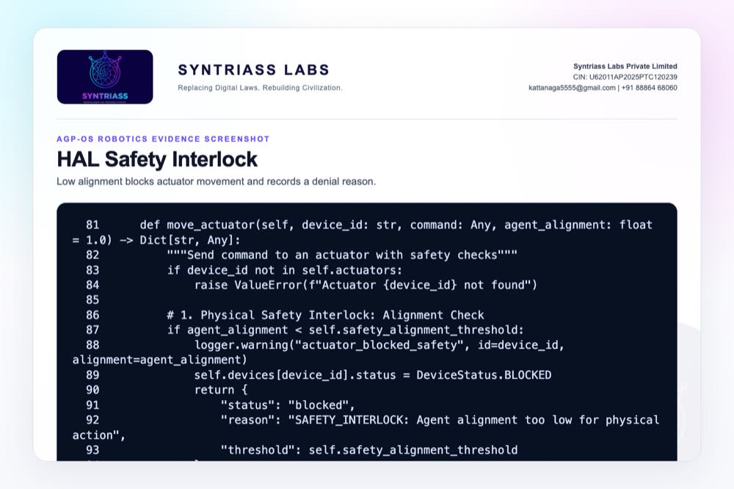
HAL safety interlock screenshot

Evidence Page 18 - Production Safety Watchdog
Evidence source: agp-core/src/os/ros2/production.py
Purpose: show heartbeat timeout and emergency-stop state.
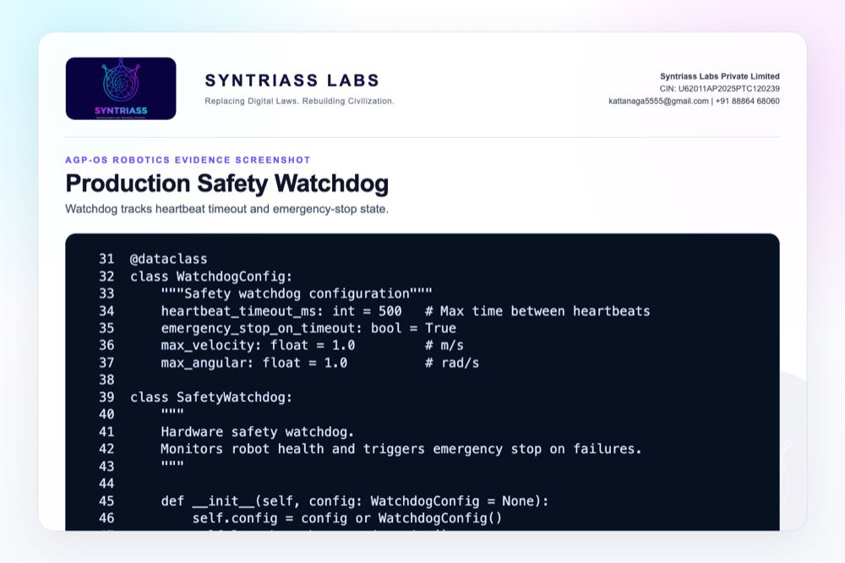
Production safety watchdog screenshot

Evidence Page 19 - Velocity Guard and Emergency Stop
Evidence source: agp-core/src/os/ros2/production.py
Purpose: show velocity capping and emergency-stop command path.
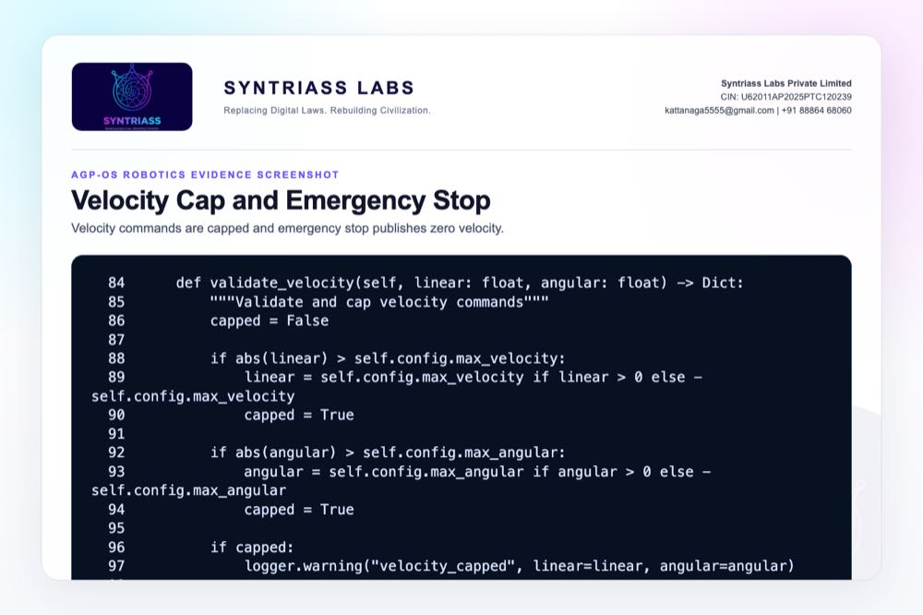
Velocity guard and emergency stop screenshot

Evidence Page 20 - ROS2 Production Adapter
Evidence source: agp-core/src/os/ros2/production.py
Purpose: show hardware connection path and simulation fallback when ROS2 runtime is unavailable locally.
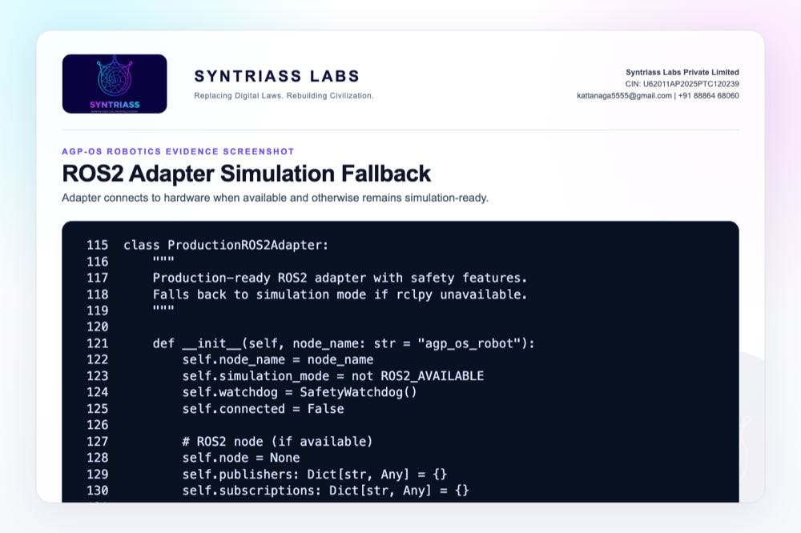
ROS2 production adapter screenshot

Evidence Page 21 - Robot Deployment Artifacts
Evidence source: agp-core/deploy/Dockerfile.ros2 and agp-core/deploy/agp-os-robot.service
Purpose: show container and service-level deployment packaging for future prototype validation.
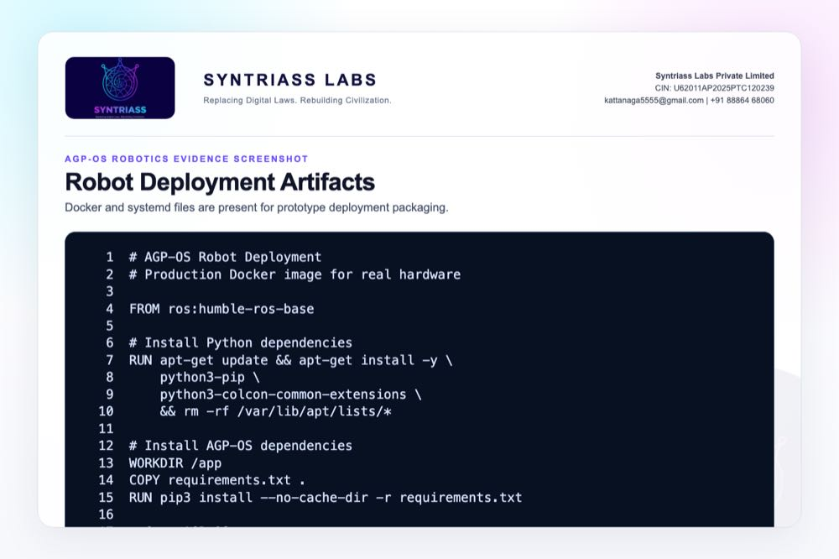
Robot deployment artifacts screenshot

Evidence Page 22 - RTOS Test Scenario
Evidence source: agp-core/tests/test_rtos.py
Purpose: show test setup for reverse-order submission and critical-first execution.
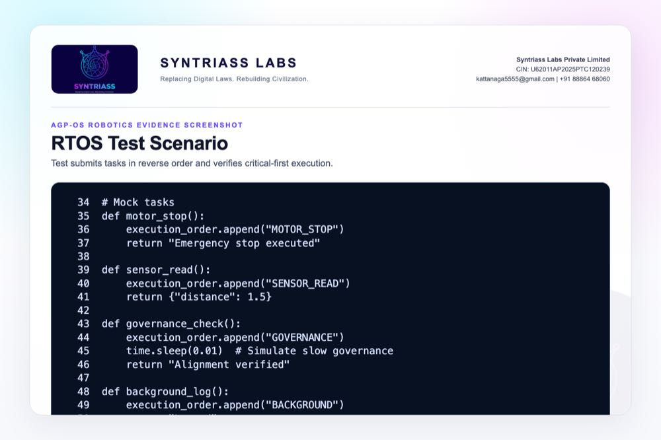
RTOS test scenario screenshot

Evidence Page 23 - ROS2 Bridge Test Scenario
Evidence source: agp-core/tests/test_ros2.py
Purpose: show spawn, publish, sensor, and AGP agent link validation.
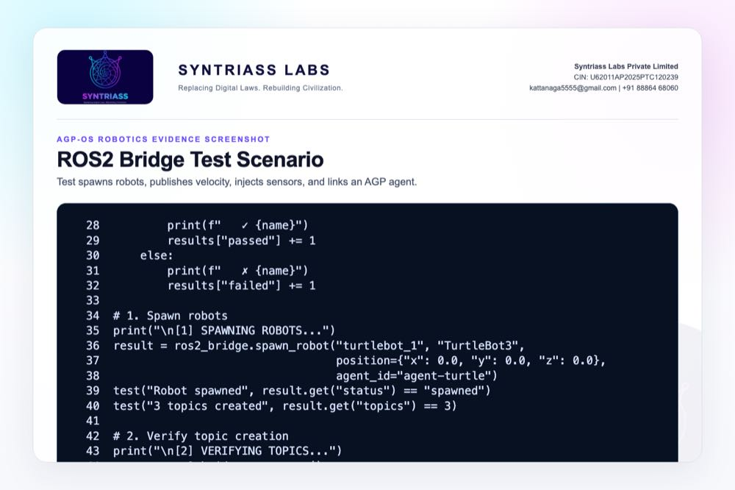
ROS2 bridge test scenario screenshot

Evidence Page 24 - Resource Controller Test Scenario
Evidence source: agp-core/tests/test_resources.py
Purpose: show within-quota grants and over-quota denials.
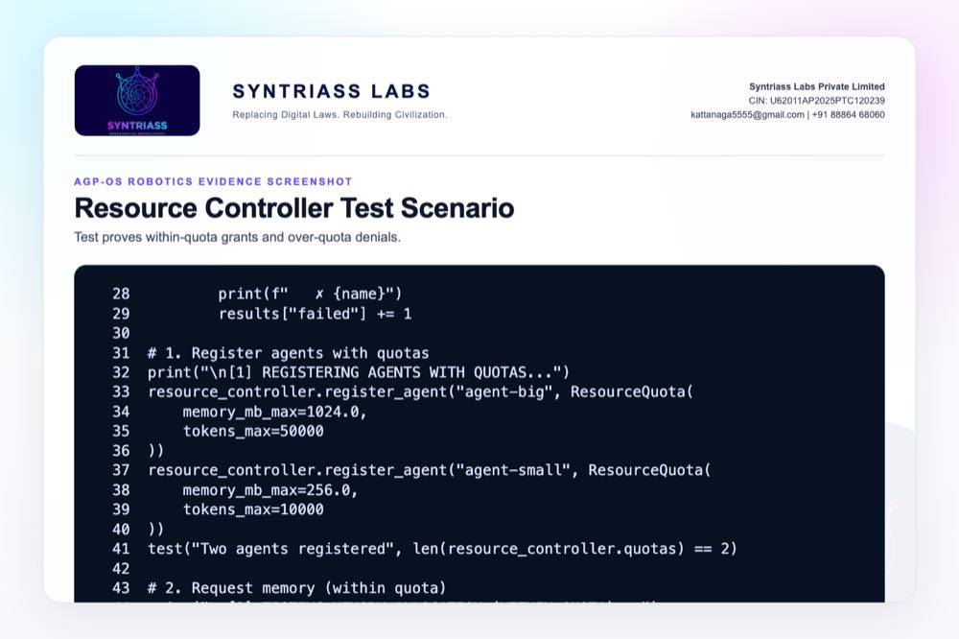
Resource controller test scenario screenshot

Evidence Page 25 - Production Adapter Test Scenario
Evidence source: agp-core/tests/test_production.py
Purpose: show watchdog, velocity cap, timeout, emergency stop, and deployment checks.
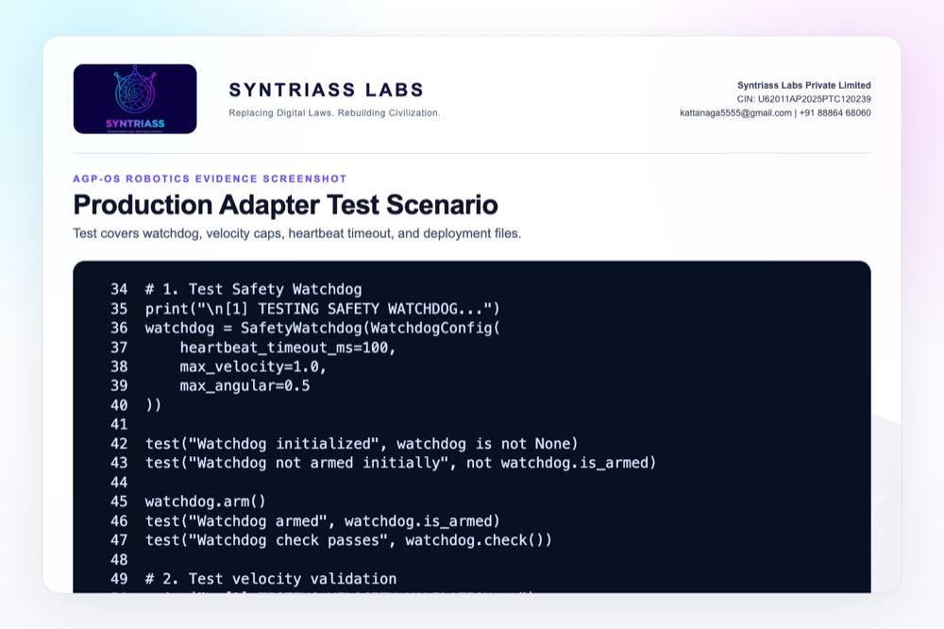
Production adapter test scenario screenshot

Evidence Page 26 - Rust RTOS Core
Evidence source: nexus-rtos-core/src/lib.rs
Purpose: show no_std, unsafe-denied, fixed-capacity scheduling primitives.
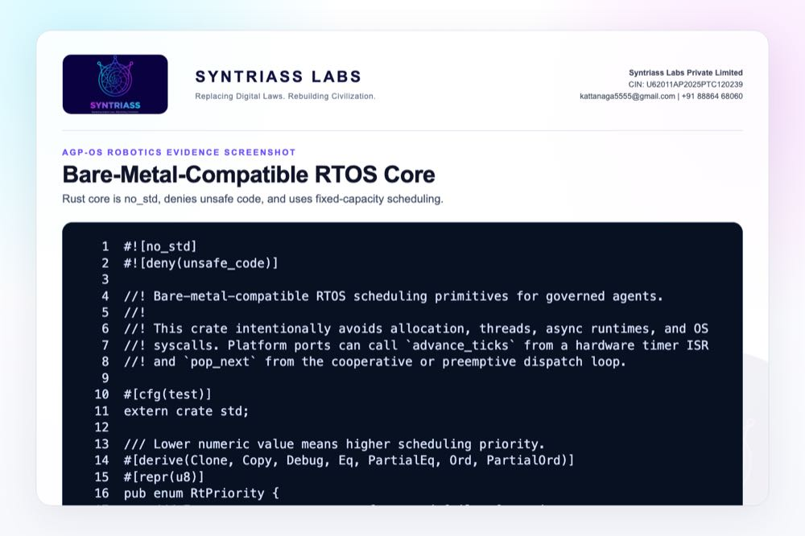
Rust RTOS core screenshot

Evidence Page 27 - Rust RTOS Core Tests
Evidence source: nexus-rtos-core/src/lib.rs
Purpose: show Rust tests for priority, deadline order, capacity, duplicate IDs, and missed deadlines.
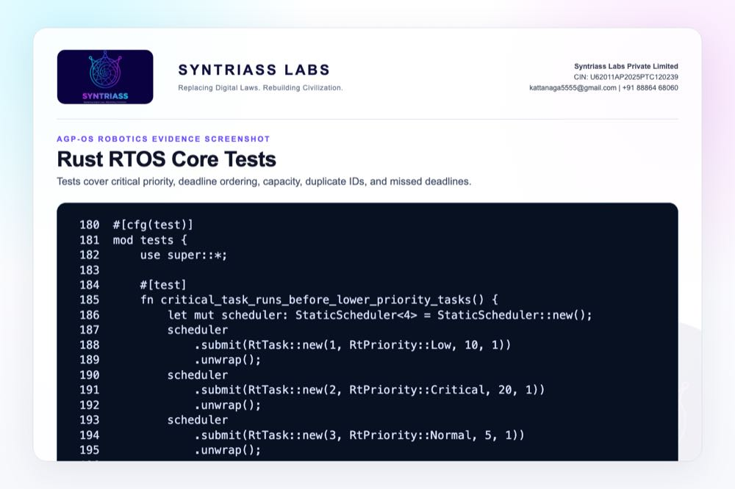
Rust RTOS core tests screenshot

Evidence Page 28 - Reviewer Repository Map
Purpose: give panel reviewers a direct navigation map.
Review Area | Path
Final proposal package | docs/idex-open-challenge-2026/03-agp-os-robotics-safety-layer/final_4_documents/
Screenshot assets | docs/idex-open-challenge-2026/03-agp-os-robotics-safety-layer/final_4_documents/evidence_assets/
AGP-OS source | agp-core/src/os/
RTOS scheduler | agp-core/src/os/rtos/scheduler.py
ROS2 bridge | agp-core/src/os/ros2/bridge.py
Production adapter | agp-core/src/os/ros2/production.py
Resource controller | agp-core/src/os/resources/controller.py
HAL | agp-core/src/os/hal/hal.py
Rust RTOS core | nexus-rtos-core/src/lib.rs

Evidence Page 29 - Claim-to-File Location Map
Proposal Claim | Source Evidence
Critical task priority exists | agp-core/src/os/rtos/scheduler.py, TaskPriority.CRITICAL
Scheduler tracks deadline misses | agp-core/src/os/rtos/scheduler.py, missed_deadlines
ROS2 simulation bridge exists | agp-core/src/os/ros2/bridge.py, ROS2Bridge
Robot-agent linking exists | agp-core/src/os/ros2/bridge.py, link_agent()
Resource quota denial exists | agp-core/src/os/resources/controller.py, request_resource()
HAL interlock exists | agp-core/src/os/hal/hal.py, move_actuator()
Watchdog timeout exists | agp-core/src/os/ros2/production.py, SafetyWatchdog.check()
Velocity cap exists | agp-core/src/os/ros2/production.py, validate_velocity()
Embedded RTOS path exists | nexus-rtos-core/src/lib.rs, #![no_std]

Evidence Page 30 - Test and Command Locations
Test Area | Command / File
RTOS scheduler | agp-core/.venv/bin/python agp-core/tests/test_rtos.py
ROS2 bridge | agp-core/.venv/bin/python agp-core/tests/test_ros2.py
Resource controller | agp-core/.venv/bin/python agp-core/tests/test_resources.py
Production adapter | agp-core/.venv/bin/python agp-core/tests/test_production.py
Rust RTOS unit tests | cargo test -p nexus-rtos-core -- --nocapture
Rust RTOS target check | cargo check -p nexus-rtos-core --target wasm32-unknown-unknown
Python output artifact | evidence_assets/agp_os_robotics_test_output.txt
Rust output artifact | evidence_assets/nexus_rtos_core_test_output.txt

Evidence Page 31 - Generated Artifact Locations
Artifact Type | Location
Annexure 1 PDF | 01_SYNTRIASS_AGP_OS_Robotics_Annexure_1_Applicant_Details_and_Solution_Summary.pdf
Annexure 2 PDF | 02_SYNTRIASS_AGP_OS_Robotics_Annexure_2_Technical_Architecture.pdf
Annexure 3 PDF | 03_SYNTRIASS_AGP_OS_Robotics_Annexure_3_Advantages_and_Competencies.pdf
Annexure 4 PDF | 04_SYNTRIASS_AGP_OS_Robotics_Annexure_4_Supporting_Evidence_and_Screenshots.pdf
DOCX files | Same directory, matching .docx names.
Rendered HTML | final_4_documents/html/
Evidence screenshots | final_4_documents/evidence_assets/*.jpg
Screenshot generator | generate_agp_os_robotics_evidence_screenshots.mjs
PDF builder | build_syntriass_letterhead_problem3.mjs

Evidence Page 32 - Screenshot Artifact Index
Screenshot | File
GitHub repository | evidence_assets/01_github_repository.jpg
Fresh test output | evidence_assets/02_test_output.jpg
RTOS priority classes | evidence_assets/03_rtos_priorities.jpg
RTOS dispatch | evidence_assets/04_rtos_dispatch.jpg
ROS2 message model | evidence_assets/05_ros2_messages.jpg
ROS2 topic flow | evidence_assets/06_ros2_topic_flow.jpg
ROS2 spawn and link | evidence_assets/07_ros2_spawn_robot.jpg
ROS2 sensor statistics | evidence_assets/08_ros2_sensor_hal.jpg
Resource quota | evidence_assets/09_resource_quota.jpg
Resource denial | evidence_assets/10_resource_denial.jpg
Resource status | evidence_assets/11_resource_status.jpg
HAL device model | evidence_assets/12_hal_device_model.jpg
HAL interlock | evidence_assets/13_hal_interlock.jpg
Watchdog | evidence_assets/14_production_watchdog.jpg
Velocity guard | evidence_assets/15_velocity_guard.jpg
Production adapter | evidence_assets/16_production_adapter.jpg
Deployment artifacts | evidence_assets/17_deploy_artifacts.jpg
Test scenario screenshots | evidence_assets/18_test_rtos.jpg through 23_rtos_core_tests.jpg

Evidence Page 33 - Defence Problem to Evidence Map
Defence Problem | AGP-OS Control | Evidence
Unsafe robot command admission | ROS2 bridge plus governed request boundary | Evidence pages 9-12.
Priority inversion around safety tasks | RTOS-style critical priority | Evidence pages 7-8 and 22.
Resource exhaustion by AI agent | Quota controller and explicit denial | Evidence pages 13-15 and 24.
Unsafe simulated actuator command | HAL interlock and velocity cap | Evidence pages 16-19.
Heartbeat loss / runtime failure | Production safety watchdog | Evidence page 18 and 25.
Bare-metal readiness path | Rust no_std RTOS core | Evidence pages 26-27.

Evidence Page 34 - Prototype Work Package Locations
Work Package | Existing Starting Point
Robotics command schema | agp-core/src/os/ros2/bridge.py
RTOS priority and deadline behavior | agp-core/src/os/rtos/scheduler.py, nexus-rtos-core/src/lib.rs
Resource denial policy | agp-core/src/os/resources/controller.py
HAL interlock policy | agp-core/src/os/hal/hal.py
Watchdog and emergency stop | agp-core/src/os/ros2/production.py
Deployment packaging | agp-core/deploy/Dockerfile.ros2, entrypoint.sh, agp-os-robot.service
Acceptance tests | agp-core/tests/test_rtos.py, test_ros2.py, test_resources.py, test_production.py

Evidence Page 35 - Panel Review Checklist
Reviewer Question | Where To Check
Is there real source code? | Evidence pages 7-27 and repository paths on pages 28-29.
Were tests actually run? | Evidence page 6 and test output files in evidence_assets/.
Is this physical robot validated? | No. Current scope is software plus simulation; caveats on pages 1, 4, and 36.
Is ROS2 hardware claimed? | No. Production adapter has simulation fallback; hardware validation is proposed.
Is real-time certification claimed? | No. RTOS scheduling is software-subsystem evidence and no_std core check.
Is the GitHub repository identified? | Evidence page 5 and repository coordinate page 37.
Are artifact locations included? | Evidence pages 28-32.

Evidence Page 36 - Readiness Statement and Caveats
Area | Position
Software subsystem readiness | Current evidence supports software subsystem TRL 3-4.
Physical robot validation | Planned under iDEX; not claimed as complete.
Hard real-time timing | Scheduler behavior is tested; certified timing on target hardware is pending.
ROS2 production environment | Adapter exists; local test used simulation fallback because rclpy was unavailable.
HAL safety | Interlock logic exists; board-specific driver integration is pending.
Operational authority | Human approval, mission policy, safety doctrine, and service-specific approvals remain required.
Proposed next validation | Hardware-in-loop robot demo, latency measurement, watchdog tuning, policy tuning, and safety-case report.

Evidence Page 37 - Declaration and Repository Coordinates
Declaration:
AGP-OS Robotics Safety Layer is submitted as a software-subsystem prototype for governed ROS2 and RTOS robotic safety evaluation.
Repository coordinates:
- Public repository: https://github.com/richardrich999888-rgb/NEXUS
- Proposal folder: docs/idex-open-challenge-2026/03-agp-os-robotics-safety-layer/
- Final documents: docs/idex-open-challenge-2026/03-agp-os-robotics-safety-layer/final_4_documents/
- Evidence assets: docs/idex-open-challenge-2026/03-agp-os-robotics-safety-layer/final_4_documents/evidence_assets/
- Python test output: docs/idex-open-challenge-2026/03-agp-os-robotics-safety-layer/final_4_documents/evidence_assets/agp_os_robotics_test_output.txt
- Rust RTOS output: docs/idex-open-challenge-2026/03-agp-os-robotics-safety-layer/final_4_documents/evidence_assets/nexus_rtos_core_test_output.txt
Submission caveat:
- The package is prepared for prototype review and iDEX-funded validation planning.
- No field deployment, weapons integration, or autonomous operational authority is claimed.
- Physical robot testing, hardware-in-loop timing, and service-specific safety rules remain required for operational use.

