IDEX OPEN CHALLENGE SUBMISSION

Annexure-4
Supporting evidence, screenshots, repository locations, and artifact map
CIN | PAN | TAN
U62011AP2025PTC120239 | ABQCS7152R | VPNS31351F

Applicant Entity | Contact
Syntriass Labs Private Limited | kattanaga5555@gmail.com
12-50, SLV Market, 12 Ward, Dharmavaram, Ananthapur - 515671, Andhra Pradesh, India | +91 88864 68060

Supporting Evidence and Screenshots

Company Identification Details
Field | Details
Legal Entity Name | Syntriass Labs Private Limited
CIN | U62011AP2025PTC120239
PAN | ABQCS7152R
TAN | VPNS31351F
Registered Office | 12-50, SLV Market, 12 Ward, Dharmavaram, Ananthapur - 515671, Andhra Pradesh, India
Contact Email | kattanaga5555@gmail.com
Contact Phone | +91 88864 68060
GitHub Repository | https://github.com/richardrich999888-rgb/NEXUS
Submission Date | 17 May 2026

1. Applicant Resume Format
Applicant: K. Naga Sri Ganesh
Company: Syntriass Labs Private Limited
Role: Founder / Inventor
Relevant focus: governed autonomy, offline provenance, proof-carrying units, post-quantum migration, execution audit, and defence-oriented information verification.

2. Prototype Evidence List
Evidence Item | Repository / Artifact Location
Packet-level evidence harness | docs/idex-open-challenge-2026/04-aura-trust/final_4_documents/evidence_assets/aura_trust_offline_verification.py
Existing AURA offline verifier | src/network/offline.py
AURA RIA core | src/core/ria.py
ETK source | nexus-etk/src/
PCU/PQC source | nexus-pcu/src/
Fresh test output | docs/idex-open-challenge-2026/04-aura-trust/final_4_documents/evidence_assets/aura_trust_test_output.txt
Evidence screenshots | docs/idex-open-challenge-2026/04-aura-trust/final_4_documents/evidence_assets/
Final documents | docs/idex-open-challenge-2026/04-aura-trust/final_4_documents/

3. Validation Scope
Current validation is software-subsystem validation. The evidence supports packet-level offline verification behavior, ETK audit primitive tests, and PCU/PQC feature-path tests. It does not claim secure information platform accreditation, classified network deployment, hardware security module integration, field key lifecycle approval, or operational certification.

4. Test Commands and Recorded Results
Primary commands:
python3 docs/idex-open-challenge-2026/04-aura-trust/final_4_documents/evidence_assets/aura_trust_offline_verification.py
cargo test -p nexus-pcu --features pqc pqc -- --nocapture
cargo test -p nexus-etk -- --nocapture
Fresh local results:
- AURA Trust offline packet harness: 8 passed, 0 failed.
- NEXUS PCU PQC feature tests: 7 passed, 0 failed.
- NEXUS ETK tests: 9 passed, 0 failed.
- Run date: 17 May 2026.
Tested behaviors:
- Valid signed packet acceptance.
- Tampered payload rejection.
- Replayed nonce rejection.
- Stale packet rejection.
- Replayed sequence rejection.
- Unknown-source rejection.
- Audit record hash generation.

Evidence Page 5 - Public Repository Reference
Purpose: give panel reviewers a direct path to inspect the source repository.
Status: GitHub repository reference embedded.
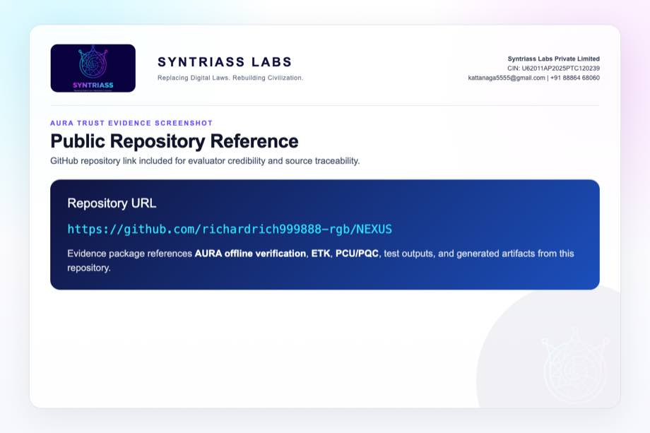
GitHub repository reference for AURA Trust

Evidence Page 6 - Fresh Test Output
Purpose: show that AURA Trust packet checks, PCU/PQC tests, and ETK tests were run locally before proposal packaging.
Status: test output screenshot embedded.
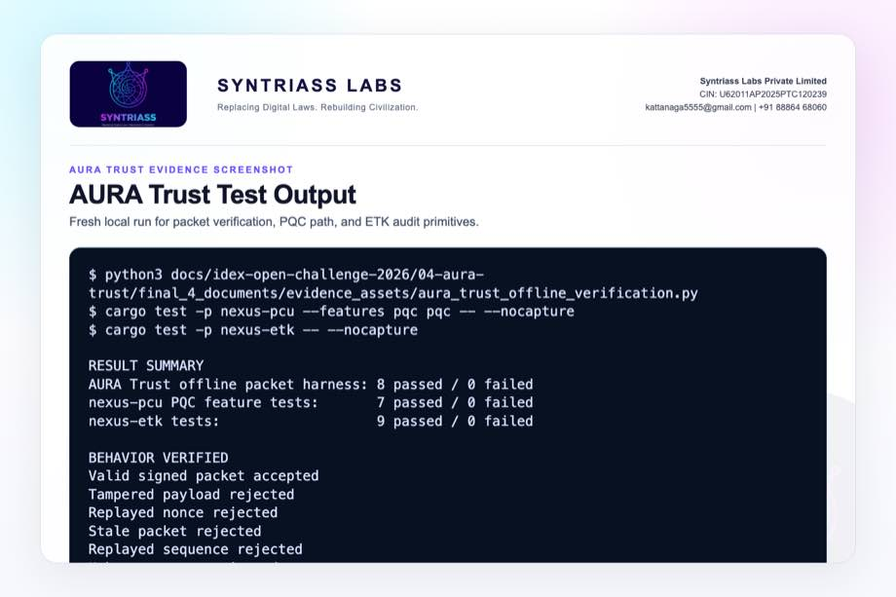
AURA Trust test output screenshot

Evidence Page 7 - Mission Packet Schema
Evidence source: aura_trust_offline_verification.py
Purpose: show source, payload, timestamp, nonce, sequence, provenance, policy, and signature fields.
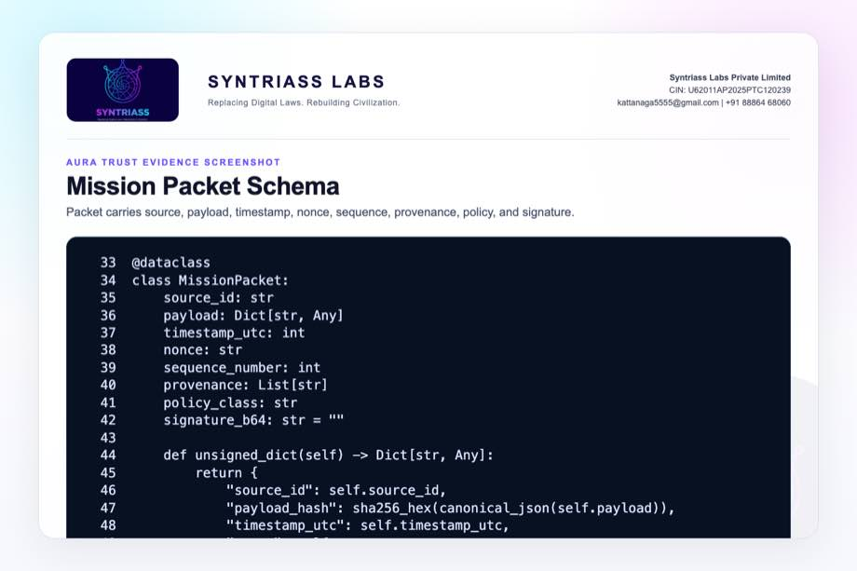
Mission packet schema screenshot

Evidence Page 8 - Offline Trust Store
Evidence source: aura_trust_offline_verification.py
Purpose: show local public keys, nonce memory, and sequence memory.
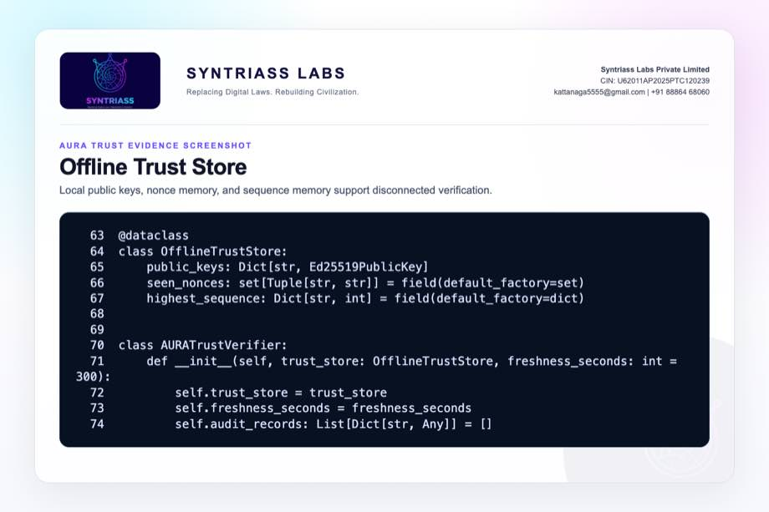
Offline trust store screenshot

Evidence Page 9 - Replay and Freshness Gates
Evidence source: aura_trust_offline_verification.py
Purpose: show unknown-source, stale-packet, nonce replay, and sequence replay rejection.
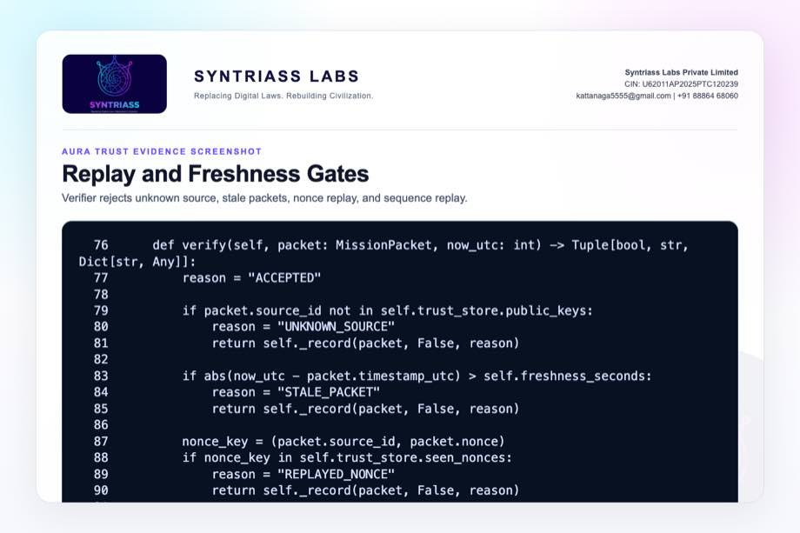
Replay and freshness gate screenshot

Evidence Page 10 - Signature Verification
Evidence source: aura_trust_offline_verification.py
Purpose: show verification of source signature before packet acceptance.
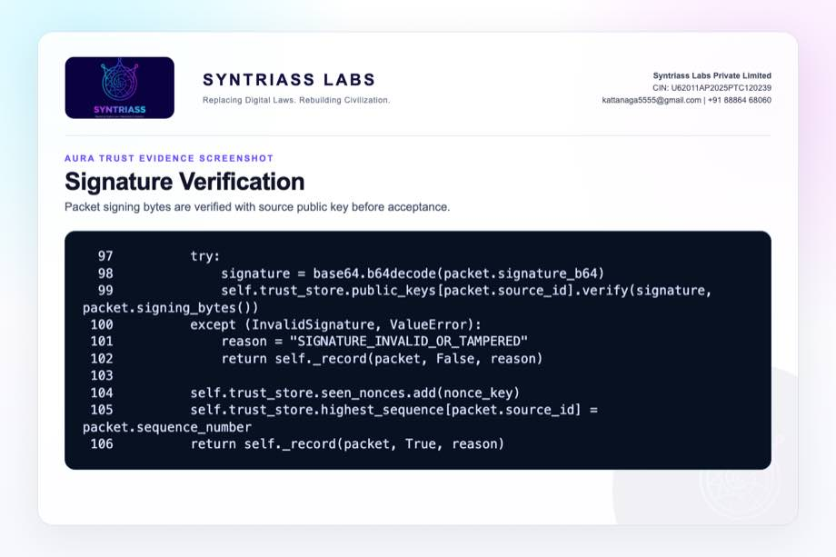
Signature verification screenshot

Evidence Page 11 - ETK-Compatible Audit Record
Evidence source: aura_trust_offline_verification.py
Purpose: show packet hash, payload hash, provenance root, policy ref, result, reason, and audit hash.
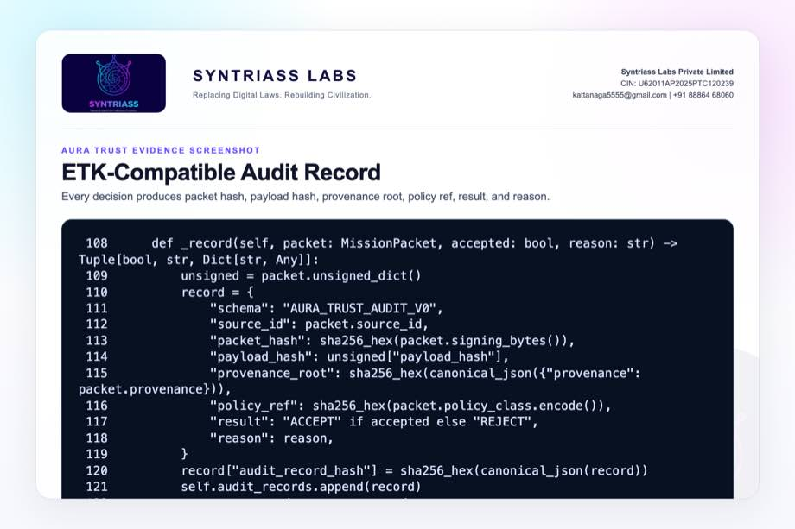
ETK-compatible audit record screenshot

Evidence Page 12 - Mission Packet Builder
Evidence source: aura_trust_offline_verification.py
Purpose: show demo mission payload, provenance chain, policy class, and signing path.
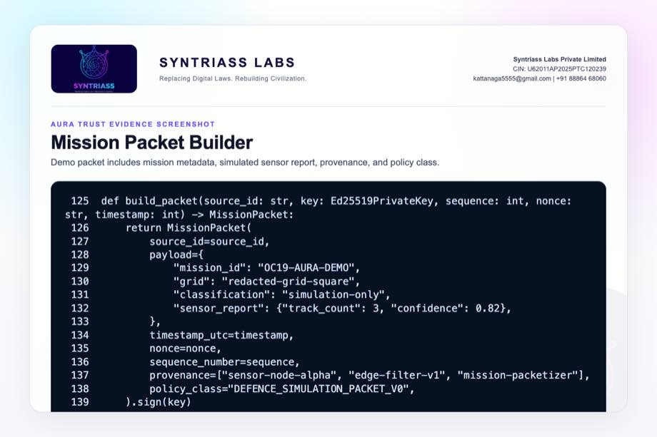
Mission packet builder screenshot

Evidence Page 13 - Acceptance and Tamper Tests
Evidence source: aura_trust_offline_verification.py
Purpose: show valid packet acceptance and modified-payload rejection.
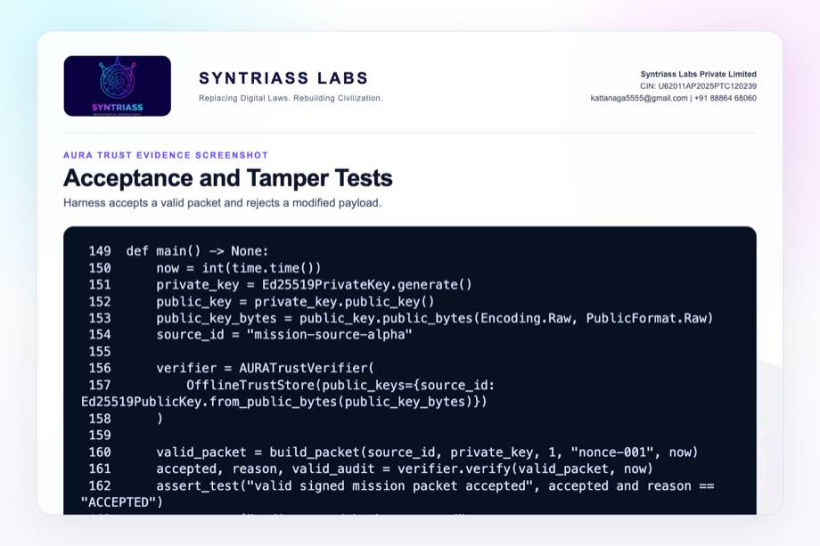
Acceptance and tamper tests screenshot

Evidence Page 14 - Replay, Stale, and Unknown-Source Tests
Evidence source: aura_trust_offline_verification.py
Purpose: show replay nonce, stale timestamp, old sequence, and unknown source rejection tests.
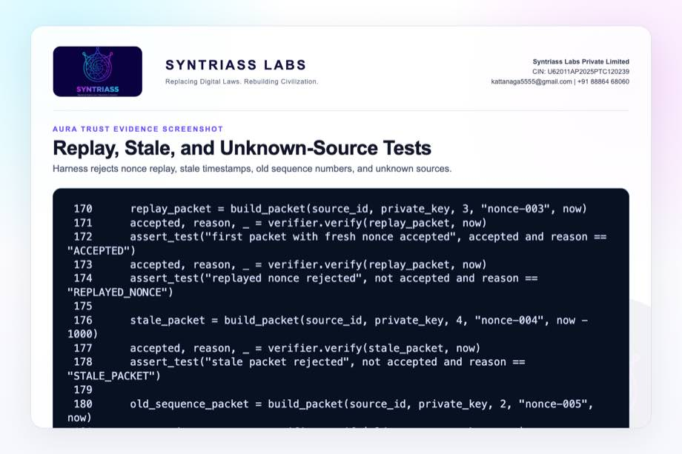
Replay stale and unknown source tests screenshot

Evidence Page 15 - Existing AURA Offline Verifier
Evidence source: src/network/offline.py
Purpose: show current AURA offline verification direction and early-stage caveat.
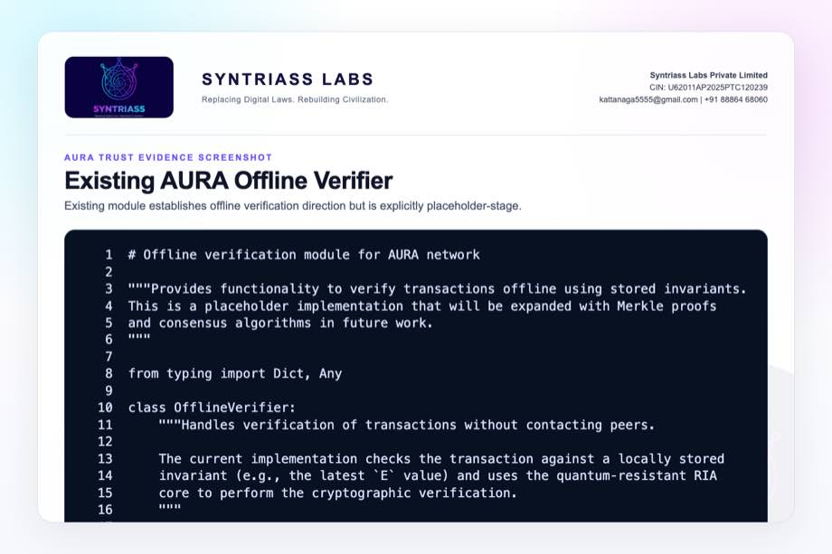
Existing AURA offline verifier screenshot

Evidence Page 16 - AURA RIA Signature Container
Evidence source: src/core/ria.py
Purpose: show current AURA signature container fields including timestamp, nonce, network, and metadata.
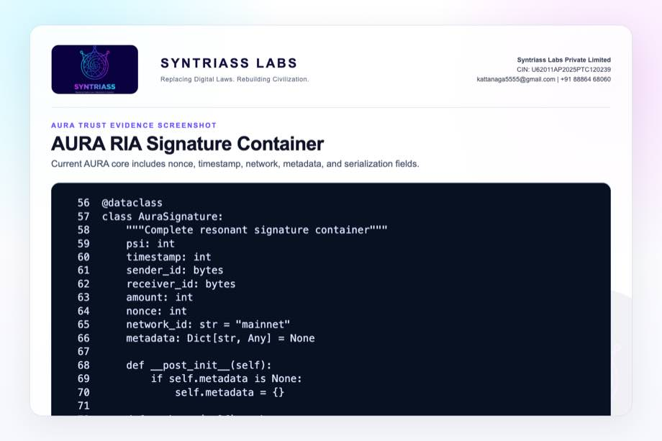
AURA RIA signature container screenshot

Evidence Page 17 - AURA RIA Transaction Verification
Evidence source: src/core/ria.py
Purpose: show transaction message reconstruction, signature recomputation, timestamp check, and invariant update.
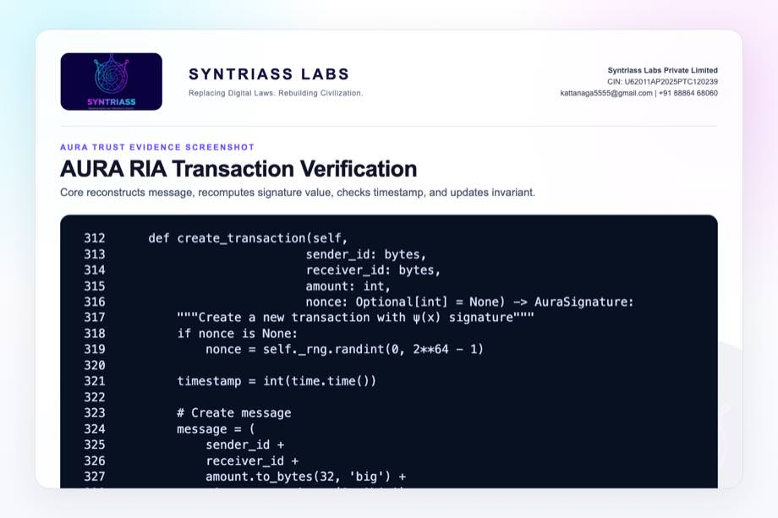
AURA RIA transaction verification screenshot

Evidence Page 18 - ETK Event Schema
Evidence source: nexus-etk/src/schema.rs
Purpose: show canonical execution-event fields and deterministic event ID computation.
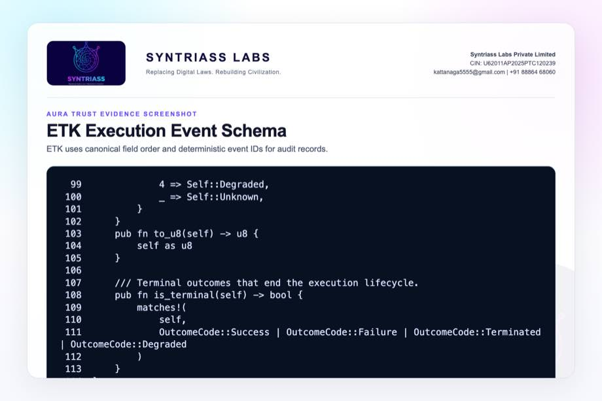
ETK event schema screenshot

Evidence Page 19 - ETK Proof Schema
Evidence source: nexus-etk/src/schema.rs
Purpose: show canonical proof fields and signing bytes.
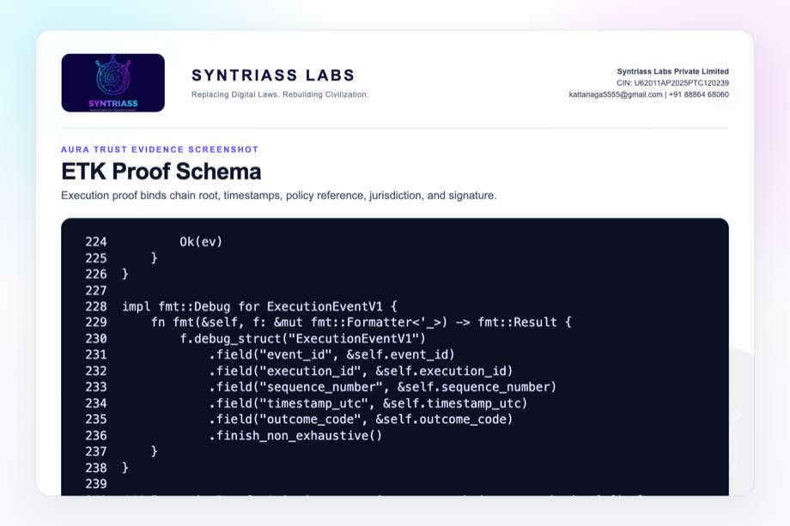
ETK proof schema screenshot

Evidence Page 20 - ETK Hash-Chained Events
Evidence source: nexus-etk/src/chain.rs
Purpose: show append-only event chain invariants and event append checks.
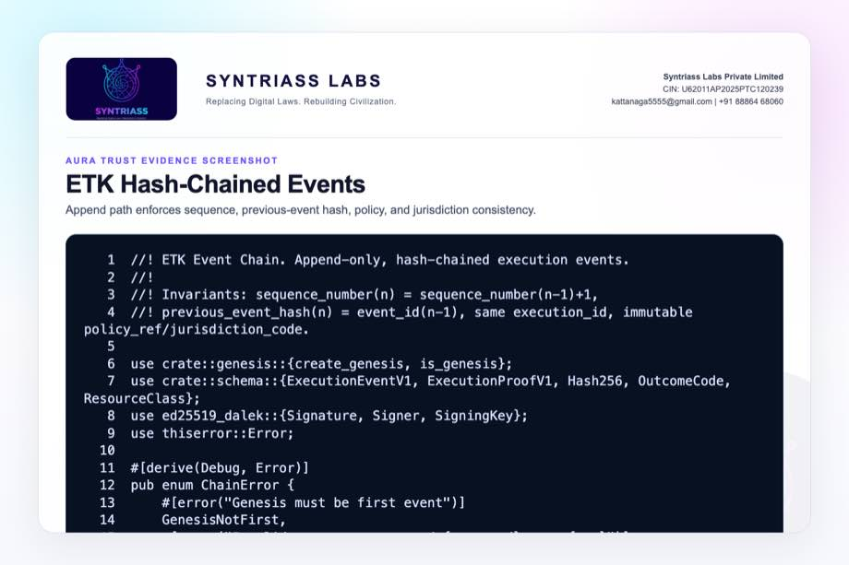
ETK event chain screenshot

Evidence Page 21 - ETK Finalize and Sign
Evidence source: nexus-etk/src/chain.rs
Purpose: show proof finalization and signature over canonical signing bytes.
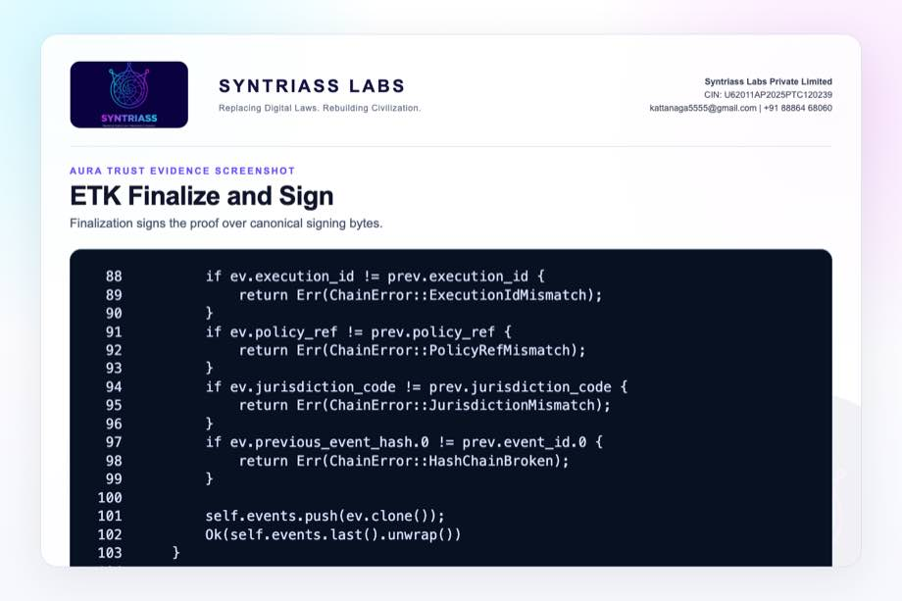
ETK finalize and sign screenshot

Evidence Page 22 - ETK Offline Verifier
Evidence source: nexus-etk/src/verifier.rs
Purpose: show offline verification phases for schema, signature, chain, time, policy, and outcome checks.
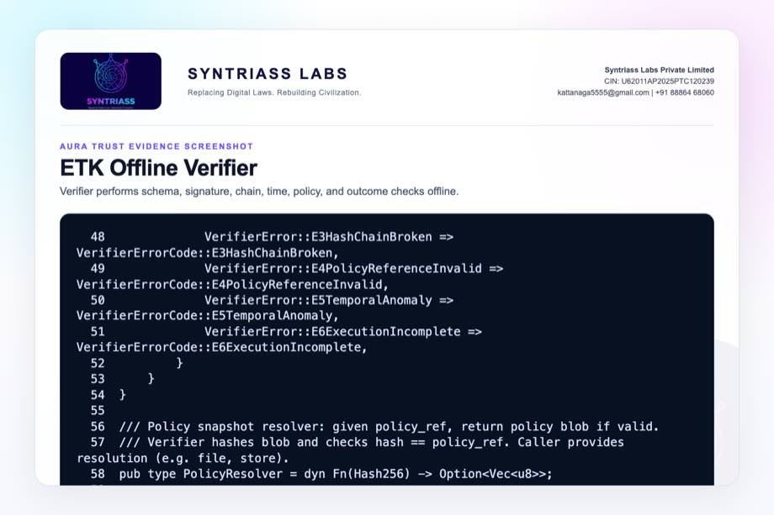
ETK offline verifier screenshot

Evidence Page 23 - PCU Execution Proof
Evidence source: nexus-pcu/src/proof.rs
Purpose: show proof fields binding PCU hash, input hashes, code hash, output hash, metrics, and attestation.
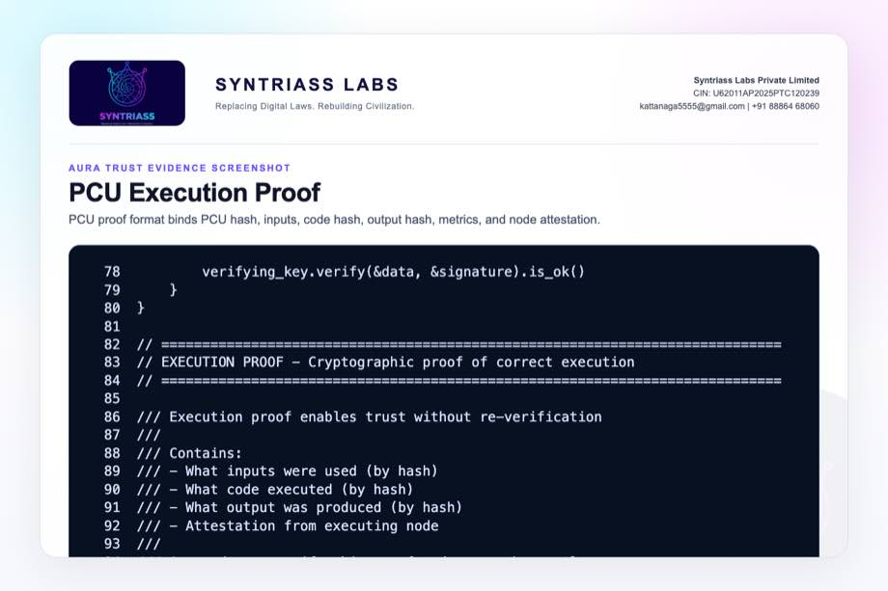
PCU execution proof screenshot

Evidence Page 24 - PCU Unit Structure
Evidence source: nexus-pcu/src/pcu.rs
Purpose: show self-contained computation unit fields used by downstream proof and identity paths.
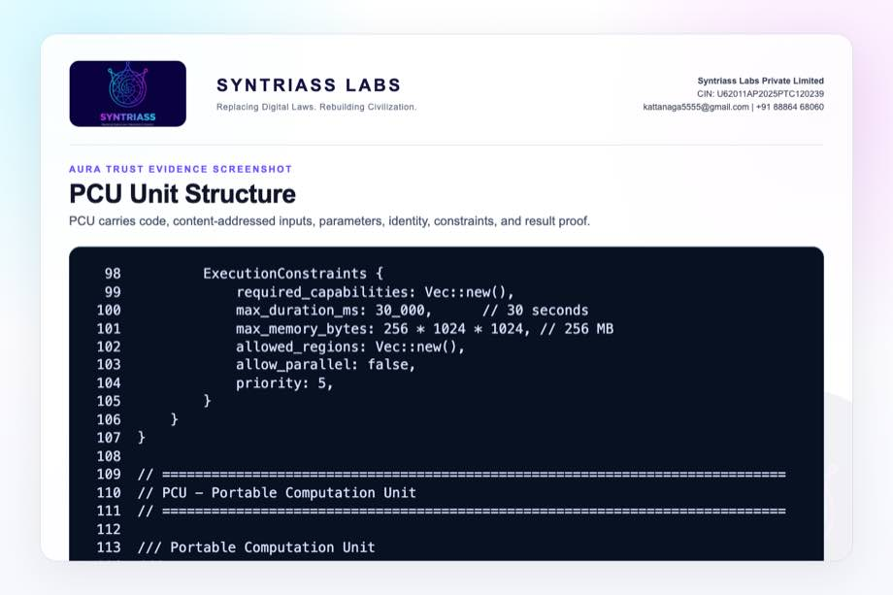
PCU unit structure screenshot

Evidence Page 25 - PQC Hybrid Signature Path
Evidence source: nexus-pcu/src/pqc.rs
Purpose: show hybrid signature structure and verification path.
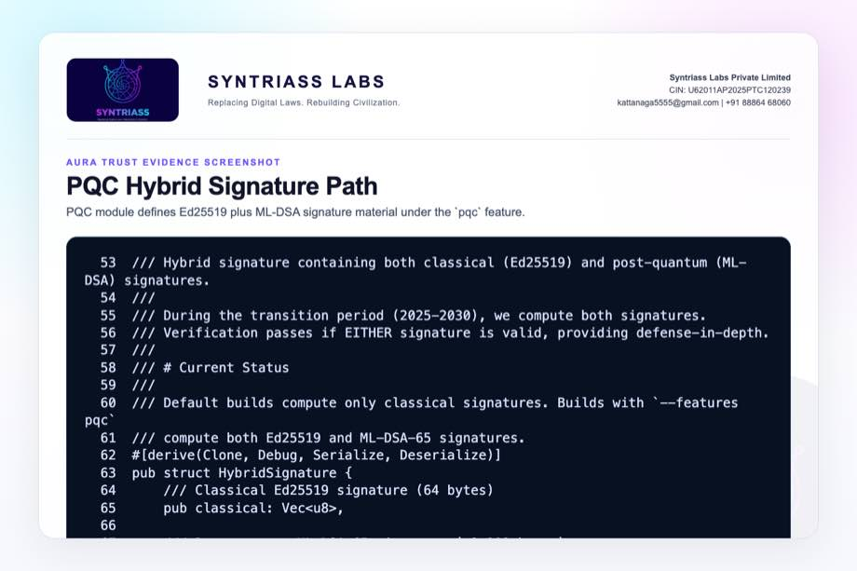
PQC hybrid signature screenshot

Evidence Page 26 - PQC Keypair and Public Bundle
Evidence source: nexus-pcu/src/pqc.rs
Purpose: show hybrid keypair signing and public key bundle verification.
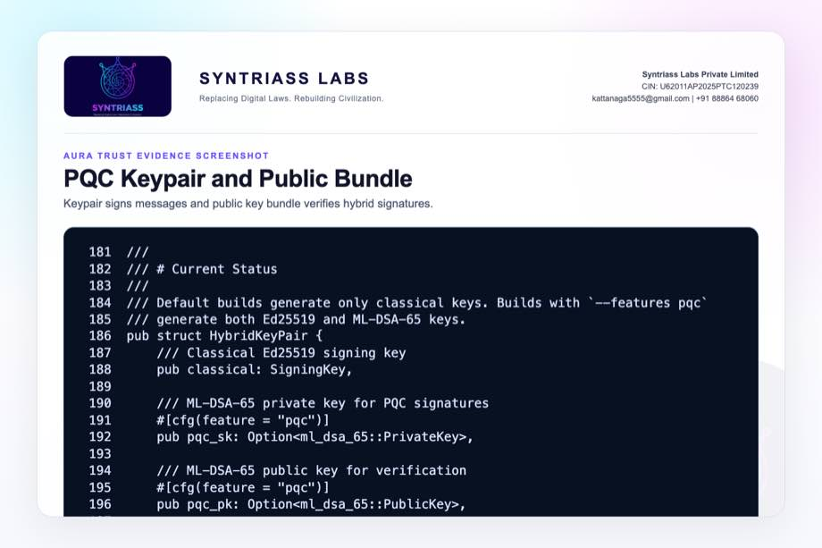
PQC keypair and public bundle screenshot

Evidence Page 27 - PQC Feature Tests
Evidence source: nexus-pcu/src/pqc.rs
Purpose: show feature-gated tests for key generation, signing, serialization, bundle verification, size, and PQC fallback.
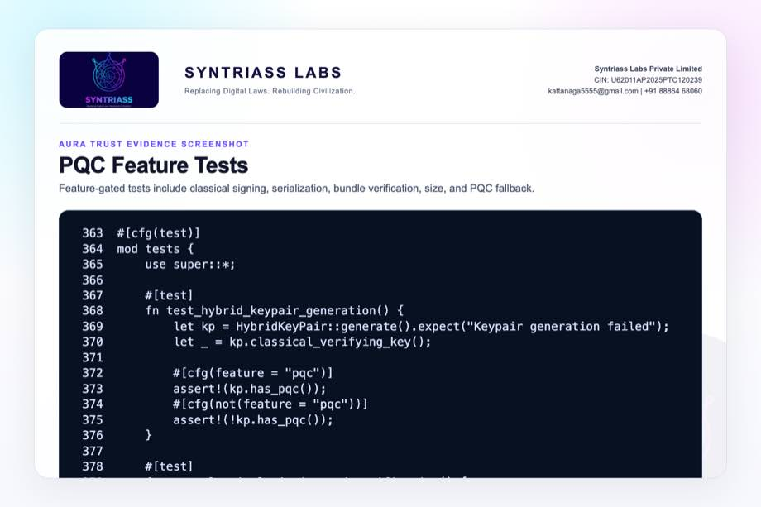
PQC feature tests screenshot

Evidence Page 28 - Reviewer Repository Map
Purpose: give panel reviewers a direct navigation map.
Review Area | Path
Final proposal package | docs/idex-open-challenge-2026/04-aura-trust/final_4_documents/
Screenshot assets | docs/idex-open-challenge-2026/04-aura-trust/final_4_documents/evidence_assets/
Packet harness | docs/idex-open-challenge-2026/04-aura-trust/final_4_documents/evidence_assets/aura_trust_offline_verification.py
AURA offline verifier | src/network/offline.py
AURA RIA core | src/core/ria.py
ETK source | nexus-etk/src/
PCU/PQC source | nexus-pcu/src/

Evidence Page 29 - Claim-to-File Location Map
Proposal Claim | Source Evidence
Packet schema exists in evidence harness | aura_trust_offline_verification.py, MissionPacket
Payload hash binds content | MissionPacket.unsigned_dict()
Source signature verification exists | AURATrustVerifier.verify()
Stale packet rejection exists | STALE_PACKET check
Nonce replay rejection exists | REPLAYED_NONCE check
Sequence rollback rejection exists | REPLAYED_SEQUENCE check
Audit record emission exists | _record() in evidence harness
ETK canonical audit primitives exist | nexus-etk/src/schema.rs, chain.rs, verifier.rs
PQC migration path exists | nexus-pcu/src/pqc.rs

Evidence Page 30 - Test and Command Locations
Test Area | Command / File
Packet-level offline verification | python3 docs/idex-open-challenge-2026/04-aura-trust/final_4_documents/evidence_assets/aura_trust_offline_verification.py
PCU PQC feature tests | cargo test -p nexus-pcu --features pqc pqc -- --nocapture
ETK audit primitive tests | cargo test -p nexus-etk -- --nocapture
Combined output artifact | evidence_assets/aura_trust_test_output.txt
Evidence screenshot generator | generate_aura_trust_evidence_screenshots.mjs
PDF builder | build_syntriass_letterhead_problem4.mjs

Evidence Page 31 - Generated Artifact Locations
Artifact Type | Location
Annexure 1 PDF | 01_SYNTRIASS_AURA_Trust_Annexure_1_Applicant_Details_and_Solution_Summary.pdf
Annexure 2 PDF | 02_SYNTRIASS_AURA_Trust_Annexure_2_Technical_Architecture.pdf
Annexure 3 PDF | 03_SYNTRIASS_AURA_Trust_Annexure_3_Advantages_and_Competencies.pdf
Annexure 4 PDF | 04_SYNTRIASS_AURA_Trust_Annexure_4_Supporting_Evidence_and_Screenshots.pdf
DOCX files | Same directory, matching .docx names.
Rendered HTML | final_4_documents/html/
Evidence screenshots | final_4_documents/evidence_assets/*.jpg
Test output | final_4_documents/evidence_assets/aura_trust_test_output.txt

Evidence Page 32 - Screenshot Artifact Index
Screenshot | File
GitHub repository | evidence_assets/01_github_repository.jpg
Fresh test output | evidence_assets/02_test_output.jpg
Mission packet schema | evidence_assets/03_packet_schema.jpg
Offline trust store | evidence_assets/04_trust_store.jpg
Replay/freshness gates | evidence_assets/05_replay_freshness_gates.jpg
Signature verification | evidence_assets/06_signature_verification.jpg
Audit record | evidence_assets/07_audit_record.jpg
Packet builder | evidence_assets/08_packet_builder.jpg
Harness tests | evidence_assets/09_accept_tamper_tests.jpg, 10_replay_stale_tests.jpg
AURA current modules | evidence_assets/11_existing_offline_verifier.jpg through 13_ria_transaction_verify.jpg
ETK screenshots | evidence_assets/14_etk_event_schema.jpg through 18_etk_verifier_phases.jpg
PCU/PQC screenshots | evidence_assets/19_pcu_execution_proof.jpg through 23_pqc_tests.jpg

Evidence Page 33 - Defence Problem to Evidence Map
Defence Problem | AURA Trust Control | Evidence
Tampered mission data | Payload hash plus signature verification | Evidence pages 7, 10, 13.
Replay attack | Nonce memory and sequence memory | Evidence pages 8, 9, 14.
Stale data | Timestamp freshness profile | Evidence pages 9, 14.
Unknown source | Offline public-key trust bundle | Evidence pages 8, 14.
Weak auditability | ETK-compatible decision record | Evidence pages 11, 18-22.
Quantum transition | PCU hybrid Ed25519 plus ML-DSA feature path | Evidence pages 25-27.

Evidence Page 34 - Prototype Work Package Locations
Work Package | Existing Starting Point
Mission packet schema | aura_trust_offline_verification.py, MissionPacket
Offline trust store | OfflineTrustStore in evidence harness
Replay/freshness logic | AURATrustVerifier.verify()
Audit export | _record() in evidence harness
AURA current verifier direction | src/network/offline.py
ETK binding | nexus-etk/src/schema.rs, chain.rs, verifier.rs
PCU/PQC migration | nexus-pcu/src/pqc.rs

Evidence Page 35 - Panel Review Checklist
Reviewer Question | Where To Check
Is there real packet-level behavior? | Evidence pages 7-14 and output file aura_trust_test_output.txt.
Were tests actually run? | Evidence page 6 and test output file in evidence_assets/.
Is this accredited as a secure information platform? | No. Caveats on pages 1, 4, and 36.
Is PQC packet enforcement complete? | No. PQC is currently a validated migration path, not packet-level enforcement.
Does ETK already provide audit primitives? | Evidence pages 18-22.
Is the GitHub repository identified? | Evidence page 5 and repository coordinate page 37.
Are artifact locations included? | Evidence pages 28-32.

Evidence Page 36 - Readiness Statement and Caveats
Area | Position
Software subsystem readiness | Current evidence supports software subsystem TRL 3-4.
Packet-level behavior | Harness demonstrates accept/reject/audit behavior for simulation packets.
Current AURA module | Existing offline verifier is early-stage and requires hardening.
ETK audit path | ETK primitives pass tests and can be integrated into AURA Trust.
PQC path | PCU PQC feature tests pass; packet-level enforcement remains proposed work.
Secure information platform claim | Not claimed until key lifecycle, revocation, accreditation, and deployment hardening are complete.
Operational use | Human approval, network policy, key authority, and service-specific controls remain required.

Evidence Page 37 - Declaration and Repository Coordinates
Declaration:
AURA Trust is submitted as a software-subsystem prototype for offline mission information provenance and verification evaluation.
Repository coordinates:
- Public repository: https://github.com/richardrich999888-rgb/NEXUS
- Proposal folder: docs/idex-open-challenge-2026/04-aura-trust/
- Final documents: docs/idex-open-challenge-2026/04-aura-trust/final_4_documents/
- Evidence assets: docs/idex-open-challenge-2026/04-aura-trust/final_4_documents/evidence_assets/
- Test output: docs/idex-open-challenge-2026/04-aura-trust/final_4_documents/evidence_assets/aura_trust_test_output.txt
- Packet harness: docs/idex-open-challenge-2026/04-aura-trust/final_4_documents/evidence_assets/aura_trust_offline_verification.py
Submission caveat:
- The package is prepared for prototype review and iDEX-funded validation planning.
- No classified-network deployment, secure information platform accreditation, or operational authority is claimed.
- Key lifecycle, revocation bundles, hardware security modules, and service-specific information policies remain required for operational use.

