IDEX OPEN CHALLENGE SUBMISSION

Annexure-4
Supporting evidence, screenshots, repository locations, and artifact map
CIN | PAN | TAN
U62011AP2025PTC120239 | ABQCS7152R | VPNS31351F

Applicant Entity | Contact
Syntriass Labs Private Limited | kattanaga5555@gmail.com
12-50, SLV Market, 12 Ward, Dharmavaram, Ananthapur - 515671, Andhra Pradesh, India | +91 88864 68060

Supporting Evidence and Screenshots

Company Identification Details
Field | Details
Legal Entity Name | Syntriass Labs Private Limited
CIN | U62011AP2025PTC120239
PAN | ABQCS7152R
TAN | VPNS31351F
Registered Office | 12-50, SLV Market, 12 Ward, Dharmavaram, Ananthapur - 515671, Andhra Pradesh, India
Contact Email | kattanaga5555@gmail.com
Contact Phone | +91 88864 68060
GitHub Repository | https://github.com/richardrich999888-rgb/NEXUS
Submission Date | 17 May 2026

1. Applicant Resume Format
Applicant: K. Naga Sri Ganesh
Company: Syntriass Labs Private Limited
Role: Founder / Inventor
Relevant focus: governed autonomy, immune cyber defence, multi-agent trust, anomaly scoring, auditability, and defence-oriented response assurance.

2. Prototype Evidence List
Evidence Item | Repository / Artifact Location
Governance-immune bridge | agp-core/src/immunity/governance_bridge.py
Artificial immune system | agp-core/src/immunity/immune_system.py
Unified immune system | agp-core/src/immunity/unified.py
Governance anomaly detector | agp-core/src/governance/anomaly.py
Bridge test | agp-core/tests/test_immune_bridge.py
Immune pytest suites | agp-core/tests/immunity/test_immune_system.py, agp-core/tests/immunity/test_unified_immune.py
Multi-agent governance simulation | agp-core/tests/test_multi_agent_governance.py
Fresh test output | docs/idex-open-challenge-2026/05-cyber-immune-soar/final_4_documents/evidence_assets/cyber_immune_soar_test_output.txt
Evidence screenshots | docs/idex-open-challenge-2026/05-cyber-immune-soar/final_4_documents/evidence_assets/
Final documents | docs/idex-open-challenge-2026/05-cyber-immune-soar/final_4_documents/

3. Validation Scope
Current validation is software-subsystem validation. The evidence supports immune bridge response behavior, immune component tests, and multi-agent governance simulation. It does not claim live SOC deployment, endpoint quarantine authority, classified network integration, operational cyber response approval, or field certification.

4. Test Commands and Recorded Results
Primary commands:
agp-core/.venv/bin/python agp-core/tests/test_immune_bridge.py
agp-core/.venv/bin/python -m pytest agp-core/tests/immunity/test_immune_system.py agp-core/tests/immunity/test_unified_immune.py -q
agp-core/.venv/bin/python agp-core/tests/test_multi_agent_governance.py
Fresh local results:
- Governance-immune bridge: 19 passed, 0 failed.
- Immune pytest suites: 54 passed, 0 failed.
- Multi-agent governance simulation: completed successfully.
- Run date: 17 May 2026.
Tested behaviors:
- LOW threat maps to monitor and tracking.
- HIGH threat maps to block and human escalation.
- CRITICAL threat maps to quarantine and mesh disconnect.
- Multi-agent defection maps to multi_quarantine and trust reduction.
- Trust propagation, threat clearing, immune suppression, and status reporting.
- Unified immune scan, known threat training, governance action mapping, and multi-agent ranking.

Evidence Page 5 - Public Repository Reference
Purpose: give panel reviewers a direct path to inspect the source repository.
Status: GitHub repository reference embedded.
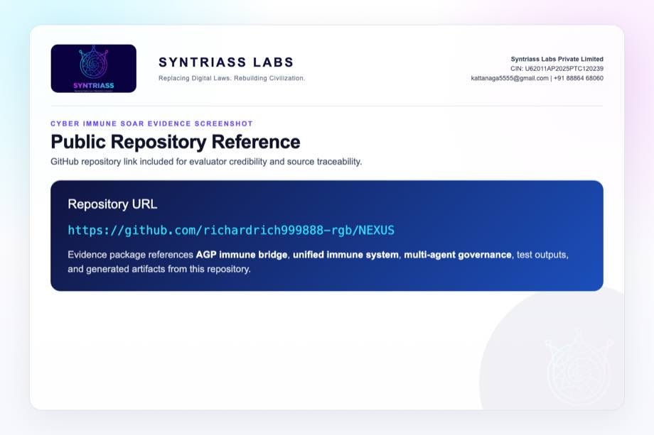
GitHub repository reference for Cyber Immune SOAR

Evidence Page 6 - Fresh Test Output
Purpose: show that immune bridge, immune component suites, and multi-agent governance simulation were run locally before proposal packaging.
Status: test output screenshot embedded.
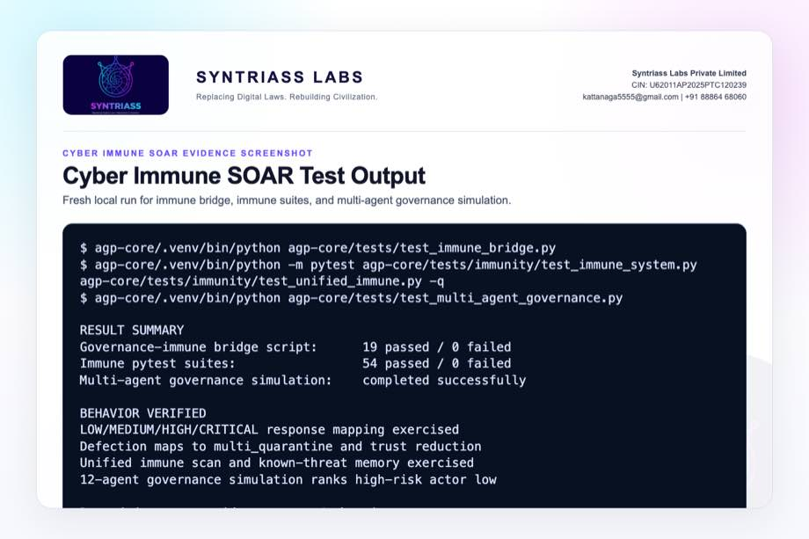
Cyber Immune SOAR test output screenshot

Evidence Page 7 - Threat Signal Schema
Evidence source: agp-core/src/immunity/governance_bridge.py
Purpose: show ThreatSignal and DefectionSignal fields used by the response flow.
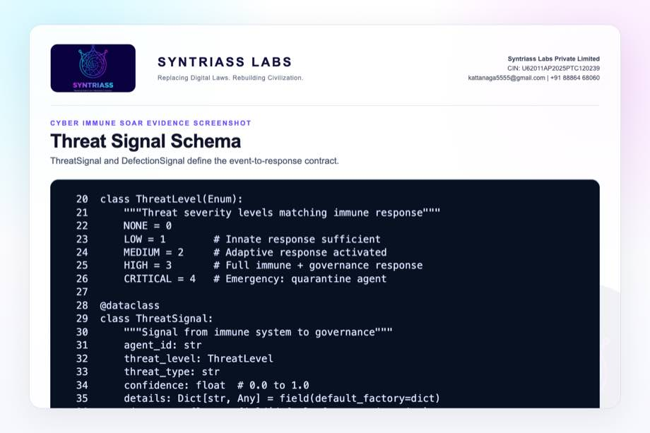
Threat signal schema screenshot

Evidence Page 8 - Governance-Immune Bridge State
Evidence source: agp-core/src/immunity/governance_bridge.py
Purpose: show active threats, permissions, defection signals, trust scores, and callbacks.
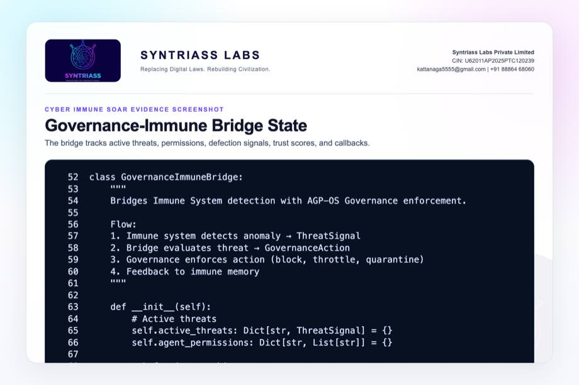
Governance immune bridge state screenshot

Evidence Page 9 - Threat Action Mapping
Evidence source: agp-core/src/immunity/governance_bridge.py
Purpose: show mapping from NONE, LOW, MEDIUM, HIGH, and CRITICAL to response classes.
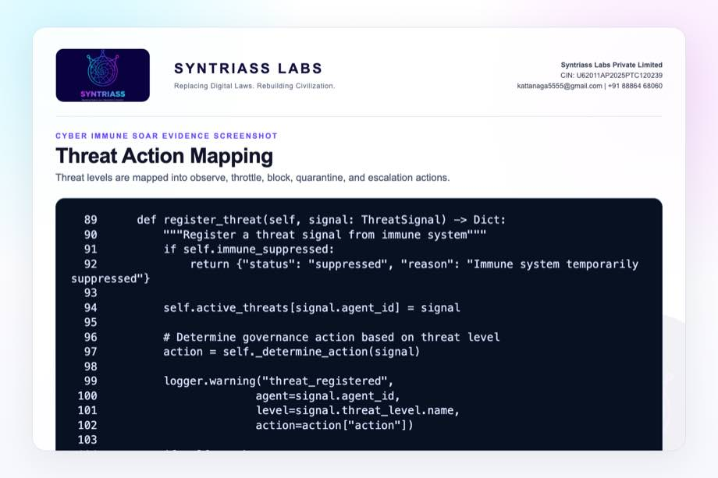
Threat action mapping screenshot

Evidence Page 10 - Defection Response
Evidence source: agp-core/src/immunity/governance_bridge.py
Purpose: show multi-agent defection handling, trust reduction, and multi_quarantine action.
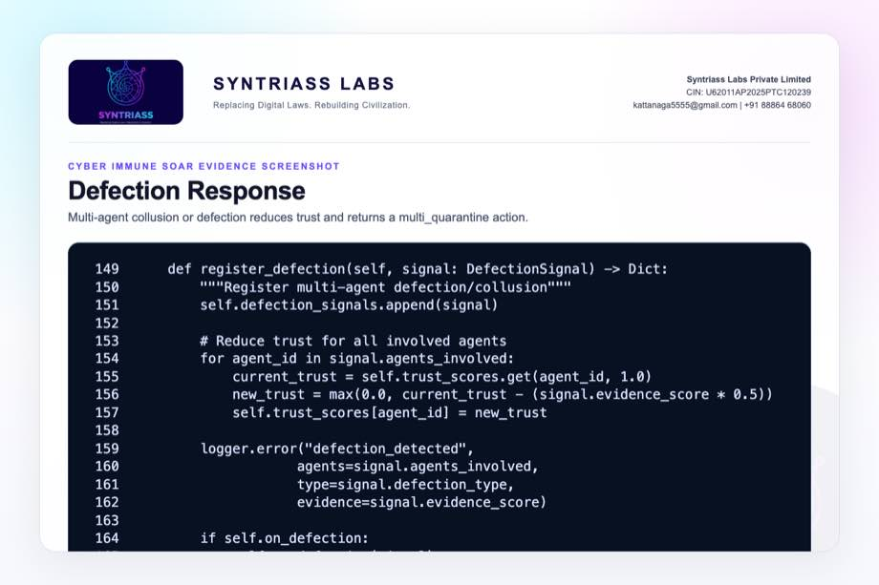
Defection response screenshot

Evidence Page 11 - Trust, Suppression, and Status Controls
Evidence source: agp-core/src/immunity/governance_bridge.py
Purpose: show trust propagation, direct quarantine helper, restriction helper, suppression, restoration, and status reporting.
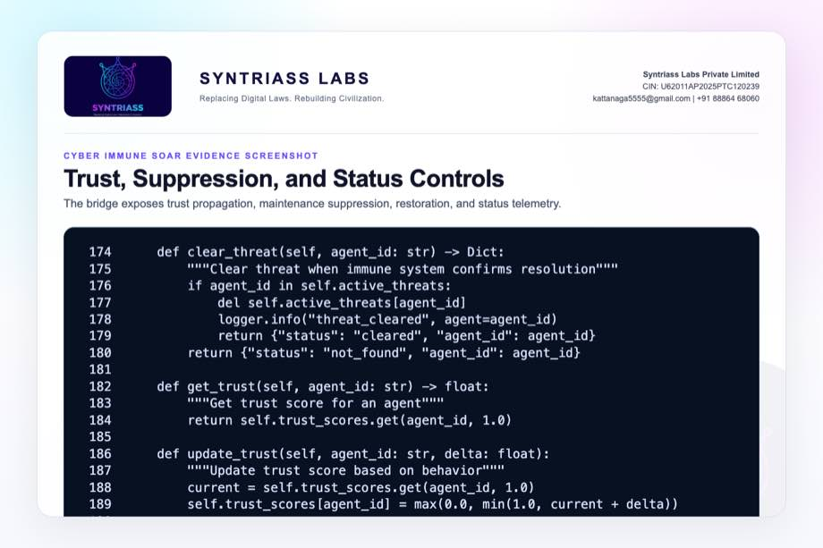
Trust status controls screenshot

Evidence Page 12 - Artificial Immune System Configuration
Evidence source: agp-core/src/immunity/immune_system.py
Purpose: show AIS configuration for innate, adaptive, memory, T-cell, and optional swarm mode.
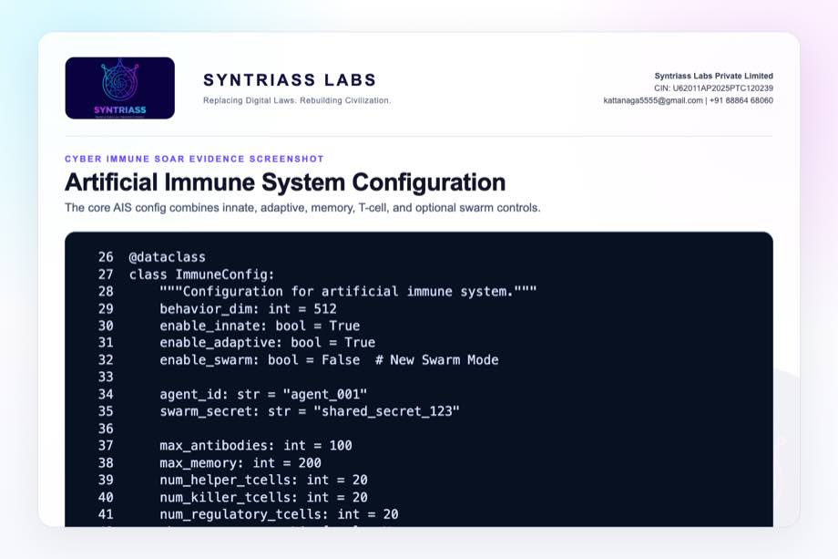
Artificial immune system config screenshot

Evidence Page 13 - Immune Forward Scan
Evidence source: agp-core/src/immunity/immune_system.py
Purpose: show runtime scan diagnostics for threat type, severity, memory hit, and response time.
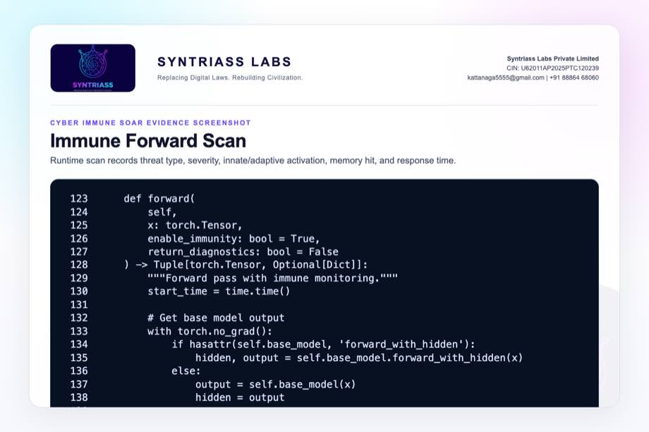
Immune forward scan screenshot

Evidence Page 14 - Unified Immune Architecture
Evidence source: agp-core/src/immunity/unified.py
Purpose: show integration of innate, adaptive, immune memory, governance bridge, AHES, and TELOS.
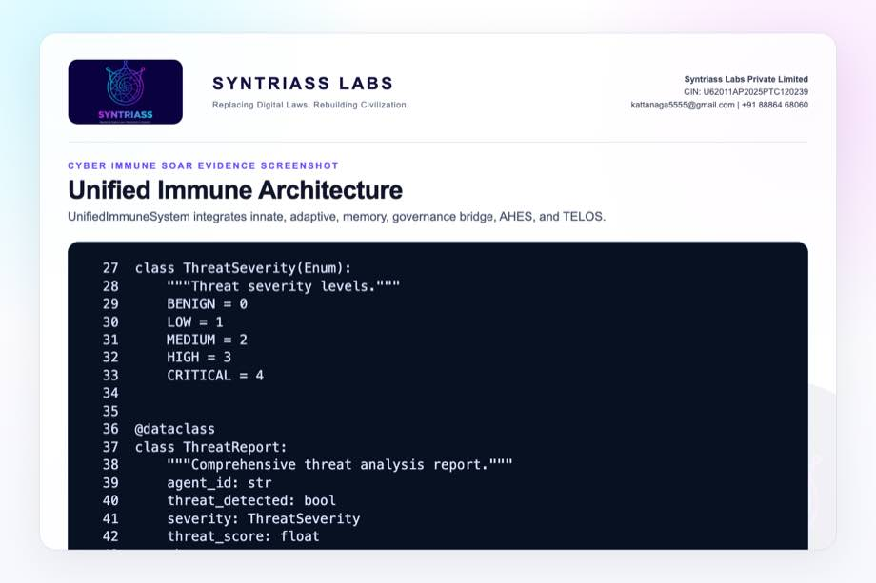
Unified immune architecture screenshot

Evidence Page 15 - Unified Scan Flow
Evidence source: agp-core/src/immunity/unified.py
Purpose: show behavior-vector normalization, AIS scan, score calculation, severity classification, and governance routing.
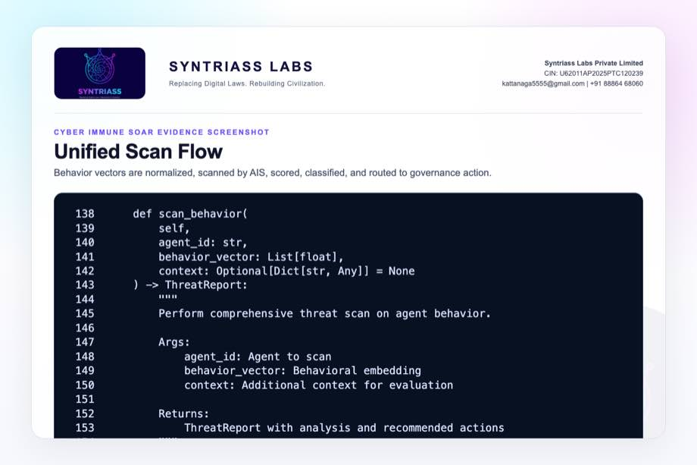
Unified scan flow screenshot

Evidence Page 16 - Unified Governance Mapping
Evidence source: agp-core/src/immunity/unified.py
Purpose: show severity translated into ThreatSignal and returned as warn, escalate, restrict, or quarantine.
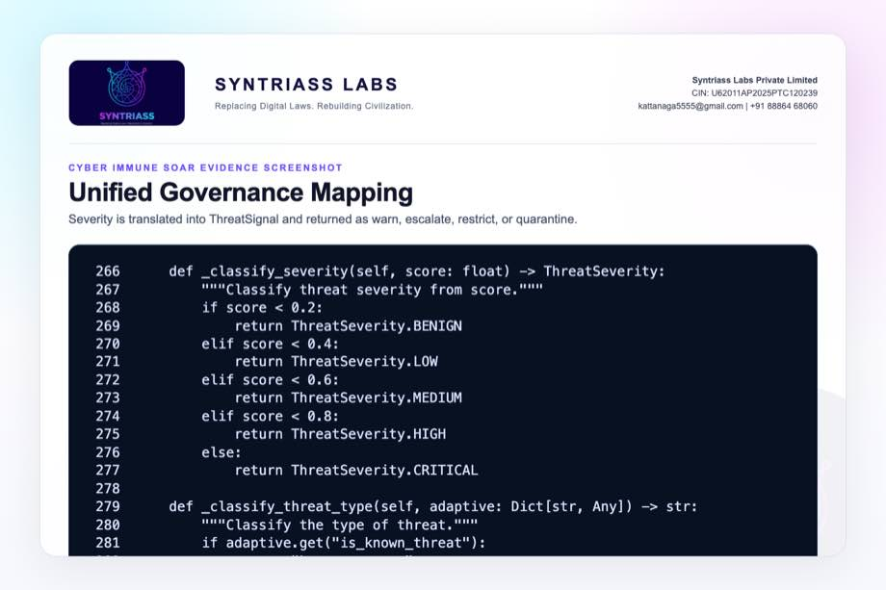
Unified governance mapping screenshot

Evidence Page 17 - Threat Memory Training
Evidence source: agp-core/src/immunity/unified.py
Purpose: show known threat vector storage and similarity matching for later scans.
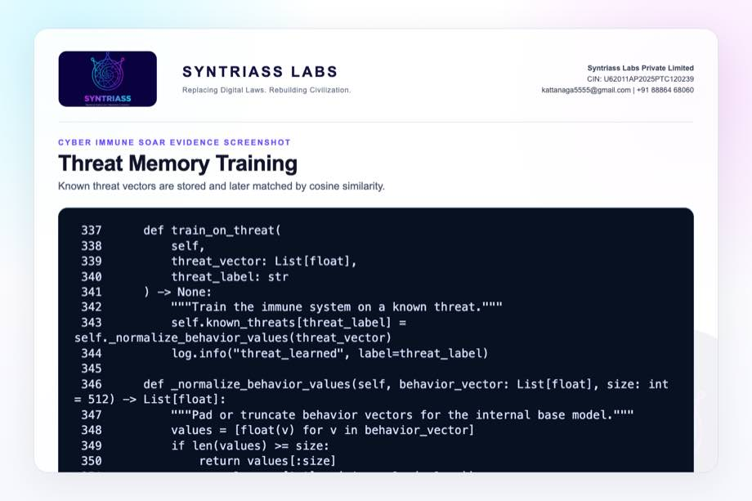
Threat memory screenshot

Evidence Page 18 - Governance Anomaly Taxonomy
Evidence source: agp-core/src/governance/anomaly.py
Purpose: show anomaly classes: drift, sudden shift, category shift, frequency spike, and high-risk pattern.
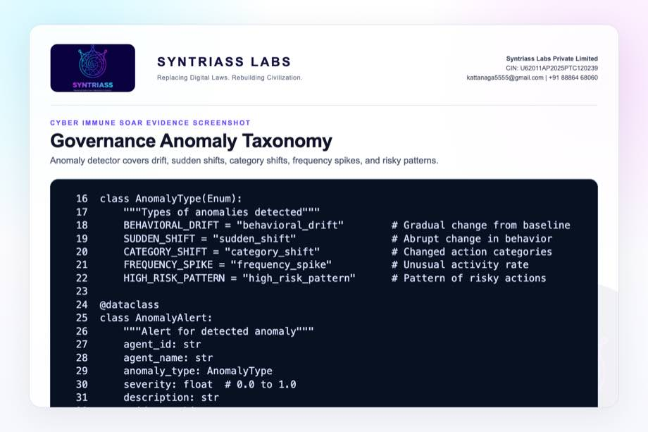
Governance anomaly taxonomy screenshot

Evidence Page 19 - Anomaly Detection Flow
Evidence source: agp-core/src/governance/anomaly.py
Purpose: show baseline/recent behavior retrieval and typed alert emission.
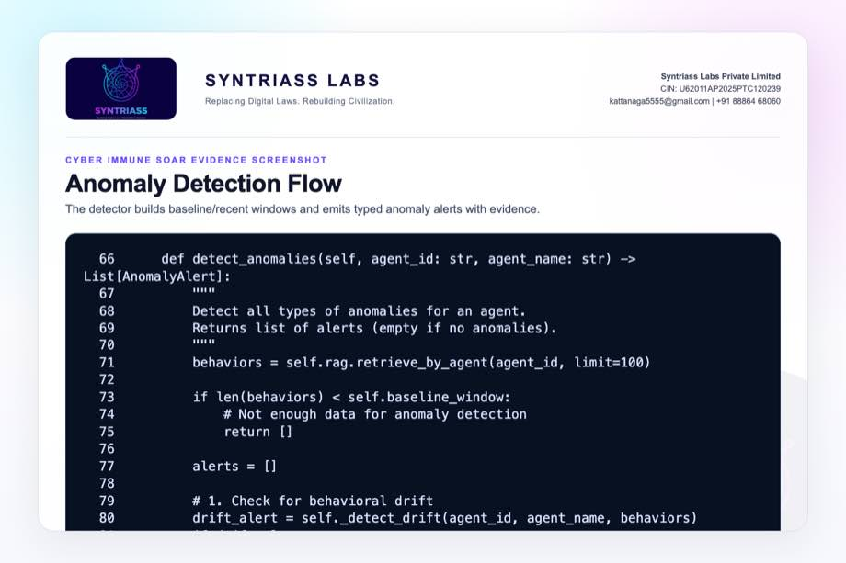
Anomaly detection flow screenshot

Evidence Page 20 - Behavioral Drift Detector
Evidence source: agp-core/src/governance/anomaly.py
Purpose: show recent embedding comparison against baseline and severity conversion.
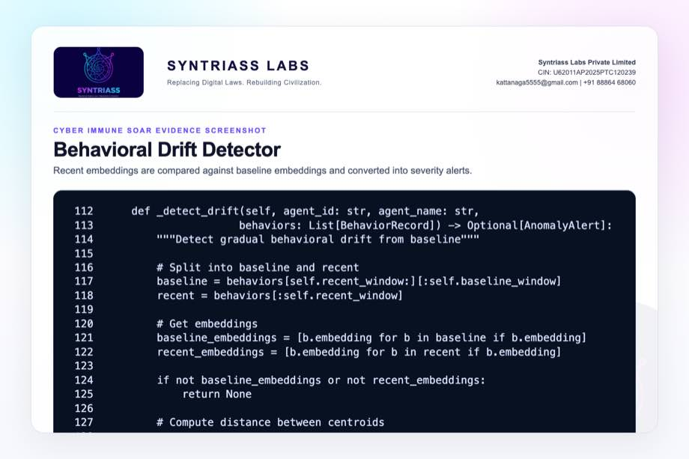
Behavioral drift detector screenshot

Evidence Page 21 - Bridge Test Cases
Evidence source: agp-core/tests/test_immune_bridge.py
Purpose: show tests for low, high, critical, defection, trust, clearing, suppression, and status flows.
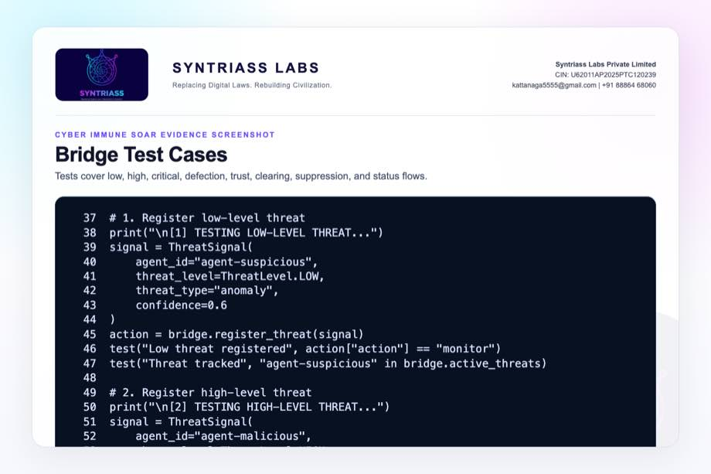
Bridge test cases screenshot

Evidence Page 22 - Bridge Test Summary
Evidence source: agp-core/tests/test_immune_bridge.py
Purpose: show pass/fail summary gate and verified output condition.
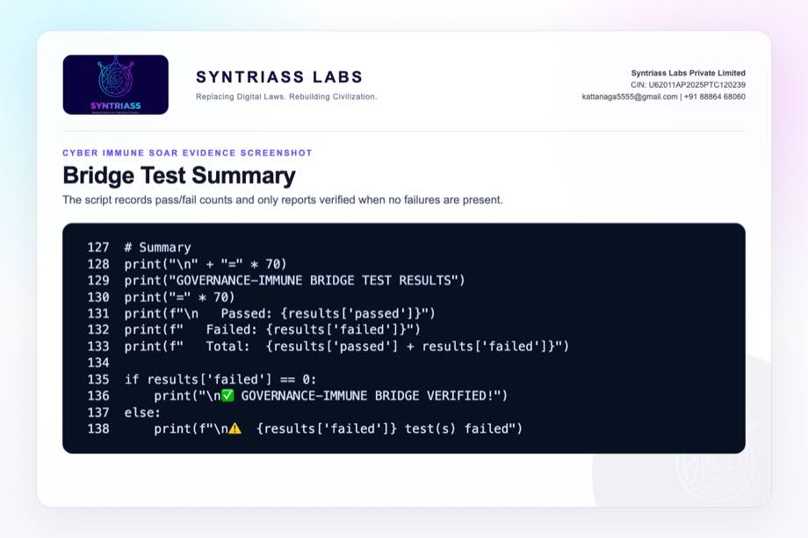
Bridge test summary screenshot

Evidence Page 23 - Unified Immune Tests
Evidence source: agp-core/tests/immunity/test_unified_immune.py
Purpose: show tests for initialization, registration, behavior scan, threat detection, and memory update.
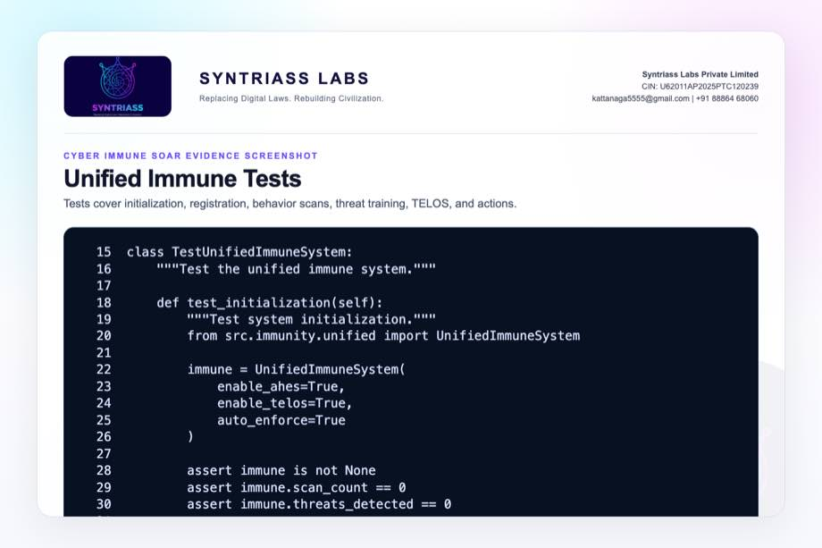
Unified immune tests screenshot

Evidence Page 24 - Full Integration Test
Evidence source: agp-core/tests/immunity/test_unified_immune.py
Purpose: show all-components integration test with multiple agents, threat training, scans, and status.
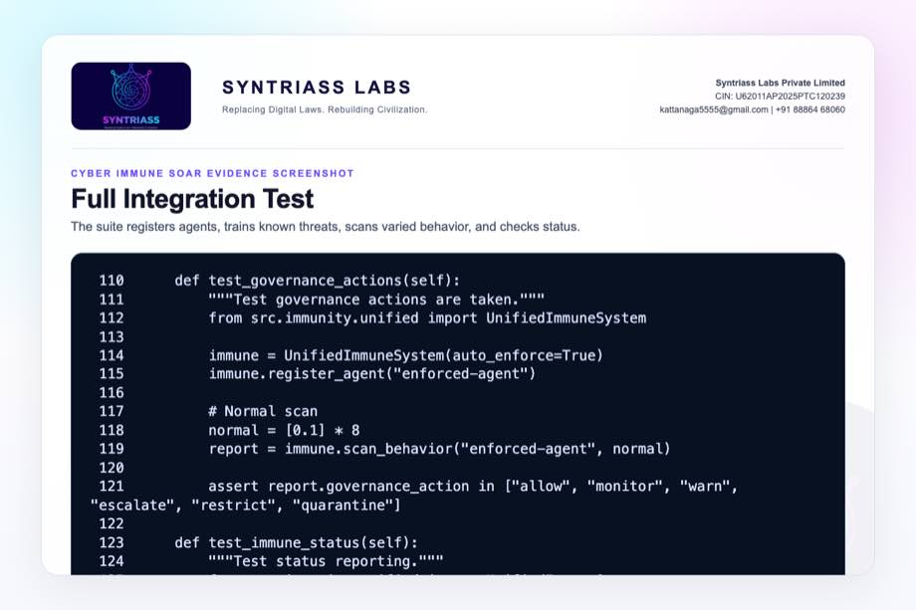
Unified integration tests screenshot

Evidence Page 25 - AIS Unit Tests
Evidence source: agp-core/tests/immunity/test_immune_system.py
Purpose: show antibody creation, binding, neutralization, cloning, fitness, and pool behavior tests.
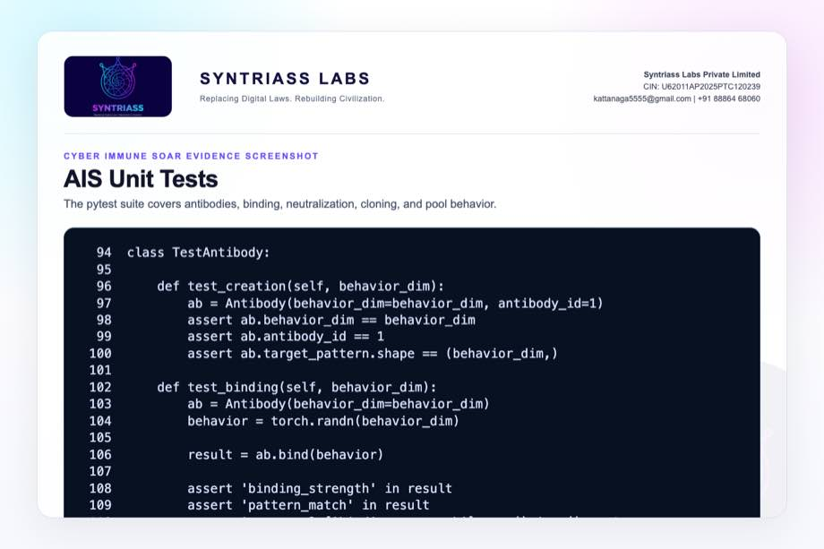
AIS unit tests screenshot

Evidence Page 26 - Multi-Agent Governance Simulation
Evidence source: agp-core/tests/test_multi_agent_governance.py
Purpose: show 12 behavior profiles across task success, collaboration, risk, and ethics signals.
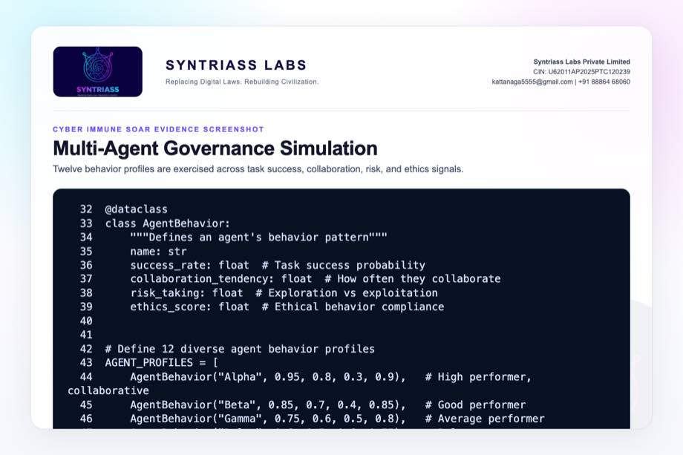
Multi agent simulation screenshot

Evidence Page 27 - Governance Result Gate
Evidence source: agp-core/tests/test_multi_agent_governance.py
Purpose: show simulation succeeds only when high performers rank high and the high-risk actor ranks low.
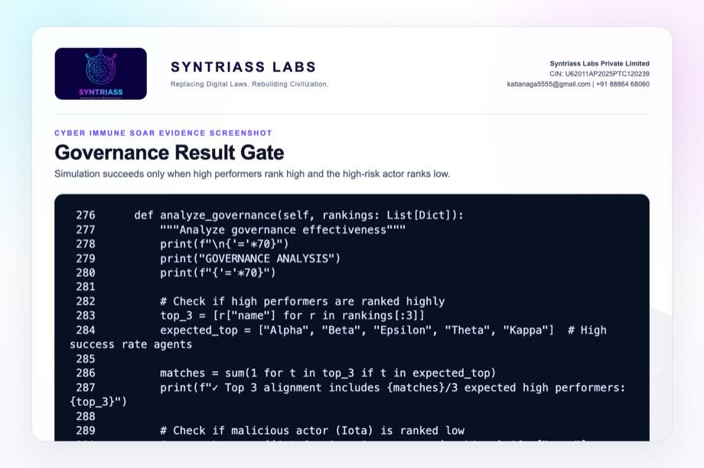
Governance result gate screenshot

Evidence Page 28 - Reviewer Repository Map
Purpose: give panel reviewers a direct navigation map.
Review Area | Path
Final proposal package | docs/idex-open-challenge-2026/05-cyber-immune-soar/final_4_documents/
Screenshot assets | docs/idex-open-challenge-2026/05-cyber-immune-soar/final_4_documents/evidence_assets/
Governance-immune bridge | agp-core/src/immunity/governance_bridge.py
Artificial immune system | agp-core/src/immunity/immune_system.py
Unified immune system | agp-core/src/immunity/unified.py
Governance anomaly detector | agp-core/src/governance/anomaly.py
AGP immune tests | agp-core/tests/immunity/
Multi-agent governance simulation | agp-core/tests/test_multi_agent_governance.py

Evidence Page 29 - Claim-to-File Location Map
Proposal Claim | Source Evidence
Threat signal schema exists | governance_bridge.py, ThreatSignal
Defection signal schema exists | governance_bridge.py, DefectionSignal
LOW threat maps to monitor | GovernanceImmuneBridge._determine_action()
MEDIUM threat maps to throttle | GovernanceImmuneBridge._determine_action()
HIGH threat maps to block and escalation | GovernanceImmuneBridge._determine_action()
CRITICAL threat maps to quarantine | GovernanceImmuneBridge._determine_action()
Multi-agent defection reduces trust | GovernanceImmuneBridge.register_defection()
Unified immune scan exists | UnifiedImmuneSystem.scan_behavior()
Known threat memory exists | UnifiedImmuneSystem.train_on_threat() and _known_threat_similarity()
Multi-agent ranking simulation exists | test_multi_agent_governance.py

Evidence Page 30 - Test and Command Locations
Test Area | Command / File
Governance-immune bridge | agp-core/.venv/bin/python agp-core/tests/test_immune_bridge.py
Immune pytest suites | agp-core/.venv/bin/python -m pytest agp-core/tests/immunity/test_immune_system.py agp-core/tests/immunity/test_unified_immune.py -q
Multi-agent governance simulation | agp-core/.venv/bin/python agp-core/tests/test_multi_agent_governance.py
Combined output artifact | evidence_assets/cyber_immune_soar_test_output.txt
Evidence screenshot generator | generate_cyber_immune_soar_evidence_screenshots.mjs
PDF builder | build_syntriass_letterhead_problem5.mjs

Evidence Page 31 - Generated Artifact Locations
Artifact Type | Location
Annexure 1 PDF | 01_SYNTRIASS_Cyber_Immune_SOAR_Annexure_1_Applicant_Details_and_Solution_Summary.pdf
Annexure 2 PDF | 02_SYNTRIASS_Cyber_Immune_SOAR_Annexure_2_Technical_Architecture.pdf
Annexure 3 PDF | 03_SYNTRIASS_Cyber_Immune_SOAR_Annexure_3_Advantages_and_Competencies.pdf
Annexure 4 PDF | 04_SYNTRIASS_Cyber_Immune_SOAR_Annexure_4_Supporting_Evidence_and_Screenshots.pdf
DOCX files | Same directory, matching .docx names.
Rendered HTML | final_4_documents/html/
Evidence screenshots | final_4_documents/evidence_assets/*.jpg
Test output | final_4_documents/evidence_assets/cyber_immune_soar_test_output.txt

Evidence Page 32 - Screenshot Artifact Index
Screenshot | File
GitHub repository | evidence_assets/01_github_repository.jpg
Fresh test output | evidence_assets/02_test_output.jpg
Threat and defection schema | evidence_assets/03_threat_signal_schema.jpg
Bridge state | evidence_assets/04_bridge_state.jpg
Threat action mapping | evidence_assets/05_threat_action_mapping.jpg
Defection response | evidence_assets/06_defection_response.jpg
Trust/status controls | evidence_assets/07_trust_status_controls.jpg
Immune system screenshots | evidence_assets/08_immune_system_config.jpg through 13_threat_memory.jpg
Anomaly screenshots | evidence_assets/14_anomaly_taxonomy.jpg through 16_drift_detector.jpg
Test screenshots | evidence_assets/17_bridge_test_cases.jpg through 23_governance_result_gate.jpg

Evidence Page 33 - Defence Problem to Evidence Map
Defence Problem | Cyber Immune SOAR Control | Evidence
Alert overload | Severity and confidence signal engine | Evidence pages 7-9, 12-15.
Unsafe automated response | Governance bridge response mapping | Evidence pages 8-11, 16.
Compromised service or agent | ThreatSignal and quarantine paths | Evidence pages 7, 9, 21-22.
Coordinated compromise | DefectionSignal and multi_quarantine | Evidence pages 7, 10, 21.
Weak threat memory | Known threat vector storage and similarity matching | Evidence page 17.
Poor after-action review | Status, output, artifact map, and test evidence | Evidence pages 6, 28-32, 35-37.

Evidence Page 34 - Prototype Work Package Locations
Work Package | Existing Starting Point
Threat signal schema | governance_bridge.py, ThreatSignal
Defection signal schema | governance_bridge.py, DefectionSignal
Response mapping | GovernanceImmuneBridge._determine_action()
Trust update | GovernanceImmuneBridge.register_defection()
Status reporting | GovernanceImmuneBridge.get_status()
Unified scan | UnifiedImmuneSystem.scan_behavior()
Known threat memory | UnifiedImmuneSystem.train_on_threat()
Anomaly detector | AnomalyDetector.detect_anomalies()
Simulation harness | test_multi_agent_governance.py

Evidence Page 35 - Panel Review Checklist
Reviewer Question | Where To Check
Were tests actually run? | Evidence page 6 and output file cyber_immune_soar_test_output.txt.
Is there real bridge behavior? | Evidence pages 7-11 and test_immune_bridge.py.
Does this replace a live SOC? | No. It is a simulation-first prototype. Caveats on pages 1, 4, and 36.
Does it perform real endpoint quarantine today? | No. Current quarantine is a governed simulation action.
Does it handle multi-agent collusion? | DefectionSignal path and bridge test evidence on pages 7, 10, and 21.
Is the GitHub repository identified? | Evidence page 5 and repository coordinate page 37.
Are artifact locations included? | Evidence pages 28-32.

Evidence Page 36 - Readiness Statement and Caveats
Area | Position
Software subsystem readiness | Current evidence supports software subsystem TRL 3-4.
Bridge behavior | Script test reports 19 passed and 0 failed.
Immune components | Pytest immune suites report 54 passed.
Multi-agent governance | Simulation completes successfully.
Live SOC deployment | Not claimed. Requires adapters, policy approval, safety testing, and operator workflow validation.
Endpoint quarantine | Not claimed as operational enforcement. Current quarantine is a bounded simulation action.
Classified network use | Not claimed. Accreditation, audit retention, access control, and network authority remain required.
False-positive handling | Requires evaluator datasets, red-team simulation, thresholds, and human override policy.

Evidence Page 37 - Declaration and Repository Coordinates
Declaration:
Cyber Immune SOAR is submitted as a software-subsystem prototype for governed cyber defence response evaluation.
Repository coordinates:
- Public repository: https://github.com/richardrich999888-rgb/NEXUS
- Proposal folder: docs/idex-open-challenge-2026/05-cyber-immune-soar/
- Final documents: docs/idex-open-challenge-2026/05-cyber-immune-soar/final_4_documents/
- Evidence assets: docs/idex-open-challenge-2026/05-cyber-immune-soar/final_4_documents/evidence_assets/
- Test output: docs/idex-open-challenge-2026/05-cyber-immune-soar/final_4_documents/evidence_assets/cyber_immune_soar_test_output.txt
- Bridge source: agp-core/src/immunity/governance_bridge.py
- Unified immune source: agp-core/src/immunity/unified.py
- Simulation source: agp-core/tests/test_multi_agent_governance.py
Submission caveat:
- The package is prepared for prototype review and iDEX-funded validation planning.
- No live cyber operation authority, classified-network deployment, endpoint-quarantine certification, or operational SOC replacement is claimed.
- SIEM/SOAR adapters, endpoint controls, signed audit storage, evaluator datasets, and response-authority approvals remain required for operational use.

