IDEX OPEN CHALLENGE SUBMISSION

Annexure-4
Supporting evidence, screenshots, repository locations, and artifact map
CIN | PAN | TAN
U62011AP2025PTC120239 | ABQCS7152R | VPNS31351F

Applicant Entity | Contact
Syntriass Labs Private Limited | kattanaga5555@gmail.com
12-50, SLV Market, 12 Ward, Dharmavaram, Ananthapur - 515671, Andhra Pradesh, India | +91 88864 68060

Supporting Evidence and Screenshots

Company Identification Details
Field | Details
Legal Entity Name | Syntriass Labs Private Limited
CIN | U62011AP2025PTC120239
PAN | ABQCS7152R
TAN | VPNS31351F
Registered Office | 12-50, SLV Market, 12 Ward, Dharmavaram, Ananthapur - 515671, Andhra Pradesh, India
Contact Email | kattanaga5555@gmail.com
Contact Phone | +91 88864 68060
GitHub Repository | https://github.com/richardrich999888-rgb/NEXUS
Submission Date | 17 May 2026

1. Applicant Resume Format
Applicant: K. Naga Sri Ganesh
Company: Syntriass Labs Private Limited
Role: Founder / Inventor
Relevant focus: governed autonomy, proof-carrying computation, hybrid cryptographic identity, PCU identity binding, post-quantum transition planning, and defence-oriented audit evidence.

2. Prototype Evidence List
Evidence Item | Repository / Artifact Location
PQC module | nexus-pcu/src/pqc.rs
Cargo PQC feature gate | nexus-pcu/Cargo.toml
PCU public exports | nexus-pcu/src/lib.rs
Capability identity | nexus-pcu/src/identity.rs
PCU identity binding | nexus-pcu/src/pcu.rs
Execution proof attestation | nexus-pcu/src/proof.rs
Classical crypto utilities | nexus-pcu/src/crypto.rs
Fresh test output | docs/idex-open-challenge-2026/06-pqc-defence-identity/final_4_documents/evidence_assets/pqc_defence_identity_test_output.txt
Evidence screenshots | docs/idex-open-challenge-2026/06-pqc-defence-identity/final_4_documents/evidence_assets/
Final documents | docs/idex-open-challenge-2026/06-pqc-defence-identity/final_4_documents/

3. Validation Scope
Current validation is software-subsystem validation. The evidence supports feature-gated PQC tests, hybrid signature structures, public-key bundle verification, and PCU identity/proof integration points. It does not claim certified cryptographic module status, HSM integration, secure element provisioning, defence key authority approval, or network-wide PQC enforcement.

4. Test Commands and Recorded Results
Primary command:
cargo test -p nexus-pcu --features pqc pqc -- --nocapture
Fresh local results:
- NEXUS PCU PQC feature tests: 7 passed, 0 failed.
- Filtered lib tests: 37 filtered out because the command selected tests containing pqc.
- Filtered integration binaries: chaos, fuzz, property, and replay selected 0 tests under the pqc filter.
- Run date: 17 May 2026.
Tested behaviors:
- Hybrid keypair generation.
- Classical signing and verification.
- Hybrid signature serialization.
- Public key bundle verification.
- Classical-only mode.
- Signature size under PQC feature.
- PQC component verification after classical component tampering.

Evidence Page 5 - Public Repository Reference
Purpose: give panel reviewers a direct path to inspect the source repository.
Status: GitHub repository reference embedded.
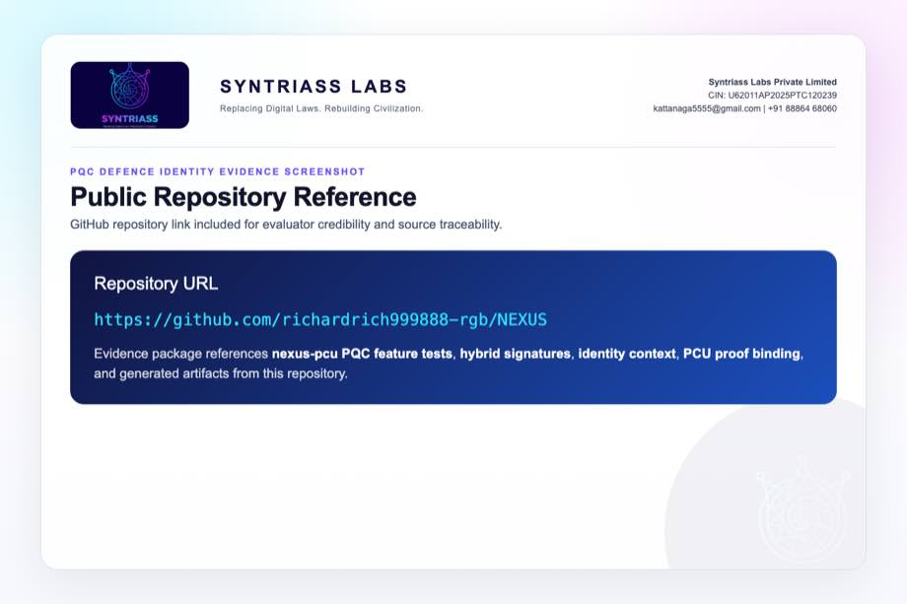
GitHub repository reference for PQC Defence Identity

Evidence Page 6 - Fresh Test Output
Purpose: show that the feature-gated nexus-pcu PQC tests were run locally before proposal packaging.
Status: test output screenshot embedded.
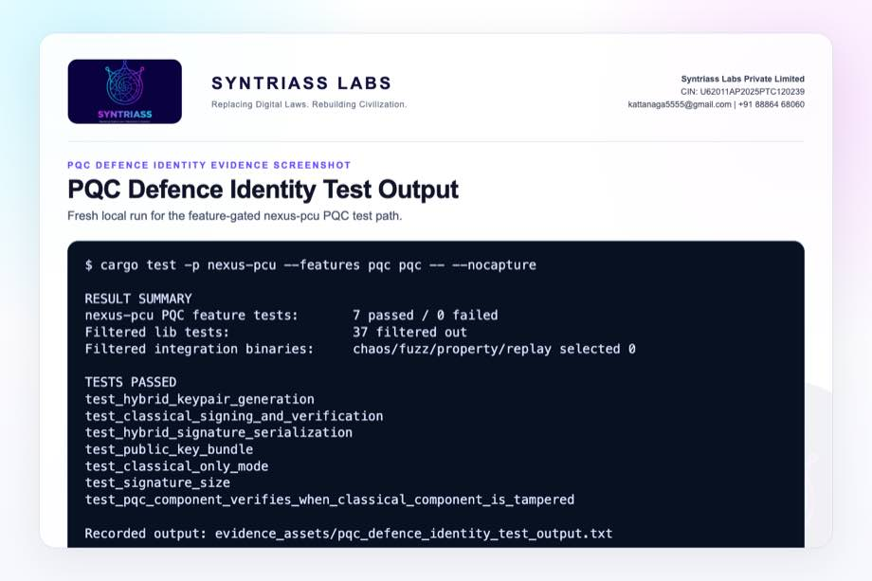
PQC Defence Identity test output screenshot

Evidence Page 7 - PQC Feature Gate
Evidence source: nexus-pcu/Cargo.toml
Purpose: show optional fips203 and fips204 dependencies and the pqc feature gate.
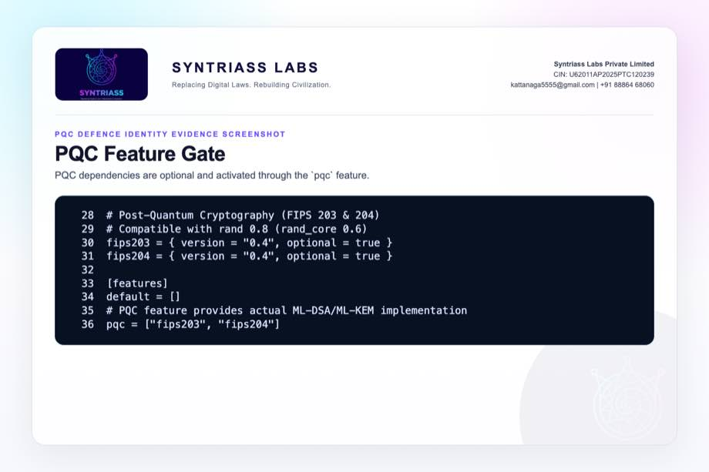
PQC feature gate screenshot

Evidence Page 8 - Public PCU Exports
Evidence source: nexus-pcu/src/lib.rs
Purpose: show exported HybridSignature, HybridKeyPair, PublicKeyBundle, IdentityContext, and ExecutionProof primitives.
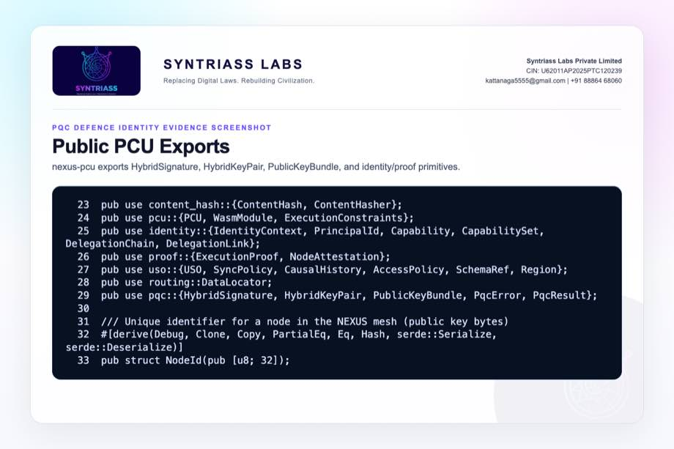
Public PCU exports screenshot

Evidence Page 9 - Hybrid Signature Structure
Evidence source: nexus-pcu/src/pqc.rs
Purpose: show Ed25519, optional ML-DSA, and version fields in the signature container.
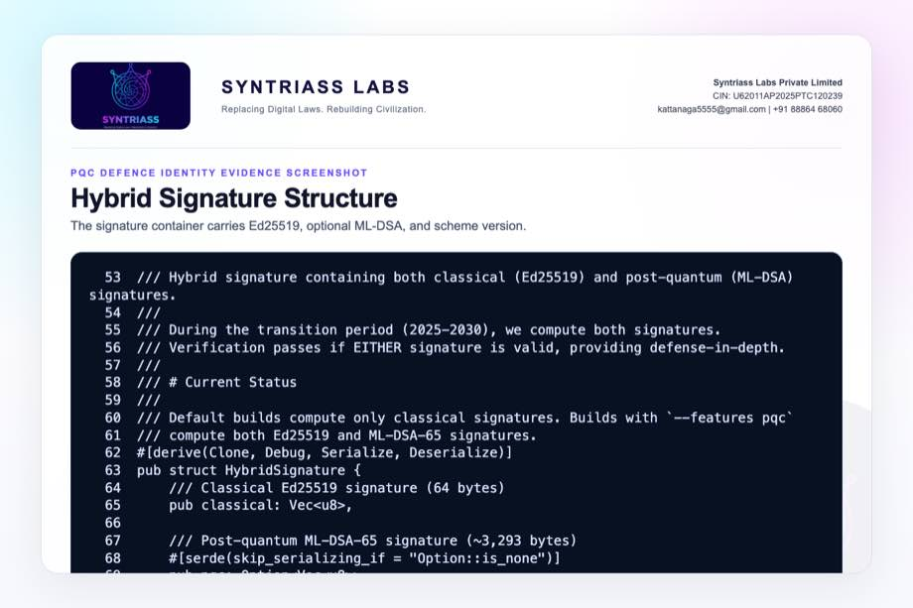
Hybrid signature structure screenshot

Evidence Page 10 - Classical and Hybrid Constructors
Evidence source: nexus-pcu/src/pqc.rs
Purpose: show classical-only and hybrid signature constructors plus helper methods.
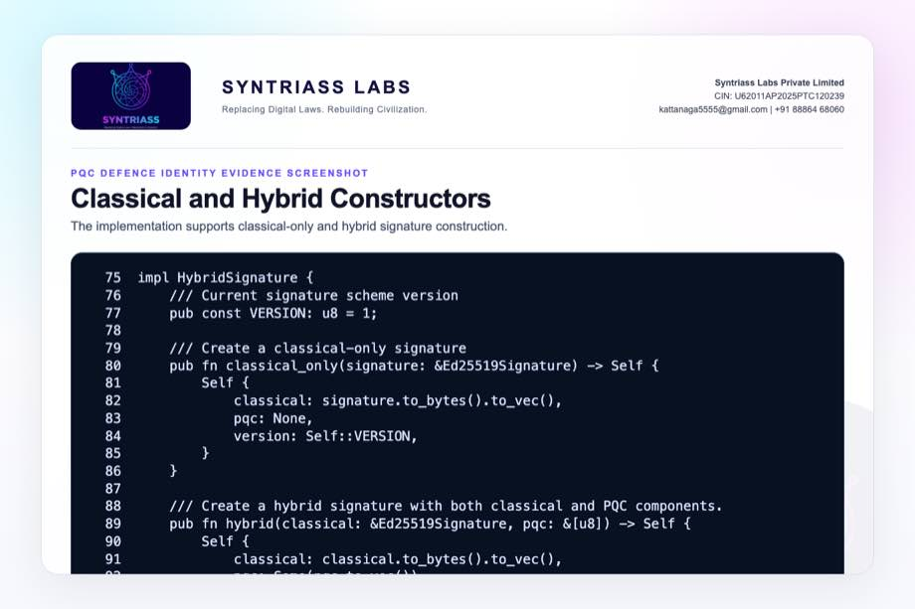
Signature constructors screenshot

Evidence Page 11 - Classical Signature Verification
Evidence source: nexus-pcu/src/pqc.rs
Purpose: show Ed25519 length check, signature reconstruction, and verification.
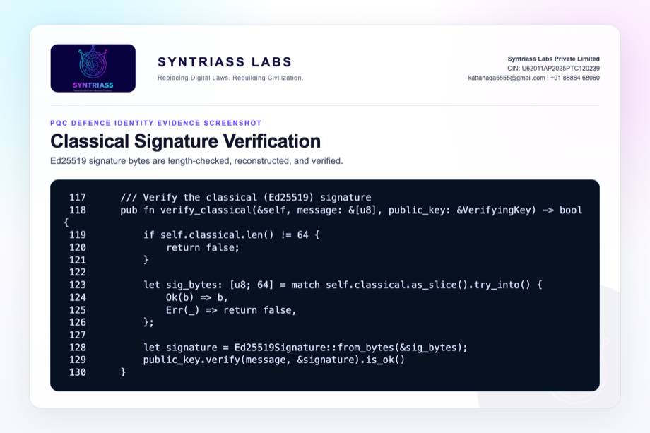
Classical verification screenshot

Evidence Page 12 - ML-DSA Verification Path
Evidence source: nexus-pcu/src/pqc.rs
Purpose: show feature-gated ML-DSA public key and signature verification path.
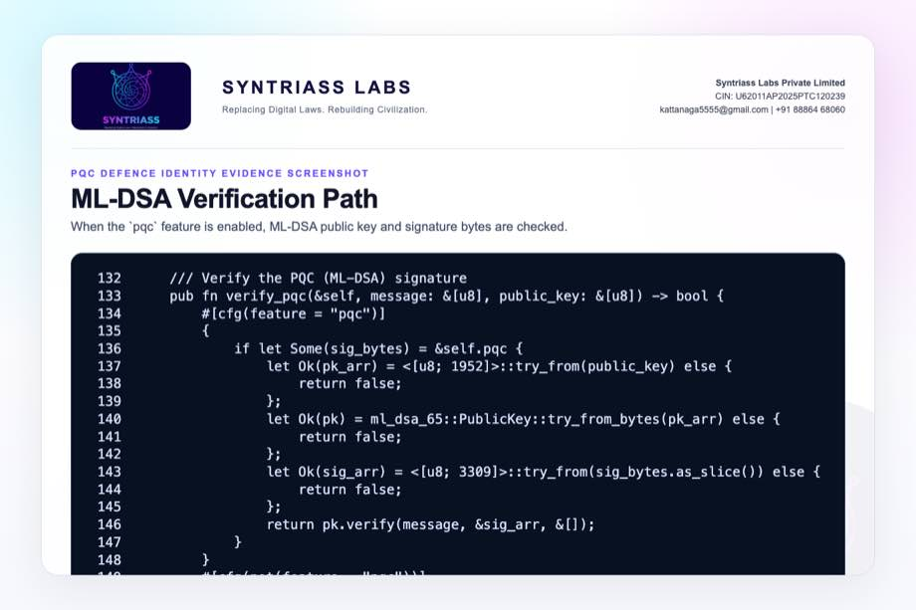
PQC verification screenshot

Evidence Page 13 - Hybrid Verification Policy
Evidence source: nexus-pcu/src/pqc.rs
Purpose: show combined classical/PQC verification policy in the transition implementation.
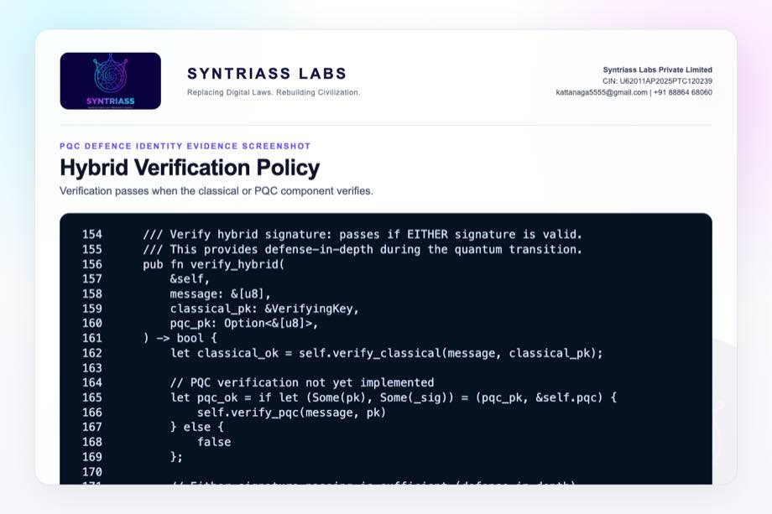
Hybrid verification screenshot

Evidence Page 14 - Hybrid Keypair Structure
Evidence source: nexus-pcu/src/pqc.rs
Purpose: show Ed25519 plus feature-gated ML-DSA key material.
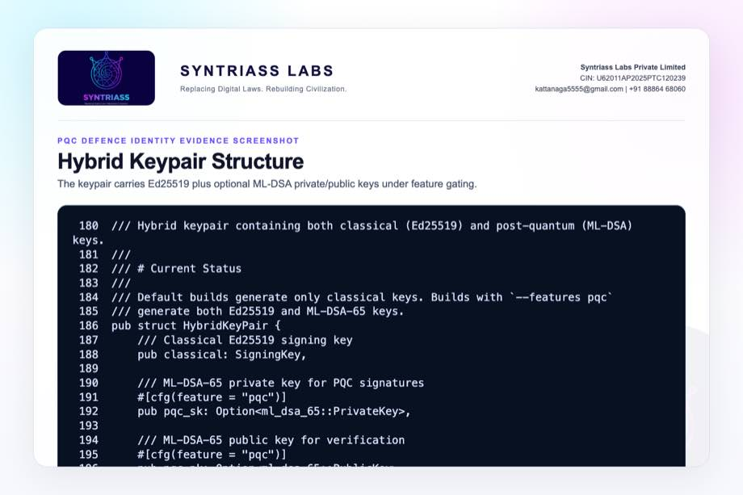
Hybrid keypair structure screenshot

Evidence Page 15 - Key Generation
Evidence source: nexus-pcu/src/pqc.rs
Purpose: show Ed25519 generation and ML-DSA-65 generation when feature is enabled.
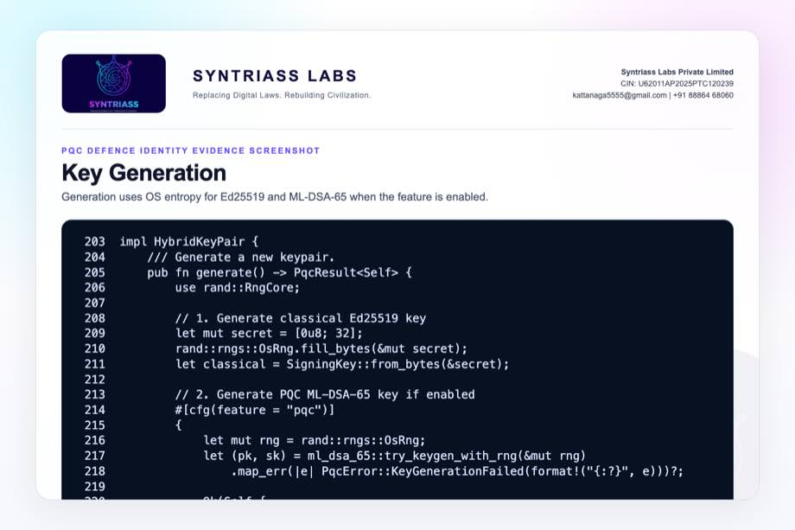
Key generation screenshot

Evidence Page 16 - Signing Path
Evidence source: nexus-pcu/src/pqc.rs
Purpose: show Ed25519 signing plus optional ML-DSA signing.
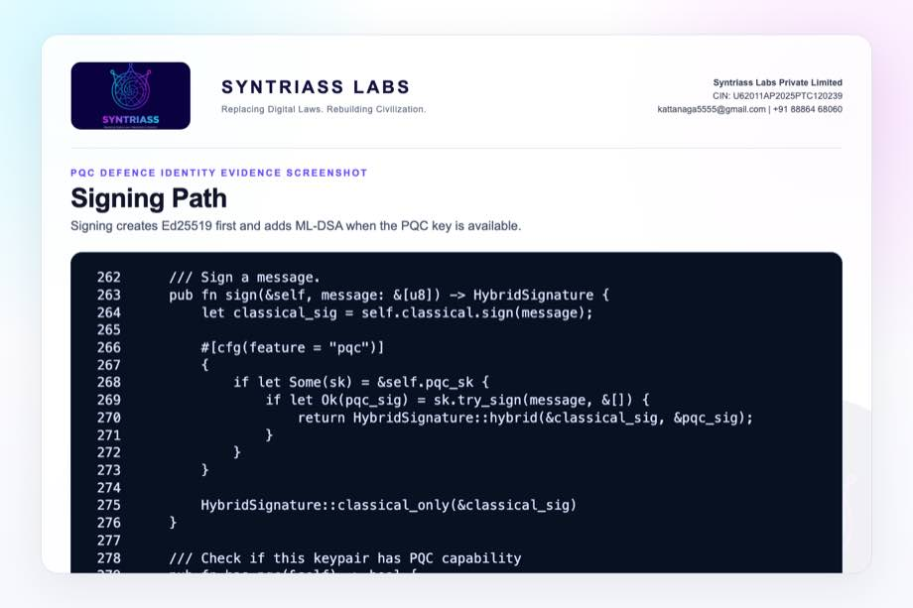
Signing path screenshot

Evidence Page 17 - Public Key Bundle
Evidence source: nexus-pcu/src/pqc.rs
Purpose: show classical and optional PQC key bundle used by verifiers.
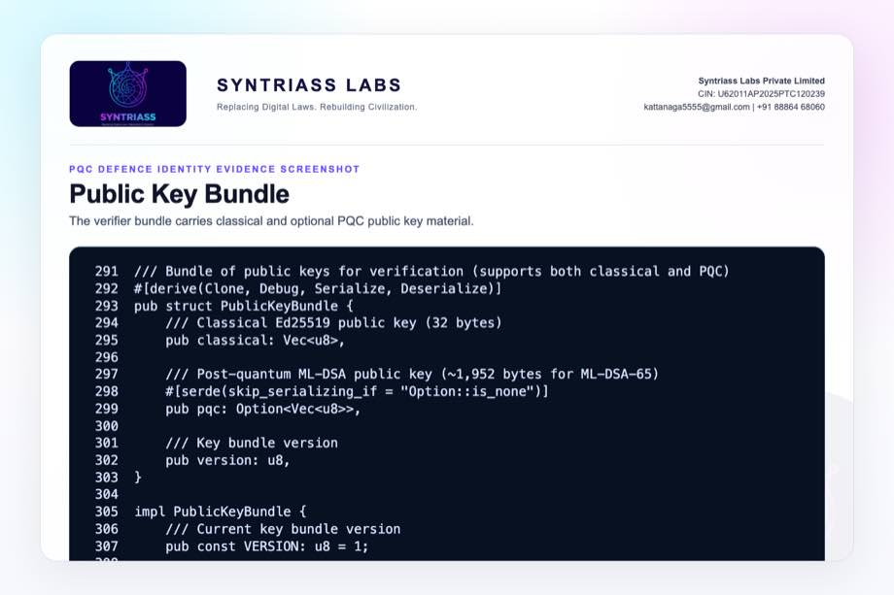
Public key bundle screenshot

Evidence Page 18 - Keypair and Classical Verification Tests
Evidence source: nexus-pcu/src/pqc.rs
Purpose: show tests for keypair generation and classical signature verification.
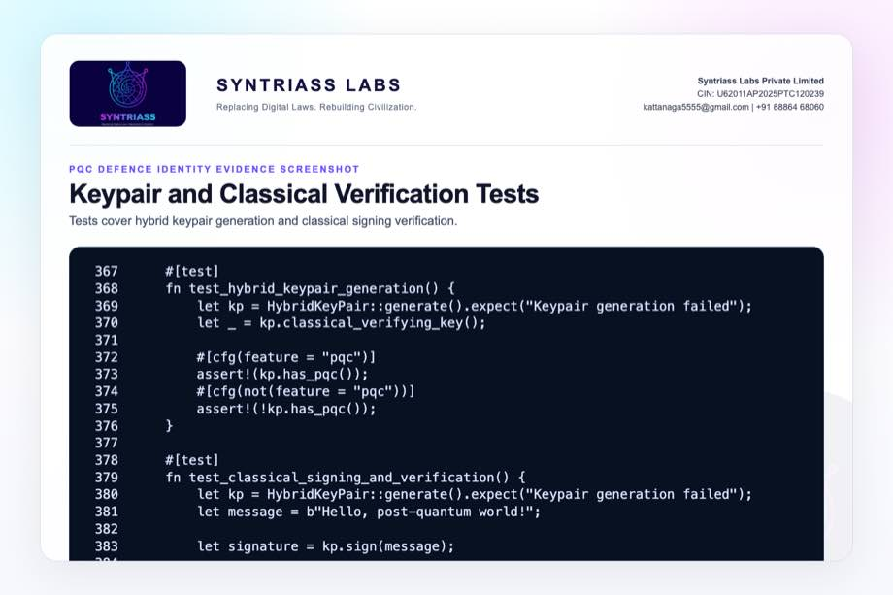
Keypair and classical tests screenshot

Evidence Page 19 - Serialization and Bundle Tests
Evidence source: nexus-pcu/src/pqc.rs
Purpose: show tests for signature serialization and public-key bundle verification.
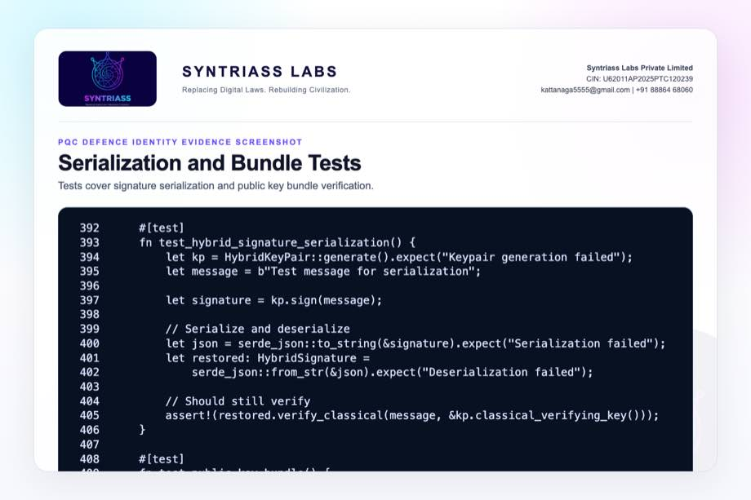
Serialization and bundle tests screenshot

Evidence Page 20 - Classical-Only and Size Tests
Evidence source: nexus-pcu/src/pqc.rs
Purpose: show tests for classical-only behavior and feature-gated signature size.
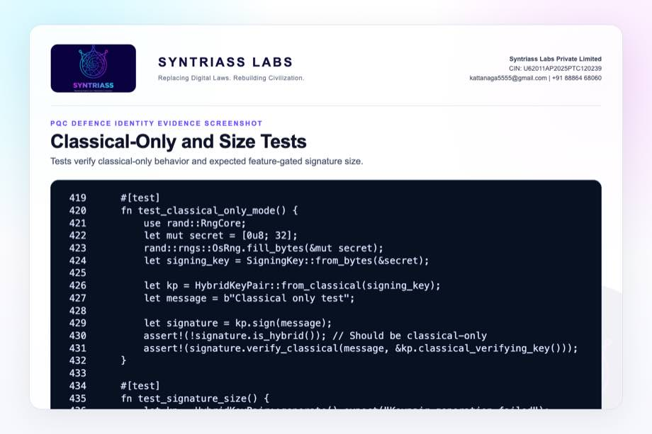
Classical only and size tests screenshot

Evidence Page 21 - PQC Tamper Fallback Test
Evidence source: nexus-pcu/src/pqc.rs
Purpose: show feature-gated test where PQC verification remains valid after classical signature tampering, then fails when both components are invalid.
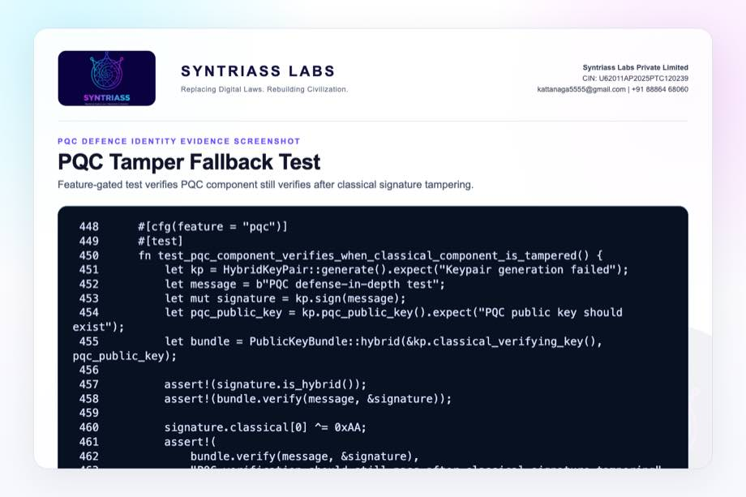
PQC tamper fallback test screenshot

Evidence Page 22 - Principal and Capability Model
Evidence source: nexus-pcu/src/identity.rs
Purpose: show identity primitives for principal IDs, capabilities, constraints, and permission checks.
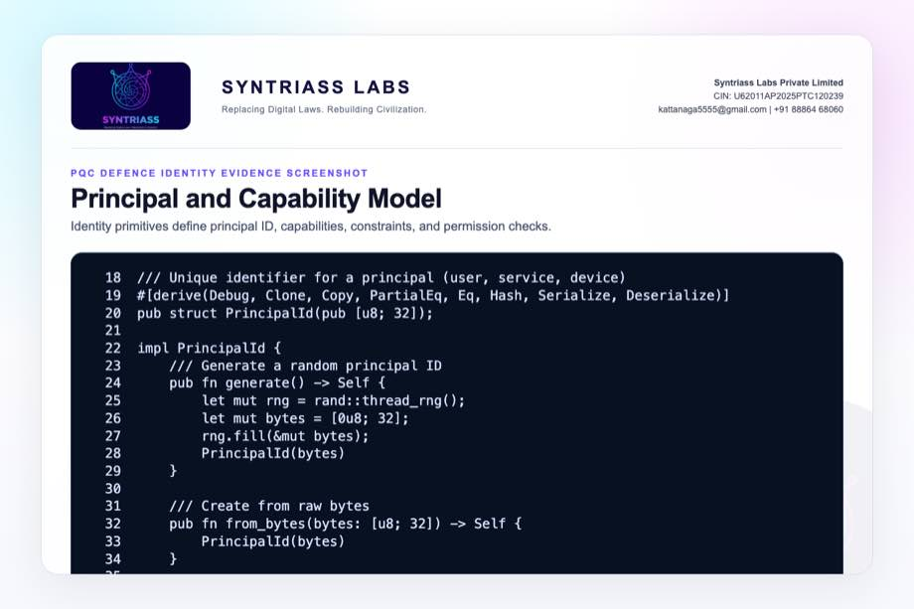
Principal and capabilities screenshot

Evidence Page 23 - Delegation Chain Verification
Evidence source: nexus-pcu/src/identity.rs
Purpose: show expiry, continuity, signature verification, and canonical signing data for delegation links.
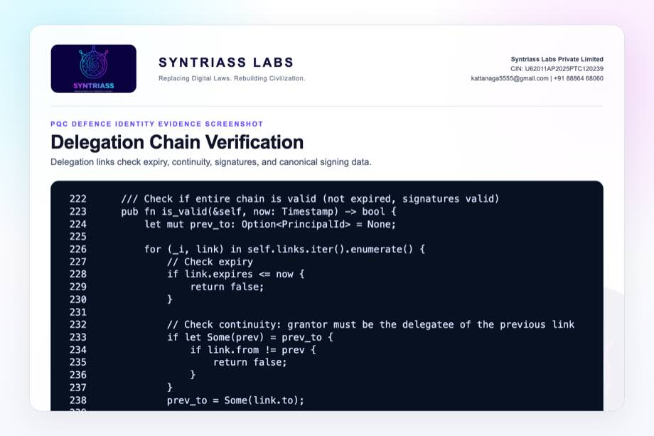
Delegation chain screenshot

Evidence Page 24 - Embedded Identity Context
Evidence source: nexus-pcu/src/identity.rs
Purpose: show PCU identity context with principal, capabilities, delegation, expiry, signature, and permission check.
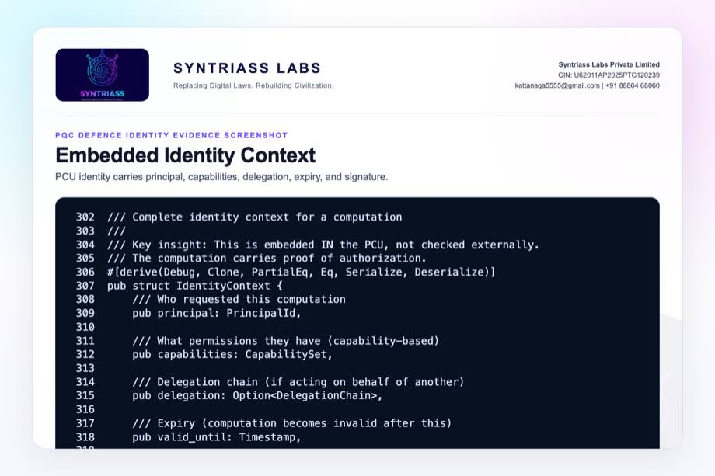
Identity context screenshot

Evidence Page 25 - PCU Identity Binding
Evidence source: nexus-pcu/src/pcu.rs
Purpose: show PCU structure embedding identity context and execution constraints.
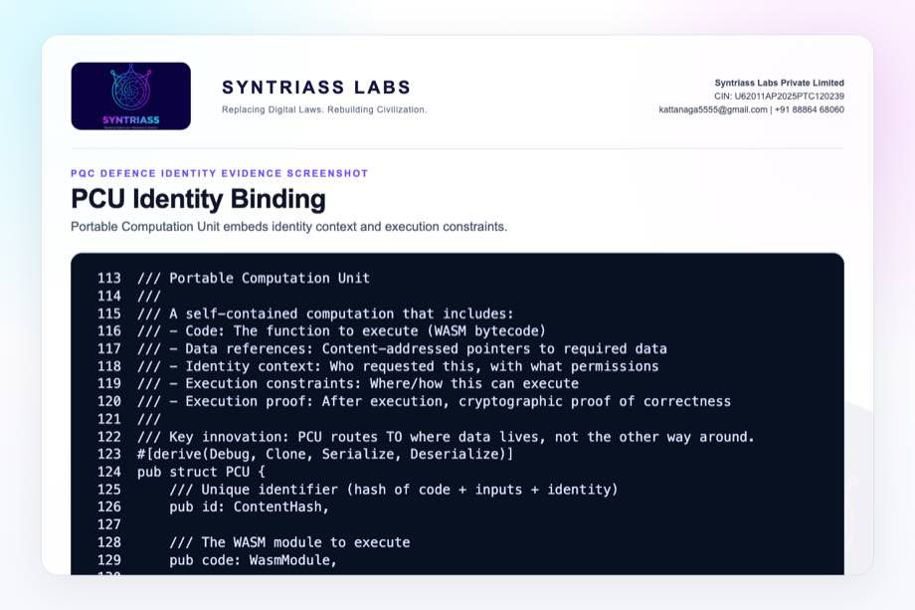
PCU identity binding screenshot

Evidence Page 26 - Execution Attestation
Evidence source: nexus-pcu/src/proof.rs
Purpose: show node attestation signing and verification over proof content.
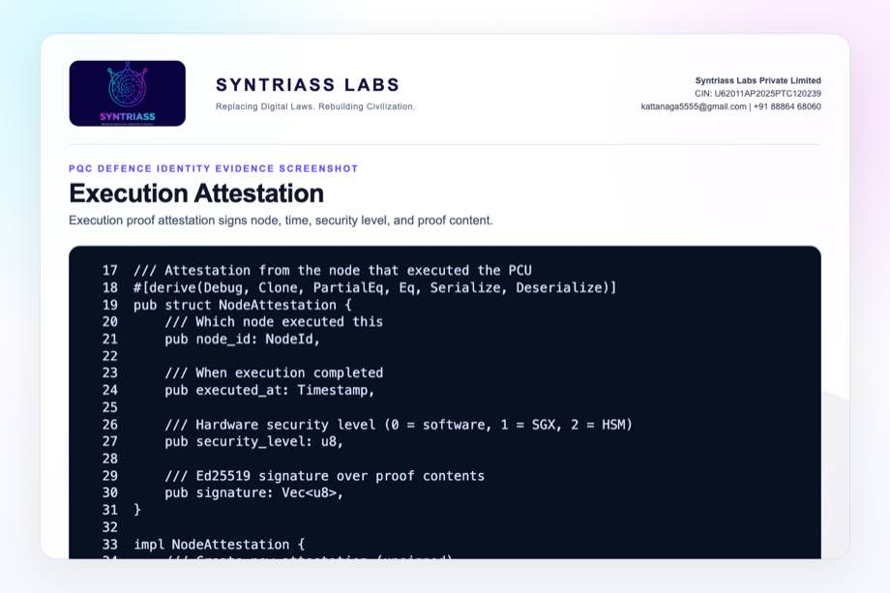
Execution attestation screenshot

Evidence Page 27 - Classical Crypto Utilities
Evidence source: nexus-pcu/src/crypto.rs
Purpose: show current Ed25519 key generation, signing, and verification utility path.
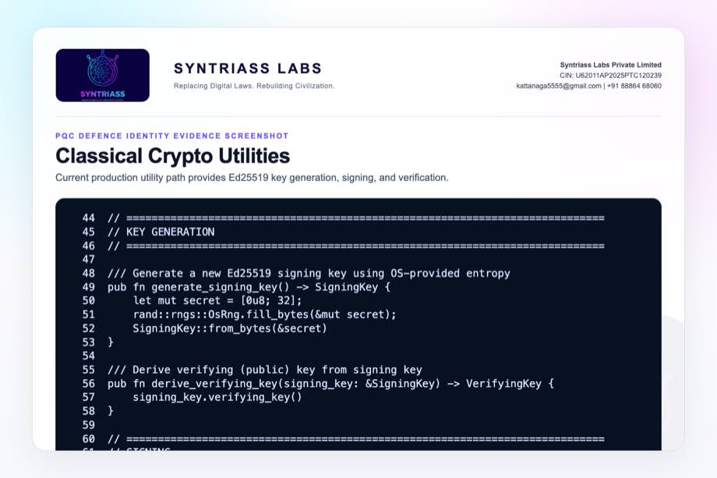
Classical crypto utilities screenshot

Evidence Page 28 - Reviewer Repository Map
Purpose: give panel reviewers a direct navigation map.
Review Area | Path
Final proposal package | docs/idex-open-challenge-2026/06-pqc-defence-identity/final_4_documents/
Screenshot assets | docs/idex-open-challenge-2026/06-pqc-defence-identity/final_4_documents/evidence_assets/
PQC module | nexus-pcu/src/pqc.rs
Cargo feature gate | nexus-pcu/Cargo.toml
Identity context | nexus-pcu/src/identity.rs
PCU structure | nexus-pcu/src/pcu.rs
Execution proof | nexus-pcu/src/proof.rs
Classical crypto utilities | nexus-pcu/src/crypto.rs

Evidence Page 29 - Claim-to-File Location Map
Proposal Claim | Source Evidence
Hybrid signature structure exists | nexus-pcu/src/pqc.rs, HybridSignature
PQC feature gate exists | nexus-pcu/Cargo.toml, [features] pqc
Hybrid keypair generation exists | HybridKeyPair::generate()
ML-DSA signing path exists under feature | HybridKeyPair::sign()
Classical verification exists | HybridSignature::verify_classical()
ML-DSA verification path exists under feature | HybridSignature::verify_pqc()
Public-key bundle exists | PublicKeyBundle
PCU identity binding exists | PCU.identity and IdentityContext
Execution attestation exists | NodeAttestation and ExecutionProof
PQC tamper behavior is tested | test_pqc_component_verifies_when_classical_component_is_tampered()

Evidence Page 30 - Test and Command Locations
Test Area | Command / File
PQC feature tests | cargo test -p nexus-pcu --features pqc pqc -- --nocapture
Test implementation | nexus-pcu/src/pqc.rs, test module
Combined output artifact | evidence_assets/pqc_defence_identity_test_output.txt
Evidence screenshot generator | generate_pqc_defence_identity_evidence_screenshots.mjs
PDF builder | build_syntriass_letterhead_problem6.mjs

Evidence Page 31 - Generated Artifact Locations
Artifact Type | Location
Annexure 1 PDF | 01_SYNTRIASS_PQC_Defence_Identity_Annexure_1_Applicant_Details_and_Solution_Summary.pdf
Annexure 2 PDF | 02_SYNTRIASS_PQC_Defence_Identity_Annexure_2_Technical_Architecture.pdf
Annexure 3 PDF | 03_SYNTRIASS_PQC_Defence_Identity_Annexure_3_Advantages_and_Competencies.pdf
Annexure 4 PDF | 04_SYNTRIASS_PQC_Defence_Identity_Annexure_4_Supporting_Evidence_and_Screenshots.pdf
DOCX files | Same directory, matching .docx names.
Rendered HTML | final_4_documents/html/
Evidence screenshots | final_4_documents/evidence_assets/*.jpg
Test output | final_4_documents/evidence_assets/pqc_defence_identity_test_output.txt

Evidence Page 32 - Screenshot Artifact Index
Screenshot | File
GitHub repository | evidence_assets/01_github_repository.jpg
Fresh test output | evidence_assets/02_test_output.jpg
Feature gate and exports | evidence_assets/03_feature_gate.jpg, 04_lib_exports.jpg
Hybrid signature screenshots | evidence_assets/05_hybrid_signature_struct.jpg through 09_hybrid_verification.jpg
Hybrid keypair screenshots | evidence_assets/10_hybrid_keypair_struct.jpg through 13_public_key_bundle.jpg
PQC tests | evidence_assets/14_keypair_classical_tests.jpg through 17_pqc_tamper_fallback_test.jpg
Identity/proof integration | evidence_assets/18_principal_capabilities.jpg through 23_crypto_utilities.jpg

Evidence Page 33 - Defence Problem to Evidence Map
Defence Problem | PQC Defence Identity Control | Evidence
Classical-only identity risk | Hybrid signature envelope | Evidence pages 9-13.
Migration disruption | Public-key bundle with classical and optional PQC material | Evidence page 17.
Signature tamper scenario | Feature-gated tamper fallback test | Evidence page 21.
Identity/proof binding | PCU IdentityContext and NodeAttestation | Evidence pages 22-26.
Current compatibility | Ed25519 crypto utilities and classical verification tests | Evidence pages 11, 18, 27.
Readiness transparency | Feature gate, test output, and caveats | Evidence pages 6-7, 35-37.

Evidence Page 34 - Prototype Work Package Locations
Work Package | Existing Starting Point
Hybrid signature envelope | HybridSignature in nexus-pcu/src/pqc.rs
Hybrid keypair | HybridKeyPair in nexus-pcu/src/pqc.rs
Public-key bundle | PublicKeyBundle in nexus-pcu/src/pqc.rs
Feature-gated ML-DSA | verify_pqc() and HybridKeyPair::generate()
Identity integration | IdentityContext in nexus-pcu/src/identity.rs
Proof integration | ExecutionProof and NodeAttestation in nexus-pcu/src/proof.rs
Current classical path | nexus-pcu/src/crypto.rs

Evidence Page 35 - Panel Review Checklist
Reviewer Question | Where To Check
Were PQC tests actually run? | Evidence page 6 and output file pqc_defence_identity_test_output.txt.
Is PQC active by default? | No. It is feature-gated through --features pqc; see pages 7 and 36.
Is this certified cryptography? | No. It is prototype evidence and transition planning.
Does the code support hybrid key material? | Evidence pages 9-17.
Does it bind identity to PCU/proof? | Evidence pages 22-26.
Is the GitHub repository identified? | Evidence page 5 and repository coordinate page 37.
Are artifact locations included? | Evidence pages 28-32.

Evidence Page 36 - Readiness Statement and Caveats
Area | Position
Software subsystem readiness | Current evidence supports software subsystem TRL 3-4.
PQC feature tests | nexus-pcu reports 7 passed and 0 failed under --features pqc.
Default build | Classical-only by default for compatibility and build speed.
PQC enforcement | Not yet network-wide or packet-wide by default.
Cryptographic accreditation | Not claimed. Requires evaluator-approved profile and certification path.
Key lifecycle | Provisioning, revocation, rotation, and compromise response remain iDEX work.
HSM/secure element | Not integrated in current evidence.
Operational use | Defence key authority, policy approval, and deployment hardening remain required.

Evidence Page 37 - Declaration and Repository Coordinates
Declaration:
PQC Defence Identity is submitted as a software-subsystem prototype for hybrid classical and post-quantum defence identity evaluation.
Repository coordinates:
- Public repository: https://github.com/richardrich999888-rgb/NEXUS
- Proposal folder: docs/idex-open-challenge-2026/06-pqc-defence-identity/
- Final documents: docs/idex-open-challenge-2026/06-pqc-defence-identity/final_4_documents/
- Evidence assets: docs/idex-open-challenge-2026/06-pqc-defence-identity/final_4_documents/evidence_assets/
- Test output: docs/idex-open-challenge-2026/06-pqc-defence-identity/final_4_documents/evidence_assets/pqc_defence_identity_test_output.txt
- PQC source: nexus-pcu/src/pqc.rs
- Identity source: nexus-pcu/src/identity.rs
- Proof source: nexus-pcu/src/proof.rs
Submission caveat:
- The package is prepared for prototype review and iDEX-funded validation planning.
- No certified cryptographic module status, operational key authority approval, HSM-backed deployment, secure element provisioning, or network-wide PQC enforcement is claimed.
- Cryptographic profile approval, lifecycle policy, hardware key protection, audit retention, and field integration remain required for operational use.

