IDEX OPEN CHALLENGE SUBMISSION

Annexure-4
Supporting evidence, screenshots, repository locations, and artifact map
CIN | PAN | TAN
U62011AP2025PTC120239 | ABQCS7152R | VPNS31351F

Applicant Entity | Contact
Syntriass Labs Private Limited | kattanaga5555@gmail.com
12-50, SLV Market, 12 Ward, Dharmavaram, Ananthapur - 515671, Andhra Pradesh, India | +91 88864 68060

Supporting Evidence and Screenshots

Company Identification Details
Field | Details
Legal Entity Name | Syntriass Labs Private Limited
CIN | U62011AP2025PTC120239
PAN | ABQCS7152R
TAN | VPNS31351F
Registered Office | 12-50, SLV Market, 12 Ward, Dharmavaram, Ananthapur - 515671, Andhra Pradesh, India
Contact Email | kattanaga5555@gmail.com
Contact Phone | +91 88864 68060
GitHub Repository | https://github.com/richardrich999888-rgb/NEXUS
Submission Date | 17 May 2026

1. Applicant Resume Format
Applicant: K. Naga Sri Ganesh
Company: Syntriass Labs Private Limited
Role: Founder / Inventor
Relevant focus: governed autonomy, distributed state synchronization, causal execution, CRDT merge systems, proof-carrying computation, compression-aware transfer, and defence-oriented audit evidence.

2. Prototype Evidence List
Evidence Item | Repository / Artifact Location
CAUSALUX version vector | causalux/src/version_vector.rs
CAUSALUX causal DAG | causalux/src/dag.rs
CAUSALUX CRDT layer | causalux/src/crdt.rs
Hierarchical sync | causalux/src/sync.rs
Snapshot manager | causalux/src/snapshot.rs
Sovereign envelope | causalux/src/envelope.rs
NEXUS sync engine | nexus-sync/src/sync_engine.rs
CRDT-backed USO | nexus-sync/src/crdt_uso.rs
PCU USO primitive | nexus-pcu/src/uso.rs
Compression path | nexus-compress/src/pcu_compress.rs, nexus-compress/src/uso_compress.rs
Clean selected test output | docs/idex-open-challenge-2026/07-causalux-contested-sync/final_4_documents/evidence_assets/causalux_contested_sync_clean_test_output.txt
Full-run caveat output | docs/idex-open-challenge-2026/07-causalux-contested-sync/final_4_documents/evidence_assets/causalux_contested_sync_test_output.txt
Evidence screenshots | docs/idex-open-challenge-2026/07-causalux-contested-sync/final_4_documents/evidence_assets/
Final documents | docs/idex-open-challenge-2026/07-causalux-contested-sync/final_4_documents/

3. Validation Scope
Current validation is software-subsystem validation. The evidence supports selected passing tests for CAUSALUX, nexus-sync library functions, PCU USO selected behavior, and compression. It does not claim physical-radio validation, EW/jamming validation, operational deployment, or fully modernized end-to-end contested-sync validation.

4. Test Commands and Recorded Results
Primary selected commands:
cargo test -p causalux-v2 --lib --tests -- --nocapture
cargo test -p nexus-sync --lib -- --nocapture
cargo test -p nexus-pcu uso -- --nocapture
cargo test -p nexus-compress -- --nocapture
Fresh selected local results:
- CAUSALUX library and integration: 59 library tests passed, 1 integration test passed.
- NEXUS sync library: 10 tests passed.
- PCU USO selected path: 10 library tests, 2 chaos tests, and 3 fuzz tests passed.
- Compression: 5 tests passed.
- Combined selected executable evidence: 90 passed checks, 0 failed in selected commands.
- Run date: 17 May 2026.
Documented caveats from broader run:
- Full CAUSALUX doctest run has one stale documentation example failure.
- Full nexus-sync integration target has stale integration_e2e.rs compile failures.
- These are listed as iDEX hardening tasks rather than hidden from the proposal.

Evidence Page 5 - Public Repository Reference
Purpose: give panel reviewers a direct path to inspect the source repository.
Status: GitHub repository reference embedded.
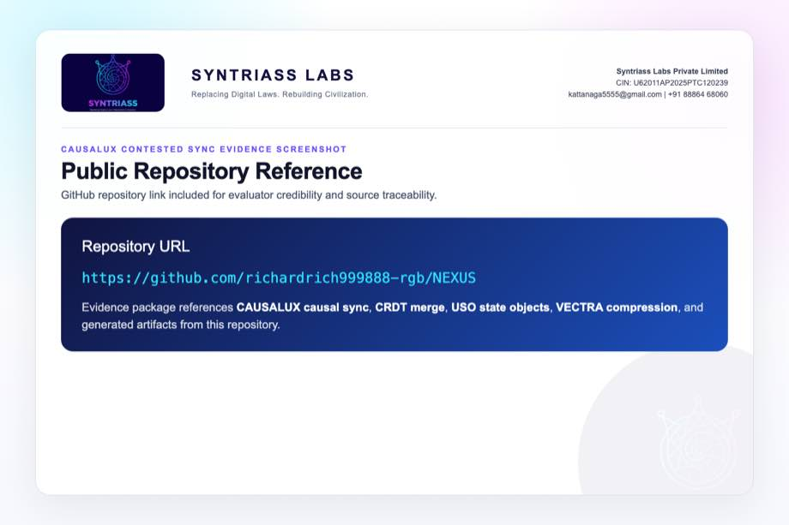
GitHub repository reference for CAUSALUX Contested Sync

Evidence Page 6 - Selected Test Output
Purpose: show the selected executable evidence run conducted before proposal packaging.
Status: clean selected test output screenshot embedded.
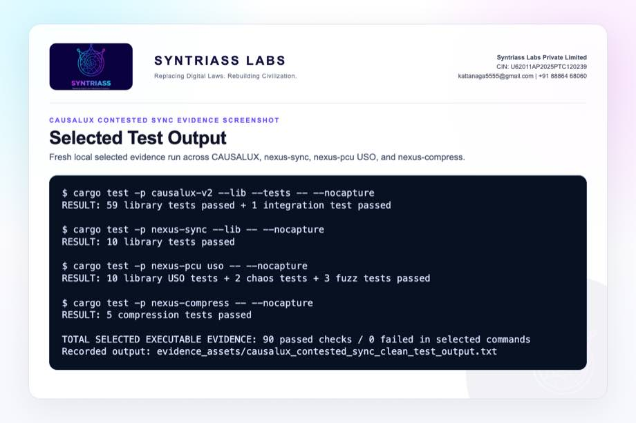
CAUSALUX Contested Sync selected test output screenshot

Evidence Page 7 - Full-Run Caveats
Purpose: show broader test caveats transparently, including stale doctest and stale E2E integration drift.
Status: caveat screenshot embedded.
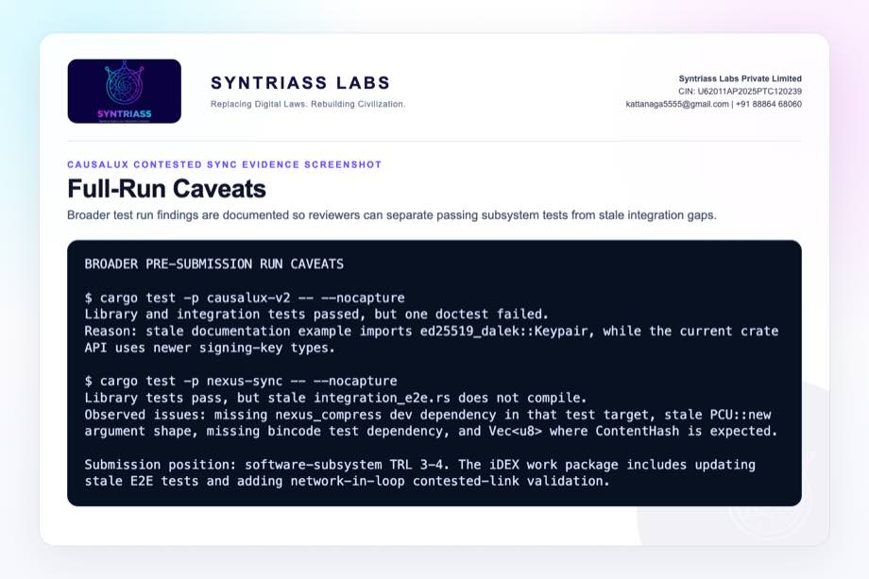
CAUSALUX Contested Sync full-run caveat screenshot

Evidence Page 8 - Version Vector Causality
Evidence source: causalux/src/version_vector.rs
Purpose: show version-vector increment, happens-before, conflict detection, merge, and tests.
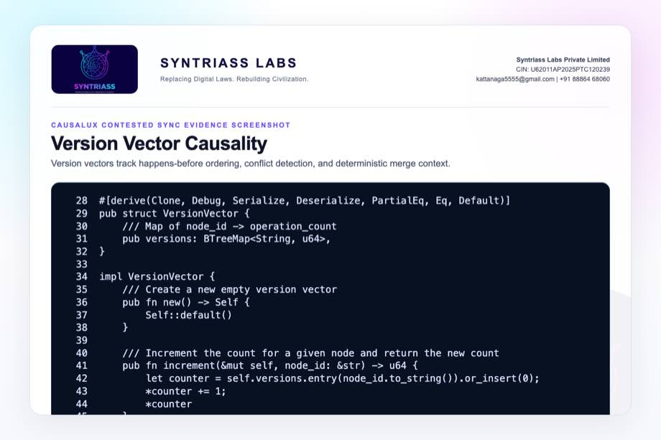
Version vector causality screenshot

Evidence Page 9 - Hierarchical Sync Protocol
Evidence source: causalux/src/sync.rs
Purpose: show sync request, response, strategy, and apply-response structures.
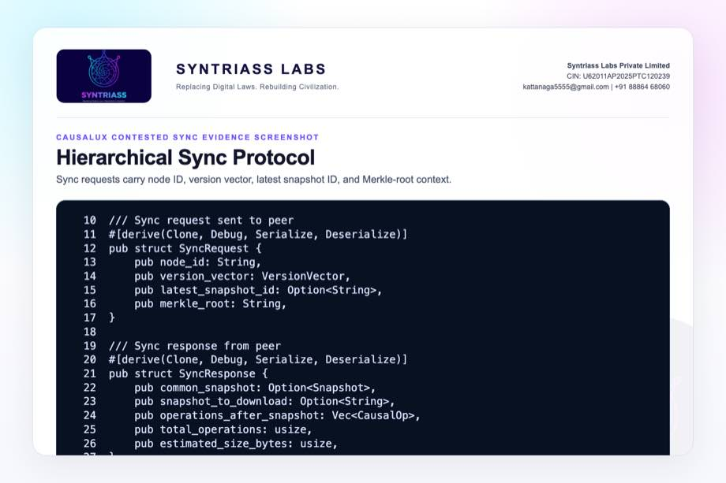
Hierarchical sync protocol screenshot

Evidence Page 10 - Adaptive Sync and Bandwidth Savings
Evidence source: causalux/src/sync.rs
Purpose: show Merkle-diff versus hierarchical selection and bandwidth-savings test.
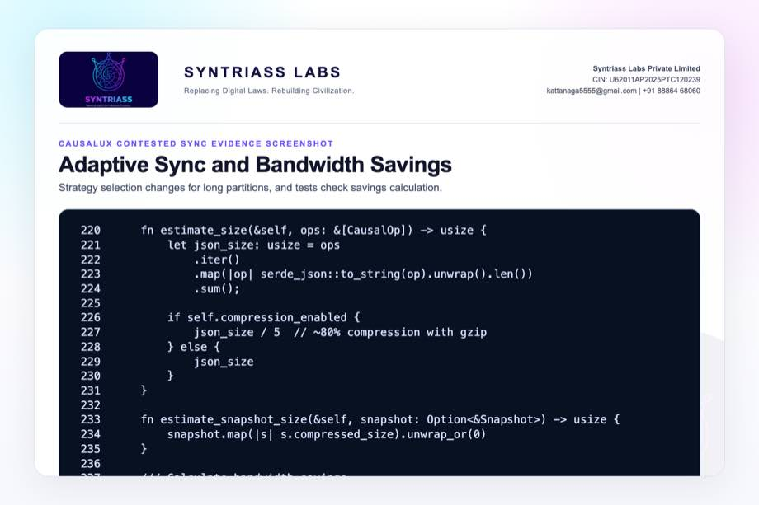
Adaptive sync and bandwidth savings screenshot

Evidence Page 11 - RGA Text CRDT
Evidence source: causalux/src/crdt.rs
Purpose: show replicated growable array text state and deterministic remote insert ordering.
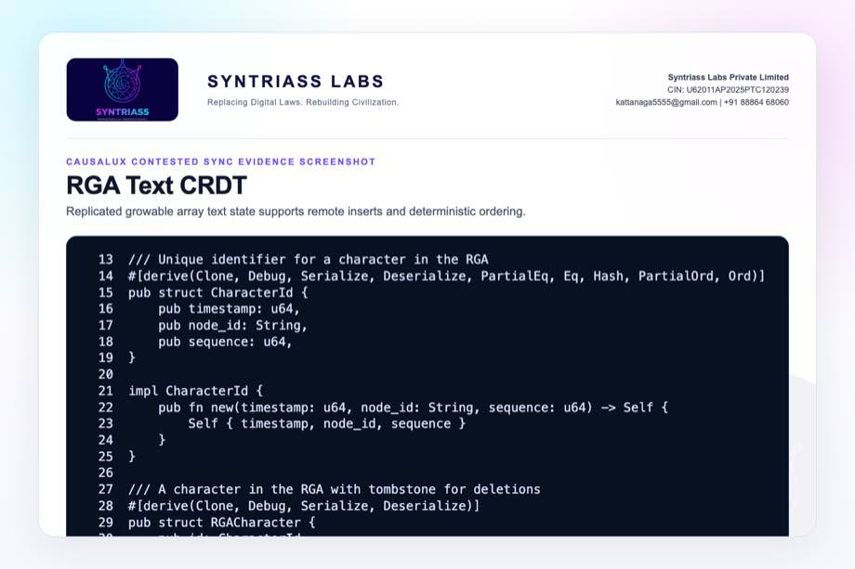
RGA text CRDT screenshot

Evidence Page 12 - Counter, Set, and Map CRDTs
Evidence source: causalux/src/crdt.rs
Purpose: show counter, positive-negative counter, observed-remove set, and last-writer map logic.
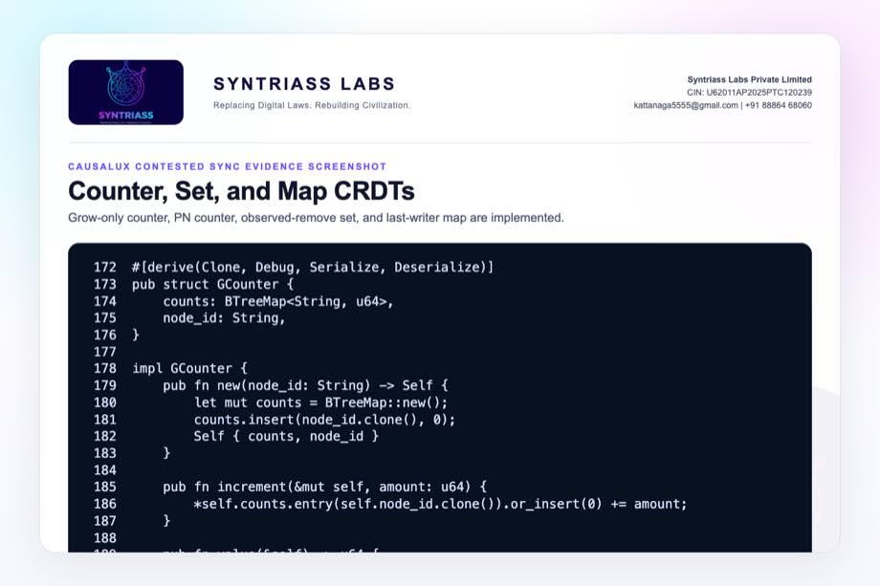
Counter set map CRDT screenshot

Evidence Page 13 - CRDT Convergence Tests
Evidence source: causalux/src/crdt.rs
Purpose: show tests for concurrent inserts, counters, observed-remove set, map merge, and document convergence.
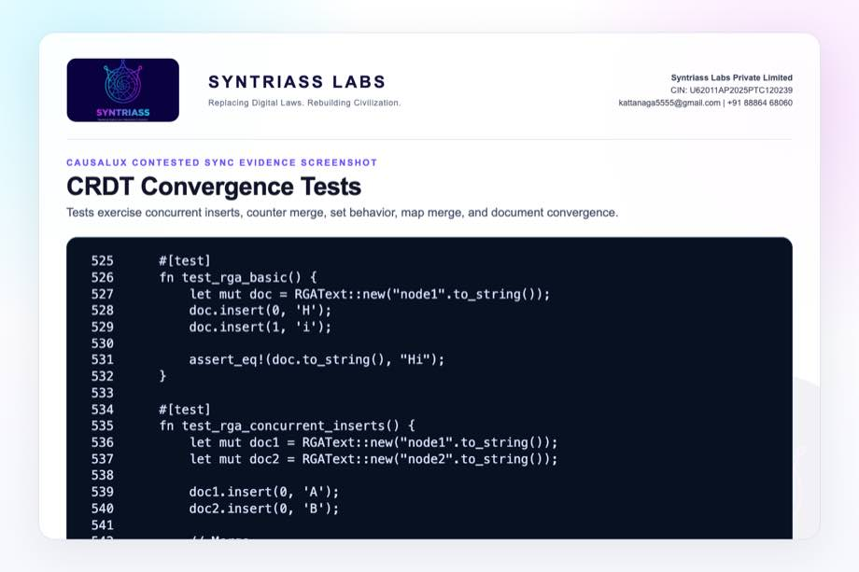
CRDT convergence tests screenshot

Evidence Page 14 - Causal DAG Insert Path
Evidence source: causalux/src/dag.rs
Purpose: show idempotence, dependency checks, conflict handling, version-vector merge, state application, and snapshot trigger.
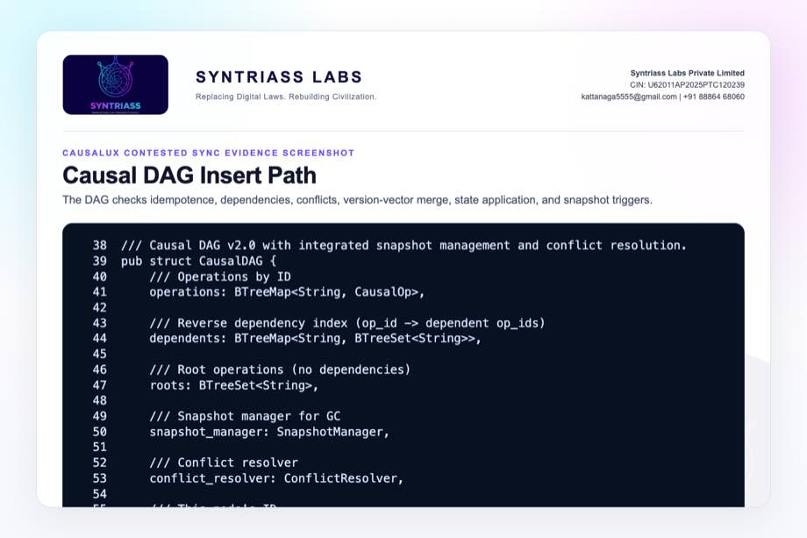
Causal DAG insert path screenshot

Evidence Page 15 - DAG Ordering and Dependency Tests
Evidence source: causalux/src/dag.rs
Purpose: show tests for DAG creation, insert, causal ordering, missing dependency, and idempotent insert behavior.
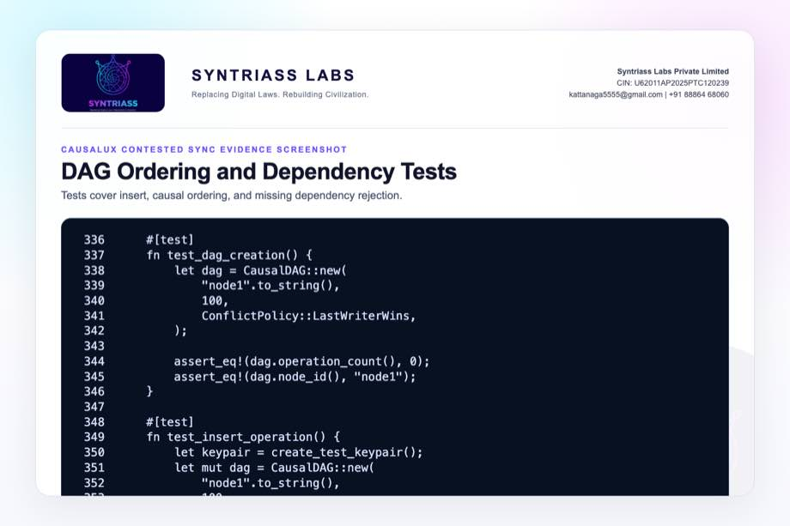
Causal DAG ordering tests screenshot

Evidence Page 16 - Runtime Disconnected Merge Tests
Evidence source: causalux/src/runtime.rs
Purpose: show software tests for document sync, collaborative editing, distributed counters, set operations, and metrics.
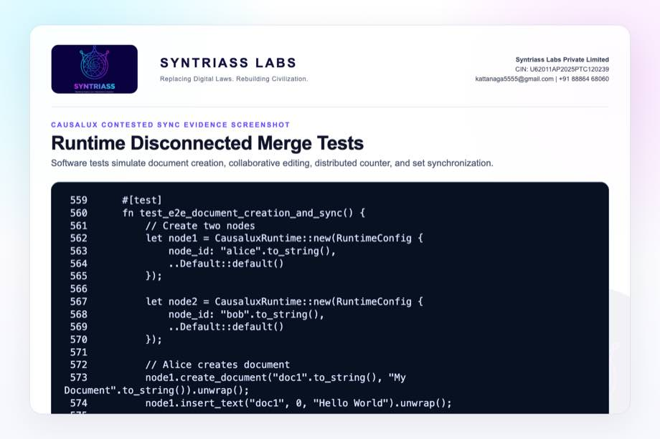
Runtime disconnected merge tests screenshot

Evidence Page 17 - Snapshots and Compression
Evidence source: causalux/src/snapshot.rs
Purpose: show snapshot ID, state, Merkle root, version vector, compressed size, common-snapshot lookup, and tests.
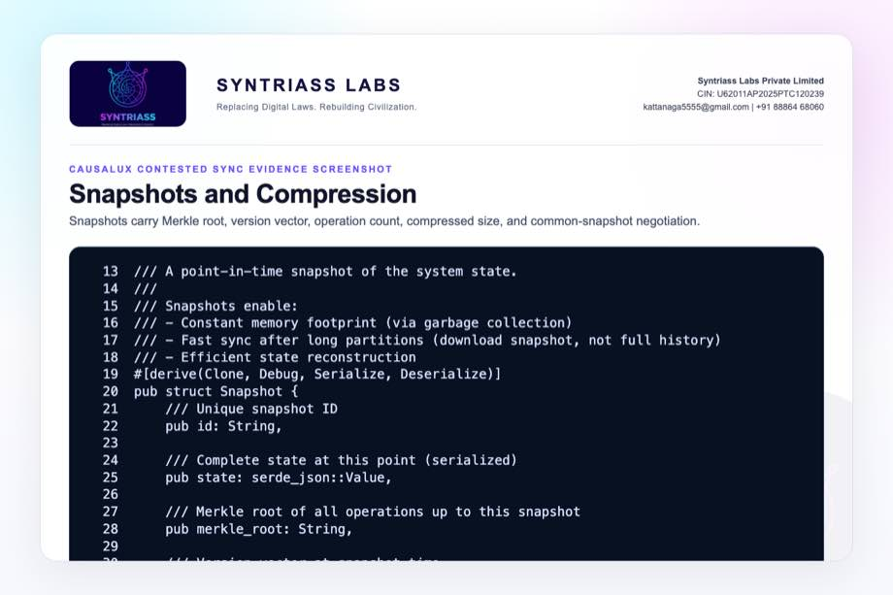
Snapshot compression screenshot

Evidence Page 18 - Encrypted Operation Envelope
Evidence source: causalux/src/envelope.rs
Purpose: show operation envelope fields, seal/unseal path, routing metadata, and authenticated decryption error path.
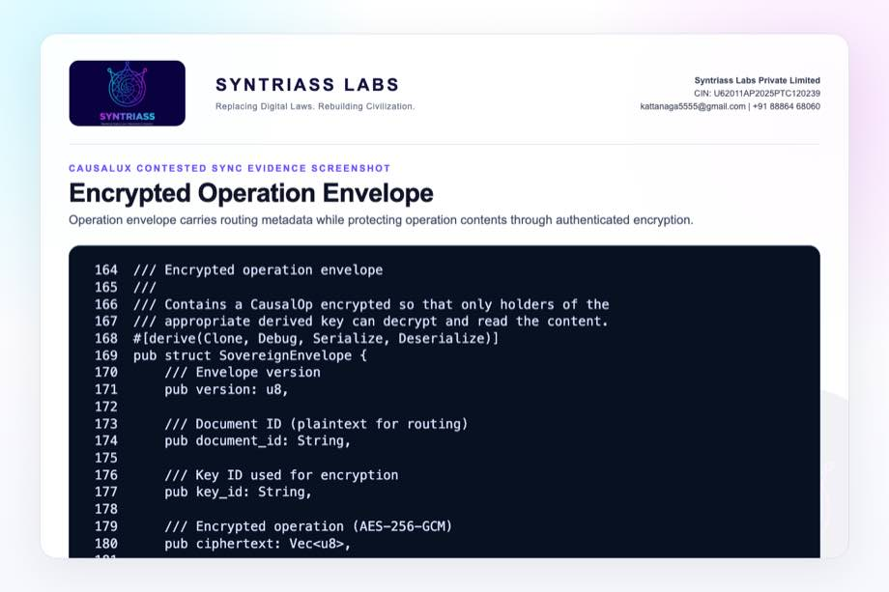
Sovereign envelope screenshot

Evidence Page 19 - Envelope Access Tests
Evidence source: causalux/src/envelope.rs
Purpose: show tests for key derivation, seal/unseal, wrong-key rejection, and key revocation.
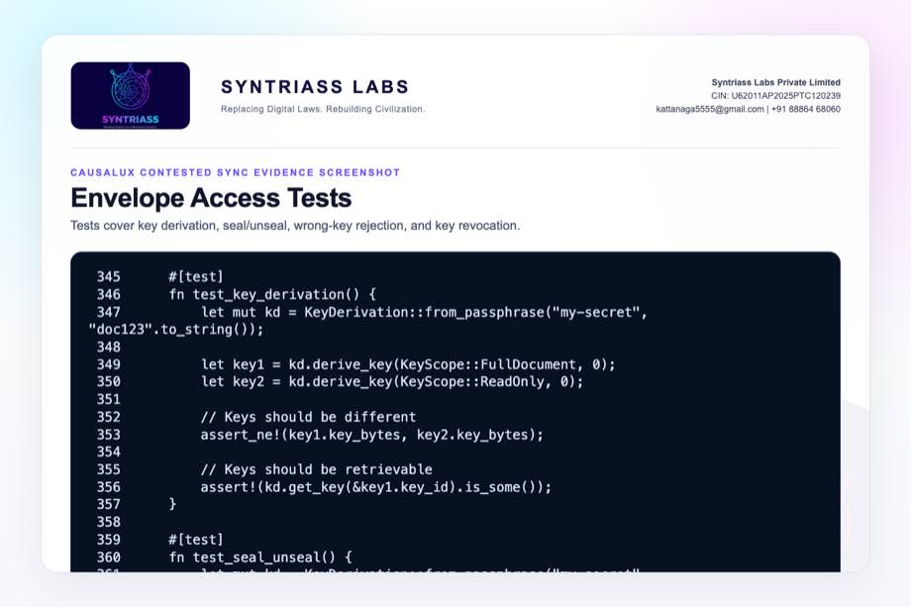
Envelope access tests screenshot

Evidence Page 20 - CRDT-Backed USO Model
Evidence source: nexus-sync/src/crdt_uso.rs
Purpose: show USO type mapping and CRDT-backed merge behavior.
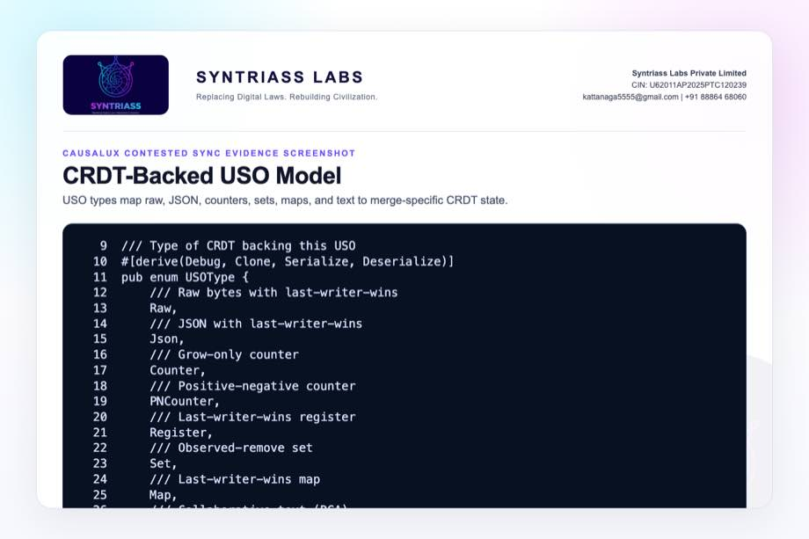
CRDT USO model screenshot

Evidence Page 21 - CRDT USO Tests
Evidence source: nexus-sync/src/crdt_uso.rs
Purpose: show tests for counter, PN counter, set, text, and counter merge.
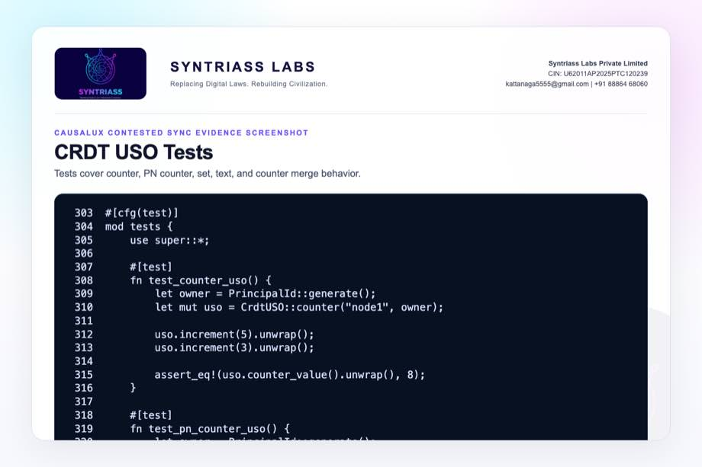
CRDT USO tests screenshot

Evidence Page 22 - NEXUS Sync Engine
Evidence source: nexus-sync/src/sync_engine.rs
Purpose: show CAUSALUX DAG wrapper, USO registry, signed operation creation, sync delta, and remote merge.
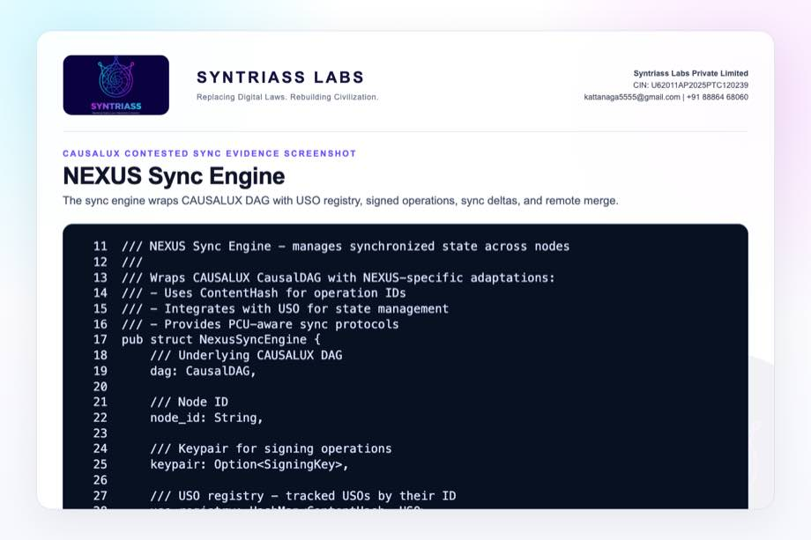
NEXUS sync engine screenshot

Evidence Page 23 - Sync Engine Tests
Evidence source: nexus-sync/src/sync_engine.rs
Purpose: show library tests for engine creation, USO registration, and signed USO update.
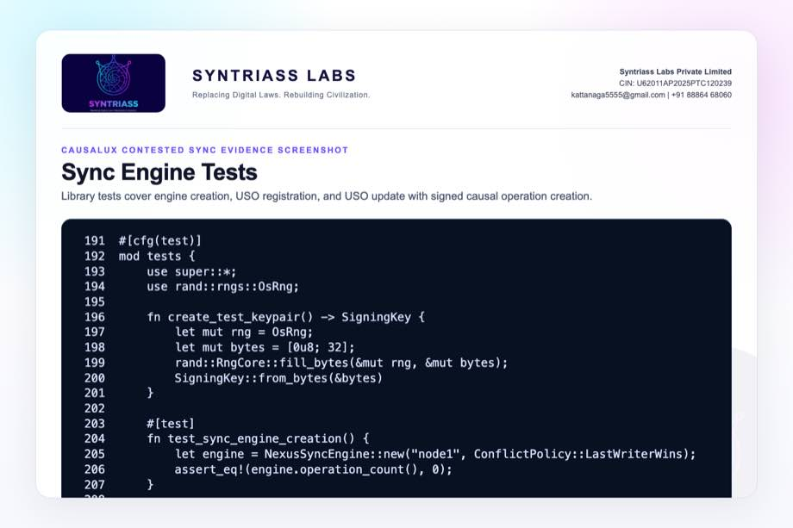
Sync engine tests screenshot

Evidence Page 24 - USO Sync Policy and Causal History
Evidence source: nexus-pcu/src/uso.rs
Purpose: show sync policy, access policy, causal history, vector clock, operation log, and happens-before model.
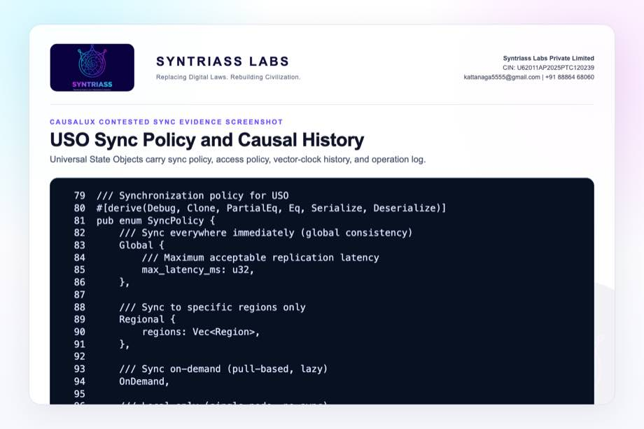
USO policy history screenshot

Evidence Page 25 - USO Merge and Serialization Tests
Evidence source: nexus-pcu/src/uso.rs
Purpose: show USO update, merge, serialization, sync policy, and causal-history tests.
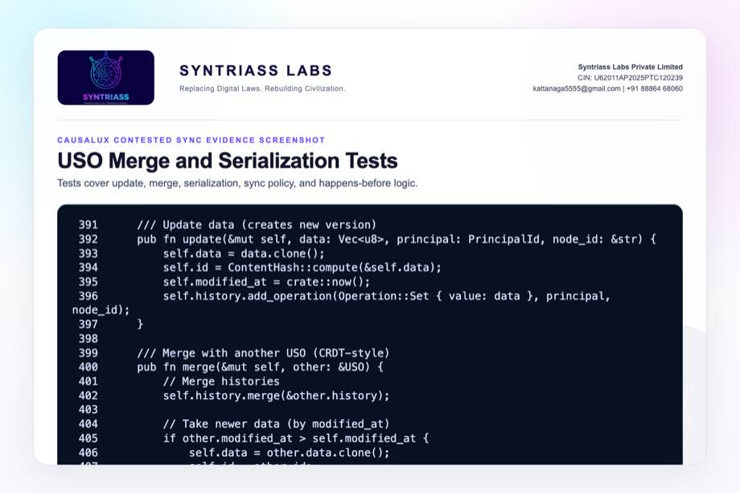
USO merge tests screenshot

Evidence Page 26 - PCU Compression Path
Evidence source: nexus-compress/src/pcu_compress.rs
Purpose: show content hash, original/compressed size, compression statistics, compression, and decompression.
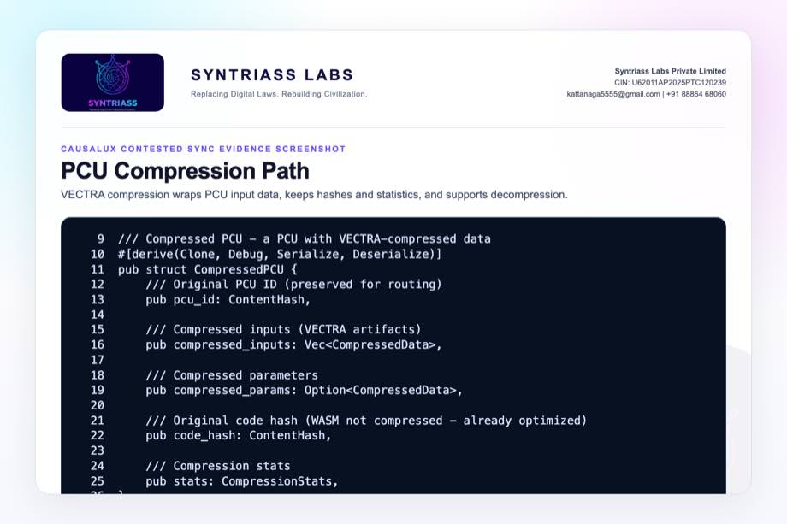
PCU compression screenshot

Evidence Page 27 - USO Compression Path
Evidence source: nexus-compress/src/uso_compress.rs
Purpose: show compressed USO fields, data decompression, compression ratio, batch compression, and tests.
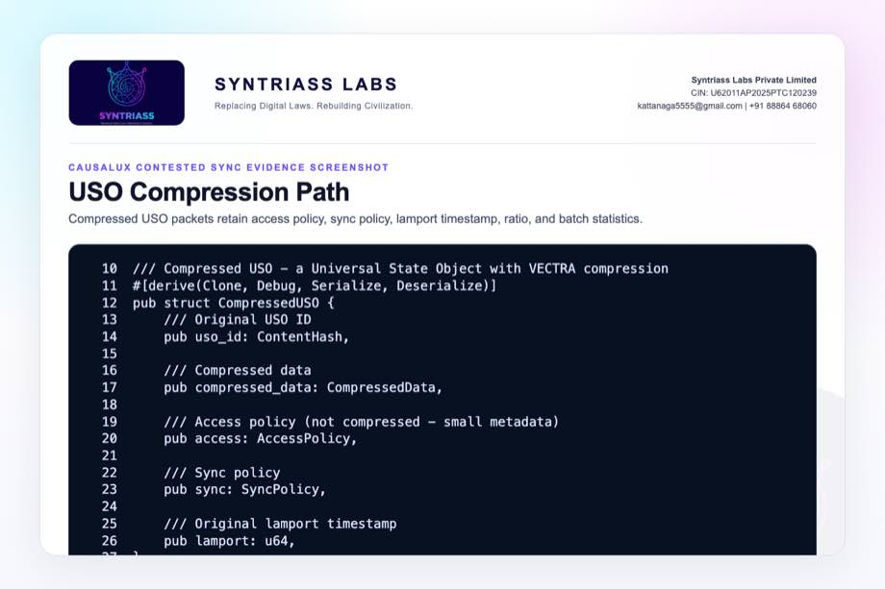
USO compression screenshot

Evidence Page 28 - Reviewer Repository Map
Purpose: give panel reviewers a direct navigation map.
Review Area | Path
Final proposal package | docs/idex-open-challenge-2026/07-causalux-contested-sync/final_4_documents/
Screenshot assets | docs/idex-open-challenge-2026/07-causalux-contested-sync/final_4_documents/evidence_assets/
Version vectors | causalux/src/version_vector.rs
CRDTs | causalux/src/crdt.rs
Sync protocol | causalux/src/sync.rs
Snapshot manager | causalux/src/snapshot.rs
NEXUS sync engine | nexus-sync/src/sync_engine.rs
PCU USO | nexus-pcu/src/uso.rs
Compression | nexus-compress/src/pcu_compress.rs, nexus-compress/src/uso_compress.rs

Evidence Page 29 - Claim-to-File Location Map
Proposal Claim | Source Evidence
Version-vector conflict context exists | causalux/src/version_vector.rs, conflicts_with() and tests.
CRDT merge types exist | causalux/src/crdt.rs, GCounter, PNCounter, ORSet, LWWMap, RGAText.
Causal DAG insert path exists | causalux/src/dag.rs, CausalDAG::insert().
Snapshot-based recovery exists | causalux/src/snapshot.rs, Snapshot and SnapshotManager.
Hierarchical sync exists | causalux/src/sync.rs, HierarchicalSync and AdaptiveSync.
Runtime sync simulation exists | causalux/src/runtime.rs, end-to-end tests.
USO causal history exists | nexus-pcu/src/uso.rs, CausalHistory.
NEXUS sync integration exists | nexus-sync/src/sync_engine.rs.
Compression path exists | nexus-compress/src/pcu_compress.rs, nexus-compress/src/uso_compress.rs.

Evidence Page 30 - Test and Command Locations
Test Area | Command / File
CAUSALUX selected tests | cargo test -p causalux-v2 --lib --tests -- --nocapture
NEXUS sync selected library tests | cargo test -p nexus-sync --lib -- --nocapture
PCU USO selected tests | cargo test -p nexus-pcu uso -- --nocapture
Compression tests | cargo test -p nexus-compress -- --nocapture
Clean output artifact | evidence_assets/causalux_contested_sync_clean_test_output.txt
Broader caveat output | evidence_assets/causalux_contested_sync_test_output.txt
Evidence screenshot generator | generate_causalux_contested_sync_evidence_screenshots.mjs
PDF builder | build_syntriass_letterhead_problem7.mjs

Evidence Page 31 - Generated Artifact Locations
Artifact Type | Location
Annexure 1 PDF | 01_SYNTRIASS_CAUSALUX_Contested_Sync_Annexure_1_Applicant_Details_and_Solution_Summary.pdf
Annexure 2 PDF | 02_SYNTRIASS_CAUSALUX_Contested_Sync_Annexure_2_Technical_Architecture.pdf
Annexure 3 PDF | 03_SYNTRIASS_CAUSALUX_Contested_Sync_Annexure_3_Advantages_and_Competencies.pdf
Annexure 4 PDF | 04_SYNTRIASS_CAUSALUX_Contested_Sync_Annexure_4_Supporting_Evidence_and_Screenshots.pdf
DOCX files | Same directory, matching .docx names.
Rendered HTML | final_4_documents/html/
Evidence screenshots | final_4_documents/evidence_assets/*.jpg
Selected test output | final_4_documents/evidence_assets/causalux_contested_sync_clean_test_output.txt
Full-run caveat output | final_4_documents/evidence_assets/causalux_contested_sync_test_output.txt

Evidence Page 32 - Screenshot Artifact Index
Screenshot | File
GitHub repository | evidence_assets/01_github_repository.jpg
Selected test output | evidence_assets/02_clean_test_output.jpg
Full-run caveats | evidence_assets/03_full_run_caveats.jpg
Version vector and sync | evidence_assets/04_version_vector.jpg through 06_adaptive_sync_savings.jpg
CRDT and DAG screenshots | evidence_assets/07_rga_text_crdt.jpg through 12_runtime_sync_tests.jpg
Snapshot and envelope | evidence_assets/13_snapshot_compression.jpg through 15_envelope_tests.jpg
USO and sync engine | evidence_assets/16_crdt_uso_model.jpg through 21_uso_merge_tests.jpg
Compression | evidence_assets/22_pcu_compression.jpg, 23_uso_compression.jpg

Evidence Page 33 - Defence Problem to Evidence Map
Defence Problem | CAUSALUX Contested Sync Control | Evidence
Command-link loss | Offline local updates and later sync | Evidence pages 8, 16, 22.
State divergence | Version vectors and CRDT convergence | Evidence pages 8, 11-13.
Low-bandwidth reconnect | Snapshot, delta, and compression path | Evidence pages 9-10, 17, 26-27.
Missing provenance | DAG order, USO history, operation IDs, and snapshots | Evidence pages 14-15, 24-25.
Stale update risk | Causal context, dependency checks, and proposed hardening tests | Evidence pages 7, 14-15, 36.
Reviewer traceability | File map, artifact map, and test output | Evidence pages 28-37.

Evidence Page 34 - Prototype Work Package Locations
Work Package | Existing Starting Point
Disconnected node simulator | causalux/src/runtime.rs end-to-end sync tests.
Causal metadata | causalux/src/version_vector.rs and nexus-pcu/src/uso.rs.
Deterministic merge | causalux/src/crdt.rs and nexus-sync/src/crdt_uso.rs.
Long-partition recovery | causalux/src/sync.rs and causalux/src/snapshot.rs.
Compact transfer | nexus-compress/src/pcu_compress.rs and nexus-compress/src/uso_compress.rs.
Provenance export | causalux/src/dag.rs, nexus-pcu/src/uso.rs, and proposed audit exporter.
Stale E2E modernization | nexus-sync/tests/integration_e2e.rs.

Evidence Page 35 - Panel Review Checklist
Reviewer Question | Where To Check
Were tests actually run? | Evidence page 6 and output file causalux_contested_sync_clean_test_output.txt.
Are broader failures disclosed? | Evidence page 7 and output file causalux_contested_sync_test_output.txt.
Is this field-tested over military radios? | No. Software-subsystem evidence only; radio/network-in-loop is proposed work.
Does the repository include CRDT merge logic? | Evidence pages 11-13 and causalux/src/crdt.rs.
Does the repository include sync and snapshot logic? | Evidence pages 9-10 and 17.
Does the repository include compression evidence? | Evidence pages 26-27.
Is the GitHub repository identified? | Evidence page 5 and repository coordinate page 37.
Are artifact locations included? | Evidence pages 28-32.

Evidence Page 36 - Readiness Statement and Caveats
Area | Position
Software subsystem readiness | Current evidence supports software subsystem TRL 3-4.
Selected tests | 90 selected executable checks passed across CAUSALUX, nexus-sync library, PCU USO, and compression.
Full CAUSALUX run | One stale doctest failure due outdated documentation import.
Full nexus-sync run | Stale E2E integration test compile failures due API/dependency drift.
Field network validation | Not yet performed. Requires network emulator and hardware/network-in-loop work.
EW/jamming simulation | Not yet performed. Proposed under iDEX validation.
Mission-state policy | Requires evaluator-approved schemas and conflict rules.
Operational use | Requires security review, radio integration, performance characterization, and deployment hardening.

Evidence Page 37 - Declaration and Repository Coordinates
Declaration:
CAUSALUX Contested Sync is submitted as a software-subsystem prototype for low-bandwidth disconnected state synchronization evaluation.
Repository coordinates:
- Public repository: https://github.com/richardrich999888-rgb/NEXUS
- Proposal folder: docs/idex-open-challenge-2026/07-causalux-contested-sync/
- Final documents: docs/idex-open-challenge-2026/07-causalux-contested-sync/final_4_documents/
- Evidence assets: docs/idex-open-challenge-2026/07-causalux-contested-sync/final_4_documents/evidence_assets/
- Clean selected test output: docs/idex-open-challenge-2026/07-causalux-contested-sync/final_4_documents/evidence_assets/causalux_contested_sync_clean_test_output.txt
- Full-run caveat output: docs/idex-open-challenge-2026/07-causalux-contested-sync/final_4_documents/evidence_assets/causalux_contested_sync_test_output.txt
- CAUSALUX source: causalux/src/
- NEXUS sync source: nexus-sync/src/
- PCU USO source: nexus-pcu/src/uso.rs
- Compression source: nexus-compress/src/
Submission caveat:
- The package is prepared for prototype review and iDEX-funded validation planning.
- No physical-radio validation, EW/jamming validation, operational deployment, or fully modernized end-to-end contested-sync validation is claimed.
- Network-in-loop testing, stale E2E modernization, mission-specific conflict policy, replay/stale-update tests, and field-integration planning remain required for operational use.

