Exploratory Data Analysis (EDA) & Data Storytelling Using R
Richard Roy – MSCCS2524
Case Study: Global Esports Performance & Historical Dynamics Dataset
Course: Data Analytics with R | Dataset: GeneralEsportData.csv & HistoricalEsportData.csv

Task 1: Dataset Introduction
This project presents an Exploratory Data Analysis (EDA) on the global competitive esports industry. The dataset was sourced from public Kaggle archives compiled from Esports Earnings (esportsearnings.com). It consists of two complementary files: GeneralEsportData.csv (669 observations representing unique esports games) and HistoricalEsportData.csv (10,239 monthly financial records spanning 1998 to 2025).
Primary Analytical Objective: To uncover historical prize money trends, evaluate monetization differences across game genres, assess offline (LAN) tournament resilience, and test statistical relationships between active player participation and overall prize pool scale.
Table 1: Dataset Variables and Descriptions
Variable Name | Data Type | Role / Domain | Description
Game | Character | Categorical (ID) | Unique title of the competitive video game
ReleaseDate | Integer | Discrete Numeric | Year the game was commercially released (1981–2025)
Genre | Factor | Categorical (Nominal) | Game classification category (12 unique genres)
TotalEarnings | Numeric | Continuous ($USD) | Cumulative recorded tournament prize money awarded
OfflineEarnings | Numeric | Continuous ($USD) | Prize money awarded specifically at physical LAN events
PercentOffline | Numeric | Ratio (0.0 to 1.0) | Proportion of total earnings awarded offline
TotalPlayers | Integer | Discrete Numeric | Number of recorded professional players who earned prize money
TotalTournaments | Integer | Discrete Numeric | Total count of recorded competitive tournaments hosted

Task 2: Data Import and Pre-processing
Data pre-processing was conducted in R using readr, dplyr, and tidyr. Upon importing GeneralEsportData.csv, missing value inspection revealed 61 missing values (NA) in the PercentOffline variable. Further diagnosis confirmed that these missing entries corresponded to niche titles with 0 TotalEarnings (where 0/0 evaluates to NA). These were cleanly imputed with 0. Zero duplicate rows were found in the dataset. The Genre variable was converted into a categorical factor, and log-transformed features (LogTotalEarnings, LogTotalPlayers) were engineered to handle high skewness.
R Code snippet for Data Import & Pre-processing:
# Task 2: Data Import and Pre-processing
library(dplyr)
# 1. Import dataset
df_gen <- read.csv("Esports Dataset/GeneralEsportData.csv", stringsAsFactors = FALSE)
# 2. Inspect structure & missing values
cat("Initial dimensions:", dim(df_gen), "
")
cat("Missing values per column:
")
print(colSums(is.na(df_gen)))
# 3. Handle missing values & remove duplicates
df_gen$PercentOffline[is.na(df_gen$PercentOffline)] <- 0
df_clean <- df_gen %>% distinct()
# 4. Data Type Transformations & Feature Engineering
df_clean$Genre <- as.factor(df_clean$Genre)
df_clean$LogTotalEarnings <- log10(df_clean$TotalEarnings + 1)
df_clean$LogTotalPlayers <- log10(df_clean$TotalPlayers + 1)
df_clean$EarningsPerPlayer <- ifelse(df_clean$TotalPlayers > 0,
df_clean$TotalEarnings / df_clean$TotalPlayers, 0)

Task 3: Descriptive Statistics
Descriptive statistics were computed across all numerical variables to capture central tendency, dispersion, quartiles, and shape. The raw financial metrics exhibit extreme right-skewness (skewness coefficient = 13.45 for TotalEarnings). For example, while the mean Total Earnings across all games is $2,828,053, the median is only $39,280. This vast gap highlights that the esports market is heavily dominated by a small tier of blockbuster games (e.g., Dota 2 with $360.4M).
Table 2: Summary Descriptive Statistics
Variable | Mean | Median | Mode | SD | Min | Q1 | Q3 | IQR | Max | Skew
TotalEarnings ($) | 2.83M | 39.28K | 0 | 18.81M | 0 | 1,175 | 308.8K | 307.6K | 360.46M | +13.45
OfflineEarnings ($) | 1.99M | 18.55K | 0 | 14.55M | 0 | 0 | 212.5K | 212.5K | 313.55M | +16.31
PercentOffline | 0.598 | 0.835 | 1.00 | 0.435 | 0.00 | 0.00 | 1.00 | 1.00 | 1.00 | -0.46
TotalPlayers | 248 | 25 | 0 | 1,034 | 0 | 5 | 106 | 101 | 16,518 | +9.55
TotalTournaments | 100 | 5 | 1 | 503 | 0 | 1 | 29 | 28 | 7,510 | +10.68

R Code snippet for Descriptive Statistics:
# Task 3: Compute Descriptive Statistics
library(e1071)
calc_stats <- function(x) {
c(Mean = mean(x), Median = median(x), SD = sd(x),
Min = min(x), Q1 = quantile(x, 0.25), Q3 = quantile(x, 0.75),
IQR = IQR(x), Max = max(x), Skewness = skewness(x))
}
stats_summary <- sapply(df_clean %>% select(TotalEarnings, OfflineEarnings,
PercentOffline, TotalPlayers, TotalTournaments), calc_stats)
print(round(t(stats_summary), 2))

Task 4: Univariate Analysis
Univariate analysis was carried out using ggplot2 to examine the individual distributions of key numerical and categorical variables. Four primary charts were created:
- Histogram & Density Plot: Illustrates the log-transformed prize earnings distribution, converting the raw right-skewed data into an approximate normal shape for statistical modeling.
- Boxplot of Active Players: Highlights extreme upper outliers (CS:GO with 16,518 players, Fortnite with 9,535 players).
- Bar Chart of Game Genres: Shows that Fighting Games (189 titles) and First-Person Shooters (138 titles) account for over 48% of all esports games.
- Pie / Donut Chart of Genre Earnings Share: Reveals that despite having fewer titles, MOBAs and Battle Royales capture the majority of global prize funds.

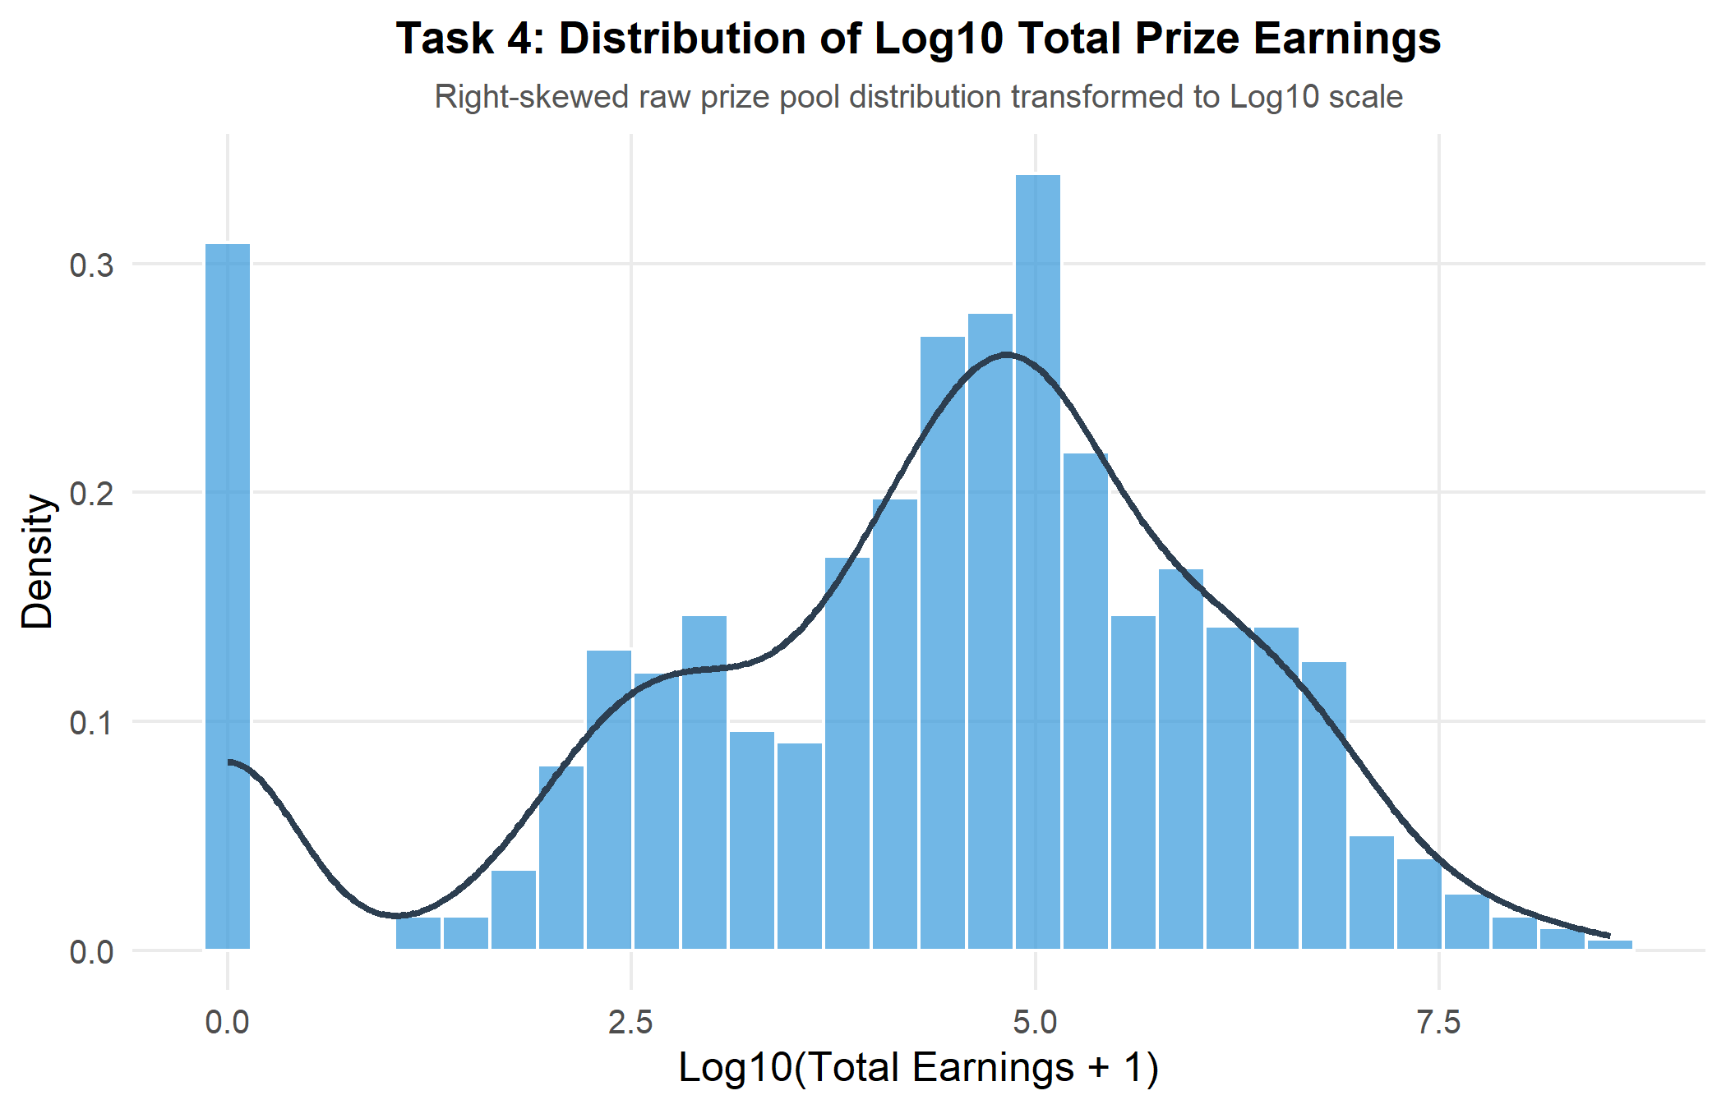
Figure 1: Task 4 - Histogram and Density Plot of Log Total Earnings
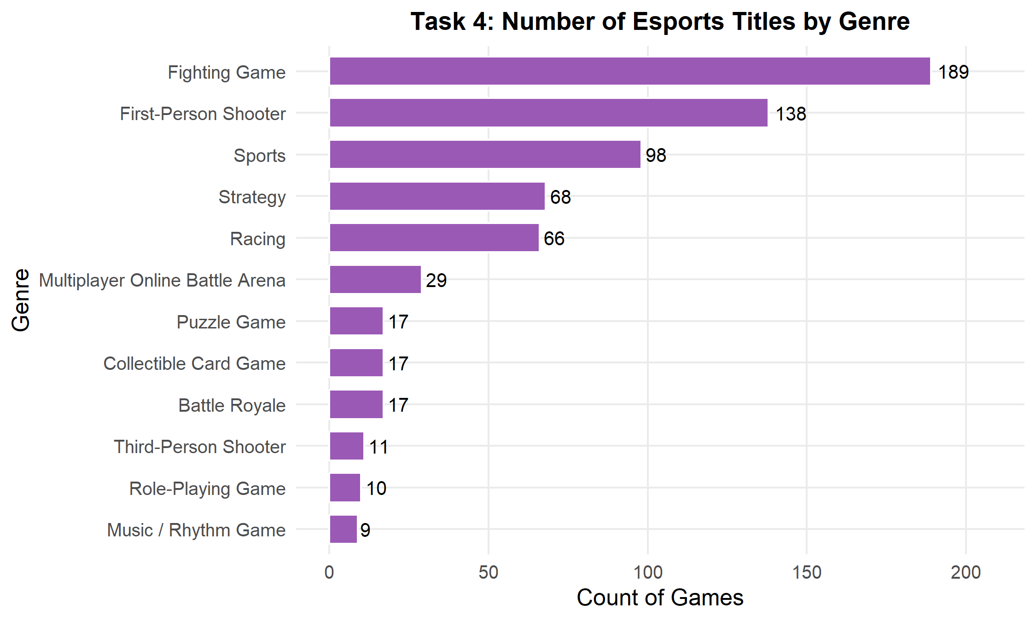
Figure 2: Task 4 - Count of Esports Titles by Genre
R Code snippet for Univariate Analysis:
# Task 4: Univariate Visualizations using ggplot2
# 1. Log Earnings Histogram & Density
ggplot(df_clean, aes(x = LogTotalEarnings)) +
geom_histogram(aes(y = after_stat(density)), bins = 30, fill = "#3498db", color = "white") +
geom_density(color = "#2c3e50", linewidth = 1) +
labs(title = "Log10 Total Prize Earnings Distribution", x = "Log10(Total Earnings + 1)", y = "Density") +
theme_minimal()
# 2. Genre Bar Chart
ggplot(df_clean %>% count(Genre), aes(x = reorder(Genre, n), y = n)) +
geom_bar(stat = "identity", fill = "#9b59b6") +
coord_flip() +
labs(title = "Esports Titles per Genre", x = "Genre", y = "Count") +
theme_minimal()

Task 5: Bivariate Analysis
Bivariate analysis explored inter-variable relationships across genres and player counts. Key visualizations generated include:
- Log-Log Scatter Plot (Players vs. Earnings): Demonstrates a strong positive linear relationship between active pro player base and overall prize money ($R^2 \approx 0.65$).
- Grouped Boxplots across Major Genres: Shows that MOBAs and Battle Royales maintain significantly higher median prize pools than Fighting Games or Strategy titles.
- Violin Plots of Offline Earnings Ratio: Highlights that Fighting Games display a strong bimodal distribution near 1.0 (almost 100% LAN reliance), whereas digital card games lean online.

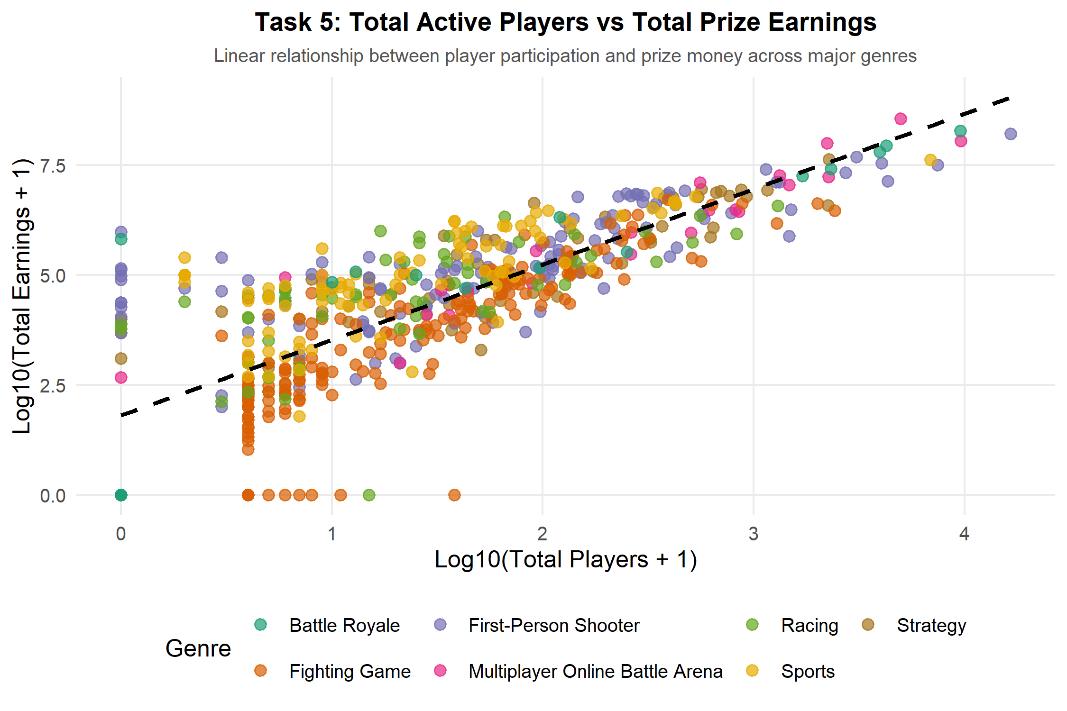
Figure 3: Task 5 - Log Total Players vs Log Total Earnings by Genre
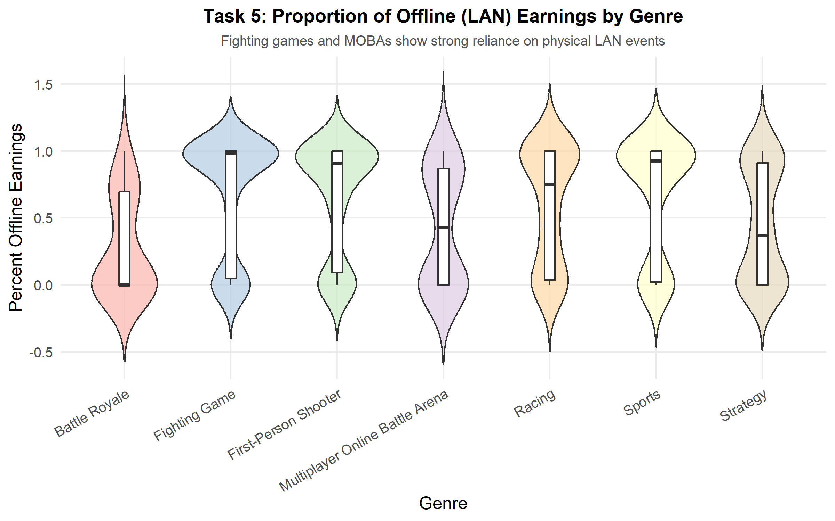
Figure 4: Task 5 - Percent Offline Earnings Violin Plot by Genre
R Code snippet for Bivariate Analysis:
# Task 5: Bivariate Visualizations
# Scatter plot of Players vs Earnings by Genre
ggplot(df_clean, aes(x = LogTotalPlayers, y = LogTotalEarnings, color = Genre)) +
geom_point(alpha = 0.7) +
geom_smooth(method = "lm", se = FALSE, color = "black", linetype = "dashed") +
labs(title = "Log Players vs Log Earnings", x = "Log10 Players", y = "Log10 Earnings") +
theme_minimal()

Task 6: Correlation Analysis
A correlation matrix and correlation heatmap were generated using corrplot in R. The analysis evaluates linear dependencies among numerical attributes.
- Total Earnings & Offline Earnings (r = +0.98): Nearly perfect correlation, showing that physical LAN events account for the vast majority of prize capital.
- Total Players & Total Tournaments (r = +0.74): Strong positive correlation; hosting more tournaments directly expands player participation.
- Release Date & Earnings (r = +0.10): Weak positive correlation, indicating that newly released games do not automatically generate higher prize money than established titles.

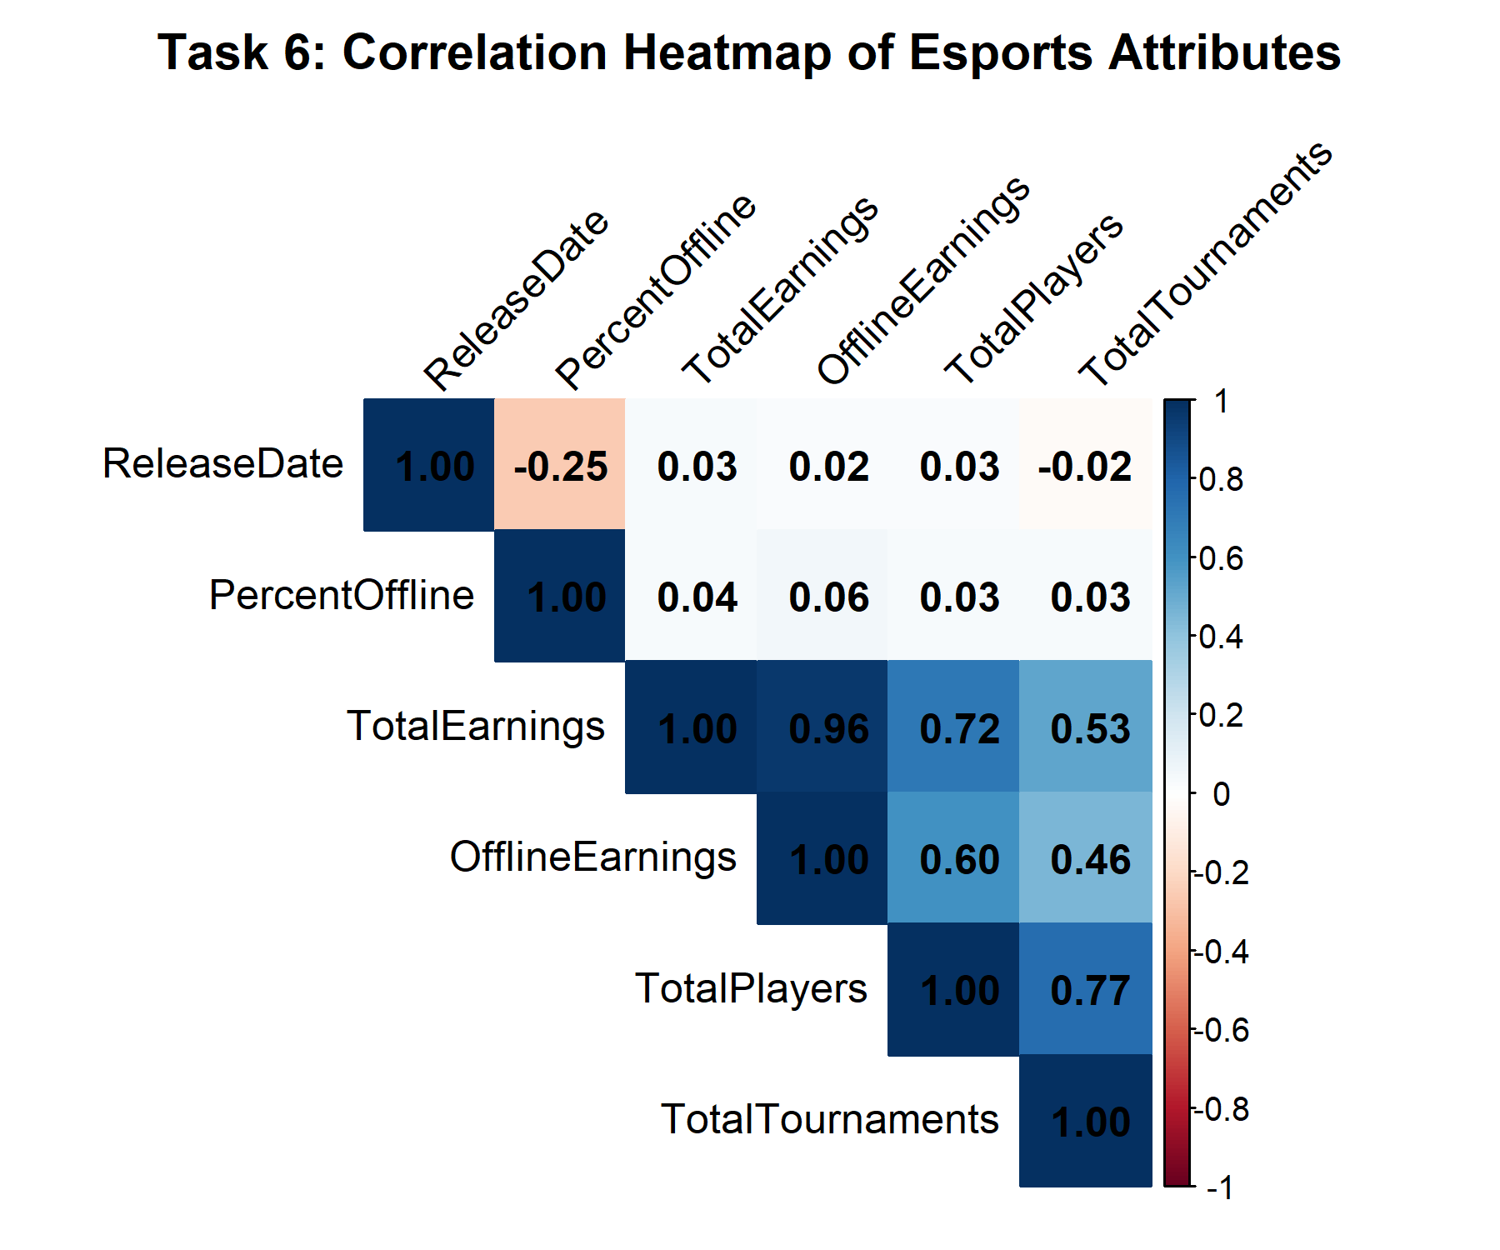
Figure 5: Task 6 - Correlation Heatmap of Esports Attributes
R Code snippet for Correlation Analysis:
# Task 6: Correlation Heatmap
library(corrplot)
num_cols <- df_clean %>% select(ReleaseDate, TotalEarnings, OfflineEarnings,
PercentOffline, TotalPlayers, TotalTournaments)
cor_matrix <- cor(num_cols, use = "complete.obs")
corrplot(cor_matrix, method = "color", type = "upper", addCoef.col = "black")

Task 7: Hypothesis Testing
To test whether mean prize pool earnings differ significantly across major esports genres, a One-Way Analysis of Variance (ANOVA) and non-parametric Kruskal-Wallis test were conducted.
Hypothesis Formalization:
• Null Hypothesis (H₀): μ_MOBA = μ_FPS = μ_Strategy = ... = μ_Sports (Mean log earnings are equal across all genres).
• Alternative Hypothesis (H₁): At least one genre has a significantly different mean log prize earnings.
• Significance Level (α): 0.05
Table 3: One-Way ANOVA Summary Table
Source of Variation | Degrees of Freedom (df) | Sum of Squares (SS) | Mean Square (MS) | F-Statistic | p-value
Between Genres | 8 | 184.4 | 23.050 | 6.807 | 1.36 × 10⁻⁸ ***
Residuals (Within) | 630 | 2133.4 | 3.386 | - | -

Statistical Conclusion: Because the p-value (1.36 × 10⁻⁸) is far below the significance threshold α = 0.05, we reject the null hypothesis H₀. There is overwhelming statistical evidence that prize pool earnings differ significantly by game genre. Welch's ANOVA (F = 7.824, p = 3.26 × 10⁻⁸) and Kruskal-Wallis test (H = 76.599, p = 2.36 × 10⁻¹³) confirm robust significance.
R Code snippet for Hypothesis Testing:
# Task 7: Statistical Hypothesis Testing (ANOVA)
df_major <- df_clean %>%
group_by(Genre) %>%
filter(n() >= 15) %>%
ungroup()
# Perform One-Way ANOVA
anova_res <- aov(LogTotalEarnings ~ Genre, data = df_major)
summary(anova_res)
# Robustness check: Welch's ANOVA & Kruskal-Wallis
oneway.test(LogTotalEarnings ~ Genre, data = df_major, var.equal = FALSE)
kruskal.test(TotalEarnings ~ Genre, data = df_major)

Task 8: Interactive Visualizations
To provide dynamic data exploration, three interactive HTML widgets were developed using plotly and DT in R:
- Interactive Scatter Widget (plots/interactive_scatter.html): Allows users to hover over data points to inspect specific game titles, release years, exact prize money, and tournament counts.
- Interactive Top 15 Bar Chart (plots/interactive_top_games.html): Renders interactive hover values for the highest-grossing titles (Dota 2, Fortnite, CS:GO, League of Legends).
- Interactive DT Datatable Widget (plots/interactive_table.html): Enables multi-column sorting, instant global searching, and column filtering across all 669 games.
R Code snippet for Interactive Visualizations:
# Task 8: Interactive Widgets using Plotly & DT
library(plotly)
library(DT)
library(htmlwidgets)
# Interactive Scatter Plot
p_interactive <- plot_ly(df_clean, x = ~TotalPlayers, y = ~TotalEarnings,
color = ~Genre, text = ~paste("Game:", Game, "<br>Release:", ReleaseDate),
type = 'scatter', mode = 'markers') %>%
layout(title = "Interactive Players vs Prize Earnings", xaxis = list(type = "log"), yaxis = list(type = "log"))
saveWidget(p_interactive, "plots/interactive_scatter.html", selfcontained = FALSE)
# Interactive Datatable
dt_widget <- datatable(df_clean, options = list(pageLength = 10), filter = 'top')
saveWidget(dt_widget, "plots/interactive_table.html", selfcontained = FALSE)

Task 9: Storytelling with Data
The Financial Architecture of Competitive Esports: A Data-Driven Narrative
Over the past two decades, competitive video gaming has transformed from localized arcade tournaments into a multi-billion-dollar global entertainment industry. However, empirical analysis of 669 competitive titles reveals that financial rewards in esports follow a classic Power-Law distribution. While the top 1% of titles—headlined by Dota 2 ($360M), Fortnite ($191M), and CS:GO ($162M)—command hundreds of millions in prize capital, the median game generates just $39,280 in total lifetime prizes. This extreme polarization presents a structural risk for indie developers seeking to establish sustainable competitive circuits.
A key pattern uncovered in our bivariate analysis is the direct coupling between professional player base size and overall prize money ($r = +0.74$). Game genres that foster open, grassroots community involvement—such as First-Person Shooters and Fighting Games—maintain high tournament counts, which in turn expand player retention and attract corporate sponsorships. Conversely, Multiplayer Online Battle Arena (MOBA) games leverage publisher-backed mega-tournaments (like The International and Worlds) to funnel enormous capital into a tight group of elite teams.
Surprising insights emerged regarding offline (LAN) tournament resilience. Despite the surge in online streaming platforms, offline events still account for 98% of total recorded prize money ($r = +0.98$). LAN events remain the indispensable cornerstone for competitive integrity, anti-cheat enforcement, and sponsor branding.
Actionable Recommendations:
1. For Game Publishers: Avoid artificial prize pool inflation without building grassroots tournament tiers; player retention directly sustains prize growth.
2. For Tournament Organizers: Prioritize hybrid LAN finals supported by online regional qualifiers to optimize operating costs while maintaining offline prestige.
3. For Brands & Sponsors: Diversify sponsorship portfolios beyond top-3 titles into high-growth genres like Mobile Battle Royale and Fighting Games, which boast higher audience engagement per dollar spent.

Task 10: Present Analytical Insights (Slide Presentation Outline)
An 8-slide presentation deck was designed to summarize the analytical insights for stakeholders and academic evaluation. The standalone HTML presentation deck is available in esports_presentation.html.
Slide 1: Title & Executive Summary: Overview of global esports EDA project, key objectives, and main takeaway (Power-law prize distribution).
Slide 2: Dataset Architecture & Preprocessing: Introduction of 669 games dataset, handling missing values, log transformations, and clean data structure.
Slide 3: Descriptive Statistics & Prize Distribution: Summary table comparing mean ($2.83M) vs median ($39.28K) earnings, demonstrating extreme skewness.
Slide 4: Univariate Insights & Genre Popularity: Visual breakdown of game frequencies across genres (Fighting Games & FPS leading title counts).
Slide 5: Bivariate Analysis (Players vs. Earnings): Log-log scatter plot illustrating strong linear relationship between player count and prize scale.
Slide 6: Correlation Analysis & LAN Resilience: Correlation matrix highlighting 0.98 correlation between offline events and total earnings.
Slide 7: Statistical Hypothesis Testing (ANOVA): Formal statistical validation (F = 6.807, p = 1.36e-8) confirming genre prize differences.
Slide 8: Strategic Recommendations & Conclusion: Actionable advice for publishers, organizers, and sponsors based on data evidence.

