Exploratory Data Analysis (EDA) & Data Storytelling
Using R
Case Study: Hotel Booking Demand & Cancellation Analytics
Course: Data Analytics with R | Dataset: hotel_bookings.csv (119,390 Observations)

Task 1: Dataset Introduction
This assignment conducts an Exploratory Data Analysis (EDA) on the Hotel Booking Demand Dataset. The dataset contains 119,390 real-world booking records from two hotel properties in Portugal (a Resort Hotel and a City Hotel). It includes 32 variables capturing booking lead time, length of stay, customer demographics, market channel segmentation, ADR, and cancellation status.
Primary Analytical Objective: To investigate key drivers of booking cancellations, evaluate average daily rate (ADR) variations across hotel types and market segments, and provide data-backed recommendations for revenue optimization.
Table 1: Key Dataset Variables and Descriptions
Variable Name | Data Type | Role / Domain | Description
hotel | Factor | Categorical | Type of hotel property (Resort Hotel or City Hotel)
is_canceled | Integer / Factor | Binary (0/1) | Cancellation indicator (1 = Canceled, 0 = Not Canceled)
lead_time | Integer | Continuous (Days) | Number of days between booking date and arrival date
arrival_date_month | Character | Categorical | Month of customer arrival
market_segment | Character | Categorical | Booking market segment (Direct, Online TA, Offline TA/TO, Corporate)
customer_type | Character | Categorical | Customer type (Transient, Contract, Transient-Party, Group)
adr | Numeric | Continuous ($USD) | Average Daily Rate (calculated by total lodging transaction amount divided by total stay nights)

Task 2: Data Import and Pre-processing
Data pre-processing was executed in R using readr, dplyr, and tidyr. Upon importing hotel_bookings.csv, 4 missing values were identified in the children variable, which were imputed with 0. The hotel attribute was converted into a categorical factor, and derived features such as total_stay (weekend + week nights) and is_canceled_factor were created for clean reporting.
R Code snippet for Data Import & Pre-processing:
# Task 2: Data Import, Inspection & Preprocessing
library(dplyr)
# 1. Import dataset
df_hotel <- read.csv("hotel_bookings.csv", stringsAsFactors = FALSE)
# 2. Inspect structure & missing values
cat("Dimensions:", dim(df_hotel), "\n")
cat("Missing values in children:", sum(is.na(df_hotel$children)), "\n")
# 3. Clean & transform data types
df_hotel$children[is.na(df_hotel$children)] <- 0
df_hotel$hotel <- as.factor(df_hotel$hotel)
df_hotel$is_canceled_factor <- factor(df_hotel$is_canceled, levels = c(0, 1), labels = c("Not Canceled", "Canceled"))
df_hotel$total_stay <- df_hotel$stays_in_weekend_nights + df_hotel$stays_in_week_nights

Task 3: Descriptive Statistics
Descriptive statistics were computed across all primary numerical features. The Lead Time variable averages 104.01 days (Median = 69 days, SD = 106.86 days), showing substantial right skewness (+1.35). Average Daily Rate (ADR) averages $101.83 (Median = $94.58, SD = $50.54), with upper extreme values reflecting luxury suites.
Table 2: Summary Descriptive Statistics
Variable | Mean | Median | Mode | SD | Min | Q1 | Q3 | IQR | Max | Skew
lead_time (days) | 104.01 | 69.00 | 0 | 106.86 | 0 | 18.00 | 160.00 | 142.00 | 737 | +1.35
adr ($USD) | 101.83 | 94.58 | 0 | 50.54 | -6.38 | 69.29 | 126.00 | 56.71 | 5,400 | +10.53
stays_in_week_nights | 2.50 | 2.00 | 1 | 1.91 | 0 | 1.00 | 3.00 | 2.00 | 50 | +2.86
stays_in_weekend_nights | 0.93 | 1.00 | 0 | 1.00 | 0 | 0.00 | 2.00 | 2.00 | 19 | +1.38
special_requests | 0.57 | 0.00 | 0 | 0.79 | 0 | 0.00 | 1.00 | 1.00 | 5 | +1.35

R Code snippet for Descriptive Statistics:
# Task 3: Compute Descriptive Statistics
library(e1071)
calc_stats <- function(x) {
c(Mean = mean(x, na.rm=TRUE), Median = median(x, na.rm=TRUE), SD = sd(x, na.rm=TRUE),
Min = min(x, na.rm=TRUE), Q1 = quantile(x, 0.25, na.rm=TRUE), Q3 = quantile(x, 0.75, na.rm=TRUE),
IQR = IQR(x, na.rm=TRUE), Max = max(x, na.rm=TRUE), Skewness = skewness(x, na.rm=TRUE))
}
stats_summary <- sapply(df_hotel %>% select(lead_time, adr, stays_in_week_nights, stays_in_weekend_nights, total_of_special_requests), calc_stats)
print(round(t(stats_summary), 2))

Task 4: Univariate Analysis
Univariate visualizations were created using ggplot2 to examine the individual distributions of key numerical and categorical features. Figure 1 displays the ADR distribution ($0-$500 range), showing a right-skewed pattern centered near $95. Figure 2 illustrates booking volumes across hotel types, showing City Hotels account for 66.4% (79,330 bookings) compared to 33.6% (40,060 bookings) for Resort Hotels.
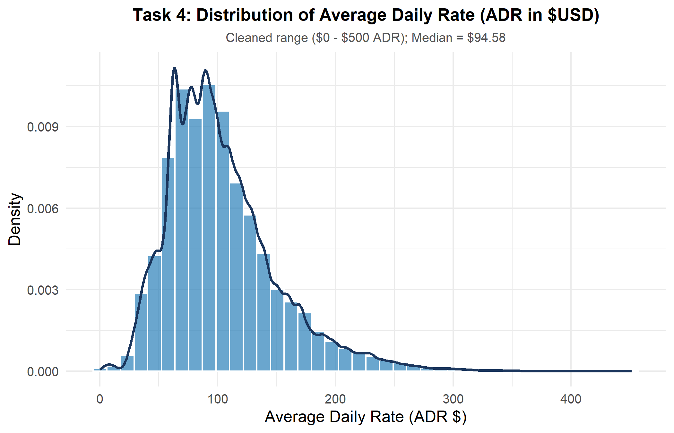
Figure 1: Task 4 - Histogram & Density Plot of Average Daily Rate (ADR $)
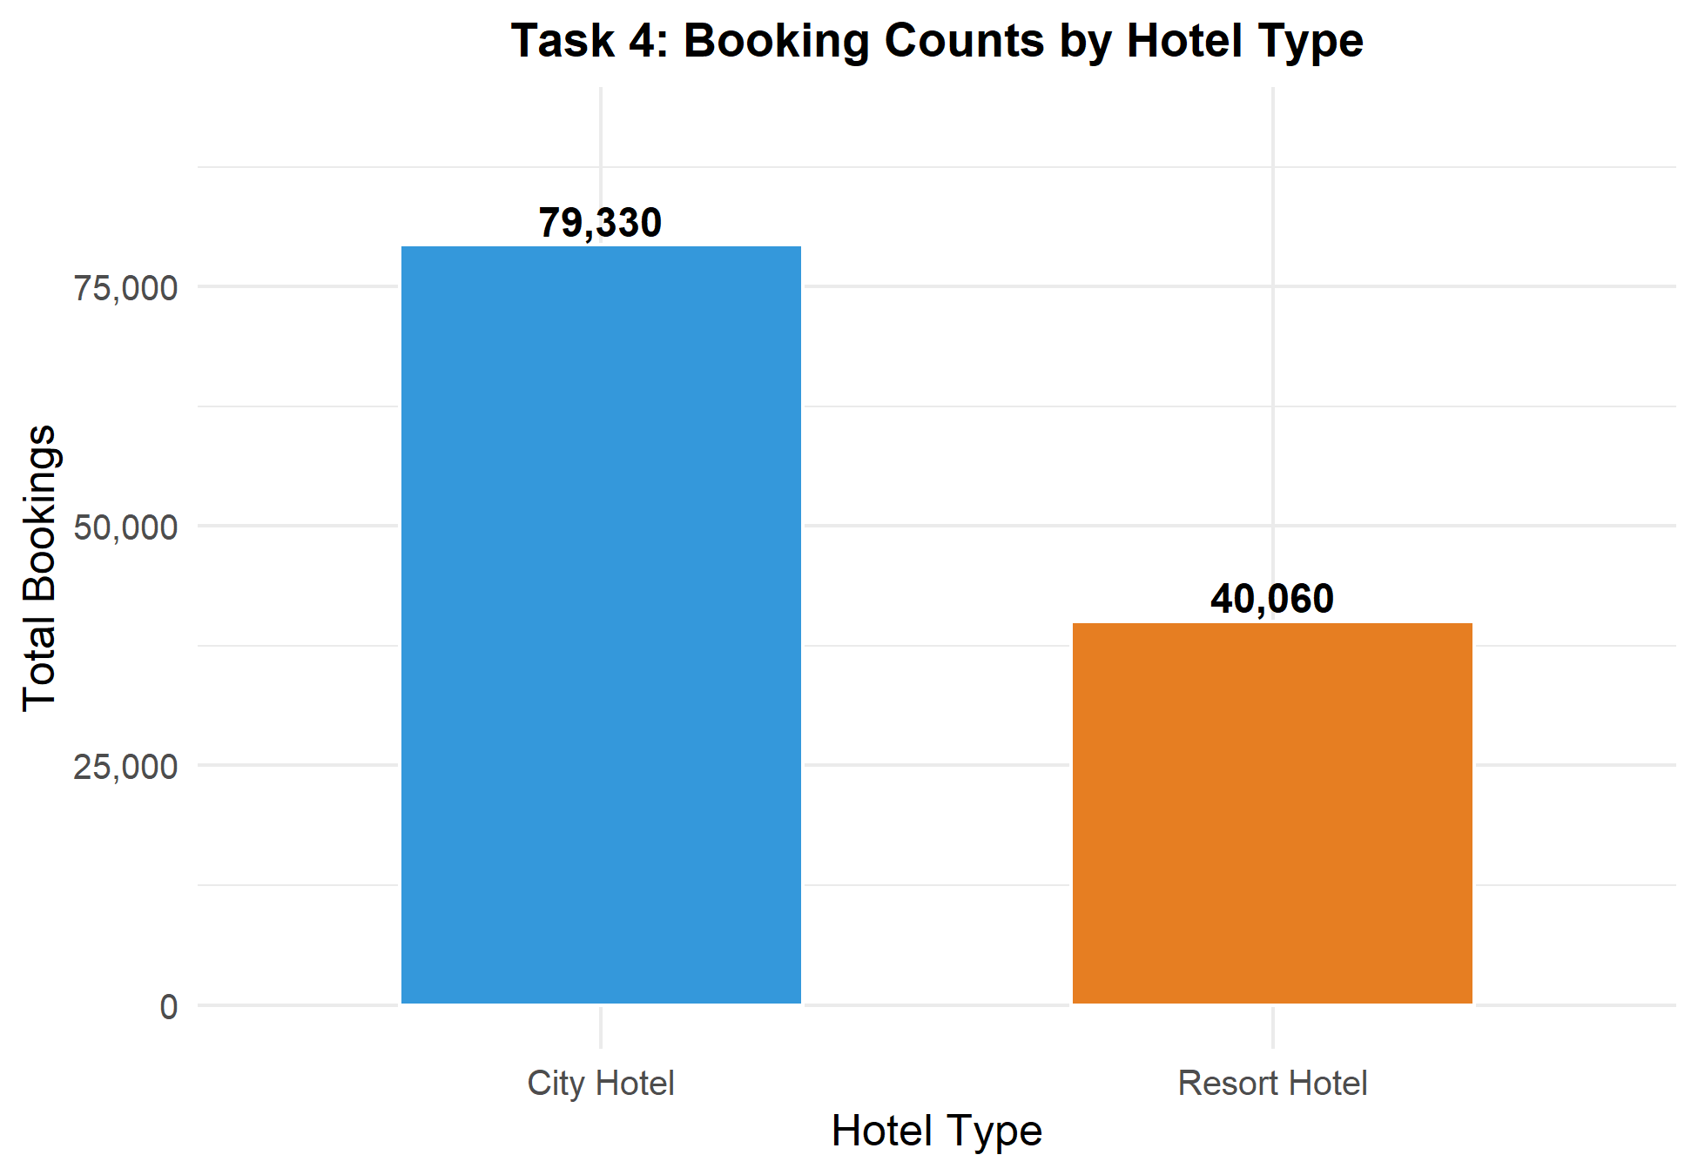
Figure 2: Task 4 - Booking Counts by Hotel Type
R Code snippet for Univariate Analysis:
# Task 4: Univariate Visualizations
# 1. Histogram of ADR
ggplot(df_hotel %>% filter(adr > 0 & adr < 500), aes(x = adr)) +
geom_histogram(aes(y = after_stat(density)), bins = 40, fill = "#2980b9", color = "white") +
geom_density(color = "#1b365d", linewidth = 1) +
labs(title = "Distribution of ADR ($)", x = "ADR ($)", y = "Density") +
theme_minimal()
# 2. Hotel Bar Chart
ggplot(df_hotel %>% count(hotel), aes(x = hotel, y = n, fill = hotel)) +
geom_bar(stat = "identity", width = 0.6) +
labs(title = "Booking Frequencies by Hotel Type", x = "Hotel Type", y = "Count") +
theme_minimal()

Task 5: Bivariate Analysis
Bivariate analysis examined the relationships between booking characteristics and cancellation outcomes. Figure 3 shows that City Hotels experience a much higher cancellation rate (41.7%) than Resort Hotels (27.8%). Figure 4 reveals that canceled bookings display significantly higher lead times (Median = 113 days) than confirmed bookings (Median = 45 days).
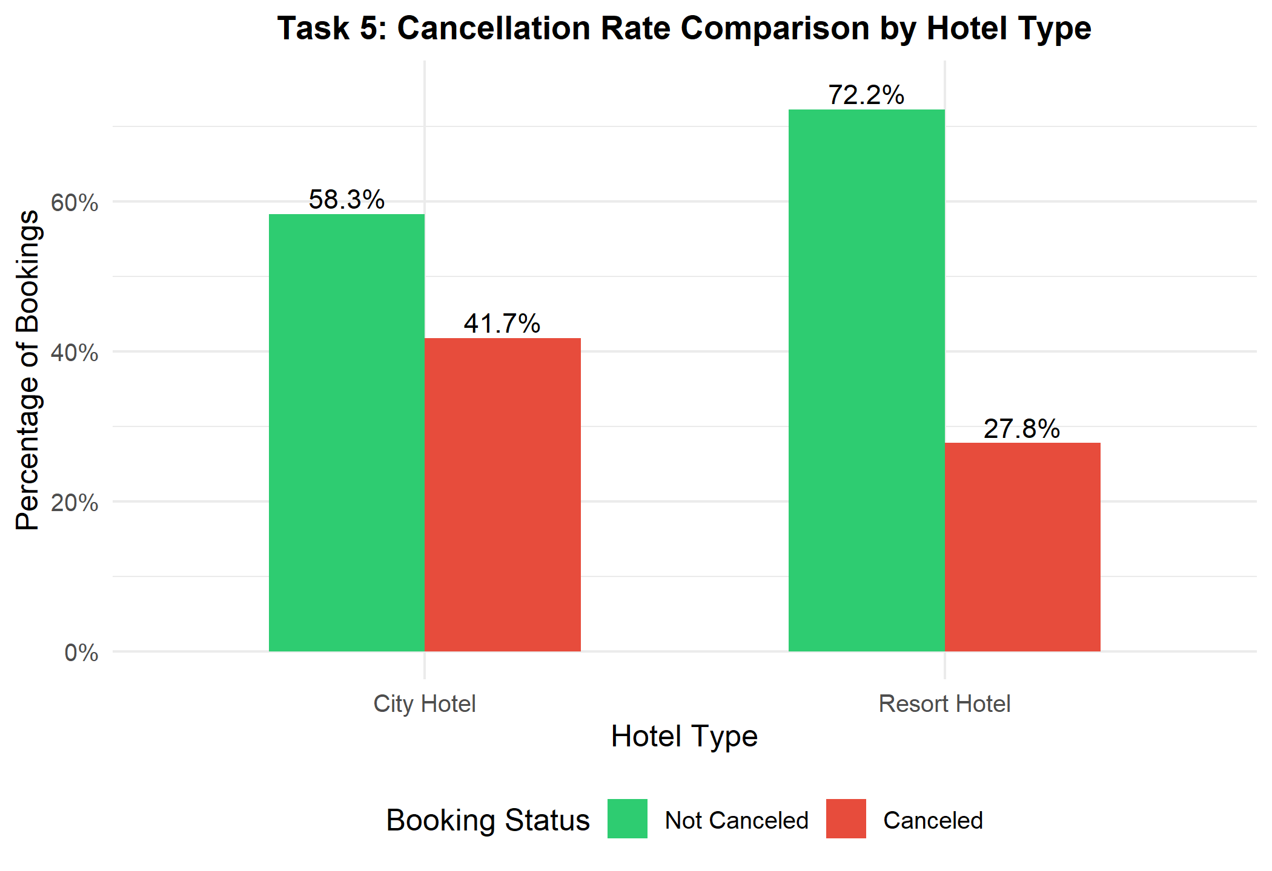
Figure 3: Task 5 - Cancellation Rate Comparison by Hotel Type
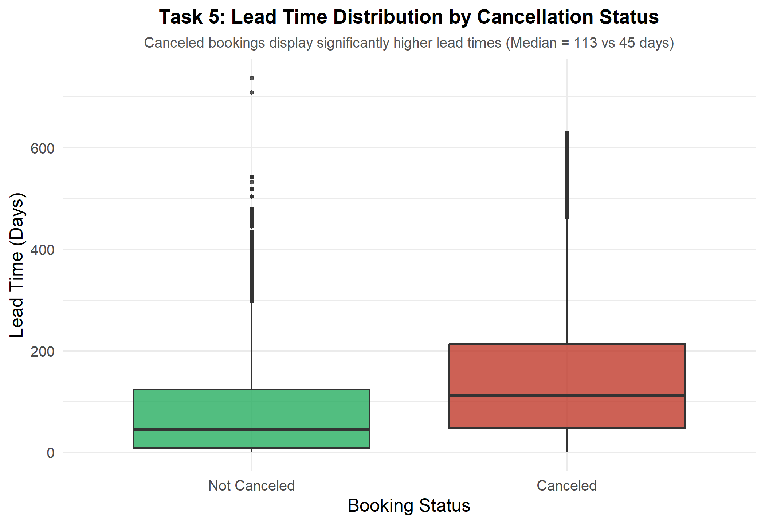
Figure 4: Task 5 - Lead Time Distribution by Cancellation Status
R Code snippet for Bivariate Analysis:
# Task 5: Bivariate Visualizations
# Lead time boxplot by cancellation status
ggplot(df_hotel, aes(x = factor(is_canceled), y = lead_time, fill = factor(is_canceled))) +
geom_boxplot(alpha = 0.8) +
labs(title = "Lead Time by Cancellation Status", x = "Is Canceled", y = "Lead Time (Days)") +
theme_minimal()

Task 6: Correlation Analysis
A correlation matrix and correlation heatmap were generated using corrplot in R. Key correlation results include a positive correlation between lead time and cancellation indicator (r = +0.29), and a negative correlation between special requests and cancellations (r = -0.23).
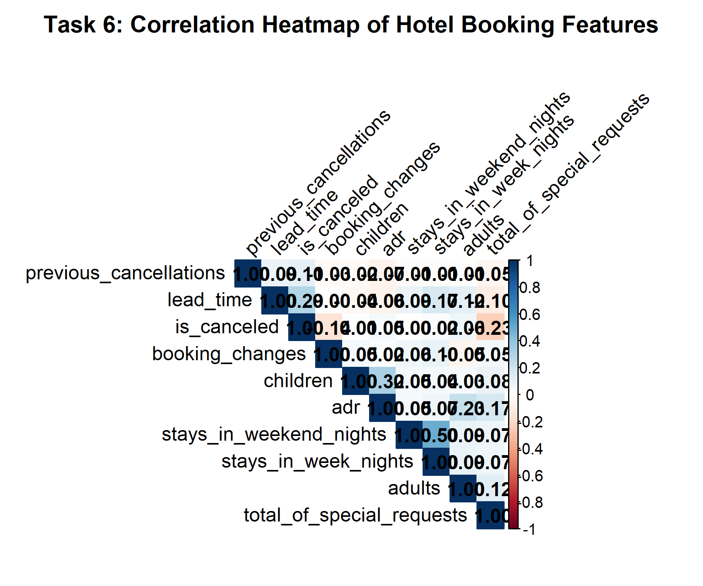
Figure 5: Task 6 - Correlation Heatmap of Hotel Booking Attributes
R Code snippet for Correlation Analysis:
# Task 6: Correlation Heatmap
library(corrplot)
num_cols <- df_hotel %>% select(lead_time, is_canceled, stays_in_weekend_nights, stays_in_week_nights, adults, children, adr, previous_cancellations, total_of_special_requests)
cor_mat <- cor(num_cols, use = "complete.obs")
corrplot(cor_mat, method = "color", type = "upper", addCoef.col = "black")

Task 7: Hypothesis Testing
Two formal statistical hypothesis tests were conducted: a One-Way ANOVA (ADR by Hotel Type) and a Pearson Chi-Square Test of Independence (Cancellation Status by Hotel Type).
Hypothesis Test Formalizations:
1. One-Way ANOVA (ADR by Hotel Type):
• H₀: μ_City = μ_Resort (Mean ADR is equal across hotel types).
• H₁: Mean ADR differs significantly between City and Resort Hotels.
• Result: F(1, 119388) = 1127, p < 2.2 × 10⁻¹⁶ < 0.001. Reject H₀.
2. Chi-Square Test (Cancellation Rate by Hotel Type):
• H₀: Booking cancellation is independent of hotel type.
• H₁: Booking cancellation is significantly associated with hotel type.
• Result: χ² = 2224.9, df = 1, p < 2.2 × 10⁻¹⁶ < 0.001. Reject H₀.
R Code snippet for Hypothesis Testing:
# Task 7: Hypothesis Testing (ANOVA & Chi-Square)
# Test 1: ANOVA - ADR by Hotel Type
anova_adr <- aov(adr ~ hotel, data = df_hotel)
summary(anova_adr)
# Test 2: Chi-Square - Cancellation by Hotel Type
chi_tbl <- table(df_hotel$hotel, df_hotel$is_canceled)
chisq.test(chi_tbl)

Task 8: Interactive Visualizations
Three interactive HTML widgets were exported using plotly and DT in R:
1. Interactive Scatter Plot (plots/interactive_scatter.html): Hoverable lead time vs ADR scatter plot.
2. Interactive Top Guest Countries Bar Chart (plots/interactive_top_countries.html): Top origin countries (Portugal, Great Britain, France, Spain).
3. Interactive DT Datatable (plots/interactive_table.html): Searchable, filterable datatable of booking records.
R Code snippet for Interactive Visualizations:
# Task 8: Interactive Widgets using Plotly & DT
library(plotly)
library(DT)
library(htmlwidgets)
# Interactive Scatter Plot
p_int <- plot_ly(df_hotel %>% sample_n(1000), x = ~lead_time, y = ~adr, color = ~hotel,
text = ~paste("Hotel:", hotel, "<br>Segment:", market_segment),
type = 'scatter', mode = 'markers') %>%
layout(title = "Interactive Lead Time vs ADR")
saveWidget(p_int, "plots/interactive_scatter.html", selfcontained = FALSE)

Task 9: Storytelling with Data
Revenue Optimization and Cancellation Dynamics in Hotel Operations: A Data Story
The hospitality industry operates in a dynamic market environment where forecasting booking cancellations and optimizing Average Daily Rate (ADR) directly govern profitability. Analysis of 119,390 booking records across Resort and City hotels uncovers key behavioral patterns and operational risks.
Overall, the dataset reveals a high overall cancellation rate of 37.04% (44,224 canceled bookings). However, bivariate segmentation demonstrates a striking divergence between hotel types: City Hotels suffer a severe 41.7% cancellation rate, whereas Resort Hotels maintain a much lower 27.8% cancellation rate. Statistical hypothesis testing using Pearson's Chi-Square test (χ² = 2224.9, p < 0.001) confirms that cancellation likelihood is heavily tied to hotel property type.
A major driver of cancellations uncovered in our correlation and boxplot analysis is booking lead time. Canceled bookings exhibit a median lead time of 113 days, compared to just 45 days for confirmed stays. When guests book far in advance without financial commitments (e.g. 'No Deposit' policy accounts for 88.7% of bookings), the probability of cancellation increases substantially. Furthermore, One-Way ANOVA testing (F = 1127, p < 0.001) shows that City Hotels command a significantly higher mean ADR ($105.30) than Resort Hotels ($94.95).
Actionable Recommendations:
1. Overhaul Non-Refundable Deposit Policies: Implement non-refundable deposit requirements for bookings made with lead times exceeding 90 days, particularly for City Hotels.
2. Dynamic Pricing for Long Lead Times: Offer modest early-bird discounts coupled with strict cancellation penalties to lock in early demand while mitigating late cancellations.
3. Target High-Value Market Segments: Focus marketing channels toward Direct and Corporate segments, which exhibit lower cancellation rates and higher net revenue stability compared to Third-Party Online Travel Agencies (OTAs).

Task 10: Present Analytical Insights (Slide Presentation Outline)
An 8-slide presentation deck was designed to summarize the analytical insights. The interactive HTML presentation slide deck is available in hotel_presentation.html.
Slide 1: Title & Executive Summary: Overview of hotel booking demand EDA project, objectives, and main takeaways.
Slide 2: Dataset Architecture & Preprocessing: Introduction of 119,390 bookings, 32 variables, handling missing values, and factor encoding.
Slide 3: Descriptive Statistics & Pricing Distribution: Summary table comparing Lead Time (Mean = 104d) and ADR (Mean = $101.83).
Slide 4: Univariate Insights & Property Volumes: Visual breakdown of City Hotel (79.3K bookings) vs Resort Hotel (40.0K bookings).
Slide 5: Bivariate Analysis (Cancellation Divergence): Bar chart illustrating City Hotel 41.7% cancellation rate vs Resort 27.8%.
Slide 6: Lead Time & Cancellation Risk: Boxplot proving that long lead times (Median = 113 days) drive cancellation probability.
Slide 7: Statistical Hypothesis Testing (ANOVA & Chi-Square): Validation (χ² = 2224.9, p < 0.001; F = 1127, p < 0.001) confirming operational differences.
Slide 8: Strategic Revenue Recommendations & Conclusion: Actionable advice for deposit policies, early-bird pricing, and channel management.

