XAMPP control module for that allows you to access MySQL through a PHP program.

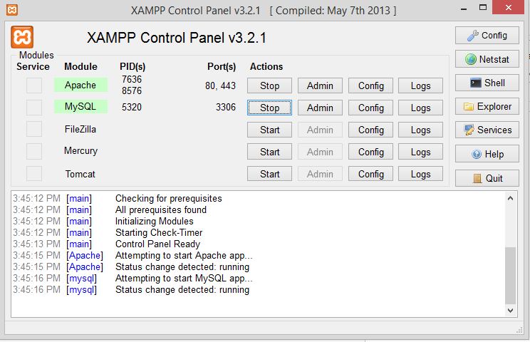

Access Local Host through a web browser.

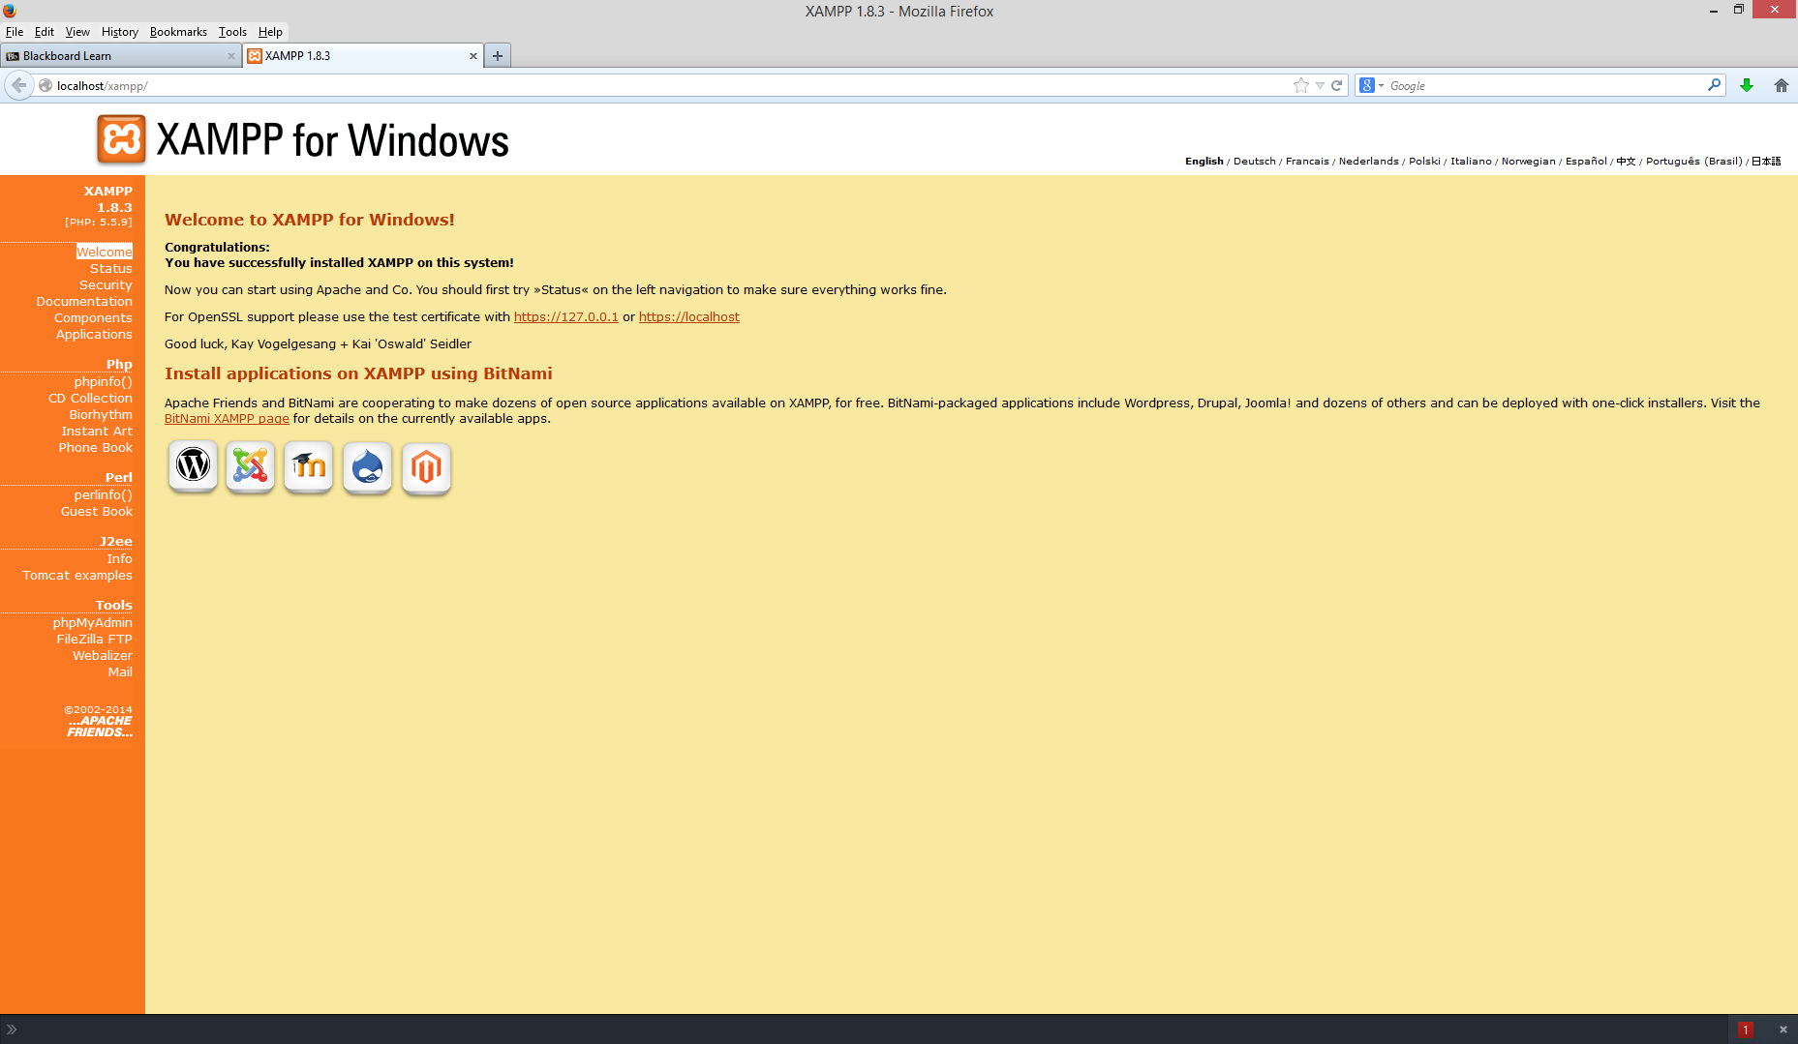

PHP code to connect to database, create tables in the database, populate tables, and disconnect from database.

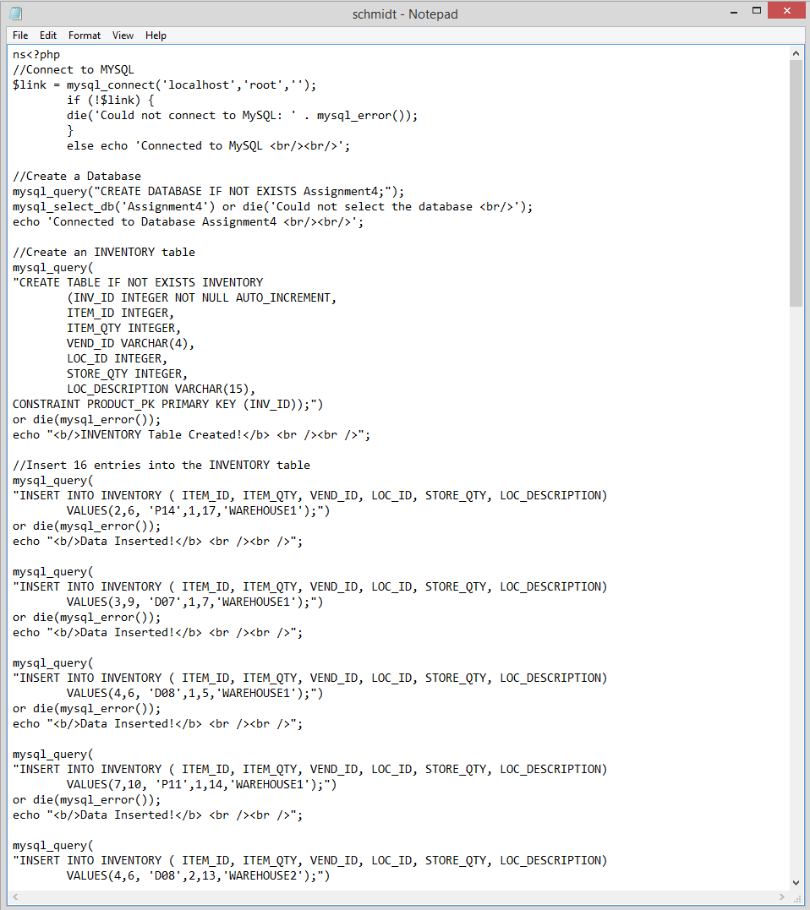

Here is how the database should look like if your code is correct.

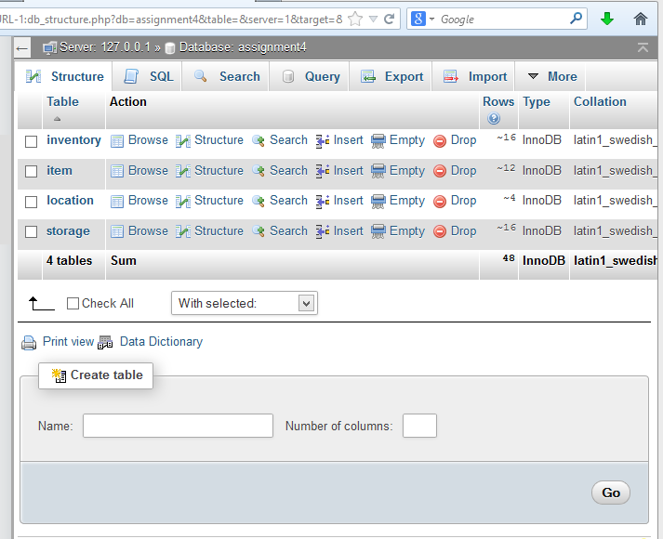

Here is a successful query against my database to make sure that it works.

