TDWG RDF Browser
Kevin Richards
Landcare Research
richardsk@landcareresearch.co.nz
September 2007

Overview
This project resulted from the requirement to set up a web based data provider service for a specimens dataset. The project was funded by funding from the TDWG Infrastructure Project (which was initially funded by the Gordon and Betty Moore Foundation).
See http://www.tdwg.org, and http://www.moore.org for more information.

The intention of the project was to provide an LSID resolver to serve up specimen RDF from a major specimen database. The specimen database chosen was the Herb IMI dataset, closely related to the index of Fungi names, IndexFungorum (http://www.indexfungorum.org). Herb IMI contains nearly 400000 specimen records including location data, and is currently hosted by CABI in the UK (a move to Kew is however in the pipeline).

The project that was proposed included setting up this Herb IMI LSID resolver, a TAPIR provider service and a desktop tool to query, harvest, browse RDF data and generally test the services. This elaborated into the idea of having multiple configurable data sources that are LSID or TAPIR based and work with any number of RDF/XML schemas. The tool was therefore to connect to the data sources, query them using the configured schemas, harvest the records, cache the results in a local RDF cahce and browse the resulting RDF data.

Design
VB.NET was chosen for writing the code for the tool (due to existing skill sets). The design was drawn up to allow extendable querying protocols and data sources to be configured whenever required. The following diagram shows the project design. The RDFQuerier interface provides an abstract interface for implementing various protocols. The implemented protocols include TAPIR, LSID, OAI-PMH. It does not always make sense to implement all functions of the RDFQuerier for every protocol, e.g. you cannot harvest records using the LSID protocol (which is purely an ID resolution protocol).

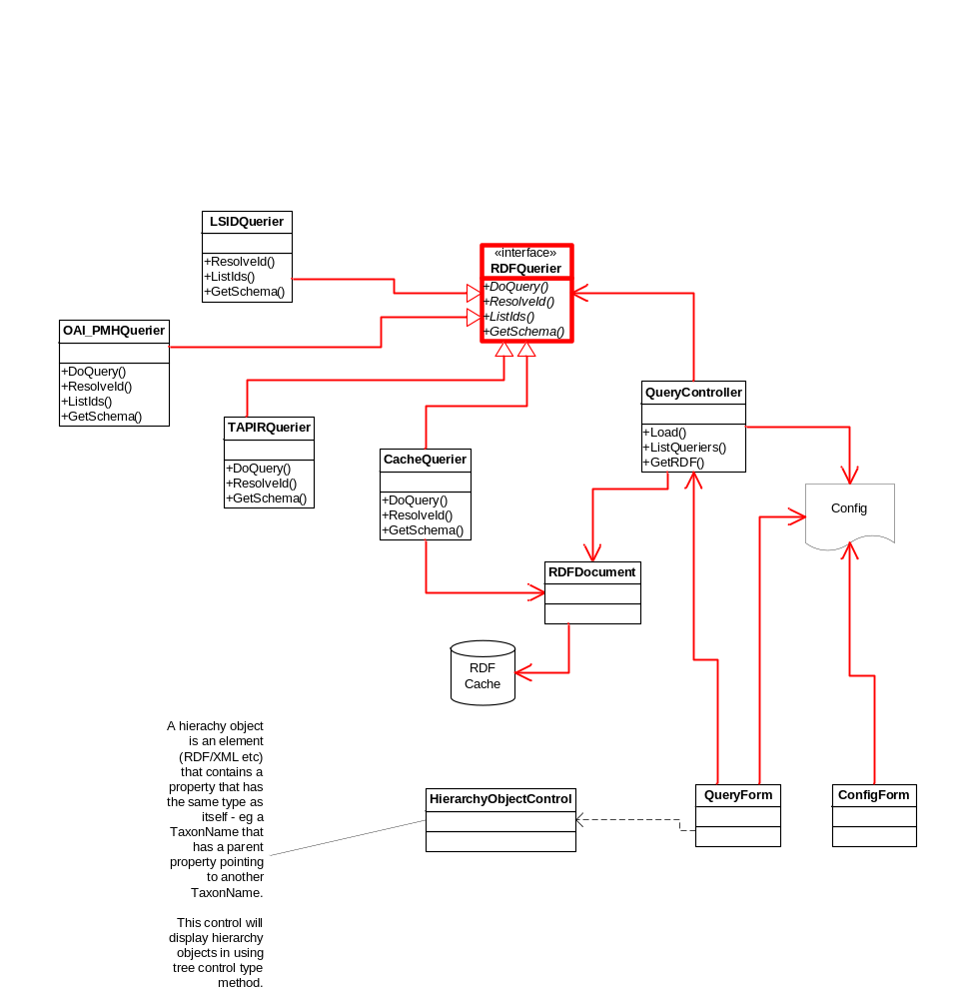

The config for the tool is stored in an MS Access database, and has the following tables.

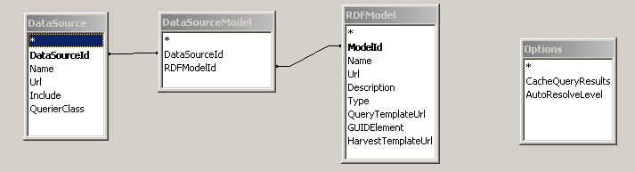

DataSource – this table contains the data sources that can be queried, e.g. the Herb IMI specimen database. A data source will provide access via one protocol, e.g. TAPIR. The class that handles this protocol is specified by the QuerierClass field (e.g. for the TAPIR protocol, the querier class is the RDFClasses.Query.TAPIRQuerier). A dataset may provide several protocols for accessing the data, this would be configured by setting up 2 data sources, with the associated URL and protocol querier class.

DataSourceModel – the joining table for data sources and RDF models. A data source may handle multiple models. E.g. the Herb IMI TAPIR data source can handle the DarwinCore model and the TaxonOccurrence model.

RDFModel – the RDF models for querying the data sources. An RDF model is really a schema and related templates for accessing data using that schema. The schema could be specified via XML schema (XSD), RDF OWL schema, or and Concept Name Server (CNS – see http://www.tdwg.org/dav/subgroups/tapir/1.0/docs/TAPIRSpecification_2007-07-18.html#toc21).

Technology
The development technology used was VB.NET, .NET framework 2.0, Visual Studio 2005.

Additional components include (these are all included in the TDWGRDFBrowser package):
- EyeFinder (Divelements) – a commercially licensed product for providing UI navigation panes. See http://www.divil.co.uk/net/controls/eyefinder/. This could be removed and replaced with other navigation components if the license becomes an issue.
- LSIDDotNET – an open source project that provides a Microsoft .NET framework for working with LSID resolution and provider services. This is used to resolve LSIDs. The configuration for the LSID resolution (e.g. WebProxy, HostMappings) are located in the lsid-client.xml file and the location is specified in the TDWGRDFBrowser app.config file. See http://sourceforge.net/projects/lsid-dotnet.
- TAPIRDotNET – an open source project that provides a Microsoft .NET framework for setting up TAPIR providers. See http://sourceforge.net/projects/tapirdotnet.
- ExpandableGridView – an unlicensed component used for the grid view for displaying the details of the RDF documents.

References
TDWG - http://www.tdwg.org
Gordon & Betty Moore Foundation - http://www.moore.org
IndexFungorum -http://www.indexfungorum.org
Landcare Research – http://www.landcareresearch.co.nz/
CABI – http://www.cabi.org/
OAI-PMH - http://www.openarchives.org/OAI/2.0/openarchivesprotocol.htm
TAPIR - http://www.tdwg.org/dav/subgroups/tapir/1.0/docs/TAPIRSpecification_2007-07-18.html
LSID - http://lsids.sourceforge.net/
RDF - http://www.w3.org/RDF/
OWL - http://www.w3.org/2004/OWL/
EyeFinder (Divelements) - http://www.divil.co.uk/net/controls/eyefinder/.
LSID .NET Source Forge - http://sourceforge.net/projects/lsid-dotnet
TAPIR .NET Source Forge - http://sourceforge.net/projects/tapirdotnet

