* **MR** (It will help if we initial whatever we add to the doc)
* So I talked to Nicole after lab about Asnt0 and she showed me some stuff we end up doing for our project. We will definitely have to think of which tests and classes we can use.
  + Hers was all about dice rolling, which got me thinking we should include a dice test in ours. There can be a section of the game where the user/player must pass a statistically poor dice roll, but with potential in the story to collect items like a loaded dice.
* The game I barely started in the other day is called The Dreamhold. It seems like one of the more notable text-games. I will work through it some more, it could be a good guideline for us. [The Dreamhold](https://zarfhome.com/dreamhold/)
* Good source for puzzles we can use → Keep Talking and Nobody Explodes
  + item/symbol mechanic - TIME stories
* Theme Idea - Steam Library (or generic video game library)
  + start
    - blank room with “ORB” or some cryptic object
    - 4 doorways (4 doorways to x games/each + starting pt = 25 locations)
      * # of games/section, 1 game per location? or 3 games with 2 locations each???
    - Doorways -
    - Start at THE ORB (1)
      * progress in a linear way until ~halfway point where the main character acquires a teleporter item

### 1) Fantasy (Skyrim)

* + - * + Edge of Village

meet Gertrude

there because she landed there after ORB

returning to THE ORB is the meaning of life

OPTIONAL ITEM - has a pamphlet on THE ORB

OPTIONAL ITEM - I also sell cleansing tonic

kills you

* + - * + Tavern

Bartender (aka Trogdor)

buy a drink

ask about the village

hint at Edmund

Simon

Gambling/Dice test (3 dice (20 sided) - roll 6 & 7 & 2)

bypass with loaded dice (Indie game - Tabletop Sim)

gives first part of the password

* + - * + Town Square

Statue of THE ORB

inspect for info about creation

Leader of the village (name)

warning about the tonic

Simon has valuable information about the orb

* + - * + Slums

Edmund the Bastard

knows how to travel through time

gives user a quiz to test if they’re ready

date THE ORB statue was created

something from pamphlet

something out of left field

* + - * Characters
        + Gertrude
        + Edmund
        + Bartender
        + Village Leader
        + Simon
      * Puzzles
        + dice test (re-visit with loaded dice)
        + quiz to travel to modern setting
      * Methods of Death
        + Tonic (Gertrude) - Use it later to kill an enemy in SciFi
        + Infected rats (Slums)

### 2) Modern (Destroyed City)

* + - * + Civil War about THE ORB destroyed society
        + Middle of abandoned city

Bad guys quickly try to kill

use a TIMER?, must act quickly to escape

can attack, if no weapon you DIE

Combat Puzzle

DIE without a weapon

DRAW if fighting nailed plank

Go BACK after visiting SciFi with Sword of THE ORB (SOTO)

* + - * + Supermarket

Find the Twinkie

Meet a scout for the good guys

* + - * + Good guys Outpost

Impressed by the “Traveller of THE ORB”

give a golden token (use in the race)

* + - * + Edge of the city

Meet Talahasssee (loves Twinkies)

doing his own thing

tellsyou about the outpost

lets you use his teleporter

“this will get you closer on your quest to return to the orb. I’m going to go get more of these twinkies”

* + - * + Characters

Talahassee

* + - * + Puzzles

Combat

Twinkie

* + - * + Methods of Death

Combat

Insult Talahassee

### 3) Sci-Fi (Mass Effect, Star Wars)

* + - * + Naboot (for Lorenzo: where Luke Skywalker’s mom is from)

Jam Jam Binks

ITEM - get the teleporter from him

Trade plank with spike for teleporter

Teleporter has preset locations for past worlds and future SW locations

from an adventurer that couldn’t defeat the hardest challenge

Jam jam tells you to talk to java the hut about the orb

* + - * + Tatooined

Talk to Java the Hut

Wants THE ORB for himself, tosses you in Rancor pit

Use tonic to kill the Rancor

Java respects you, welcomes you to his VIP area

Smuggler character

Need to “impress/persuade” them

or just pay them with “token” from outpost

Get the “chance cube” (aka Loaded Die)

* + - * + Death Orb

Sneak around (to find the sword)

Encounter invader (tak or fight him)

get the Sword of the Orb from him - invader is impressed by your knowledge

Talk to vader and he is astonished about the orb

Tells you he’s heard of another realm

Try to fight him and he kills you

* + - * + Hothe

Meet Ackbar

Needs your help finding the Princess

Explore on Tauntauns

Probe droids surprise attack “It’s a trap!!”

defeat them, find a cave where Lele is taking refuge

Get password from Lele - tips you off about the race to return to the orb

* + - * + Characters:Jam Jam Binks, Vader,
        + Puzzles:
        + Methods of Death:

### 4) Racing (Garfield Kart) (2 Rooms)

* + - * + Pre-race area

Meet Garfield

setup for the race

Actions

Start race

Talk to garfield

Examine the area

* + - * + Race area

PUZZLE: timed race against garfield

car runs on math equations

quickly enter answers using numpad

* + - * + Post-Race

if victorious

return to THE ORB

if lose

return to staging area

retry the race

* + - * + Characters:
        + Puzzles

Racing

* + - * + Methods of Death: crash during the race

### 5) Fortnite location

* + - * + teleport there, immediately die

### 6) The ORB

* + - * + Pearl colour - useful info to give to Invader
        + Enter the password
        + final password: orbis beatus est - “blessed theis the orb”

If wrong you die

If right you win

* + - Display
      * use a switch statement and present options for user
      * ie. a = left, d = right, w = up, s = down
      * j = journal?
      * x = examine
      * l = look
    - Key Events
      * dice test
        + have the user encounter a dice test they must pass
        + makes sense that this is in the fantasy realm?

previously can obtain an item like a loaded die to easily pass the test

can challenge the test by luck but with punishment for failure

* + - * it’s a trap!!
        + makes sense that this is in a SW situation
        + not sure of details yet
        + generally screw the user over on purpose
      * combat
        + maybe turn based combat
      * **puzzles**
        + riddles work well in text
        + information fetch - observations from other areas/locations
      * **RACE** - overlap with puzzle
        + timed event, must complete with active timer!!
* Feb 07/19 Meeting
* 4. Project Management
  + Team Organization
    - Team Lead - Mat
    - Design Lead - Ricky
    - QA Lead - Lorenzo
    - Documentation - Lorenzo
    - Software Developer - Everyone
    - Software Tester - Everyone
  + Risk Management
    - not yet
* 5. Development Process
  + Code Review Process
    - each work on a separate branch, then when finished a section create a merge request
  + Communication Tools
    - WhatsApp group message (for now)
    - switch to Slack if there are persistent issues with connections through ULeth network
  + Change management
    - * Team lead will delegate bug reports based on priority
* 5b: Software Design

[THE ORB]

# 

[Team IT'S A TRAP]

[AKBAR]

# 

**Bueckert, Ricky**

**Conrad, Lorenzo**

**Richards, Mathew**

**Feb. 15, 2019**

# 

Table of Contents

Introduction……………………………………………………………………………………………...1

Project Management…………………………………………………………………………………...1

Team Organization……………………………………………………………………………..1

Risk Management……………………………………………………………………………...2

Development Process……………....………………………………………………………………….4

Software Design.……..………………………………………………....…....………………..4

Appendices……………………………………………………………………………………………...5

Appendix A………………………………………………………………….…………………..5

# 

# 

# 

# 

# 

# 

# 

# **Introduction**

The project is a text based adventure game called [THE ORB]. The Orb is game in which the object is to collect the required password, return to the location of The Orb, and input the password into The Orb. The pathway through the game is semi-linear, but around the midpoint you can obtain a teleporter that allows you to travel to location in a non-linear pathway. Without the teleporter the progression through the game is linear in manner. Actions in the game include: interacting with non-playable characters, picking up or using items, solving puzzles, combat, smovement, and even solving a timed event puzzle. This report includes details about how the team will be organized for the development of the game, as well as how the team will respond to potential problems that could appear during the development of the game. The problems/risks include: the planned project was too large, team underestimated how long parts of the project would take, major changes are needed during implementation, addition or loss of a team member, unproductive team members, team members lacking the technical background, major life events, inexperience with new tools, learning curve for tools is steeper than expected, and tools do not work together in an integrated way. The report also goes into detail about the code review process because we are working in different branches and using merge requests to bring changes in the implementation together across group members. While bug reports will be delegated by the team lead, they are based on priority that has been decided as a group. The communication we are using is a whatsapp group chat as messaging is easy and it allows us to compare code using pictures. Detail about all the above topics is given further into the report.

# **Project Management**

**Team Organization**

Mathew Richards

* + Team Lead, Software Developer, Software Tester

Lorenzo Conrad

* + Quality Assurance Lead, Documentation Lead, Software Developer, Software Tester

Ricky Bueckert

* + Design Lead, Software Developer, Software Tester

## 

## 

## 

## **Risk Management**

### 1) Requirements/Design/Estimation

* Risk 1: The planned project was too large
  + If the project we planned is too large we would prioritize the core of the game and make the game more linear to make the coding simpler and less time consuming. The core of the game being prioritized simply means that the important features and classes are done first reducing the number of items that are required to complete the final objective. When deciding what to drop to reduce the project size we would drop things that had not been started, meaning if we already implemented part of a secondary objective we would finish it and remove another secondary objective from the game. The reason for this is so that we do not waste time and effort already put into the project.
* Risk 2: Team underestimated how long parts of the project would take
  + If the team underestimated how long different parts would take then similar actions would be taken as if the project was planned too large. The team would re-assign resources to get the core of the game finished. We would re-assign people working on secondary systems to help finish the core classes in order to get back on schedule. We may need to drop secondary objectives like a timed event, which at present none of the group members know how to implement. However with deadlines set during team meetings as well as constantly pushing to the repository to see the progress of the separate parts we hope to catch this problem before it becomes a problem. If noticed in time we can adjust the timeline to better suit the project goals and deadline.
* Risk 3: Major changes are needed during implementation
  + If major changes are needed the first thing we would do is hold a team meeting to get consensus of the changes and delegate actions in the new plan. Then we would reallocate resources in order to prioritize the changes that need to be implemented. Meanwhile, less critical systems would take a back burner. We would also update our diagrams to match the change being made so that there is no confusion when implementing the changes and time is not wasted on coding things we are no longer implementing.

### 2) People

* Risk 4: Addition or loss of a team member
  + If we lost or added a team member, we would first call a team meeting with the new team to discuss the future of the project. In the case of a lost team member we may have to downsize the game to something manageable with fewer people. In the case of an addition to the team we would bring that person up to speed as fast as possible and delegate the current workload taking into consideration the skill set of the new team member.
* Risk 5: Unproductive team members
  + If we have unproductive team members, our first consideration would be to check if the goals we have set are achievable within the given time. Then we would talk to them about their responsibilities and ask them to increase their productivity. However, if team members are not meeting the goals set out during the team meetings continuously, we would report this to the professor and delegate the tasks to the remaining team members so that the credit is given to the team members who are doing the work. If the project becomes to much for the productive team members, we would consider dropping secondary objectives from the game and simplifying the game.
* Risk 6: Team members lacking the technical background
  + All team members are fluent at an intermediate level in C++, which will be used to program the game. If there are difficult sections each member will try to research for themselves how to overcome the obstacle. Then, if the problems remain, we would consult each other, then an instructor. If a group member is unable to program a section we would re-assign their tasks and give them easier tasks to complete, also notify the professor of the situation in order to give credit to the team members who deserve it.
* Risk 7: Major life events
  + If a team member encounters major life events causing them to be less productive, we would try to accommodate the best we could, but we would notify the professor so the credit for the work that is done is given to the people who did it. Then we would delegate the workload to the remaining team members however if it is too much for two people to handle, we would simplify the game a bit and remove some of the secondary objectives/systems and focus our effort of the core of the game.

### 3) Learning & Tools

* Risk 8: Inexperience with new tools
  + In the case that the team is inexperienced with a new tool, we would have a team meeting to discuss how the tools are supposed to work (a kind of workshop to figure out together where and how to use the tool). If, however we cannot figure out the tool is supposed to be used as a team then we would talk to the professor to see if there are better tools to use that are simpler or easier to implement while still do the same thing.
* Risk 9: Learning Curve for tools is steeper than expected
  + If the learning curve for the new tool is steeper than we initially thought, we would see if there tools that are easier to implement and understand without losing functionality. The team would try to stick to the tools taught in class as much as possible so that we can ask the professor/TA for help with the tools. As well as being able to ask for help when using tools that are not taught in class, the responsibility lies solely on the team to make sure the tools works properly in the first place.
* Risk 10: Tools do not work together in an integrated way
  + If the tools that we are using are not working together in an integrated way, the first thing we would do is find out if our implementation of the tools is correct. If the implementations were correct then we would try find out if there are tools being used that could be replaced with another tool without losing functionality or efficiency of the project.

# 

# **Development Process**

### Code Review Process

For the code review process each group member will work separately on their respective branch when changes are made and solidified then the group member will request a merge request with the master. This is so that the Quality Assurance Lead can go through the code to double check that is will not break the pipeline. This ensures that code will have been reviewed at least twice before added to master; once by the primary author, and then again by the QA lead.

### Communication Tools

The team will be using WhatsApp to communicate with each other because it allows us to call, message and also send pictures. The reason pictures are helpful in this case is because if anyone is having trouble with a certain line of code a fresh set of eyes is always good to help and find the problem. If WhatsApp becomes to unreliable because of the Uleth network connections, then we will switch to Slack.

### Change Management

Bug Reports will be delegated by the team lead based on the priorities that have been discussed by the group (with core programs/ code obviously have priority over sub programs) and giving it to the person/people who wrote that section of code that is causing the bug. When the bug is fixed the Quality Assurance Lead will double check if the bug is fixed and report thus clearing the bug report.

### Software Design

The software design is shown in detailed UML diagrams in the appendices.

# 

# **Appendices**

## **Appendix A: Figures and Tables**

Class Diagrams

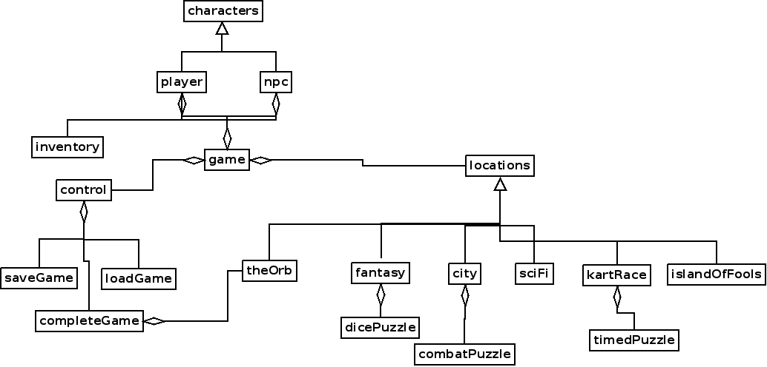

Figure 1 - Overview of classes (does not include exception classes)

## 

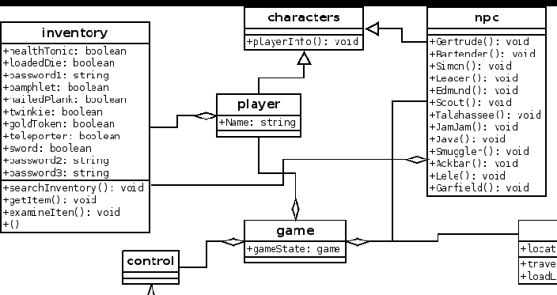

Figure 2 - Implementation of character classes and relationships

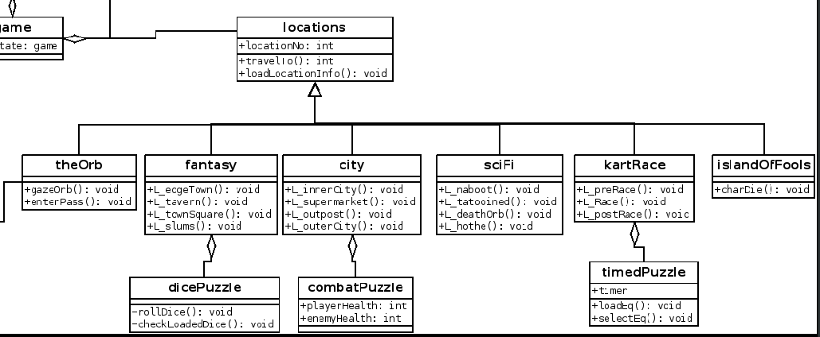

Figure 3 - Implementation of locations

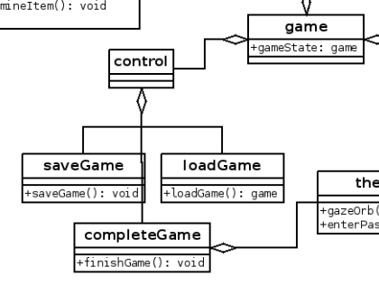

Figure 4 - Implementation of game state control

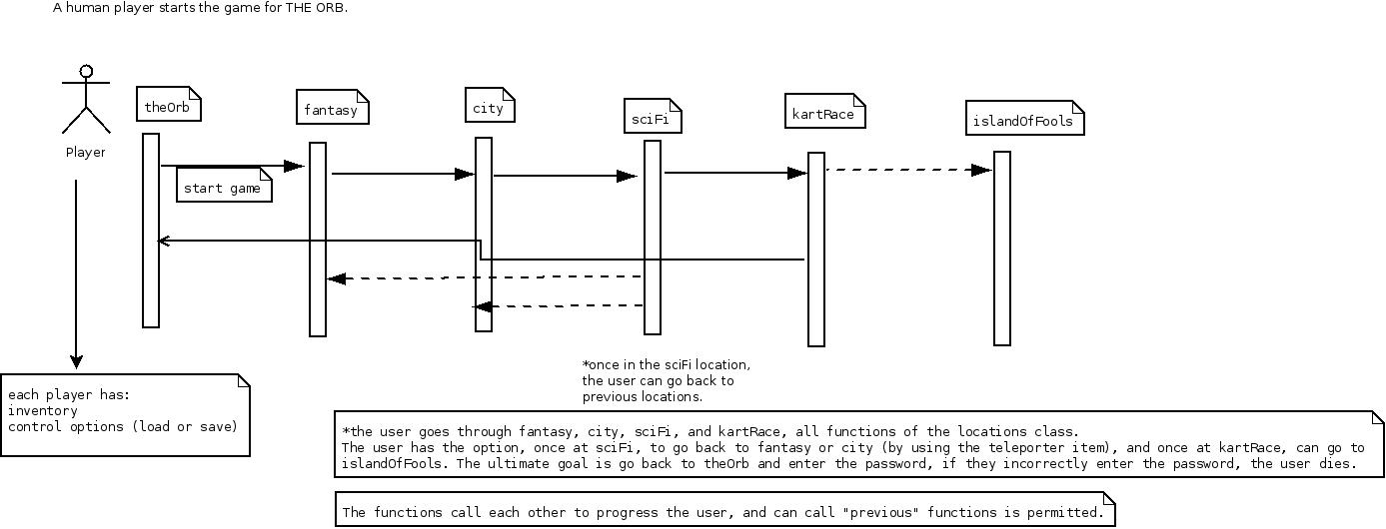

Figure 5 - sequence diagram showing the general progression through the game