The Gut Guardians
Grace Liu is a PharmD from the Bay Area who has been fascinated by the gut microbiome for many years. She focuses on the following organisms she calls the “gut guardians”, the keystone species that, when properly groomed will keep pathogenic organisms at bay and ensure the overall health of the body’s ecosystem.

The importance of butyrate

The cells lining your intestines will die without proper nourishment, and a key food they expect is butyrate, a type of short-chain fatty acid. Fortunately, your colon is covered with bacteria that can ferment plant fiber, producing butyrate as a by-product.
From Wikipedia:
{\Scrv_ps=Butyrates are important as food for cells lining the mammalian colon (colonocytes). Without butyrates for energy, colon cells undergo autophagy (self digestion) and die.[1] Short-chain fatty acids, which include butyrate, are produced by beneficial colonic bacteria (probiotics) that feed on, or ferment prebiotics, which are plant products that contain adequate amounts of dietary fiber. These short-chain fatty acids benefit the colonocyte by increasing energy production,and cell proliferation and may protect against colon cancer.[2]

Butyrate is a major metabolite in colonic lumen arising from bacterial fermentation of dietary fiber and has been shown to be a critical mediator of the colonic inflammatory response.
\end_Scrv_ps}Faecalibacterium prausnitzii

http://www.sciencedirect.com/science/article/pii/S1369527413000775
{\Scrv_ps=Faecalibacterium prausnitzii is the most abundant bacterium in the human intestinal microbiota of healthy adults, representing more than 5% of the total bacterial population. Over the past five years, an increasing number of studies have clearly described the importance of this highly metabolically active commensal bacterium as a component of the healthy human microbiota. Changes in the abundance of F. prausnitzii have been linked to dysbiosis in several human disorders.
\end_Scrv_ps}

Roseburia
This genus, under the phylum firmicutes, is known to be associated with health.

There is some evidence that bariatric surgery works partly because it changes the composition of gut bacteria, especially Roseburia, which can increase up to 12 times.

My Roseburia levels over time:
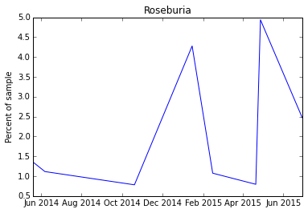

Christensenellaceae
Christensenella

Akkermansia

Correlates well with weight: the less you have, the higher your BMI.

It has this affect on weight apparently by regulating the amount of LPS in the blood.

Akkermancia likes to live in a thick mucus layer, so it persuades the cells in the gut to produce more mucus. This prevents LPS from crossing over into the blood.

High fat diets appear to lower Akk levels, but extra fiber seems to increase it.

Here is my Akk levels over time:

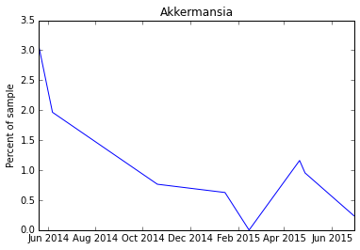

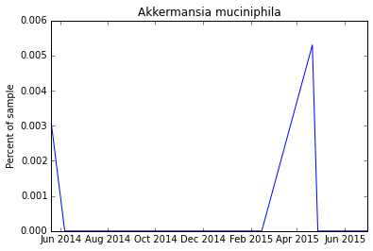

Bifidobacteria longum
Bifidobacterium

B. Longum as % of total Bifido
Bacteroidetes/Firmicutes ratio

