Every human body is home to a rich environment of tiny living organisms, trillions of them, with their own genes, their own ways of living and surviving, and their own long histories, permanently intertwined with humanity since the beginning. These microbes inhabit every possible niche inside and outside the body. Covering every inch of skin, lining every part of the nose and ears, they have burrowed deep inside nearly every organ, consuming as well as producing, living in such quantities that together they would weigh somewhere between three and five pounds — about as much as the brain.

The word “microbe” refers to any tiny organism that carries its own genetic information for purposes of propagating itself. Far too small to see with the naked eye, dozens could fit inside a typical human cell. The vast majority of microbes are bacteria, though viruses and phages fit this description too, as well as archaea, the extremophile life forms that live and thrive in environments too challenging for bacteria.

A typical human will have somewhere between [n and m] individual cells — blood, skin, neurons, other tissues — each descended from a single germ cell, the fertilized egg that began dividing itself and multiplying after the moment of conception. By contrast, microbes had to hitch their own rides later, beginning in the womb and turning into a flood at the moment of birth and beyond. But each microbe, like each human cell, remains deeply interconnected with the fates of all the other cells, all the way to the moment of death, and even after that.

[Examples of odd microbes everywhere]

A team in France, performing experiments on snowflakes, discovered microbes in the sky.
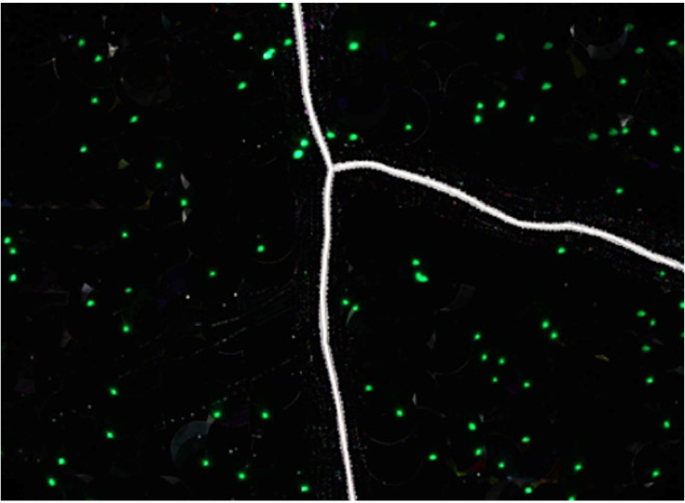

!fig(amatoSkyMicrobe)

These microbes are so numerous that they affect the climate.

Traces of plankton have been found in space, on the surface of the International Space Station, where they are believed to have floated from the upper atmosphere.

http://tass.ru/en/non-political/745635

