Hacking my sleep

About a year ago, I started to notice my sleep becoming less regular. Nothing serious — thankfully, I’ve never had sleep problems — but I was waking up too early, and I didn’t seem to be quite as refreshed. Maybe it’s just a sign of age, I thought, until I read in Martin Blaser’s excellent book Missing Microbes (p.304) that most (80%) of the precursors to the sleep- and mood-regulating neurotransmitter serotonin is made in the gut. Could my gut microbes affect my sleep?
A few internet searches later led me to evidence that B. infantis modulates tryptophan, the stuff in turkey that urban legends have long blamed for that sleepy feeling you get after Thanksgiving dinner, so my first step was to look at my gut biome results to see my levels of bifidobacterium.
As I suspected, I had no B. infantis, and in fact my overall bifido numbers were pretty low as you can see from this item on my uBiome results sample explorer page:
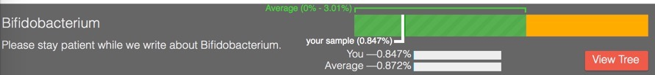
You may already know about pre-biotics, foods that feed bacteria, as opposed to pro-biotics, which are simply pills or foods that already contain a bunch of (presumably) beneficial microbes. Lately a number of people have noticed that a particular kind of starch, so-called resistant starch is a prebiotic that acts like a yummy smorgasboard for bifido and other bacteria. I followed a protocol that uses plain ole Bob’s Red Mill Potato Starch (easy to find any nice grocery store): just a couple of tablespoons one hour before bedtime to give the starch time to make it to the upper colon where the bifido live.
Whoah! You wouldn’t believe how wonderfully I slept that night. Over 8 hours of rock-solid, uninterrupted sleep, and more vivid dreams than I’ve had in years. It was amazing!
After a few days of this, I submitted another sample to uBiome for testing:
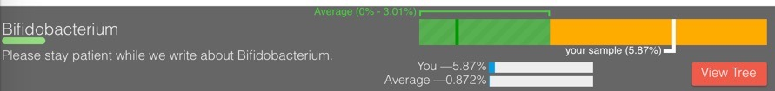
Holy bloom, Batman! That’s just plain stratospheric: up from 0.847% before the potato starch, to over 5.87% afterwards. That 8x improvement it seems clearly explains my much-improved sleep.
But nothing’s free, right? If the bifido are increasing that much, then something else is decreasing. My sleep might be improving, but am I sacrificing some other aspect of my long-term health?
To find out, I wrote a couple of utilities to examine my uBiome results in more detail. One of the things I like most about uBiome is that they give users access to the raw data, which you can convert to work in Excel or another programming environment. If you’re interested in more details, you can read how I did this later, but here are some of the major species that went extinct after I took potato starch:

{\Scrv_ps=## missing.count_norm missing.tax_name
## 1 8295 Bifidobacterium tsurumiense
## 2 4650 Subdoligranulum variabile
## 3 2074 Dialister sp. oral clone BS095
## 4 780 Desulfovibrio sp. oral clone BB161
## 5 475 Adlercreutzia equolifaciens
## 6 459 Ruminococcus sp. ID1

\end_Scrv_ps}
What do these microbes do? After a few more internet searches, my answer is: nobody knows! We have some guesses, but so far scientists just haven’t had enough samples from real people to understand much. That’s another reason I hope you’ll submit your samples to uBiome, to increase the number of data points that scientists can work with in hopes of understanding this better.
Meanwhile, my sleep continues to be much better than before I began this experiment, so I’ve stopped taking potato starch and have been substituting a few other foods that seem to affect the microbiome.

