The Illumina machines spit off huge amounts of data (FASTQ files can be hundreds of thousands of lines long), so to be useful you’ll need a summary. UBiome provides a much more concise version called a “raw taxonomy” file, which is generally only a few hundred lines showing just the organisms they think they found in the sample.

What is JSON
UBiome’s taxonomy files come in a simple structured text format called JSON (JavaScript Object Notation), commonly used across the web. Although it’s not as convenient for people as the rest of the uBiome web site, programmers refer to JSON as “human readable”, because if you squint enough you can sorta tell what it means without a computer program. Here’s a sample:

{\Scrv_ps={
"ubiome_bacteriacounts": [{
"taxon": "2",
"parent": "131567",
"count": "22691",
"count_norm": "1000000",
"avg": null,
"tax_name": "Bacteria",
"tax_rank": "superkingdom",
"tax_color": null
}, {
"taxon": "1239",
"parent": "2",
"count": "15414",
"count_norm": "679300",
"avg": null,
"tax_name": "Firmicutes",
"tax_rank": "phylum",
"tax_color": "5E6591"
}
\end_Scrv_ps}
JSON is just structured data. That’s it. The data is organized according to keys and values. The keys are unique identifiers and the values are their values. The whole file looks that way. The only requirement of a JSON file is that it be consistent with this pattern, because after all it will need to be read by a computer eventually.
The uBiome Taxonomy JSON files identify the key ```uBiome_bacteriacounts``` which is mapped to a bunch of fields, each representing a particular organism found in your sample. Look at the figure above to get the basic idea.

Because uBiome JSON files are well-structured, it’s easy to process them with other software, including Excel. That’s our next step: bring this data into Excel.

Converting uBiome taxonomy JSON to Excel

If you just have one or two files, it’s easy to bring uBiome taxonomy data into Excel. Go to the uBiome apps page and click on the section labeled “Download taxonomy”.

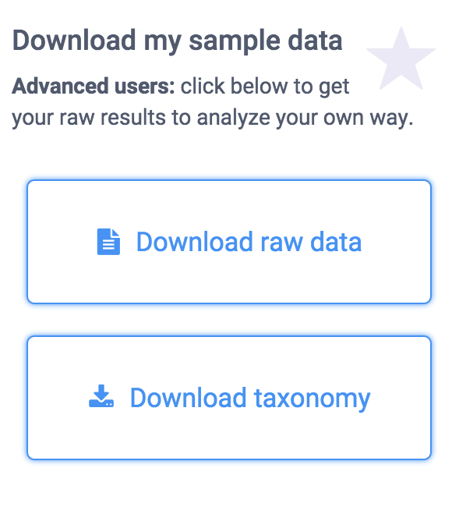

You’ll see a page of JSON representing what uBiome found in your sample.

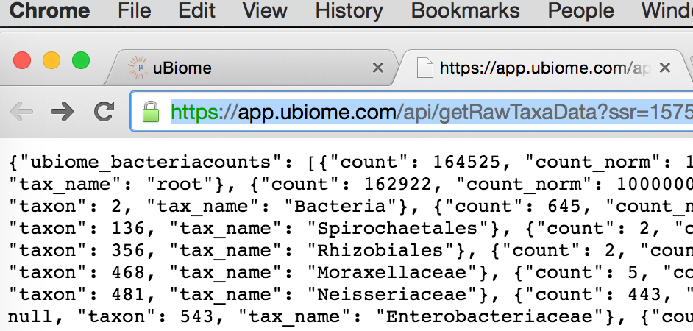

On a desktop computer, if you select-all (press control-A or command-A) then you can copy this data to the clipboard to prepare to paste it to another web site.

There are many web sites that will convert JSON to a format that will work in Excel. Google “Json to Excel” or “Json to CSV” and you’ll find one. Just paste your data into one of those sites to convert it for either Excel’s native (XLS or XLSX) format, or the more universal CSV format, readable by Excel. Here are a few of the sites I’ve tested:
http://www.convertcsv.com/json-to-csv.htm
http://www.json-xls.com/json2xls

Once the data is in Excel, you can work with it just as you would with any Excel data sheet. Here’s how one of my recent uBiome taxonomy files looks in Mac Excel:

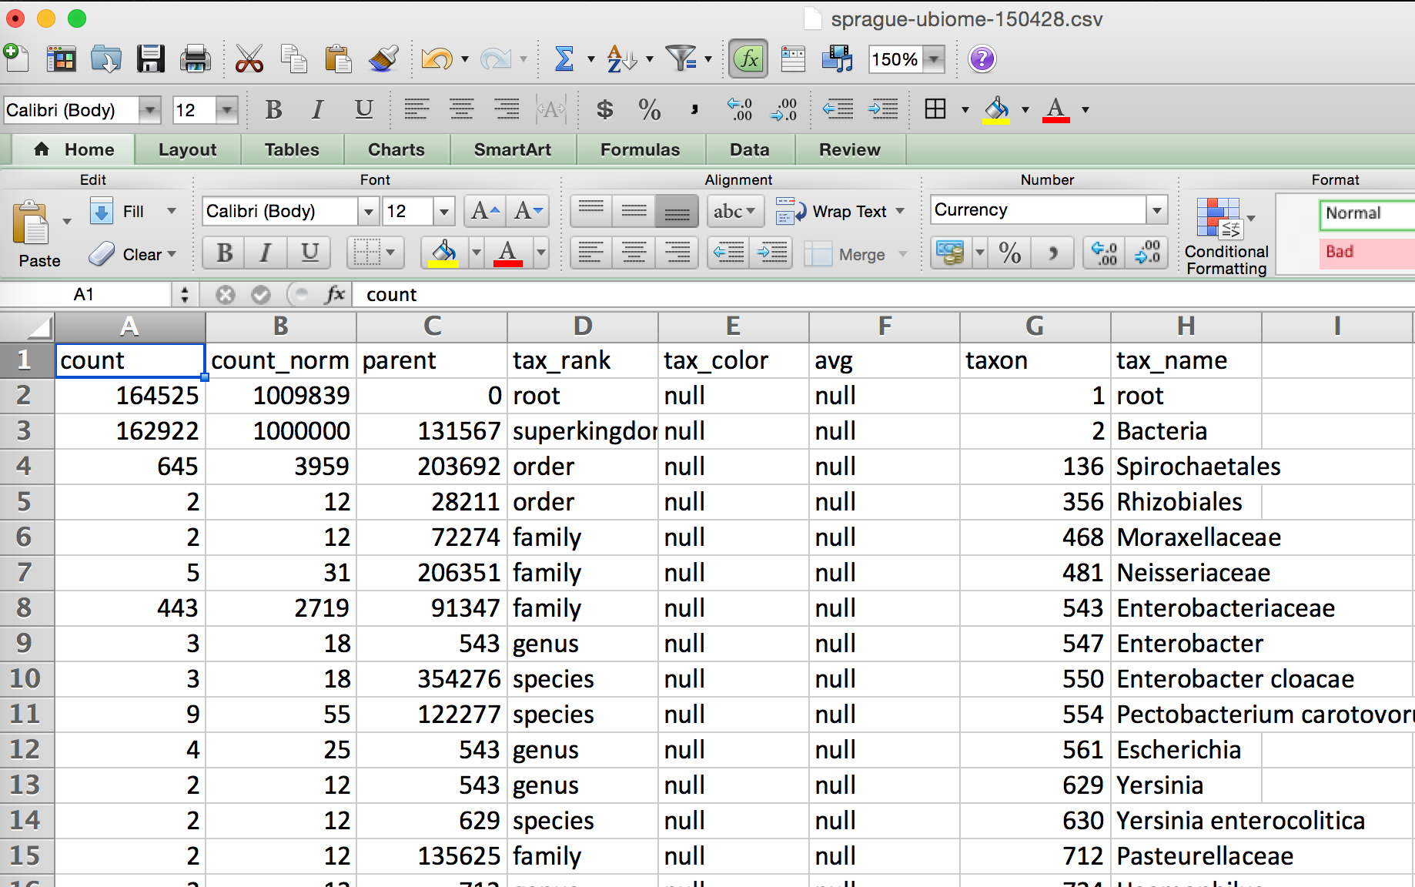

Yours may look slightly different. Sometimes uBiome changes the labels on the taxonomy slightly, and the ordering of the columns may be different depending on how the JSON was converted, but none of that matters. The key is that you are now able to work with it in a full-blown spreadsheet.

The uBiome data tags
Let’s review the meaning of each of the columns. The uBiome JSON taxonomy data includes the following fields:

The uBiome JSON taxonomy data includes the following fields:

count: an absolute measure of number of organisms found in the sample. Without knowing the size of the sample, or how many times the DNA inside was processed through PCR amplification, this number doesn’t mean much except in relation to other counts at the same taxonomical rank.

count_norm: a “normalized” version of the count, created by simply dividing the count on a given row by the count found on the row with tax_name = Bacteria and then multiplying by one million. It’s easier to just think of it as parts per million: each unit is 1 / 10,000th of a percent. For example, if you see a row with count_norm = 500,000, you can just think of that as 50% of the sample.

tax_name: this is the classification of the organism based on the level of its taxonomy. If you were looking at a human being, for example, you would see homo sapiens if you selected tax_rank = species, but you’d see mammalia if you selected tax_rank = class.

tax_rank: tells the level of the taxonomy. In daily conversation about animals or plants, we usually refer to the species (e.g. homo sapiens), but sometimes it’s more useful to talk about bigger groupings of related organisms. For example, humans are members of the class mammalia, along with tigers and horses. If this spreadsheet were counting organisms at the level of class mammalia, the count_norm would almost certainly be bigger than the count_norm for humans alone, unless humans were the only type of mammal found in the sample.

taxon and parent: these help identify the ranking in a more precise way by pointing out which tax_ranks are subsets of which. For example, Bacteroidia above has a parent = 976, meaning that it is a subset of the taxon 976, Bacteroidetes. When you follow the various taxons and parents up the chain, you’ll see they all end in the superkingdom Bacteria, which has a taxon of 2. The values for these numbers, incidentally, are taxonomical numbers from the curated database at NCBI, the national bioinformatics center run by the U.S. government. Enter the number into the taxonomy browser at the NCBI Taxonomy Browser and you can learn as much as you want about that organism.

tax_color doesn’t matter for this anaysis, but uBiome software uses this to colorize their pretty graphs to make them more readable.

Of these fields, the most important ones are tax_name, tax_rank, and count_norm.

