BEFORE THE IOWA BOARD OF BEHAVIOR HEALTH PROFESSIONALS

IN THE MATTER OF THE STATEMENT OF CHARGES AGAINST RACHEL SHUM MCALPIN, RESPONDENT
FILE NO. 15-0221

TERMINATION ORDER

COMES NOW the Iowa Board of Behavior Health Professionals (“Board”) and enters this Termination Order. On August 4, 2015, Rachel Shum McAlpin (“Respondent”) and the Board entered a combined Settlement Agreement and Final Order. The Board finds that Respondent has successfully completed the terms of the August 4, 2015, Board Order.

THEREFORE IT IS HEREBY ORDERED that the terms of Respondent’s Board
Order are terminated and Respondent’s Iowa Board of Behavior Health Professionals license is returned to its full privileges, free and clear of all restrictions.

Dated this 21st day of April 2026.

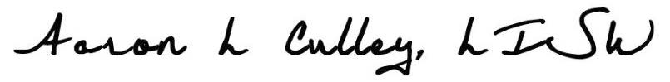
Aaron L. Culley, Chair
Iowa Board of Behavior Health Professionals
6200 Park Avenue Suite 100
Des Moines, Iowa 50321

