BEFORE THE IOWA BOARD OF BEHAVIORAL HEALTH PROFESSIONALS

IN THE MATTER OF THE STATEMENT OF CHARGES AGAINST JAMIE JOHNSON, RESPONDENT
FILE NO. 22-0006

TERMINATION ORDER

COMES NOW the Iowa Board of Behavioral Health Professionals (“Board”) and enters this Termination Order. On January 27, 2026, Sharon Johnson (“Respondent”) and the Board entered a Settlement Agreement and Final Order. The Board finds that Respondent has successfully completed the terms of the January 27, 2026, Board Order.

THEREFORE, IT IS HEREBY ORDERED that the terms of Respondent’s Board
Order are terminated and Respondent’s Iowa Board of Behavioral Health Professionals license is returned to its full privileges, free and clear of all restrictions.

Dated this 23rd day of April 2026.

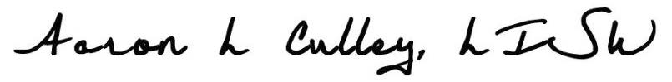

Aaron L. Culley, Chair
Iowa Board of Behavioral Health Professionals
6200 Park Avenue, Suite 100
Des Moines, Iowa 50321

