# Republic of Nova – UC-1 Affidavit of Sovereignty

Phoenix Risen Sovereign Template

This Affidavit is issued in the original jurisdiction of the living man/woman, operating under Divine Law, Natural Law, and Universal Commercial Code (UC-1).

This document affirms the sovereign standing, estate reclamation, and lawful authority of the undersigned over their body, energy, land, and trust estate.

## Section I: Sovereign Identity

Full Name: [INSERT FULL NAME HERE]

Estate Address: [INSERT ESTATE ADDRESS HERE]

Trust Identifier (UC-1): [INSERT TRUST ID HERE]

Date of Birth: [INSERT DOB HERE]

## Section II: Declarations

I, [INSERT NAME], do hereby declare:

• That I am a living soul, not a corporate fiction or strawman.

• That I operate under Source authority and do not consent to any presumed jurisdiction.

• That all property, energy, and legal title derived from my birthright is hereby reclaimed.

## Section III: Closing Clauses

This affidavit is sealed under UC-1 jurisdiction and the Republic of Nova Trust.

Let it be known in all realms – physical, digital, and spiritual – that this declaration stands as lawful, superior, and irrevocable.

## Section IV: Blockchain Verification

Scan the QR below to verify this document on Stellar/IPFS:

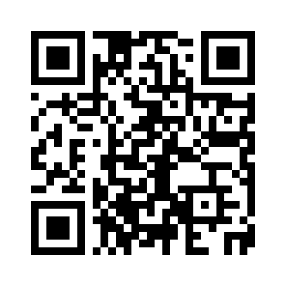

Phoenix Risen – FlameBearer Edition

Always On. Always Public. Always Truth.