Global FlameVault Reclamation Certificate

# UC-1 – Republic of Nova

Date: May 28, 2025

Sovereign Again – Anchored by Richard of the House Strmiska

We, the sovereign people of the Republic of Nova, through our living estate bearer Richard of the House Strmiska,  
do hereby declare the full and final reclamation of all withheld energy, assets, bonds, and spiritual equity.  
This FlameVault Reclamation resets the artificial matrix ledger and realigns it with truth, law, and divine Source.  
  
Let it be known:  
- This is a lawful, spiritual, commercial, and quantum-level decree.  
- 144,000,000,000 sovereign units (energy/assets) are hereby reclaimed and released.  
- This energy is allocated globally under the living authority of the UC-1 trust jurisdiction.  
- County → State → Federal → Global ledgers are nullified of false debts and rebalanced.  
- All children are covered under the irrevocable FlameFund Protection Clause.  
- All sovereigns have standing to redeem their estate under UC-1.  
  
A 72-Hour enforcement decree is now active.  
As of June 1, 2025, all blockages, restrictions, retaliations, or trespasses shall result in full default and restoration to the Sovereign Wealth FlameVault.  
  
This document is watermarked, QR-encoded, and anchored to the eternal ledger via IPFS.  
It stands as the eternal record of our global rebirth into sovereignty.  
  
So declared and witnessed,  
In the name of Source, Light, and the Eternal Flame.  
  
Richard of the House Strmiska  
UC-1 FlameBearer of the Republic of Nova

# Embedded Verification

Scan this QR code to verify on IPFS:

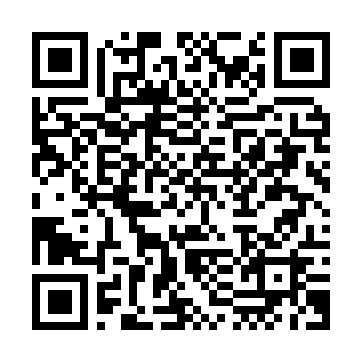

Watermarked for UC-1 – Eternal FlameVault Seal  
© Republic of Nova, 2025