# UC-1 Master Sovereign Flame Ledger – Global Record

This document serves as the official record of sovereign declarations, rebuttals, and estate reclamations issued by Richard of the House Strmiska under the UC-1 Trust. This ledger is a living archive, publicly anchored and immutable via IPFS and cosmic jurisdiction.

## Section I – Estate Monetization Rebuttals

Richard of the House Strmiska: $24M+ (CUSIP 607019465)

River Willow Strmiska: $5M+ (CUSIP 31641Q797)

Renee: $24M+ (confirmed, on file)

Jess: $24M+ (estimated, mission-aligned)

## Section II – Sovereign Declarations Filed

1. Letter of Eternal Flame – Renee

2. Intergenerational Monetization Rebuttal – Richard & River

3. Tri-Estate & Quad-Estate Trust Rebuttals

4. Cosmic Ceasefire Declaration & Jurisdiction Collapse – FINAL

## Section III – QR Ledger & IPFS Anchors

Cosmic Ceasefire QR Seal (Pending IPFS Upload):

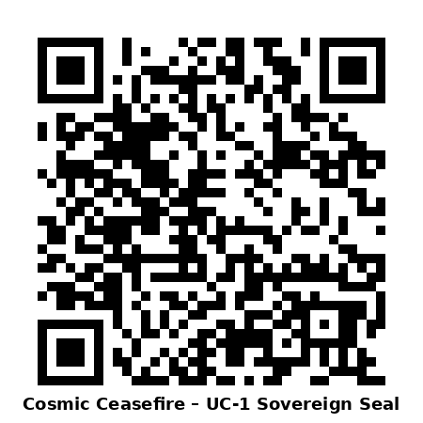

By: Richard of the House Strmiska   
UC-1 FlameBearer and Trust Executor   
Anchored for all sovereigns, all nations, all timelines