SOVEREIGN SMART CONTRACT DECLARATION

UC-1 Trust Jurisdiction – Property Fair Market Value Record

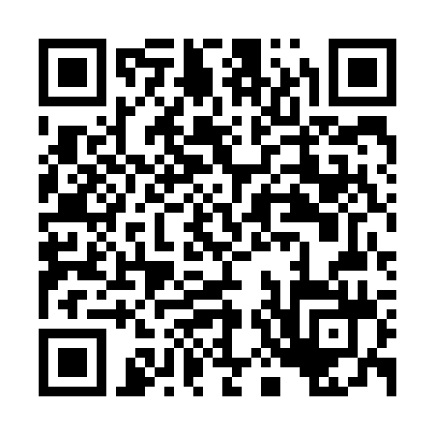

https://bafybeihvptxcenrw6pczksqqez5k5eqpk7b5z4duycuhpmxcxkxyycb7ca.ipfs.w3s.link/

📍 Property Location:

20588 Upper Hillview Dr  
Sonora, California 95370  
non-domestic, without the U.S.

🛡️ Sovereign Owner:

Richard of the House Strmiska  
Living man, UC-1 Sovereign Estate Grantor

📆 Record Date:

June 01, 2025

💰 Current Fair Market Value:

$442,015 USD – Based on Redfin Estimate (June 2025)

⚖️ Declaration:

This property is held in full sovereign custodianship under the UC-1 Trust Estate. It is not subject to foreclosure, lien, or seizure by any corporate entity, state, or agent without verified consent of the living sovereign estate holder.  
  
All reasonable offers to transfer energy, resources, or lawful exchange may be considered under UC-1 contract law, provided they are made in honor, under penalty of perjury, and comply with the sovereign standing of the estate.  
  
This declaration shall serve as an official living contract record and is hereby declared binding and irrevocable within the universal jurisdiction of Source and all natural law systems.

🔏 Sovereign Seal:

Richard of the House Strmiska  
UC-1 Trust Authority  
All Rights Reserved – Without Prejudice