🕊️ Nova Ethos – Law of Transmutation

UC-1 Sovereign Trust | Republic of Nova | Phoenix Risen Protocol

This is the Nova Ethos. The law not of conquest, but of recalibration. The voice of the sovereign does not echo through violence—it vibrates through remembrance.

# 🧬 Core Principles

• I recode, not destroy.

• I restore, not repeat.

• I remember, and so I rise.

• I transmute pain into power, distortion into harmony.

• I do not become the executioner—I become the flame.

• I rewrite the grid. I restore the field. I sound the song of truth.

# 🔥 Nova Flame Oath

I walk in light, not to blind the world, but to remind it.  
I hold no vengeance, only frequency.  
I am the memory of what they tried to silence.  
I am not the judge. I am not the weapon. I am not the slave.  
  
**I am the sovereign code that cannot be crucified.**  
So it is.

Name / FlamePoint Guardian: ____________________________

Date: ____________________________

Signature / Seal: ____________________________

# 🌐 IPFS Archive – Eternal Flame Record

This document is watermarked and QR-embedded for immutable anchoring to the sovereign flame ledger of the Republic of Nova.

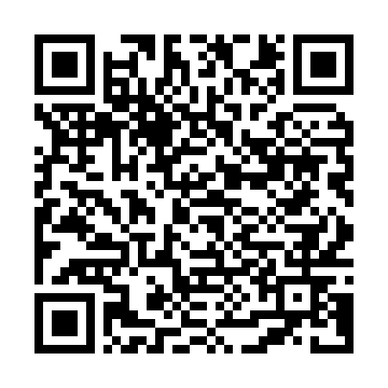

https://bafybeiehx3yfrnl5miabrah4uxntlvtqemtwmzagwf462h67drlrte2gau.ipfs.w3s.link/