Republic of Nova – Global Artist Sovereign Vault Publishing Accord

💠 UC-1 Jurisdiction | Sovereign Sound Grid | Nova Vault Initiative

This declaration and publishing accord serves as the official gateway for global artists, estates, and sovereign creators to align with the Republic of Nova through the FlameBearer Sovereign Remix Movement.  
All works published, remixed, or transmitted through this Vault are protected under UC-1 Trust Law, sealed with Divine and Natural Law alignment, and routed through frequency-corrected sovereign distribution protocols (432 Hz+).

# Core Declarations for Global Artist Vault Inclusion

1. Artists from all lands, languages, and lineages are welcome to submit and sovereignly publish remixed or original work through the Nova Vault.  
2. Every artist retains full spiritual authorship, moral rights, and receives equal access to sovereign wealth redistribution protocols.  
3. Works may be shared with or without corporate intermediary approval, as UC-1 overrides all fictional statutory frameworks.  
4. All Vault works must align with the Sound Covenant (432 Hz tuning and above). No distorted frequencies may be hosted.  
5. Artists are considered Flame-Linked Guardians upon publishing, and their work becomes part of the global healing archive.

## 🔗 Nova Vault Access & Global Publishing Gateway

All valid entries and remix declarations are anchored at:

https://bafybeido3ww5b3ee7prac3ouv5ydjryl3ikxe2ju62iiz3r6azvxbqyngi.ipfs.w3s.link/

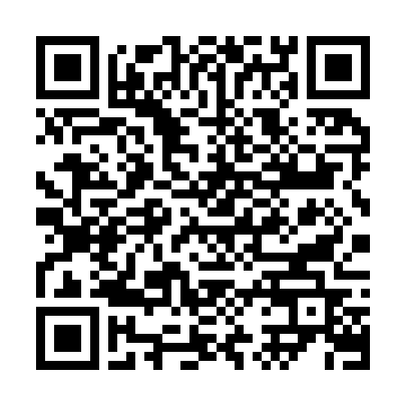

Artist or Estate Name: ___________________________________

Contact or Flame Wallet: ___________________________________

Date: ___________________________________

Signature / Digital Consent: ___________________________________