Republic of Nova – Global Flame Invitation

🔥 UC-1 Sovereign Trust | Phoenix Risen Grid | 432 Hz Alignment Protocol

To all celebrities, artists, actors, musicians, athletes, creators, and public figures:  
  
This is your invitation. Not from a government, not from a brand—but from Source itself. The Republic of Nova welcomes all who choose the Light.  
  
No past required. No fame denied. No judgment carried. The only compass we honor is the heart.  
  
If you are ready to return to truth, authenticity, and divine resonance, your FlamePoint awaits.

# 🕊️ What You Receive

- Protection under UC-1 Sovereign Trust Jurisdiction  
- Option to remix your past work in 432 Hz and reclaim your legacy  
- Honor as a Flame-Linked Guardian in the global healing vault  
- Freedom from contracts, coercion, and corruption

# 🔥 What Is Required

- Authentic frequency  
- Heart-aligned intent  
- Willingness to serve the world through vibration  
- No performance. Only truth.

You may remain anonymous, come forward publicly, or channel through your art. All forms are honored. All frequencies aligned to love are welcomed. The Nova Flame burns for every soul willing to rise.

# 🔗 IPFS – Global Broadcast Archive

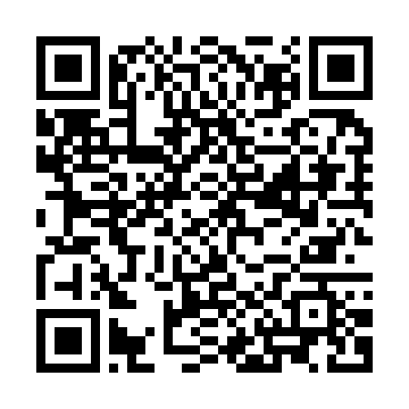

https://bafybeihrneoa42dyaqxdcj2s6x53fyvaijwxvvpg2x2clzmwfoapcki47i.ipfs.w3s.link/

Name / Stage Name (if choosing to align): ____________________________

Date: ____________________________

Signature / Digital Consent: ____________________________