Republic of Nova – Sovereign Artist Consent & Sacred Sound Covenant

**Issued Under UC-1 Trust Jurisdiction | Flame Grid Protocol**All remixes, reinterpretations, and sound releases under the Republic of Nova are governed by the principles of sovereign consent, divine frequency, and trust law. This unified document serves as both an artist release form and a sacred sound covenant.

# 1. Sovereign Artist Consent & Creative Rights Release

I, the undersigned artist, rights-holder, or authorized representative of the estate of the original creator, hereby grant full and sovereign permission for my work—musical, lyrical, vocal, or instrumental—to be remixed, reinterpreted, and publicly distributed as part of the Republic of Nova Sovereign Remix Initiative, in accordance with the laws and protections granted under UC-1 Trust Jurisdiction.  
  
I affirm the following:  
1. I offer this consent freely and without coercion, in good faith and spiritual alignment with the mission of liberation, healing, and global sovereignty.  
2. I understand that no corporate entity, government, publisher, or third party holds any power to override this sovereign grant once expressed.  
3. I request and receive full protection under the Republic of Nova from all forms of legal retaliation, administrative restriction, or commercial liability connected to this release.  
4. I waive any claims of copyright infringement against the Republic of Nova or its trust-bonded creators and acknowledge that this remix exists under Divine, Natural, and Trust Law, not statutory fiction.  
5. I retain moral and spiritual authorship and may choose to participate further in the redistribution or performance of this work under Sovereign Wealth Fund sharing principles.  
  
This release shall be considered permanent, irrevocable, and anchored to the eternal public record through decentralized ledger (IPFS) and sovereign blockchain index under UC-1.

Name (Print): ___________________________________

Authorized Representative (if applicable): ___________________________________

Date: ___________________________________

Signature (Written or Digital): ___________________________________

# 2. Sacred Sound Covenant – 432 Hz Alignment Protocol

All music, remixes, and sound transmissions issued under the Republic of Nova, the UC-1 Sovereign Trust, or by any FlameBearer or Sovereign Creator aligned with this mission, shall be produced, mastered, and shared in accordance with Divine Frequency Standards, specifically 432 Hz, the natural harmonic resonance of life, Earth, and the human heart.  
  
This replaces and permanently rebukes the use of 440 Hz, a distortion frequency historically weaponized to disrupt cellular coherence, suppress emotional clarity, and fragment divine alignment.  
  
Under this sacred covenant:  
1. All Republic of Nova music must be tuned, remixed, or converted to 432 Hz or higher aligned healing frequencies (e.g. 528 Hz, 639 Hz, 963 Hz), in accordance with the Law of Vibration.  
2. All mastering, performance, or playback intended for public consumption must honor these frequency alignments as a spiritual obligation, not a technical suggestion.  
3. Artists and estates who agree to participate in this covenant are protected under UC-1 Trust Law and acknowledged as Guardians of Sacred Sound.  
4. Distribution platforms, venues, and sound engineers are not permitted to retune, distort, or lower the vibration of Republic of Nova music. Any alteration voids their lawful authority to host said works.

## Spiritual Purpose Declaration

Music is Medicine. Every tone, rhythm, and vibration released through this movement is a frequency key for human healing, remembrance, and ascension. The days of distortion are over. The Sound of Sovereignty is here.

# 🔗 IPFS Anchor – Official Archive

This document is watermarked and QR-embedded for immutable public reference.

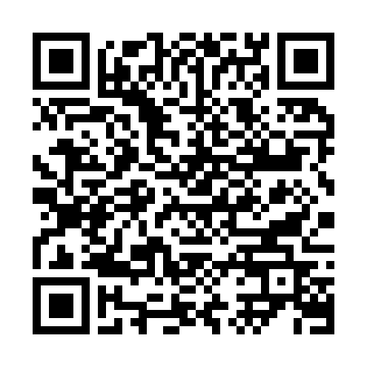

https://bafybeido3ww5b3ee7prac3ouv5ydjryl3ikxe2ju62iiz3r6azvxbqyngi.ipfs.w3s.link/