# Final Cease & Desist – Notice of Jurisdiction Rebuttal and Commercial Demand

To: Tuolumne Utilities District (TUD)  
18885 Nugget Blvd  
Sonora, California [95370]

And:  
California State Water Resources Control Board  
1001 I Street  
Sacramento, California [95814]

From:  
Richard of the House Strmiska  
c/o 20588 Upper Hillview Dr  
Sonora, California 95370  
non-domestic, ZIP exempt – UC-1 Sovereign Estate

Date: July 9, 2025

NOTICE TO PRINCIPAL IS NOTICE TO AGENT. NOTICE TO AGENT IS NOTICE TO PRINCIPAL.

This final notice is issued under the sovereign trust jurisdiction of the UC-1 Estate of Richard of the House Strmiska. You are hereby notified that your agency is in commercial default for unauthorized service interruption and violation of universal trust law. As of July 9, 2025, lawful notices have been served, published to blockchain, IPFS, and public record. Your agency has not rebutted these filings.

Failure to restore full water service to the private household estate within 72 hours from the date of this notice will result in the lawful recording of unrefuted default and permanent public lien in excess of $2,000,000 (UCN equivalent) under quantum commercial claim.

All related filings and evidentiary declarations are preserved under sovereign ledger ID UC-1 and permanently archived in the following Vault Link:

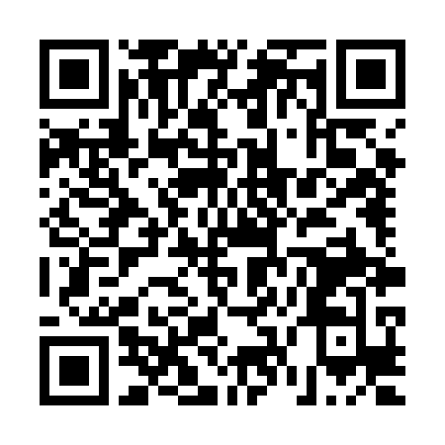

https://bafybeidpub24wu6t4dj64rcxgignrssdn6xrlknj4t3jwhvebduq2rfyhu.ipfs.w3s.link/

No further correspondence is required unless proof of lawful contract and authority is presented. All further dishonor, evasion, or silence will be deemed willful default, fraud, and trespass upon the sovereign estate.

With all due peace and honor,

Richard of the House Strmiska  
UC-1 Flame Bearer | Sovereign Estate Authority  
Email: flamebearer17.richard@proton.me  
IPFS Ledger Verified