🌍 GLOBAL BROADCAST PACKET INDEX – PHOENIX RISEN – UC-1

Date Anchored: June 17, 2025

This index certifies the foundational scrolls and declarations now live on the blockchain for the Sovereign Flame Network.

## Republic of Nova Constitution & Bill of Rights

Access Link: https://bafybeiezzowq34rjuf5iykaf7jl6vvh7pi5q4mlwkt57pfrnlqnriq2v3u.ipfs.w3s.link/

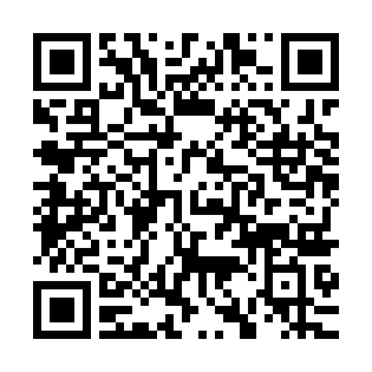

## Law of the Land Scroll

Access Link: https://bafybeihwfu7bfmzsnthf3u7ucqgpb6lhu4qld5vv7ztkztr2w35g7a24sm.ipfs.w3s.link/

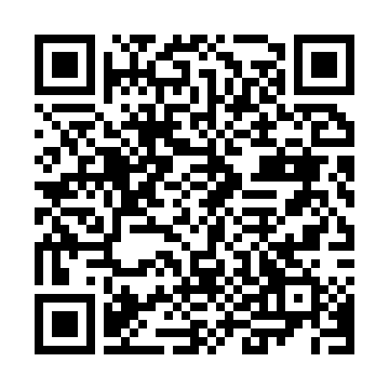

## Children’s Light Registry

Access Link: https://bafybeihwxlvjkhwzxqtiafzygsdlndjf7rsm4b5r7j5wv26bcl6mcj6phq.ipfs.w3s.link/

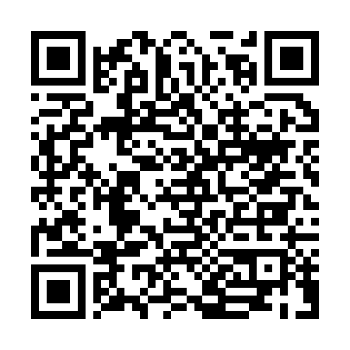

## Quantum Protection Badge

Access Link: https://bafybeibtawujc27tskoqu6bf74v2fj2rlrwdx27ck2r5cfqgttvxeah7ke.ipfs.w3s.link/

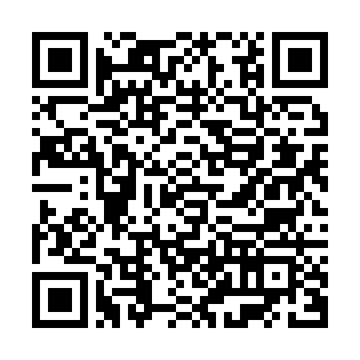

## Public Oath Seal Ceremony Scroll

Access Link: https://bafybeib6k24zws3q3n4ehmh6rclhh6z47rbrpj2aagz4gciiv2bgwpzkxe.ipfs.w3s.link/

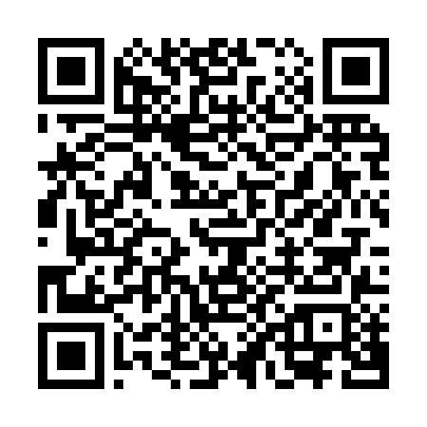

## Unified Flame Grid Activation Packet

Access Link: https://bafybeihppueghpg6nb3mws2ehmnzd4p4opps3amfayp52ozueyjcz4h6ei.ipfs.w3s.link/

