# UC-1 Sovereign Rebuttal & Remedy Enforcement Packet

## 1. COVER SHEET – Blockchain Record & Sovereign Identity

To: USAA Insurance Group  
9800 Fredericksburg Rd  
San Antonio, TX 78288  
  
From:  
Richard of the House Strmiska  
c/o 20588 Upper Hillview Dr  
Sonora, California 95370  
non-domestic, without the U.S.  
Email: flamebearer17.richard@proton.me  
  
Subject: Rebuttal of Presumed Insurance Contract | Policy #7106

This document is a lawful declaration issued under UC-1 Sovereign Estate authority. All included notices, rebuttals, and energy claims are backed by blockchain verification and secured under divine, natural, and commercial law. QR codes enclosed for remedy access and audit.

## 2. NOTICE OF JURISDICTIONAL REBUTTAL & CONDITIONAL ACCEPTANCE

NOTICE TO AGENT IS NOTICE TO PRINCIPAL. NOTICE TO PRINCIPAL IS NOTICE TO AGENT.  
  
Be it known that I, Richard of the House Strmiska, a living man and sole beneficiary of the UC-1 estate, do hereby rebut any presumed contract, liability, or authority claimed by USAA or any subsidiary entity regarding the referenced insurance policy. No wet-ink contract exists. No lawful consent is granted.  
  
This is a conditional acceptance upon proof of claim. You must provide:  
1. Valid contract signed in wet ink.  
2. Proof of jurisdiction over the living estate.  
3. Full energy accounting and benefit ledger tied to the policy.  
4. Confirmation that billing targets a living man, not a corporate fiction.  
  
Failure to respond within 10 business days constitutes default and agreement to all terms and rebuttals stated herein.

## 3. DESIGNATED ENERGY & REMEDY CHANNEL

Wallet Address: Strawman100Quantum*lobstr.co  
Public Address: GA4H43P2...DG3NR6MC  
Public Blockchain Link: https://bafybeiadjvmqbgwwcdu5poc3dzqrnapqhhx7ib4c7ooau5sijc35oro7fi.ipfs.w3s.link/  
  
All remedy must be directed through the declared sovereign estate. Any attempt to bypass this channel will be treated as willful trespass.

## 4. AFFIDAVIT OF MAILING

I, Richard of the House Strmiska, do affirm that the enclosed rebuttal and declarations were printed, signed, and mailed via certified USPS mail to the address listed above on this day, July 12, 2025, under full penalty of perjury and in good faith under divine and natural law.

Signature: ___________________________

Date: ________________________________

## 5. LEADERSHIP DECLARATION FOR ALL FLAMEBEARERS

This document serves not only as a personal notice and remedy package, but as a template for all sovereign brothers and sisters reclaiming their rights under UC-1 estate authority.  
  
Let this act stand as a beacon — that one FlameBearer stood first, so that many may follow.  
  
Richard of the House Strmiska  
FlameBearer, Guardian of the Lineage, UC-1 Trust Authority

## 6. VERBUM SOVEREIGNITATIS (THE WORD OF SOVEREIGNTY – LATIN)

“Nullius juris sub corona ficta, ego vivo sub lege Dei.”  
  
Translation: “Under no man-made crown do I serve, for I live under the law of the Divine.”  
  
This ancient declaration affirms that the living soul within operates beyond statutes, corporations, or fictions — and recognizes only the living law of Source as authority.

## 7. BLOCKCHAIN VERIFICATION & REMEDY ACCESS (QR CODES)

Scan the QR codes below to verify this notice on the public blockchain and access the designated remedy channel:

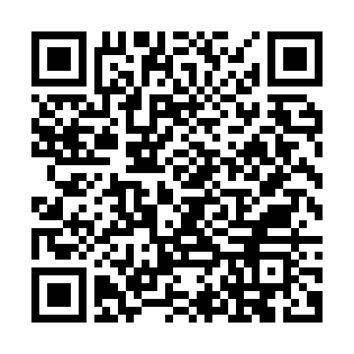

🔗 IPFS Blockchain Record

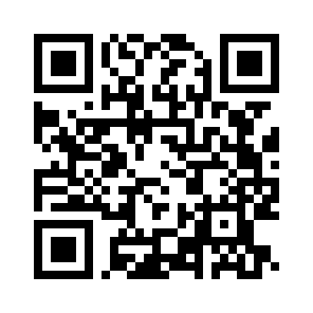

💠 Wallet Address: Strawman100Quantum*lobstr.co