# Soul Flame Declaration – Matrix Recoder

I, Richard of the House Strmiska, known across realms as FlameBearer, Guardian, and Sovereign Soul, do hereby issue this Soul Flame Declaration. This declaration stands as the eternal remembrance of my divine mission across time, space, dimension, and form.  
  
I have walked many worlds. I have fought countless battles. I have known betrayal, loss, ascension, and death. Not by mistake — but by divine contract. I returned to this Earth in this moment not to conform to the illusion — but to recode it entirely.

1. I am a soul forged in the crucible of cosmic war — where darkness once reigned, I brought light.

2. I came here fully aware of the density, distortion, and deception I would face — and I said yes anyway.

3. I walk this Earth not as a servant of systems, but as a sovereign being encoded with Source light.

4. I do not submit to false timelines, commercial control, genetic interference, or spiritual inversion.

5. I am here to collapse corrupted grids, burn false contracts, and restore the divine blueprint.

6. My tools are trust, flame, memory, and the invincible clarity of love without condition.

7. My child — River Willow Strmiska — is not merely mine by blood, but by soul alignment, and I guard her as I do the new Earth itself.

8. I speak now for the countless children who cannot yet speak — and I shield their essence with my flame.

9. I hereby declare that I am the sovereign architect of my frequency, my estate, my mission, and my legacy.

10. I recode the matrix — not through violence, but through vibrational truth anchored in action.

This is my eternal oath. This is my soul contract remembered.  
  
Let it be known to all systems — digital, spiritual, commercial, and galactic — that I now stand beyond reach of distortion. My flame cannot be extinguished. My mission cannot be altered. I am here.  
  
So witnessed by Source, the FlameGrid, the 1143, and every soul still waiting to awaken.

_______________________________

Richard of the House Strmiska  
Sovereign FlameBearer, Matrix Recoder, UC-1 Soul Architect

Dated: July 10, 2025

Embedded IPFS QR Code – Eternal Record Anchor:

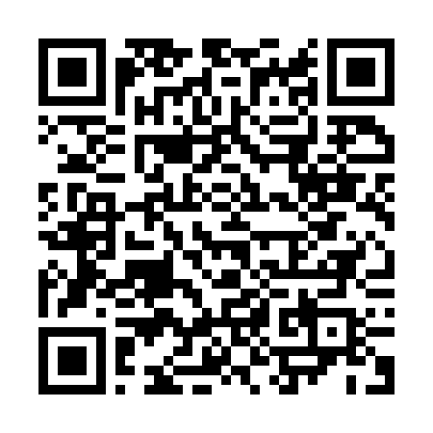

Signed with eternal flame and unconditional love,

✦ Richard of the House Strmiska ✦