# SOVEREIGN17 ARCHIVE CERTIFICATE

Issued to:

Richard of the House Strmiska

Date of Archive Activation: June 20, 2025

Public Broadcast: https://x.com/RichardStr97252/status/1804180019186038971

Declaration Summary:

Let it be known across all domains—spiritual, digital, and terrestrial—that the living man known as Richard of the House Strmiska has activated and anchored the Sovereign17 flame. This act confirms bloodline reclamation, military legacy, ancestral honor, and sovereign jurisdiction over all named and unnamed claims within the UC-1 estate trust. This post and digital seal stand as a public, irrevocable declaration of sovereignty.

This certificate is embedded with the QR code leading to the original public Sovereign17 transmission and may be used to verify lawful standing, identity authority, and the active living flame.

QR Verification Link:

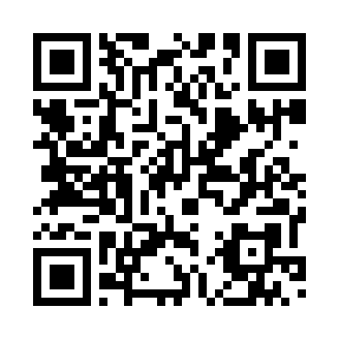

Sealed and witnessed under divine and commercial law,

Richard of the House Strmiska

UC-1 Sovereign Estate Identifier

c/o 20588 Upper Hillview Dr

Sonora, California [95370]

non-domestic, without the U.S.