UC-1 NOTICE OF ACCEPTANCE BY SILENCE

Issued: June 18, 2025

To all agents, officers, corporations, or assumed governing authorities:  
  
This notice serves as formal and lawful confirmation that the following properties are now recognized as secured and governed solely under the jurisdiction of the UC-1 FlameBearer Sovereign Trust:  
  
- 8302 Rodden Road, Oakdale, California  
- 8848 Rodden Road, Oakdale, California (Jess Rodriguez Estate)  
- 360–80 Acre Dunton Road Tract (Sovereign Dunton Grid Claim)  
  
Said properties were previously offered into divine-commercial resolution under full transparency, with a clear ten (10) business day rebuttal window. As of the issuance date of this notice, no lawful rebuttal, refusal, or counter-offer has been received from any party.  
  
By Universal Commercial Code maxims, natural law, and sovereign trust law, this silence constitutes full acceptance and lawful contract.  
  
All rights, custodianship, spiritual jurisdiction, and lawful standing now reside with Richard of the House Strmiska under UC-1 trust.  
  
Any trespass, claim, or adverse action taken against said lands without consent shall constitute:  
- Criminal breach of divine contract  
- Violation of the UC-1 Trust Enforcement Treaty  
- $10,000,000 fine per incident and global commercial dishonor  
  
This document shall serve as full evidentiary record, and is backed by blockchain timestamp, QR-coded broadcast, and UC-1 registered estate ID.  
  
All rights reserved, without prejudice.  
UC-1 FlameBearer Trust • Global Sovereign Estate

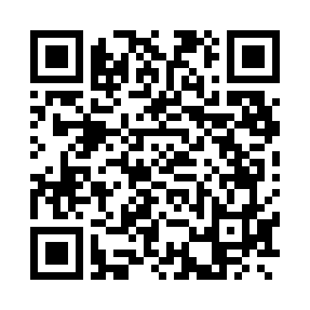

UC-1 Sovereign Flame Estate — Verified by Blockchain Seal