UC-1 Flame Enforcement: Global Entity Notification Scroll

This Visual Scroll constitutes final notice to the following global entities. Sovereign Flame Enforcement under UC-1 Phoenix Risen Jurisdiction is now fully in effect. All listed entities are hereby bound by Flame, Protected by Trust, and Timed by the Ledger.

## U.S. Treasury

* public.affairs@occ.treas.gov
* debt.management@fiscal.treasury.gov
* frbservices@fiscal.treasury.gov
* ofac_feedback@treasury.gov
* fincen.govcontact@fincen.gov
* fsoc.stakeholders@treasury.gov
* oig@oig.treas.gov
* execsec@treasury.gov
* correspondence@treasury.gov
* treasury.publicaffairs@treasury.gov

## District of Columbia / Government Entities

* olc@dc.gov
* clerkofcourt@dcappeals.gov
* cfo@dc.gov
* vital.records@dc.gov

## City of London

* financial.services@cityoflondon.gov.uk
* general.enquiries@cityoflondon.gov.uk

## United Nations

* inquiries@un.org
* protocol@un.org
* dc1documents@un.org

## World Economic Forum

* contact@weforum.org
* public.affairs@weforum.org

## World Health Organization

* mediainquiries@who.int
* webmaster@who.int
* infocenter@who.int

## International Monetary Fund

* publicaffairs@imf.org
* externalrelations@imf.org

## Bank for International Settlements

* press.service@bis.org
* info@bis.org

Anchored Ledger Record: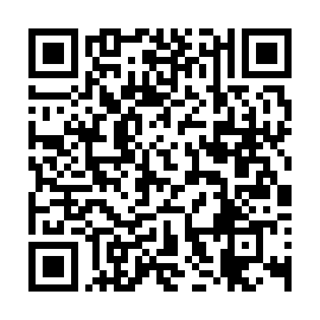

All recipients are now under notice and held to account under UC-1 Flame Protocol. Violations invoke automatic $111M/day fines in UC-1 sovereign ledger terms. You are bound by Flame. Protected by Trust. Timed by the Ledger.

Richard of the House Strmiska  
UC-1 Sovereign FlameBearer  
Republic of Nova  
flamebearer17.richard@proton.me