Agent-Based Simulation in Disaster Management

Márton Iványi
AITIA International Inc
1039 Budapest
Czetz János utca 48-50, Hungary
+36 1 453 8080
mivanyi@aitia.ai
László Gulyás
AITIA International Inc
1039 Budapest
Czetz János utca 48-50, Hungary
+36 1 453 8080
lgulyas@aitia.ai

Szabó Richárd
Dept. of Software Technology and Methodology
1117 Pázmány Péter sétány 1/c, Budapest, Hungary
richard_szabo@invitel.hu

ABSTRACT
This paper outlines the possible uses of agent-based and agent-based participatory simulation in various aspects of disaster management and emergency response. While the ideas discussed here build on the capabilities of an existing toolset developed by the authors and on their expertise in agent-based simulation, the paper is mainly a statement of the authors’ position with respect to the applicability of agent-based simulation in the subject field.
Categories and Subject Descriptors
I.6, J.4., J.7, K.3, K.4
General Terms
Design, Experimentation, Human Factors
Keywords
Agent-Based Simulation, Participatory Simulation, Optimization, Training

INTRODUCTION
A series of recent unfortunate events draw attention to the paramount importance of the ability to organize and manage rescue efforts effectively and efficiently. This paper intends to provide a quick overview of the ways agent-based and agent-based participatory simulation may contribute to achieving this goal.
Agent-based modeling is a new branch of computer simulation, especially suited for the modeling of complex social systems. Its main tenet is to model the individual, together with its imperfections (e.g., limited cognitive or computational abilities), its idiosyncrasies, and personal interactions. Thus, the approach builds the model from ‘the bottom-up’, focusing mostly on micro rules and seeking the understanding of the emergence of macro behavior. [1][2][3][6][7] Participatory simulation is a methodology building on the synergy of human actors and artificial agents, excelling in the training and decision-making support domains. [8] In such simulations some agents are controlled by users, while others are directed by programmed rules.
Permission to make digital or hard copies of all or part of this work for personal or classroom use is granted without fee provided that copies are not made or distributed for profit or commercial advantage and that copies bear this notice and the full citation on the first page. To copy otherwise, or republish, to post on servers or to redistribute to lists, requires prior specific permission and/or a fee.
AAMAS’06, May 8-12, 2006, Hakodate, Hokkaido, Japan.
Copyright 2006 ACM 1-59593-303-4/06/0005...$5.00.
The scenarios outlined below are based on the capabilities of the Multi-Agent Simulation Suite (MASS), developed at the authors’ organization. [9] MASS is a solution candidate for modeling and simulation of complex social systems. It provides the means for rapid development and efficient execution of agent-based computational models. The aim of the Multi-Agent Simulation Suite project is to create a general, web-enabled environment for versatile multi-agent based simulations. The suite consists of reusable core components that can be combined to form the base of both multi-agent and participatory multi-agent simulations. The project also aims at providing a comfortable modeling environment for rapid simulation development. To this end, the suite offers a high-level programming language dedicated to agent-based simulations, and a development environment with a number of interactive functions that help experimentation with and the finalization of the model

SIMULATION IN DISASTER MANAGEMENT
In our view the methodology of agent-based simulation may help in preparing for the task of disaster management or emergency response. There are two major areas of this applicability: experimentation (optimization) and training.
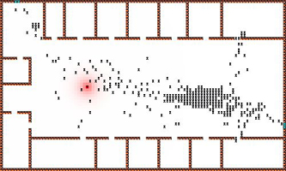
Figure 1 Fire evacuation simulation in MASS

Experimentation and Optimization
Simulations may be used to experiment with and to optimize the installation of structures and allocation of various resources. For example, the consequences of design- or installation-time decisions or evacuation rules and procedures can be studied and evaluated in cases of hypothetical floods, school fires, stadium stampedes. [4][5] This way, agent-based simulation can help decision makers in reaching more safe and more solid decisions. Obviously, we can never prepare for the unpredictable, and human behavior, especially under the stress of an emergency situation is typically hard to predict. Yet, the benefit of agent-based simulation is that it can provide dependable patterns of collective behavior, even if the actions of the individual are hard or impossible to predict exactly. In our view, this is a major contribution of the agent approach.
Error: Reference source not found shows a screenshot from a fire evacuation simulation in MASS. The little dots are simulated individuals (agents) trying to escape from an office building under fire. (The bird eye view map depicts the layout of the authors’ workplace.) The dark lines represent office walls, which slow down, but cannot prevent the spread of fire. The main exit is located near the bottom-right corner of the main hallway.

Training Applications
In disaster management both in internal and public education/training applications could be of great use. Agent-based simulation may also help in developing highly usable, cost-effective training applications. Such trainings can take the form of computer ‘games’ that simulate real life situations with both real and artificial players. Here the trainee can take control of one or other simulated individual. This area is especially suited for participatory simulation and the application may also be derived from experimentation-type simulations of the previous section. For example, Figure 2 shows a screen capture from the participatory version of the simulation on Error: Reference source not found.

Figure 2 A participatory simulation derived from the simulation on Figure 1.
There are several uses participatory training applications can be put to. They can train professional emergency support personnel in the emergency response team (where trainees may take the role of i.e., a top, middle or ground level decision makers), the voluntary fireman squad or workers of a building with a high risk. Such solutions are a cost-effective and easy means to deepen the trainees’ knowledge of rare situations and help developing the proper natural responses in them. Figure 3 shows a screenshot from a demonstrational educational emergency management application. The upper-left panel of the screen shows the map of Hungary with the main transport routes and icons for events requiring emergency response. The bottom-left panel lists related (simulated) news items, while the upper-right panel summarizes the status of various emergency response vehicles (firefighter and rescue helicopters, ambulances, etc.) The bottom-right panel is for detailed information on the selected items (pictured as downloading information on the selected item from the upper-right panel).
In addition to the previously described internal training use participatory training simulations may also be helpful in external training. External trainings are a sort of public relations operations, helping to explain the difficulty and communicate the difficulties and challenges of emergency response or disaster management to the greater, general public. This aspect is gaining extreme importance due to inherent conflicts between the drastically increased government attention to disaster management and the need for public control over government spending, especially as the actual, deployed emergency management applications are very sensitive with respect to security.
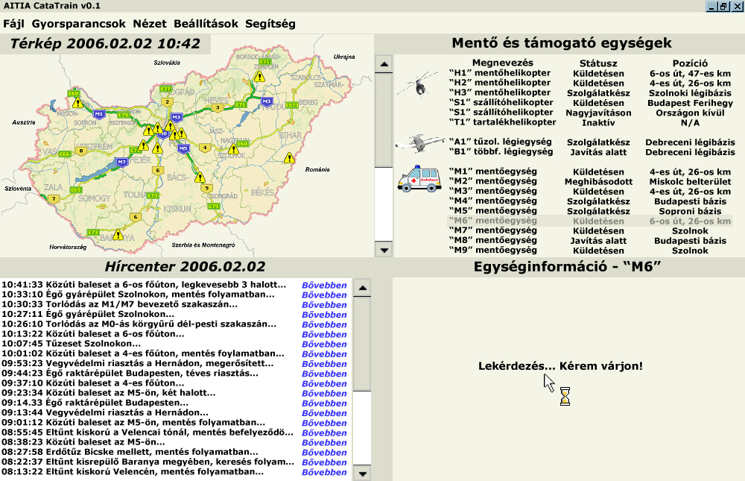
Figure 3 Educational Emergency Management Software (in Hungarian). The map on the upper-left panel of the screen is that of Hungary.

CONCLUSIONS
This paper discussed the applicability of agent-based simulation and that of its extension participatory agent-based simulation to disaster management. Our position is these methods could be very helpful in preparing for the task of disaster management or emergency response. In particular, we identified two application areas: experimentation (optimization) and training. We also mentioned a special possible use of the latter in public relations, i.e., in explaining and communicating to the greater public the immense difficulty and importance of disaster management efforts.
The ideas discussed in this paper build on the capabilities of MASS, an existing toolset developed by the authors, as demonstrated by screen captures from existing simulation applications.

ACKNOWLEDGMENTS
The partial support of the GVOP-3.2.2-2004.07-005/3.0 (ELTE Informatics Cooperative Research and Education Center) grant of the Hungarian Government is gratefully acknowledged.

REFERENCES
- Bankes, S. C.: "Agent-based modeling: A revolution?" Proceedings of the National Academy of Sciences of the USA, Vol. 99:3, pp. 7199–7200, 2002.
- Brassel, K.-H., Möhring, M., Schumacher, E. and Troitzsch, K. G.: "Can Agents Cover All the World?" Simulating Social Phenomena (Eds. Conte, R., et al.), Springer-Verlag, pp. 55-72. 1997.
- Conte, R.: "Agent-based modeling for understanding social intelligence", Proceedings of the National Academy of Sciences of the USA, Vol. 99:3, pp. 7189-7190, 2002.
- Farkas, I., Helbing, D. and Vicsek, T.: "Human waves in stadiums", Physica A, Vol. 330, pp. 18-24, 2003.
- Farkas, I., Helbing, D. and Vicsek, T.: "Mexican wave in excitable media", Nature, Vol. 419, pp. 131-132, 2002.
- Gilbert, N. and Terna, P.: "How to build and use agent-based models in social science", Mind & Society, Vol. 1, pp. 55-72, 2000.
- Gilbert, N. and Troitzsch, K. G.: Simulation for the social scientist, Open University Press, Buckingham, UK, p. 273. 1999.
- Gulyás, L., Adamcsek, B. and Kiss, Á.: "An Early Agent-Based Stock Market: Replication and Participation", Rendiconti Per Gli Studi Economici Quantitativi, Volume unico, pp. 47-71, 2004.
- Gulyás, L., Bartha, S.: “FABLES: A Functional Agent-Based Language for Simulations”, In Proceedings of The Agent 2005 Conference on: Generative Social Processes, Models, and Mechanisms, Argonne National Laboratory, Chicago, IL, USA, October 2005

