Getting started with jPhone.

- Environment

At a minimum, jPhone requires a Java installation together with libraries to interface with the serial port. The environmental set up described here is not the only possible configuration and is used here for illustration purposes.

1.1 Eclipse

The Eclipse IDE is available here: http://www.eclipse.org/

The configuration for Java developers 4.2 is sufficient to run jPhone and provides a number of other convenient plugins in one download.

Optionally, download and install the Eclipse CDT plugins to facilitate browsing the Osmocom reference code included in the git repository.

The Eclipse platform is equipped with Git functionality and can be used to check out the project into the Eclipse workspace.

1.2 Serial Communication

A library to communicate with the phone via the serial port is required as the basic JVM runtime does not provide such functionality. This can be downloaded here: http://rxtx.qbang.org/wiki/index.php/Main_Page

There is already a version of this in the lib folder of the project and if the project is checked out via Eclipse, it should be preconfigured to use this library.

1.3 Osmocom

Osmocom can be downloaded from: http://bb.osmocom.org/trac/

Once downloaded and compiled, a binary for your phone is produced. jPhone must be told the location of this binary so it can upload it to the phone.

Optionally, a precompiled binary for the C123 phone is located in the lib folder of the project and jPhone is preconfigured to use this. Should you require the use of a different binary please update the code. You must also ensure that the handshake mechanism between the phone and ram loader is the same i.e. the same sequence of messages and the same messages being sent and received for the loader to successfully work. In the future, support for a broader range of phones will be provided.

- Runtime

Once the environment is configured and the source code is downloaded, you run jPhone like any other Java application in Eclipse. Right click on the Main.java file in the jPhone class and select “Run as Java Application”.

In some instances you may be required to change the access privileges on the serial port in order for the port to be visible. This is done using chmod in Linux or whatever alternative is provided by your operating system.
Once the GUI appears, there will be a progress bar displayed. At this point, briefly press the power button on the phone to begin the upload of the binary. Some hardware has a finite number of writes available so with this in mind, jPhone will test to see if the binary is already uploaded before commencing an upload. Once the progress bar disappears and the phone lights up the upload is complete and the GUI can be used.

Note that in some cases, the code will upload to the phone but it will fail to start. This happens especially if the phone has not been used in a while. Simply remove the battery from the phone to reset it and restart the GUI until the phone starts. This can take a number of times before it works.

2.1 Scan

The scan feature provides the user with the ability to scan all frequencies for towers in their locality. The ARFCN number from and to should be entered in their appropriate boxes as shown below and then the button Scan should be pressed.
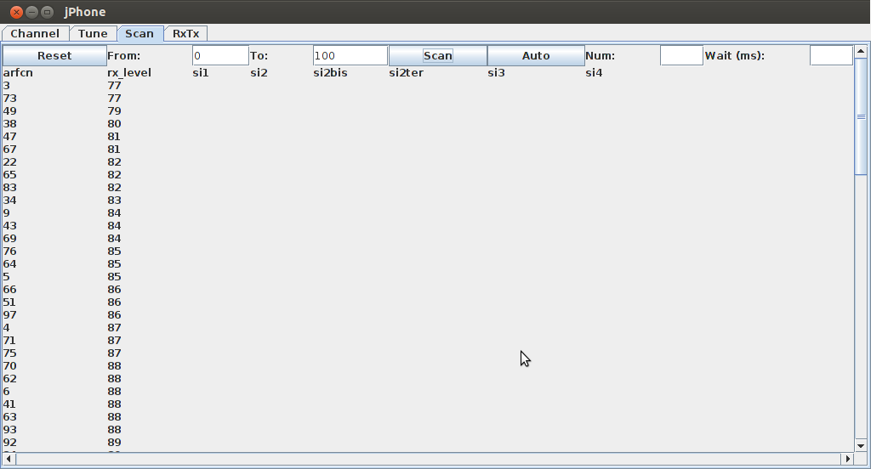
The code can scan all frequencies but for demo purposes ARFCN 0-100 have been used. It is simply a matter of changing the number in the box. This also provides the signal strength indicators for each tower. Towers are sorted based on the signal strength.

2.2 Auto-tune

Some towers that show up in the ARFCN scan do not in fact provide the required System Information in order to sync with them. The auto tune feature provides an automatic way to see which towers are providing the required information.

The parameters available are the number of towers to include in the auto tune and the number is from the top down i.e. the tower with highest signal strength is selected first. The second parameter is the amount of time that jPhone will listen to the tower sync info before moving on to the next tower. The smaller this value, the quicker the scan will complete, however, some System Information from the tower may be missed.

In the example below, tower on AFRCN 73 has the highest signal strength that provides the required information. Note that tower on ARFCN 3 does not provide the information and so it can be concluded that this tower at present is not valid.

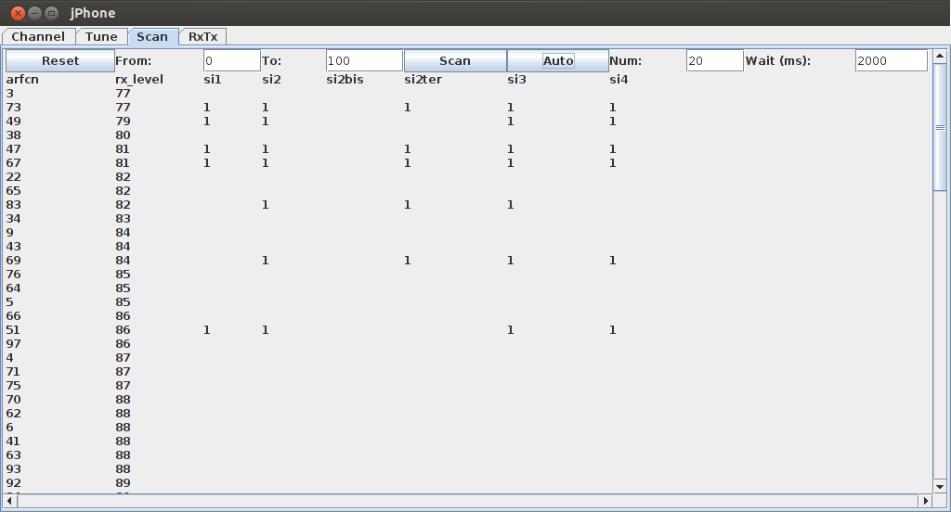
2.3 Tune

The Tune tab allows tuning to the frequency of the tower and deciphering the messages received. Once we have all the parameters decoded, as shown in the diagram, we can then use them to connect to the tower to send and receive data. In the diagram, the only variable that can really be changed is the tower based on the table populated by the previous tab.

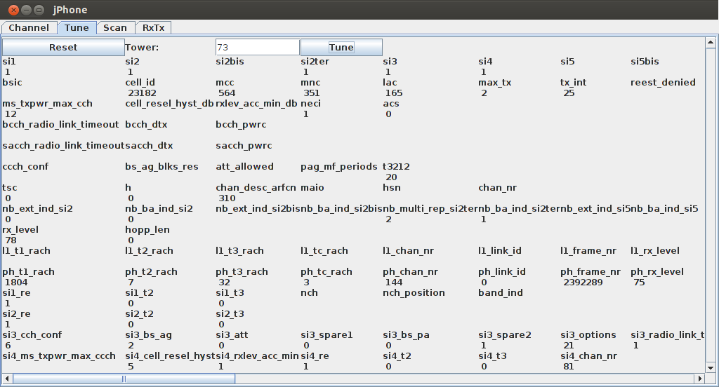

2.4 RxTx

The final tab in the GUI is the RxTx tab that just monitors all the messages to and from the phone. It can also logs those messages to the appropriate files.

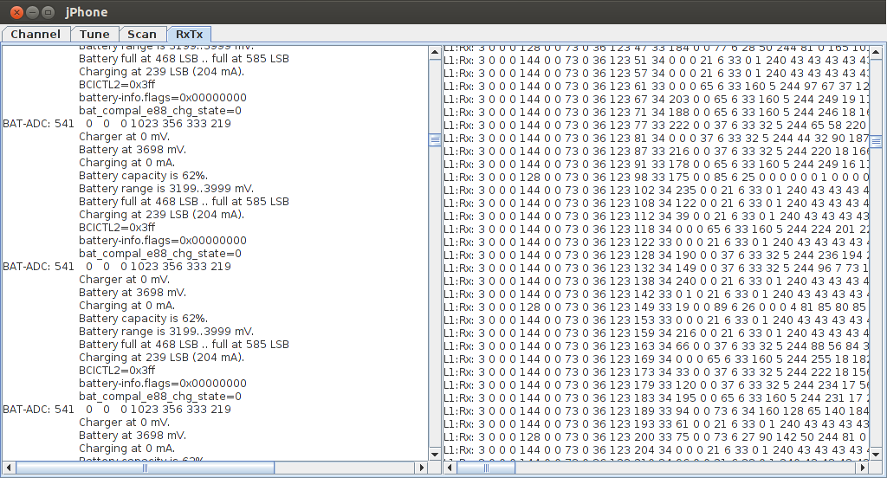
3. Future Work

- Support for more Osmocom compatible phone.
- Get a channel from the tower
- Send data to the tower
- Respond to messages from the tower e.g paging
- Receive data from the tower
- Mobility Management
- Call Control
- SMS capability

