Ionospheric Propagation
Ionospheric Propagation is the major mode of propagation for frequencies between 2MHz and 30MHz. (h.f.)

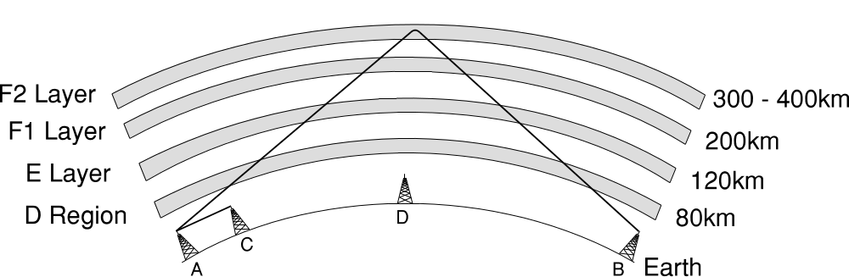
The ionosphere consists of an area of gas particles which are “ionised” by Ultra Violet radiation from the sun. The amount of ionisation varies on a daily and seasonal basis. Radio waves entering the ionosphere are bent or reflected and the amount of refraction is known as the “refractive index”. Lower frequencies bend more easily and require less ionisation to reflect them than higher frequencies. As the day progresses the effect of the sun increases and it is possible to use higher frequencies for any given path. At night a lower frequency will cover the same path. For a short distance radio path during the day a lower frequency would be used. The signal would be reflected by a lower layer.

In the diagram, the transmitter at station A emits a signal which results in an ionospheric wave being reflected by the F2 Layer. This is received by station B. A ground wave is also transmitted by A and this is received by C. Station D, being in the “Skip Zone” and out of range of the ground wave, hears nothing at all.

The height of the `E’ layer remains about the same at both day and night. The F1 and F2

layers combine at night and in winter to form a single layer. The D region disappears totally at night; this layer causes both absorption and reflection of radio waves.

The distance between station A and station B is known as the `Skip Distance’ and can be a maximum of 4000km (2500 miles)

The angle at which a radio wave is reflected is the same as the angle at which it reaches the ionosphere. By careful choice of antenna and height we can control the “angle of radiation” and obtain the best possible result for any given path, the longest distances requiring the lower angles of radiation and the higher frequencies.

When a refracted wave returns to earth, it is sometimes possible for it to be reflected by the earth’s surface and the same process starts again. This is known as multi-hop propagation. Occasionally this can continue right around the world and arrive at the same place as the first hop with a slight time delay.

© Northampton Scout Amateur Radio Group HSCOMM04 Iss.3
The ionosphere consists of an area of gas particles which are “ionised” by Ultra Violet radiation from the sun. The amount of ionisation varies on a daily and seasonal basis. Radio waves entering the ionosphere are bent or reflected and the amount of refraction is known as the “refractive index”. Lower frequencies bend more easily and require less ionisation to reflect them than higher frequencies. As the day progresses the effect of the sun increases and it is possible to use higher frequencies for any given path. At night a lower frequency will cover the same path. For a short distance radio path during the day a lower frequency would be used. The signal would be reflected by a lower layer.

In the diagram, the transmitter at station A emits a signal which results in an ionospheric wave being reflected by the F2 Layer. This is received by station B. A ground wave is also transmitted by A and this is received by C. Station D, being in the “Skip Zone” and out of range of the ground wave, hears nothing at all.

The height of the `E’ layer remains about the same at both day and night. The F1 and F2

© Northampton Scout Amateur Radio Group HSCOMM04 Iss.3
© Northampton Scout Amateur Radio Group HSCOMM04 Iss.3

