Tropospheric Propagation
Sometimes the weather conditions in the atmosphere can create a phenomenon known as “ducting”. A radio wave enters into a region of the troposphere where temperature changes, air pressure and the presence of water vapour have in effect formed two layers, trapping the wave. A wave which gets “trapped” in such a tropospheric duct can travel for very long distances (1500km or more) but can return to the surface of the Earth at any point.

Changes in temperature, air pressure and humidity of the troposphere cause large changes in its Refractive Index. (A measure of how much a radio wave is bent as it passes through the atmosphere). If the weather conditions are right it is possible to contact stations in near European countries on 144MHz. A tropospheric opening usually follows a spell of good weather and high atmospheric pressure. Under these conditions, VHF and UHF signals which normally travel up to 100 miles may cover distances up to 1000 miles and may cause interference to radio and television transmissions.

© Northampton Scout Amateur Radio Group HSCOMM04 Iss.3
Tropospheric propagation is the major mode of propagation over long distances (beyond the line of sight range) at frequencies above about 50MHz. The Troposphere extends from the surface of the Earth to a height of approximately 10km, although this varies according to conditions.

The troposphere can attenuate, scatter and refract electromagnetic waves. It can also produce electromagnetic waves in the form of radiation from lightning discharges. These may be detected as visible light or as wideband noise on a radio receiver.
© Northampton Scout Amateur Radio Group HSCOMM04 Iss.3
© Northampton Scout Amateur Radio Group HSCOMM05 Iss.3
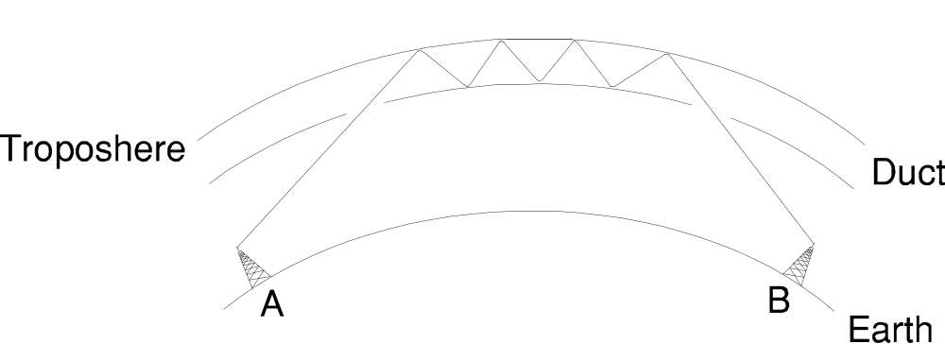
Fortunately, VHF “lift” conditions are not regular occurrences. Although amateur radio signals travel much further, there are many radio and television transmitters which share the same frequencies as do several VHF amateur repeaters. Regular opening would make co-channel operation impossible.

