Installation process:

1. Go to Help -> Install new software. Then click on Add. Select the PiviPlugin.zip archive after clicking on Archive.

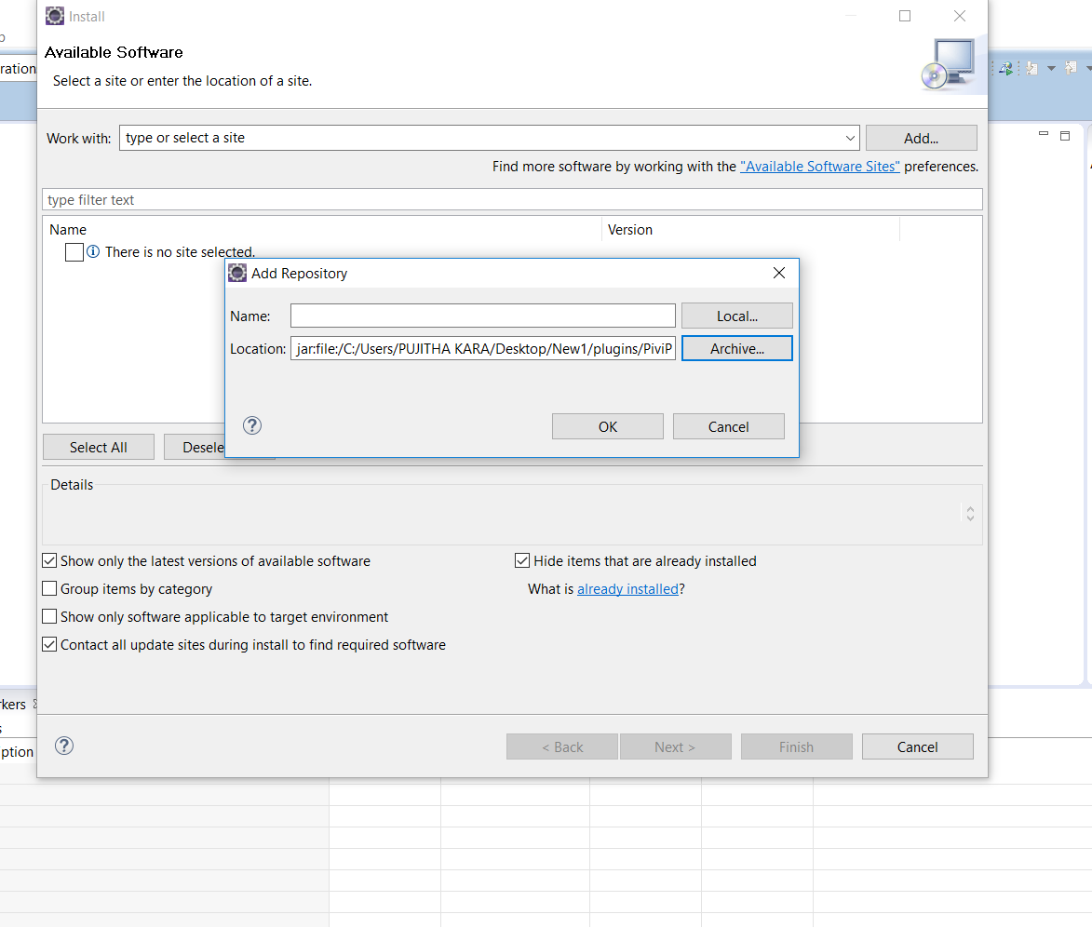

1. Uncheck ‘Group items by category’ then select PiviPulginFeature and click next and install.

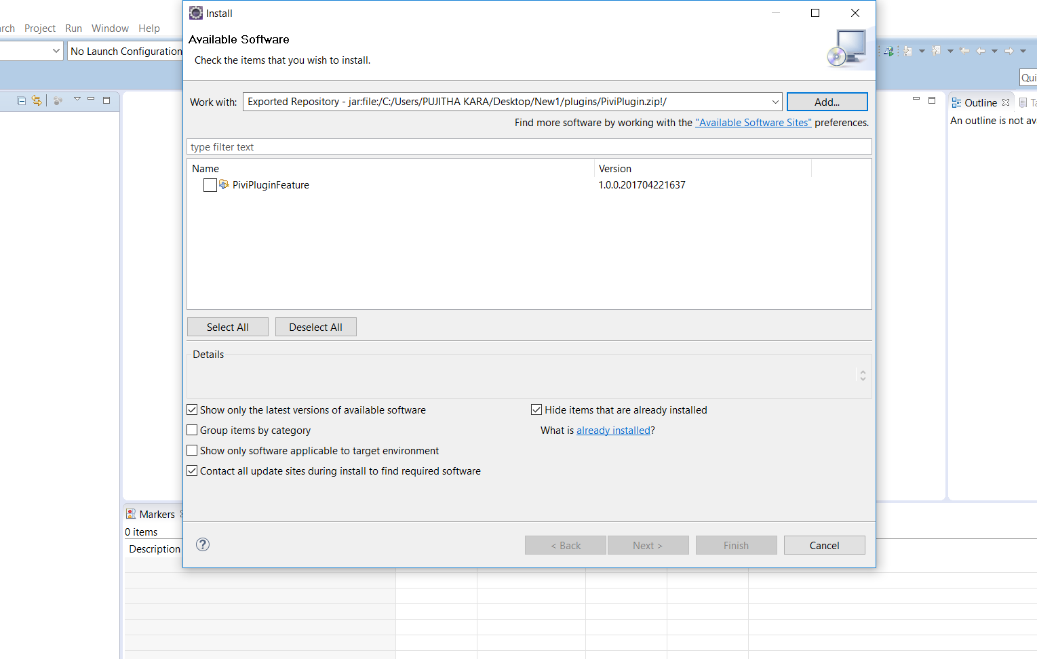

1. Click ok for unsigned content.

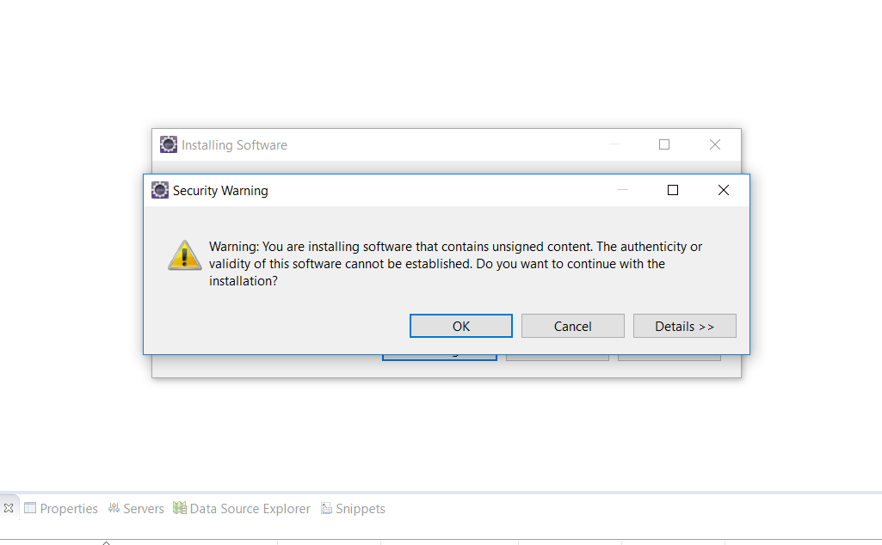

1. Restart eclipse create new Project.

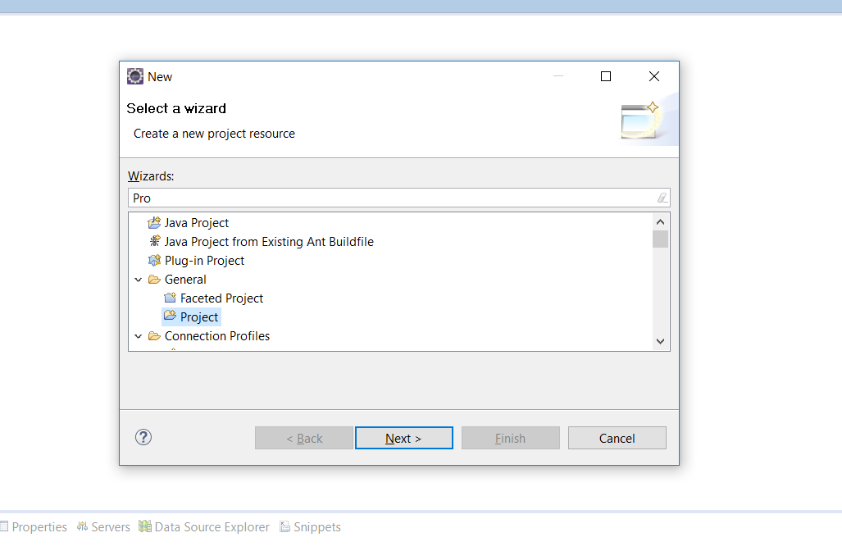

1. Create new Pivi Diagram inside the project.

