**IRIS DATA**

#Attribute Information:

* sepal length in cm
* sepal width in cm
* petal length in cm
* petal width in cm
* class:
* Iris Setosa
* Iris Versicolour
* Iris Virginica

#Number of Instances: 150 (50 in each of three classes)

#Number of Attributes: 4 numeric, predictive attributes and the class

**#SUMMARY**

Summary contains points are as follows: -

* Minimum Value
* 1st Quadrant
* Median
* Mean
* 3rd Quadrant
* Maximum Value

Summary for whole data: -

|  |  |  |  |  |
| --- | --- | --- | --- | --- |
| **sepal_length** | **sepal_width** | **petal_length** | **petal_width** | **class** |
| Min. :4.300  1st Qu.:5.100  Median :5.800  Mean :5.843  3rd Qu.:6.400  Max. :7.900 | Min. :2.000  1st Qu.:2.800  Median :3.000  Mean :3.054  3rd Qu.:3.300  Max. :4.400 | Min. :1.000  1st Qu.:1.600  Median :4.350  Mean :3.759  3rd Qu.:5.100  Max. :6.900 | Min. :0.100  1st Qu.:0.300  Median :1.300  Mean :1.199  3rd Qu.:1.800  Max. :2.500 | Iris-setosa :50  Iris-versicolor:50  Iris-virginica :50 |

Summary for class: Iris-Setosa

|  |  |  |  |  |
| --- | --- | --- | --- | --- |
| **sepal_length** | **sepal_width** | **petal_length** | **petal_width** | **class** |
| Min. :4.300  1st Qu.:4.800  Median :5.000  Mean :5.006  3rd Qu.:5.200  Max. :5.800 | Min. :2.300  1st Qu.:3.125  Median :3.400  Mean :3.418  3rd Qu.:3.675  Max. :4.400 | Min. :1.000  1st Qu.:1.400  Median :1.500  Mean :1.464  3rd Qu.:1.575  Max. :1.900 | Min. :0.100  1st Qu.:0.200  Median :0.200  Mean :0.244  3rd Qu.:0.300  Max. :0.600 | Iris-setosa :50  Iris-versicolor: 0  Iris-virginica : 0 |

Summary for class: Iris-Versicolor

|  |  |  |  |  |
| --- | --- | --- | --- | --- |
| **sepal_length** | **sepal_width** | **petal_length** | **petal_width** | **class** |
| Min. :4.900  1st Qu.:5.600  Median :5.900  Mean :5.936  3rd Qu.:6.300  Max. :7.000 | Min. :2.000  1st Qu.:2.525  Median :2.800  Mean :2.770  3rd Qu.:3.000  Max. :3.400 | Min. :3.00  1st Qu.:4.00  Median :4.35  Mean :4.26  3rd Qu.:4.60  Max. :5.10 | Min. :1.000  1st Qu.:1.200  Median :1.300  Mean :1.326  3rd Qu.:1.500  Max. :1.800 | Iris-setosa : 0  Iris-versicolor:50  Iris-virginica : 0 |

Summary for class: Iris-Virginica

|  |  |  |  |  |
| --- | --- | --- | --- | --- |
| **sepal_length** | **sepal_width** | **petal_length** | **petal_width** | **class** |
| Min. :4.900  1st Qu.:6.225  Median :6.500  Mean :6.588  3rd Qu.:6.900  Max. :7.900 | Min. :2.200  1st Qu.:2.800  Median :3.000  Mean :2.974  3rd Qu.:3.175  Max. :3.800 | Min. :4.500  1st Qu.:5.100  Median :5.550  Mean :5.552  3rd Qu.:5.875  Max. :6.900 | Min. :1.400  1st Qu.:1.800  Median :2.000  Mean :2.026  3rd Qu.:2.300  Max. :2.500 | Iris-setosa : 0  Iris-versicolor: 0  Iris-virginica :50 |

#Graphs:-

Attribute: Sepal_length

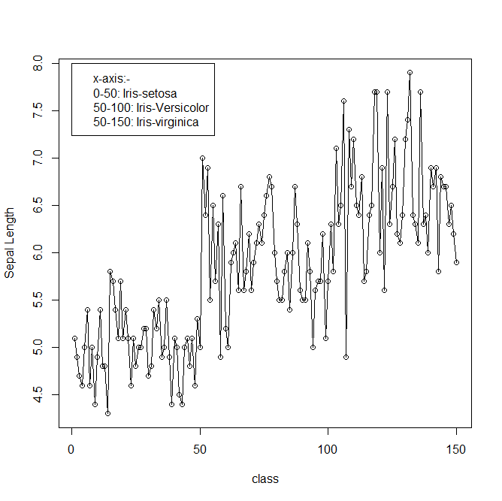

Attribute: Sepal_width

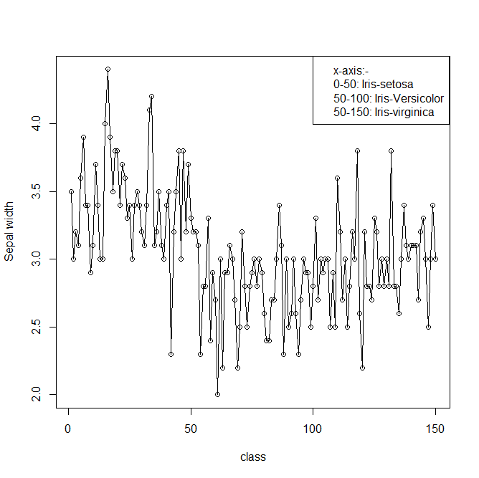

Attribute: Petal_length

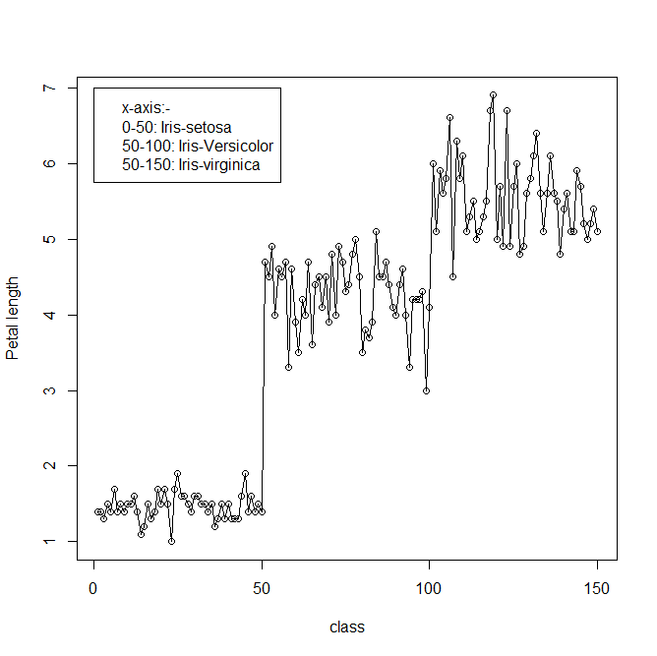

Attribute: Petal_width

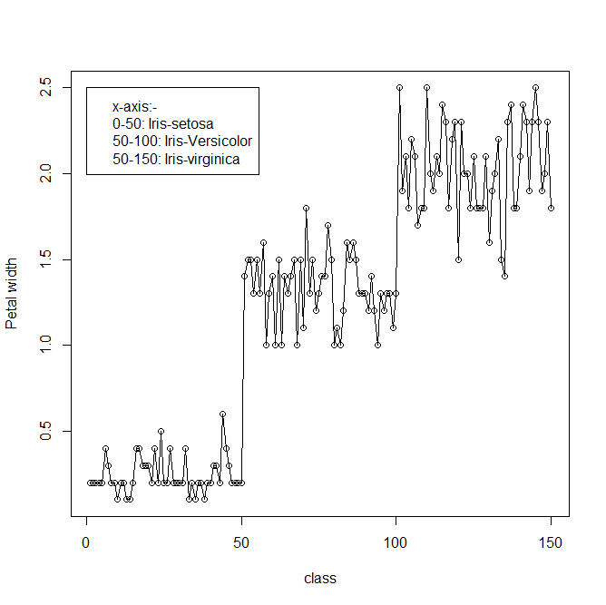

#Sources:

(a) Creator: R.A. Fisher

(b) Donor: Michael Marshall (MARSHALL%PLU@io.arc.nasa.gov)

(c) Date: July, 1988