Social Media Emotion Detection
Project Proposal & Model Design Document (MDD)

Batch-13 Capstone Project
Social Media Usage and Emotional Well-Being

Project Detail | Value
Project Type | Multi-class Classification
Target | Dominant_Emotion
Emotion Classes | Anger, Anxiety, Boredom, Happiness, Neutral, Sadness
Primary Models | Optimized Random Forest and Optimized XGBoost
Deployment | Streamlit web application
Project Owner | Richa Trivedi

Table of Contents
1. Project Proposal
2. Business Problem & Objectives
3. Resources Overview
4. System Architecture
4.1 Architecture Workflow
5. Model Training Pipeline
5.1 Models Evaluated
5.2 Data Preprocessing
5.3 Exploratory Data Analysis
5.4 Cross-Validation and Hyperparameter Tuning
6. Model Evaluation
6.1 Evaluation Visualizations
6.2 Best Models
6.3 Model Comparison
6.4 Evaluation Metrics
7. Technology Stack
8. Application Structure & Deployment
9. Individual Details
10. Streamlit Application
11. Project Milestones
12. Project Summary
13. Business Impact

1. Project Proposal

1.1 Title of the Project
Social Media Emotion Detection
Streamlit Application: Social Media — Dominant Emotion Predictor
Project Type: Multi-class Classification
Industry / Domain: Social Media Analytics / User Emotional Well-Being

1.2 Brief on the Project
The project develops a machine learning solution to analyze social-media usage patterns and predict the dominant emotional state of a user. The supplied notebook describes the dataset as capturing social media usage and the dominant emotional state of users, with the objective of understanding the relationship between usage trends and emotional well-being.
The target variable, Dominant_Emotion, contains six classes: Happiness, Sadness, Anger, Anxiety, Boredom and Neutral. The production application converts model predictions into these emotion labels and supports both single-row and batch CSV prediction.
This project delivers an end-to-end machine learning solution that:
- Loads and explores social media usage data.
- Handles missing values and prepares numerical and categorical variables.
- Performs exploratory data analysis and outlier review.
- Encodes the six emotion classes for machine learning.
- Compares multiple classification algorithms.
- Uses 5-fold stratified cross-validation for the leading Random Forest and XGBoost models.
- Tunes Random Forest and XGBoost using GridSearchCV.
- Saves optimized Random Forest and XGBoost pipelines for production inference.
- Provides a Streamlit interface for individual and batch emotion prediction.

2. Business Problem & Objectives

2.1 The Challenge
Social media has become an important part of daily communication and interaction. Usage intensity, posting activity, engagement received and messaging behavior can be studied alongside a user's dominant emotional state. The business/analytics challenge is to convert these behavioral signals into a repeatable classification model that can predict a user's dominant emotion.
The model is intended as an analytical prediction tool rather than a clinical or diagnostic system. Its output represents the emotion class learned from the supplied dataset.

2.2 Deliverables of Project
- Data loading and feature analysis.
- Data preprocessing and missing-value handling.
- Exploratory data analysis, distribution analysis and outlier review.
- Categorical encoding and numerical scaling through a preprocessing pipeline.
- Training and comparison of multiple machine learning models.
- 5-fold stratified cross-validation of leading models.
- GridSearchCV hyperparameter tuning for Random Forest and XGBoost.
- Evaluation using Accuracy, Precision, Recall and F1-score.
- Saving optimized Random Forest and XGBoost model artifacts.
- Streamlit application for single-row and batch prediction.

2.3 Evaluation Strategy
Metric | Rationale | Project Result / Target
Accuracy | Overall correctness across the six emotion classes. | 1.00 on the supplied test set for both optimized models
Precision | Correctness of predicted emotion classes. | 1.00 weighted on the supplied test set
Recall | Coverage of the actual emotion classes. | 1.00 weighted on the supplied test set
F1 Score | Balance between precision and recall. | 1.00 weighted on the supplied test set

3. Resources Overview

3.1 Dataset
Source: Kaggle — Social Media Usage and Emotional Well-Being
The notebook identifies three files: train.csv, test.csv and val.csv.
Dataset Split | Rows | Columns | Purpose
Training | 1,001 | 10 | Model development and tuning
Testing | 103 | 10 | Held-out testing in the notebook; the notebook's ML split also uses a 20% test split from training data
Validation | 145 | 10 | Validation data supplied with the dataset

The dataset contains User_ID, Age, Gender, Platform, Daily_Usage_Time (minutes), Posts_Per_Day, Likes_Received_Per_Day, Comments_Received_Per_Day, Messages_Sent_Per_Day and Dominant_Emotion columns.

3.2 Feature Description
Feature | Type / Treatment | Description
User_ID | Identifier / excluded | Unique identifier for the user; removed from the ML feature set.
Age | Categorical in preprocessing | Age of the user.
Gender | Categorical | Female, Male or Non-binary in the source data.
Platform | Categorical | Social media platform such as Instagram, Twitter, Facebook, LinkedIn, Snapchat, Whatsapp or Telegram.
Daily_Usage_Time (minutes) | Numeric + StandardScaler | Daily time spent on social media in minutes.
Posts_Per_Day | Numeric + StandardScaler | Number of posts made per day.
Likes_Received_Per_Day | Numeric + StandardScaler | Number of likes received per day.
Comments_Received_Per_Day | Numeric + StandardScaler | Number of comments received per day.
Messages_Sent_Per_Day | Numeric + StandardScaler | Number of messages sent per day.
Dominant_Emotion | Target / LabelEncoder | Six-class target: Anger, Anxiety, Boredom, Happiness, Neutral, Sadness.

3.3 Key Questions Addressed
- Can social-media usage and engagement variables predict the user's dominant emotion?
- Which classification algorithm performs best on the supplied test set?
- Do optimized Random Forest and XGBoost improve over their initial versions?
- Can the trained model be packaged into a practical Streamlit prediction application?

4. System Architecture
The solution consists of four major components:
- Batch13-Social_Media_Emotion_Detection_Richa_Trivedi.ipynb — data preparation, EDA, model development, evaluation and tuning.
- optimized_random_forest_model.pkl — optimized Random Forest pipeline.
- optimized_xgboost_model.pkl — optimized XGBoost pipeline.
- App.py — Streamlit inference application for single and batch prediction.
The application loads serialized model pipelines and uses the same training feature names and preprocessing-compatible inputs during inference.

4.1 Architecture Workflow
Social Media Dataset → Data Cleaning → EDA → Feature/Target Preparation → Preprocessing Pipeline → Train/Test Split → Train Multiple Classifiers → 5-Fold Stratified CV → GridSearchCV → Evaluate → Save Optimized RF & XGBoost → Streamlit Single/Batch Prediction

5. Model Training Pipeline

5.1 Models Evaluated
Model | Role / Description | Test Accuracy
Random Forest | Ensemble tree classifier; initial model | 0.995
XGBoost | Gradient-boosted tree classifier; initial model | 0.985
Logistic Regression | Linear classification baseline | 0.755
Kernel SVM | RBF-kernel support vector classifier | 0.920
Decision Tree | Single decision-tree baseline | 0.970
Gaussian Naive Bayes | Probabilistic baseline classifier | 0.530
Neural Network (MLP) | MLPClassifier; DL-style comparison | 0.985
Random Forest (Optimized) | GridSearchCV-tuned production candidate | 1.000
XGBoost (Optimized) | GridSearchCV-tuned production candidate | 1.000

5.2 Data Preprocessing
The notebook separates the input variables into numerical and categorical groups. The numerical variables are Daily_Usage_Time (minutes), Posts_Per_Day, Likes_Received_Per_Day, Comments_Received_Per_Day and Messages_Sent_Per_Day. StandardScaler is applied to these numeric features.
The categorical preprocessing group contains Age, Gender and Platform. OneHotEncoder is used with handle_unknown='ignore'. This preprocessing is packaged in a ColumnTransformer and used inside the model pipelines.
The target Dominant_Emotion is converted to integer labels using LabelEncoder. User_ID is removed before model training.
The notebook identifies missing values and drops missing training rows. The training data contains one missing value in Gender, Platform and each of several numeric/target columns; the test set is complete in the displayed checks, while validation has one missing target value.

5.3 Exploratory Data Analysis
- Dataset shape and data types were reviewed for training, testing and validation splits.
- Missing-value counts were checked.
- Feature distributions and relationships were explored.
- Box plots were used to inspect outliers.
- The notebook notes higher-end outliers in daily usage, posting, likes, comments and messages.
- No explicit outlier capping/removal was applied; the notebook notes that tree-based models are generally robust to such outliers.

5.4 Cross-Validation and Hyperparameter Tuning
A StratifiedKFold strategy with 5 folds, shuffling and random_state=42 was used for the leading Random Forest and XGBoost pipelines.
Model | CV Accuracy | Std. Dev. | Grid Search
Random Forest | 0.9930 | 0.0060 | 5-fold, 27 combinations
XGBoost | 0.9850 | 0.0045 | 5-fold, 81 combinations

Optimized Random Forest parameters:
- n_estimators = 50
- max_depth = None
- min_samples_leaf = 1
Optimized XGBoost parameters:
- n_estimators = 200
- max_depth = 7
- learning_rate = 0.2
- subsample = 0.7

6. Model Evaluation

6.1 Evaluation Visualizations
- Classification reports with precision, recall and F1-score by emotion class.
- Model accuracy comparison across the evaluated classifiers.
- Confusion-matrix and ROC-related libraries are included in the notebook for evaluation.
- The application can display class probabilities when the selected model exposes predict_proba().
Note: The supplied notebook's final model-selection table reports Accuracy, Precision, Recall and F1-score. A separate final numeric ROC-AUC result is not established in the supplied notebook outputs, so it is not reported here as a model-selection value.

6.2 Best Models
Property | Optimized Random Forest | Optimized XGBoost
Algorithm | Random Forest Classifier | XGBoost Classifier
Task Type | Multi-class classification | Multi-class classification
CV Accuracy | 0.9930 | 0.9850
Test Accuracy | 1.000 | 1.000
Test Precision | 1.000 weighted | 1.000 weighted
Test Recall | 1.000 weighted | 1.000 weighted
Test F1 | 1.000 weighted | 1.000 weighted
Saved Artifact | optimized_random_forest_model.pkl | optimized_xgboost_model.pkl

Both optimized models achieved identical perfect scores on the supplied 200-row held-out test split. The notebook therefore identifies both optimized Random Forest and optimized XGBoost as top-performing production candidates rather than naming only one unique winner.

6.3 Model Comparison
Model | Accuracy | Precision | Recall | F1 Score | Status
Random Forest (Optimized) | 1.000 | 1.000 | 1.000 | 1.000 | Top candidate
XGBoost (Optimized) | 1.000 | 1.000 | 1.000 | 1.000 | Top candidate
Random Forest (Initial) | 0.995 | 0.9951 | 0.995 | 0.9950 | Evaluated
XGBoost (Initial) | 0.985 | 0.9856 | 0.985 | 0.9850 | Evaluated
Neural Network (MLP) | 0.985 | 0.9860 | 0.985 | 0.9850 | Evaluated
Decision Tree | 0.970 | 0.9703 | 0.970 | 0.9700 | Evaluated
Kernel SVM | 0.920 | 0.9278 | 0.920 | 0.9209 | Evaluated
Logistic Regression | 0.755 | 0.7684 | 0.755 | 0.7485 | Evaluated
Gaussian Naive Bayes | 0.530 | 0.5089 | 0.530 | 0.4479 | Evaluated

6.4 Evaluation Metrics
The optimized models were evaluated on the notebook's 20% held-out split from the training dataset, which contains 200 rows. Each of the six emotion classes received precision, recall and F1-score of 1.00 for both optimized models in the displayed classification reports.
Emotion | Support | Optimized RF P/R/F1 | Optimized XGBoost P/R/F1
Anger | 29 | 1.00 / 1.00 / 1.00 | 1.00 / 1.00 / 1.00
Anxiety | 39 | 1.00 / 1.00 / 1.00 | 1.00 / 1.00 / 1.00
Boredom | 31 | 1.00 / 1.00 / 1.00 | 1.00 / 1.00 / 1.00
Happiness | 35 | 1.00 / 1.00 / 1.00 | 1.00 / 1.00 / 1.00
Neutral | 42 | 1.00 / 1.00 / 1.00 | 1.00 / 1.00 / 1.00
Sadness | 24 | 1.00 / 1.00 / 1.00 | 1.00 / 1.00 / 1.00

7. Technology Stack
Category | Library / Tool | Version / Detail | Purpose
Language | Python | As environment | Core development language
Web Framework | Streamlit | 1.55.0 (requirements) | Interactive prediction application
Data Processing | Pandas | 2.3.3 | Data loading and tabular processing
Numerical Computing | NumPy | 2.4.3 | Numerical operations
ML Framework | scikit-learn | 1.6.1 | Preprocessing, pipelines and classifiers
Gradient Boosting | XGBoost | 3.4.0 (requirements) | XGBClassifier model
Scientific Computing | SciPy | 1.17.1 | Scientific/ML dependency
Model Persistence | pickle | Python standard library | Save/load serialized model pipelines
Development | Jupyter Notebook | Supplied notebook | EDA, training and evaluation

Note: The requirements file supplied with the project specifies Streamlit 1.55.0, Pandas 2.3.3, NumPy 2.4.3, scikit-learn 1.6.1, XGBoost 3.4.0 and SciPy 1.17.1.

8. Application Structure & Deployment
The supplied Streamlit application is an inference application. It searches for the two known serialized model files and lets the user select an available model from the sidebar.
Component | Artifact | Purpose
Training notebook | Batch13-Social_Media_Emotion_Detection_Richa_Trivedi.ipynb | EDA, preprocessing, training, tuning and evaluation
Model 1 | optimized_random_forest_model.pkl | Optimized Random Forest inference pipeline
Model 2 | optimized_xgboost_model.pkl | Optimized XGBoost inference pipeline
Application | app.py | Streamlit UI and inference logic
Dependencies | requirements.txt | Python package requirements

Deployment Environment
- Target: Streamlit-based web application.
- Model artifacts are loaded with Python pickle.
- The application checks for the expected model files before enabling prediction.
- A model can be selected from the sidebar when multiple artifacts are present.
- Streamlit deployment URL: https://emotional-detection-richatrivedi28.streamlit.app/

9. Individual Details
Field | Details
Name | Richa Trivedi
Email Id | Richatrivedi28@gmail.com
Phone Number | +91 8861177716

10. Streamlit Application
The application is titled “Social Media — Dominant Emotion Predictor”. It supports two prediction modes: single-row prediction through the sidebar and batch prediction from an uploaded CSV.
URL: https://emotional-detection-richatrivedi28.streamlit.app/

10.1 Sidebar / Single Prediction
- Model selection between available optimized Random Forest and XGBoost artifacts.
- Age input.
- Gender selection: Male, Female, Non-binary, Unknown.
- Platform selection: Instagram, Twitter, Facebook, LinkedIn, Snapchat, Whatsapp, Telegram.
- Daily Usage Time (minutes).
- Posts Per Day.
- Likes Received Per Day.
- Comments Received Per Day.
- Messages Sent Per Day.
- Click on Predict button and dominant emotion result will display.

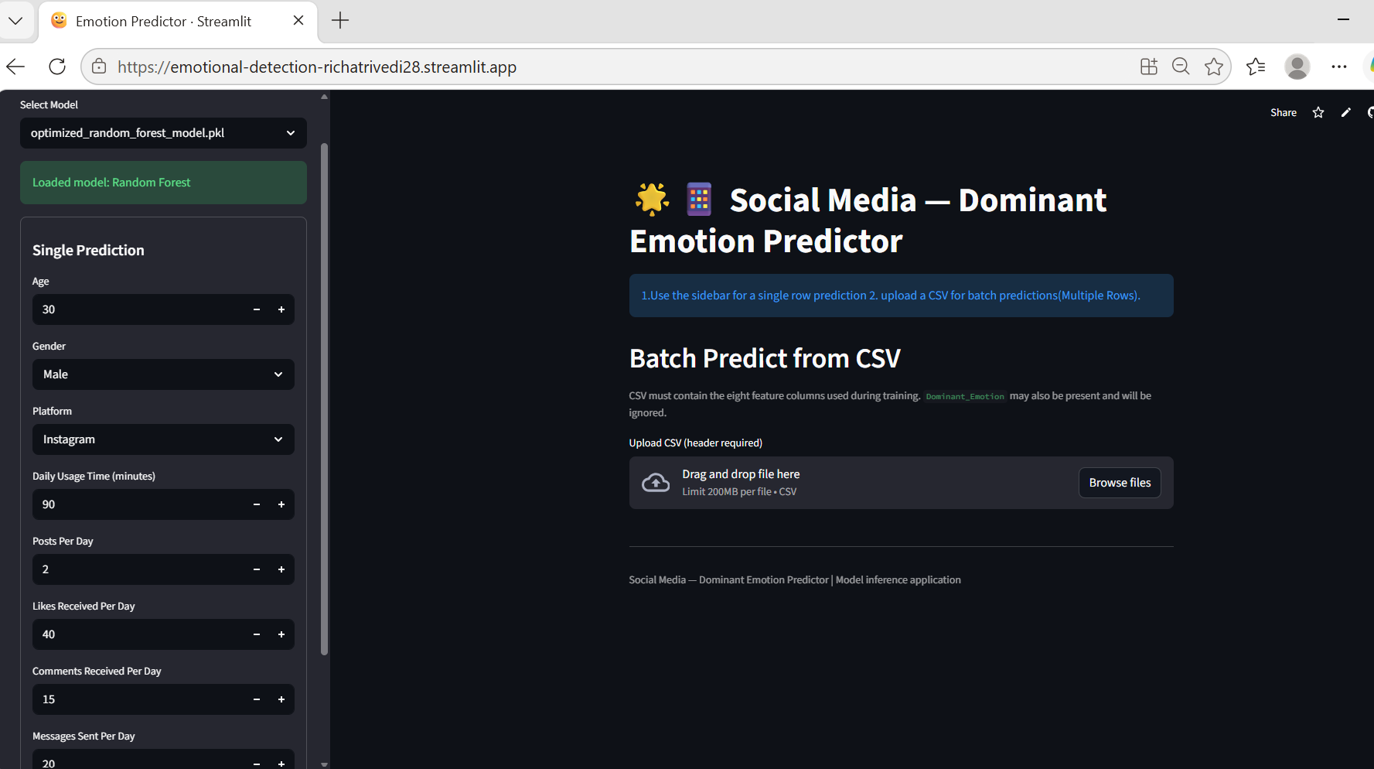

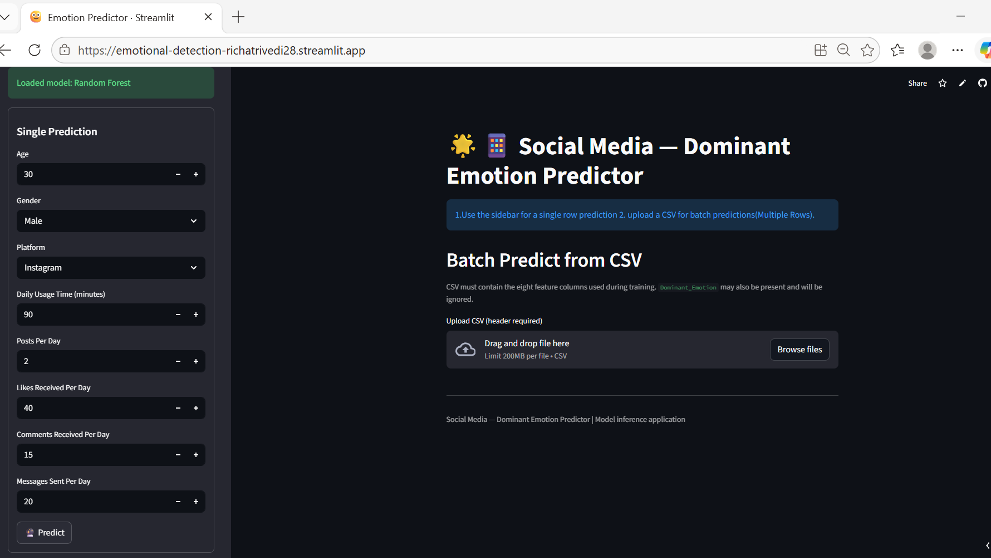

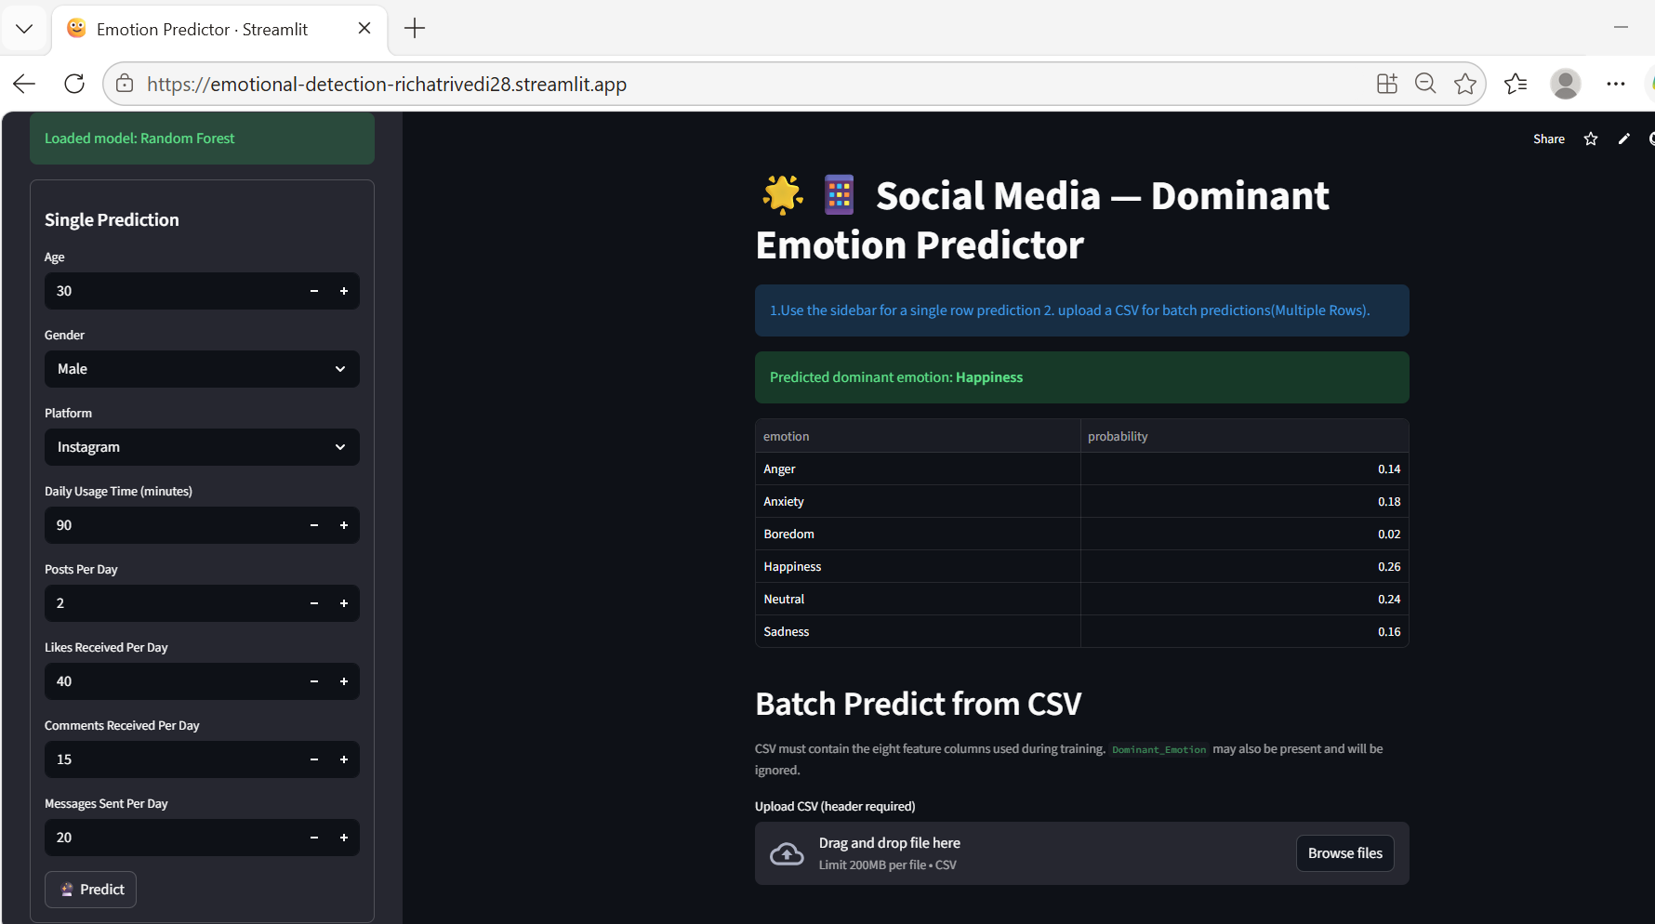

10.2 Batch Prediction
- CSV upload with header required.
- The CSV must contain the eight model feature columns used during training.
- Dominant_Emotion may be present in an evaluation CSV but is removed before inference.
- Required numeric columns are converted to numeric values; invalid numeric values are filled with 0 in the application.
- Predicted emotion is appended as predicted_emotion.
- The result is displayed and can be downloaded as predictions.csv.

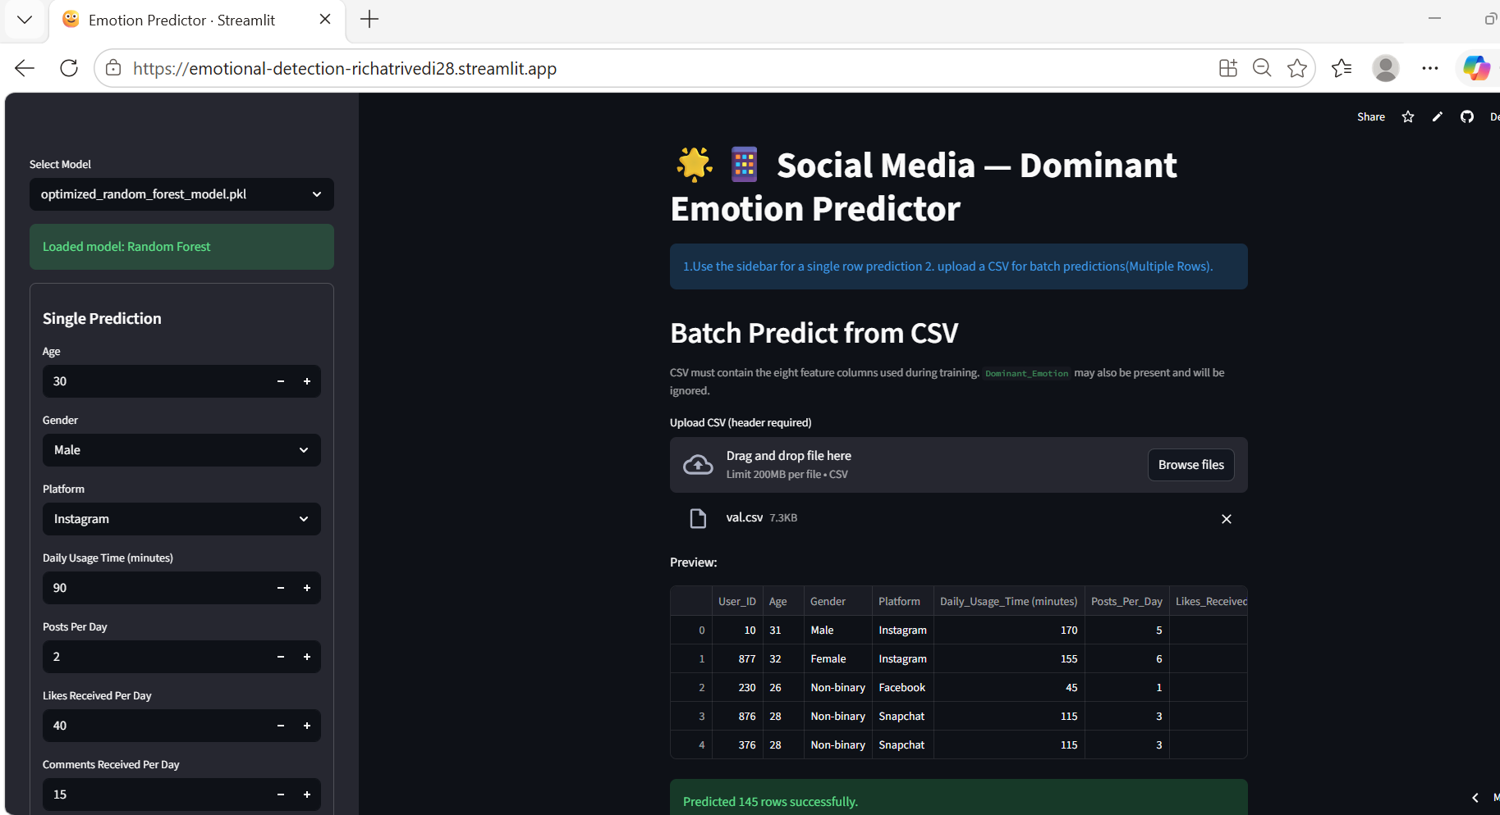

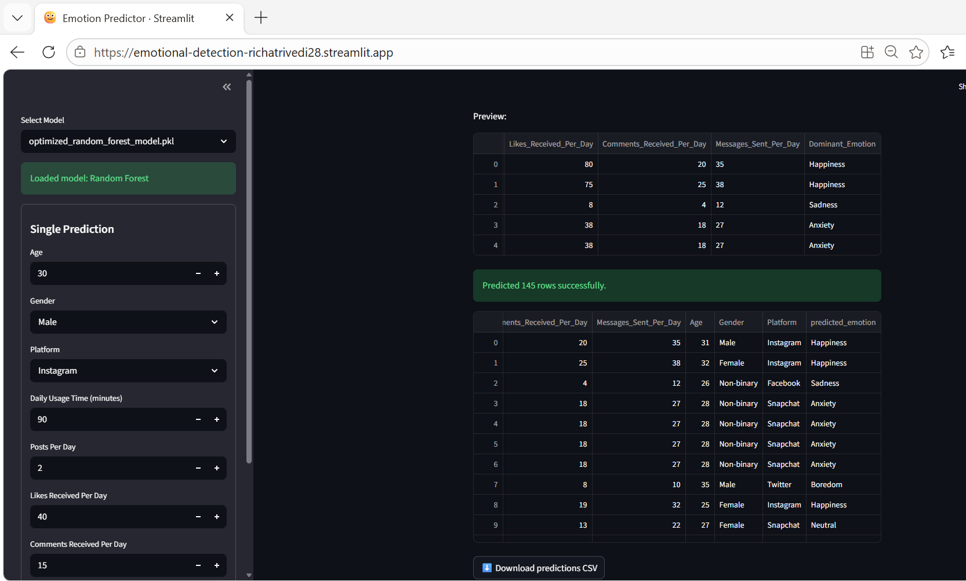

10.3 Model Input Contract
# | Required Feature
1 | Daily_Usage_Time (minutes)
2 | Posts_Per_Day
3 | Likes_Received_Per_Day
4 | Comments_Received_Per_Day
5 | Messages_Sent_Per_Day
6 | Age
7 | Gender
8 | Platform

The application maps numeric model predictions back to the six trained labels in this order: Anger, Anxiety, Boredom, Happiness, Neutral, Sadness.

11. Project Milestones
# | Milestone | Deliverable / Output | Status
1 | Define the Problem | Problem statement, scope and success criteria | Complete
2 | Understand Business Problem | Requirements and project objectives | Complete
3 | Get the Data | train.csv, test.csv and val.csv | Complete
4 | Explore & Pre-process Data | EDA, missing-value checks, scaling and encoding | Complete
5 | Select Development Platform | Python/Jupyter + Streamlit application | Complete
6 | Create Features | Numerical/categorical preprocessing pipeline | Complete
7 | EDA | Distribution, relationships and outlier analysis | Complete
8 | Create Model | Multiple classifiers trained | Complete
9 | Model Evaluation | Classification metrics and cross-validation | Complete
10 | Hyperparameter Tuning | Random Forest and XGBoost GridSearchCV | Complete
11 | Save Best Models | Optimized Random Forest and XGBoost.pkl artifacts | Complete
12 | Streamlit Application | Single and batch emotion predictor | Complete
13 | Report Writing | Project Proposal & MDD preparation | Complete

12. Project Summary
The Social Media Emotion Detection project demonstrates a complete machine learning lifecycle from data preparation to deployable inference. The supplied notebook evaluates a range of classifiers and uses a preprocessing pipeline combining StandardScaler for numerical features and OneHotEncoder for categorical inputs.
Random Forest and XGBoost were the strongest initial ensemble models. After 5-fold stratified cross-validation and GridSearchCV tuning, both optimized models achieved 1.00 accuracy, precision, recall and F1-score on the notebook's 200-row held-out test split. Both optimized artifacts were saved for production deployment.
- Six-class emotion prediction: Anger, Anxiety, Boredom, Happiness, Neutral and Sadness.
- 1,001 training rows, 103 test rows and 145 validation rows in the supplied dataset splits.
- Initial Random Forest accuracy: 0.995.
- Initial XGBoost accuracy: 0.985.
- Optimized Random Forest accuracy: 1.000.
- Optimized XGBoost accuracy: 1.000.
- Streamlit application supports both individual and batch prediction.

12.1 Project Interpretation
The Social Media Emotion Detection project is an end-to-end machine learning workflow for studying the relationship between observable social-media usage behavior and a user's dominant emotional state. Rather than treating emotion as a manually assigned category, the project formulates the task as a multi-class classification problem in which behavioral and demographic attributes are supplied to a trained model and the model predicts one of six dominant emotion classes: Anger, Anxiety, Boredom, Happiness, Neutral or Sadness. This framing makes the project suitable for repeatable analytical experiments and for deployment through a simple prediction interface.
A key strength of the project is that it covers the complete machine learning lifecycle. The workflow begins with dataset inspection and exploratory analysis, continues through data cleaning and feature preparation, and then moves into model training, comparison, validation and hyperparameter tuning. The final stage packages the strongest models as reusable pipelines and connects them to a Streamlit application. Consequently, the project is not limited to demonstrating an algorithm; it shows how a classification model can move from raw tabular data to a practical inference system.

12.2 Importance of the Input Features
The selected input variables represent several dimensions of social-media activity. Daily usage time captures the amount of time spent on social platforms, while posts, likes, comments and messages provide additional indicators of activity and interaction. Age, gender and platform add categorical context to the behavioral variables. Together, these features allow the model to learn patterns across both numerical and categorical information. User_ID is intentionally excluded because it is an identifier rather than a meaningful predictive attribute.
The preprocessing design is particularly important because the dataset contains mixed data types. Numerical variables are standardized using StandardScaler, while categorical variables are transformed with OneHotEncoder. These transformations are placed inside a ColumnTransformer and model pipelines, helping ensure that the same preparation logic is applied consistently during training and prediction. This pipeline-based design also reduces the risk of applying different preprocessing steps manually at deployment time.

12.3 Model Development and Selection
Several classification approaches were evaluated so that the project could compare simple baselines with stronger ensemble methods. Logistic Regression provides a linear baseline, while Decision Tree and Kernel SVM offer alternative classification strategies. Gaussian Naive Bayes and an MLP neural network were also evaluated. The initial Random Forest and XGBoost models produced the strongest results among the evaluated approaches, motivating further cross-validation and hyperparameter optimization.
For the leading models, the project uses 5-fold stratified cross-validation followed by GridSearchCV. Stratification helps maintain the distribution of the six emotion classes across folds, while grid search systematically evaluates combinations of model parameters. The optimized Random Forest uses 50 estimators with no maximum depth and a minimum leaf size of one. The optimized XGBoost configuration uses 200 estimators, maximum depth of seven, a learning rate of 0.2 and subsampling of 0.7. This tuning stage provides a structured way to identify stronger configurations rather than relying only on default settings.

12.4 Evaluation and Practical Interpretation
The reported evaluation results are exceptionally strong on the supplied held-out split. Both optimized Random Forest and optimized XGBoost achieved 1.000 accuracy, weighted precision, weighted recall and weighted F1-score. The displayed class-level results also show perfect precision, recall and F1-score for all six emotion categories. These results indicate that, on this particular evaluation split, the models correctly separated the supplied emotion classes without recorded classification errors.
At the same time, the results should be interpreted in the context of the supplied dataset and evaluation procedure. A perfect score on one held-out dataset does not by itself establish that the model will achieve the same performance on new populations, platforms or behavioral patterns. The project therefore appropriately describes the system as an analytical prediction tool rather than a clinical or diagnostic system. Future evaluation on additional and independently collected data would be useful for assessing generalization and robustness.

12.5 Deployment and User Experience
The Streamlit application converts the trained machine learning workflow into an accessible prediction tool. A user can select an available optimized model and enter the required demographic and social-media activity fields for a single prediction. The application also supports batch prediction through CSV upload, which is useful when analysts need to process multiple records at once. For batch inference, the predicted emotion is appended as predicted_emotion and the resulting data can be downloaded as predictions.csv.
The deployment structure separates training from inference. The notebook is responsible for data preparation, exploratory analysis, model development, evaluation and tuning, while the serialized Random Forest and XGBoost pipelines are used by the Streamlit application. This separation makes the application lighter and allows the trained artifacts to be reused without retraining the models every time a prediction is requested.

12.6 Limitations and Responsible Use
The project should be used with appropriate caution because emotional state is complex and cannot necessarily be fully represented by a small set of behavioral variables. The predicted label reflects patterns learned from the supplied dataset; it should not be interpreted as a medical, psychological or clinical diagnosis. The project's own documentation emphasizes privacy, consent, fairness and appropriate use of behavioral data. These considerations become especially important if the system is extended from a project demonstration to real-world user analytics.
Another practical consideration is data quality. The training data contains missing values, and the notebook performs missing-value checks and drops missing training rows. The analysis also identifies higher-end outliers in several activity variables. Although tree-based models are generally robust to such outliers, future versions could investigate additional data-quality strategies and external validation. Such work could help determine whether the observed high performance remains stable when the system encounters noisier or more diverse data.

12.7 Future Enhancement Opportunities
The current system provides a strong foundation for future development. Possible extensions include adding more behavioral features, monitoring model performance over time, comparing additional algorithms, and performing broader validation on unseen datasets. Feature-importance or explainability techniques could also be added so that analysts can better understand which input patterns contribute to a prediction. In addition, future versions could introduce model monitoring, automated retraining and stronger input validation for production environments.
Overall, the project demonstrates how social-media activity data can be organized into a structured machine learning pipeline and exposed through a practical web application. Its combination of preprocessing, exploratory analysis, multiple model comparisons, cross-validation, hyperparameter tuning and deployment provides a complete project workflow. The optimized Random Forest and XGBoost models serve as the principal production candidates, while the Streamlit interface provides a straightforward mechanism for both individual and batch emotion prediction.

13. Business Impact
A social-media emotion prediction solution can support analytical use cases where organizations want to understand how observed social-media usage patterns relate to dominant emotional states in a dataset.
- Enable faster analysis of large numbers of user activity records.
- Support social-media engagement and audience analytics.
- Help identify behavioral patterns associated with different dominant emotion classes.
- Provide a repeatable ML-based classification workflow instead of manual categorization.
- Allow analysts to run both single-user and batch CSV predictions through a simple interface.
- Create a foundation for future monitoring, model comparison and expanded feature engineering.

Note: The project is an analytical prediction model. Emotion predictions should not be treated as medical, psychological or clinical diagnoses, and deployment should consider privacy, consent, fairness and appropriate use of user behavioral data.

Appendix A. Source Artifacts Reviewed
- Batch13-Social_Media_Emotion_Detection_Richa_Trivedi.ipynb — used for dataset, preprocessing, models, tuning and evaluation details.
- app.py — used for Streamlit application inputs, model artifacts, output labels and batch-prediction behavior.
- requirements.txt — used for package/version information.
- optimized_random_forest_model.pkl and optimized_xgboost_model.pkl —model artifacts for deployment context.

