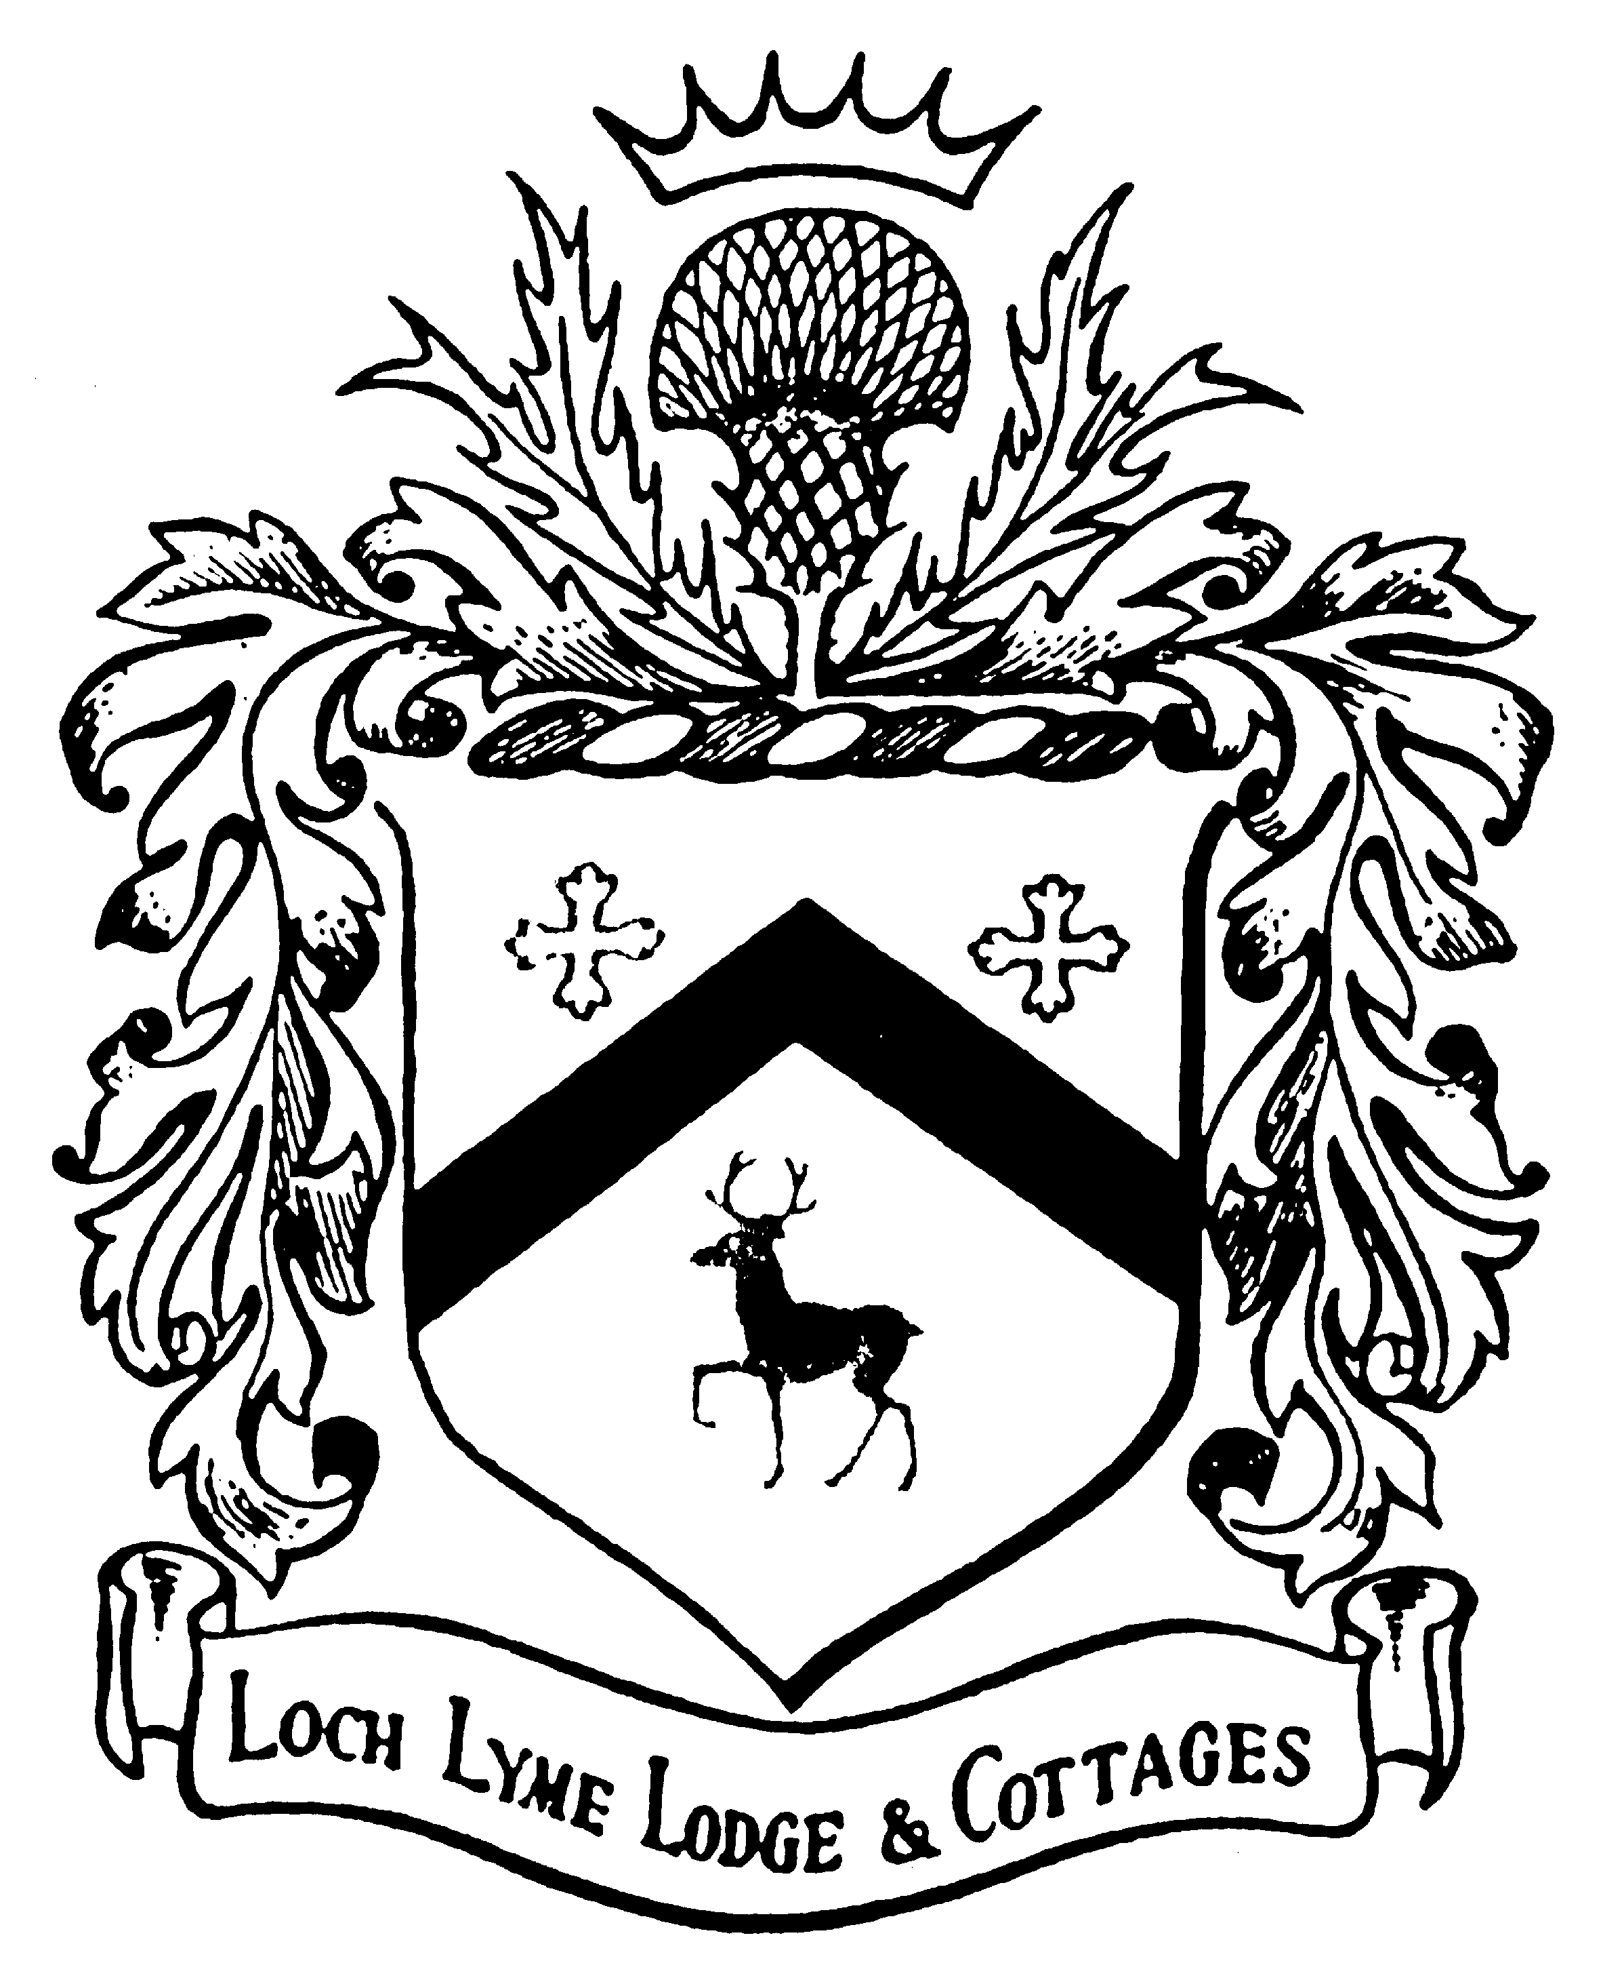
Loch Lyme Lodge
◊
Established 1923
Volume 8 January 2014

Cabins available for 2014!

Contact us for availability (603) 795.2141 or email LochLymeLodge@valley.net

We look forward to seeing all our old friends and welcoming the many new ones (young & old) to Loch Lyme!

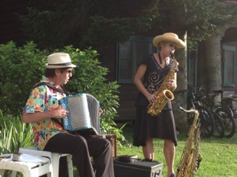

Sunday Buffet Concert Series
We are having fun booking musicians to provide entertainment to compliment the Lodge’s tradition of great Sunday buffet dinners by Post Pond. With repeat performers from Carlos Ocasio, to Mimi & Gus, to the Lyme Town Band, and new talent every summer, we look forward to watching the sun set over Post Hill and the fireflies sparkle.

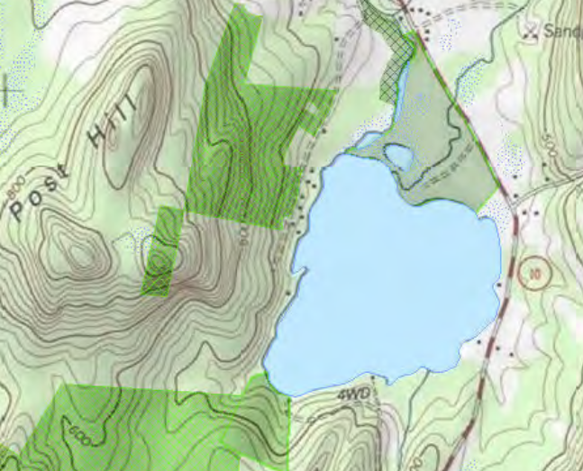

TOPOGRAPHICAL MAP OF POST POND AND THE SURROUNDING AREA

Summer Is Coming!

We are all hoping that is true as the temperature dipped to an all-time low recently. We hit -25 degrees on January 3rd! We’ve had wind chills that cold before but we never actually saw a reading that low on the thermometer. Lucky for us, the school had cancelled for the day due to about 10 inches of the lightest, powder puff snow you ever saw fall and we didn’t have to try and start the car until the sun came out later. We know a lot of you are experiencing nearly the same thing. Why is that important? Because it will soon be a distant memory as you lie on a raft in Post Pond, looking up at the clear blue summer sky, soaking in the warm sunshine and listening to children play as they jump off the float.

Nature Notes
For the fisher-folk that visit Loch Lyme Lodge you can find rainbow trout, pickerel, horned pout, walleye and other varieties of fish in Post Pond. Fishing license are easily purchased down the road at the Lyme Country Store. For you bird watchers you can spy many bird species such as numerous songbirds, woodpeckers, owls, raptors, loons, ducks, herons, and others that are commonly found utilizing the waterways, grasslands, meadows, and forests in this area. Aquatic and terrestrial mammals such as muskrat, beaver, river otter and fisher cat, moose, white-tailed deer, black bear, raccoons, bats, red fox and gray fox, coyote, bobcat, and many others also rely heavily upon our local habitats.
Post Pond is the town’s largest water body, (with the exception of the Connecticut River), and is just over 114 acres. It has an average depth of 23 feet and a max depth of 38. Of course, the beavers may beg to differ!

Pinnacle Project to Lease Cabins

Pinnacle is offering 16 Loch Lyme cabins for long-term lease to members. This fall, as part of our repair and improvement plan, we will install a septic system for cabins and Lodge and stabilize and repair the barn. Leasing cabins will help make the entire place more comfortable and useable for more of each year, but fear not, rentals will still all be managed by Jay & Amy and LLL. A letter of invitation will be circulated to guests in March unless all the cabins are leased by word of mouth before that time. If you would like more information on leasing a cabin, let us know.

Theater Workshop 2014

Attention Thespians and Scribblers!

Faith Catlin and her charismatic staff will continue to lead one and two week theatre camps in the barn. We will also repeat the film-making workshop led by John Griesemer and Whit Ingertsoll.

Camps run July 7 – August 8

For details, go to our website
LochLymeLodge.com in the Spring or
call Faith at 603-795-4103



Hooray for Summer!


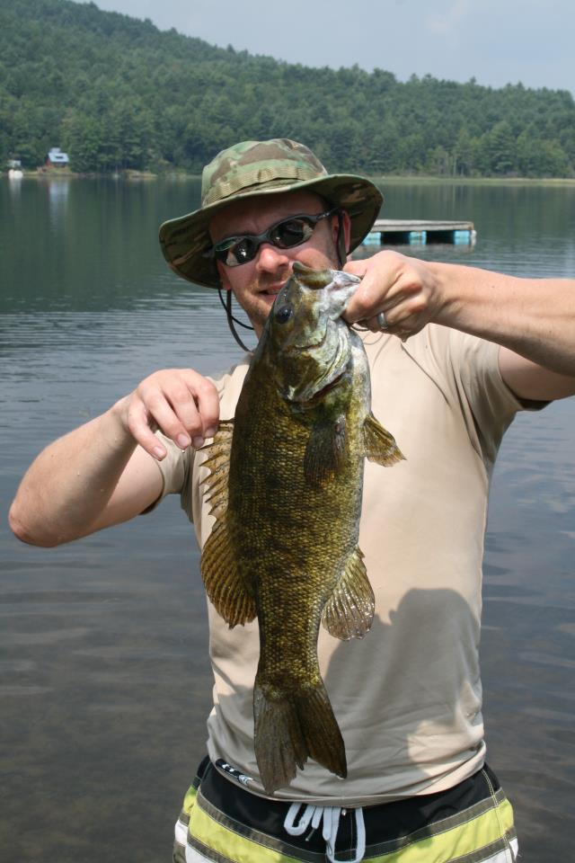

Courtesy of Justin Gaudet, father of 3rd generation Loch Lymies with catch & release of a 23” small mouth bass on Post Pond.

Housekeeping Cabins
The weekly rate for the housekeeping cabins includes lodging, the use of all Loch Lyme facilities, daily firewood delivery and trash collection, and linens & towels. It does not include meals. Fresh linens are delivered on Wednesdays and Saturdays

Summer 2014 Rates
Cabin | Guest Limit | Weekly Rate
Applewood | 4-5 | $1250.00
Balsam | 6 | $1495.00
Beechwood | 4-5 | $1025.00
Fernwood | 4-5 | $1075.00
Iron & Basswood | 7-8 | $1135.00
Lakefield | 5 | $1495.00
Lakeside | 5 | $1495.00
Pine & Pop'lwood | 2-3 | $835.00
Rockwood | 6 | $1290.00
Wildwood | 2-3 | $835.00
The above rates do not include the 9% New Hampshire State Meals
and Rooms Tax or gratuities for the staff.

Bed and Breakfast Cabins - 2014
Includes a full breakfast, all linens & towels, daily maid service, use of all facilities, and daily firewood delivery.

One Bedroom B&B Cabins (sleeps 2-3)
The following cabins have one bedroom: Cherrywood, Edgewood, Glenwood, Knollwood, Sprucewood, and Wicopywood. The rates below include breakfast.
 | B & B Per Night | B & B Per Week
 | $190.00 | $1135.00

Two Bedroom B&B Cabins (sleeps 3-4)
The following cabins have two bedrooms: Butternutwood, Deep & Dellwood, Larch & Laurelwood, and Maplewood. The rates below include breakfast.
 | (Per Cabin Per Night) | (Per Cabin Per Week)
 | $260.00 | $1560.00

Contact us for off-season rates

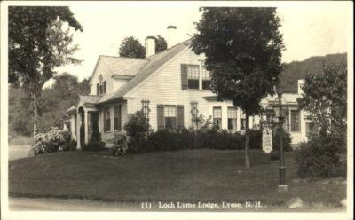

“For how shall we define the undefinable word “charm,” and how shall we weave the spell of “atmosphere?” To tell of flowered fields, of shadowed woods, of mountain slope, and meadow-bordered lake cannot begin to do justice to the nostalgic beauty, the pastoral peace and quietude that delight the eye, and soothe the senses of those who vacation here.” - Mr. & Mrs. E.B. Fulton, Hosts at Loch Lyme Lodge. Excerpt from advertising pamphlet circa 1950’s.

LOCH LYME LODGE & COTTAGES

~ ESTABLISHED IN 1923 ~

Post Pond Lodge, LLC
70 Orford Rd
PO Box 239
Lyme, NH 03768
Telephone: 603-795-2141
E: lochlymelodge@valley.net
W: www.LochLymeLodge.com

