FireFox

* Same for IE8

Add Image icon – the file name area seems to be to wide for the box size

You can’t see the file names and the red text we insert is also not fully shown or formatted

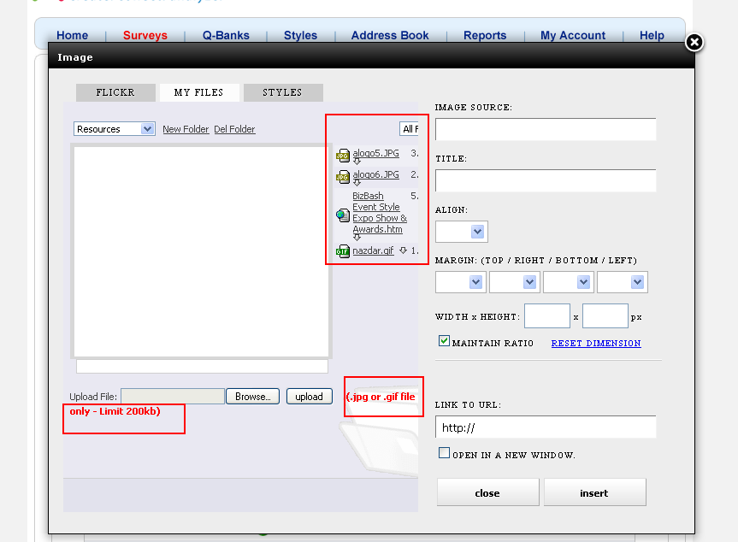

Upload won’t work –

Same for IE8, ie10

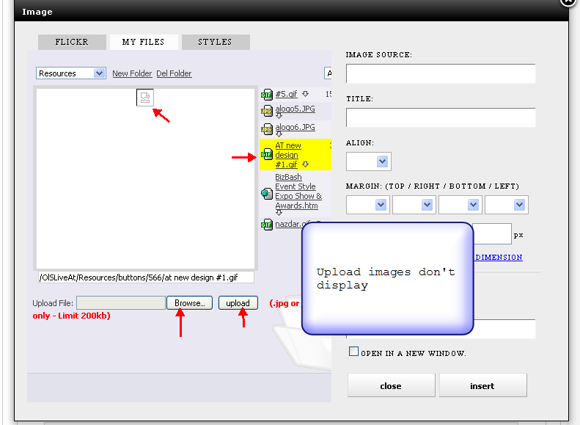

Same for IE8, ie10

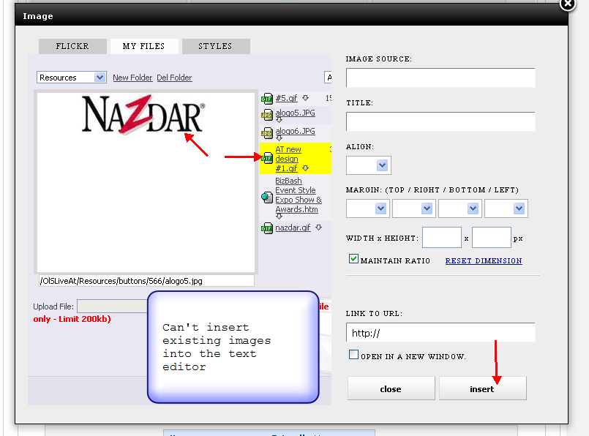

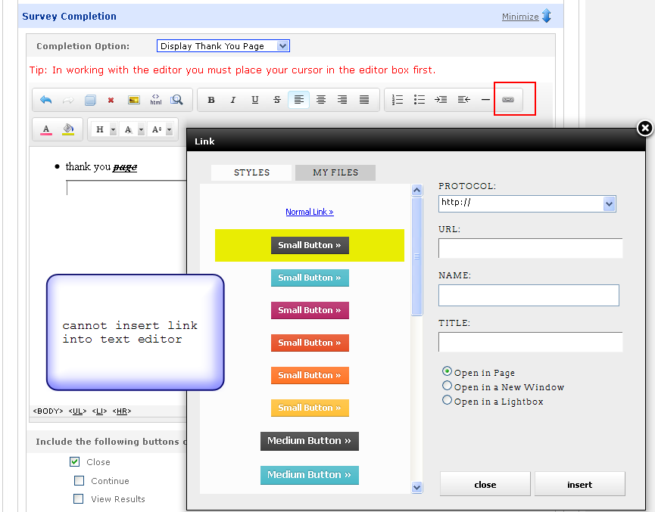

Survey Options/Edit Page Options

Same for ie8

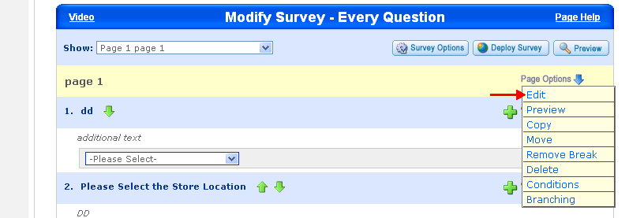

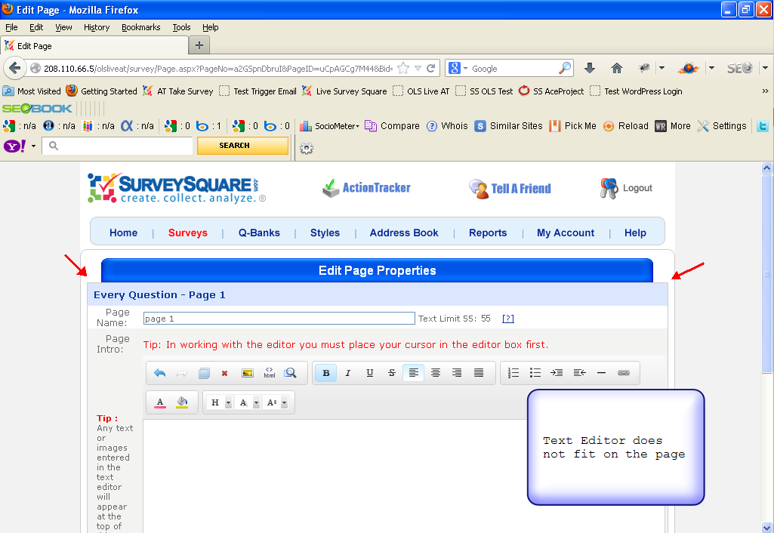

See LIVE on next page to compare

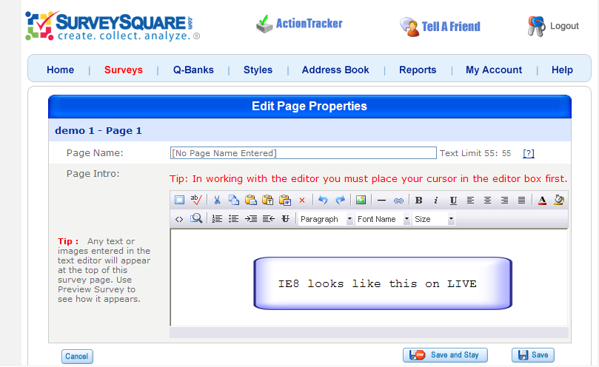

Survey Option Greeting & Thank You Text Editor

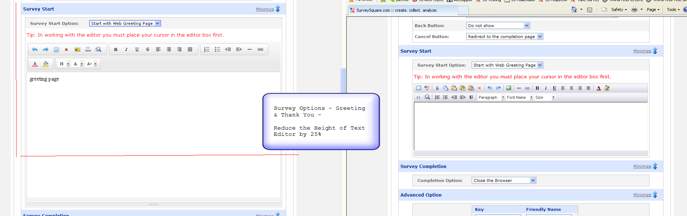

Styles

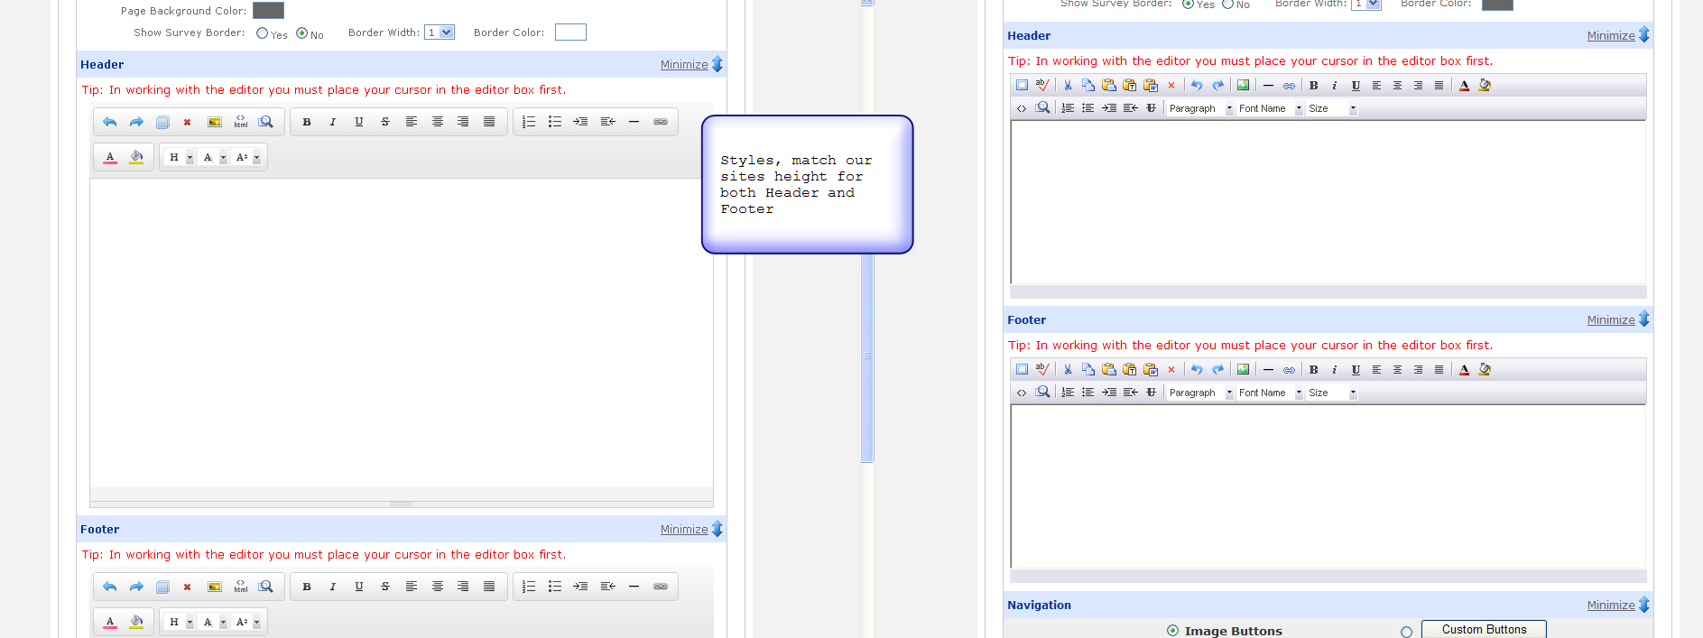

Image Uploader On Styles Page

Same for ie8

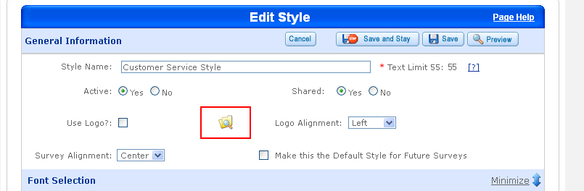

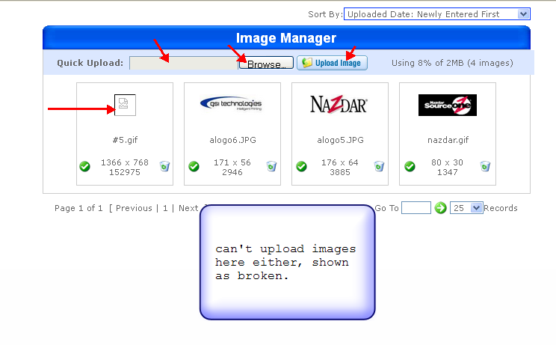

Reports Report Options

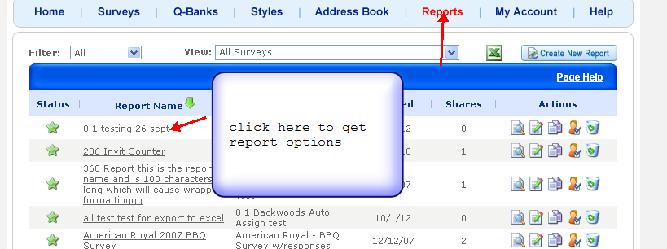

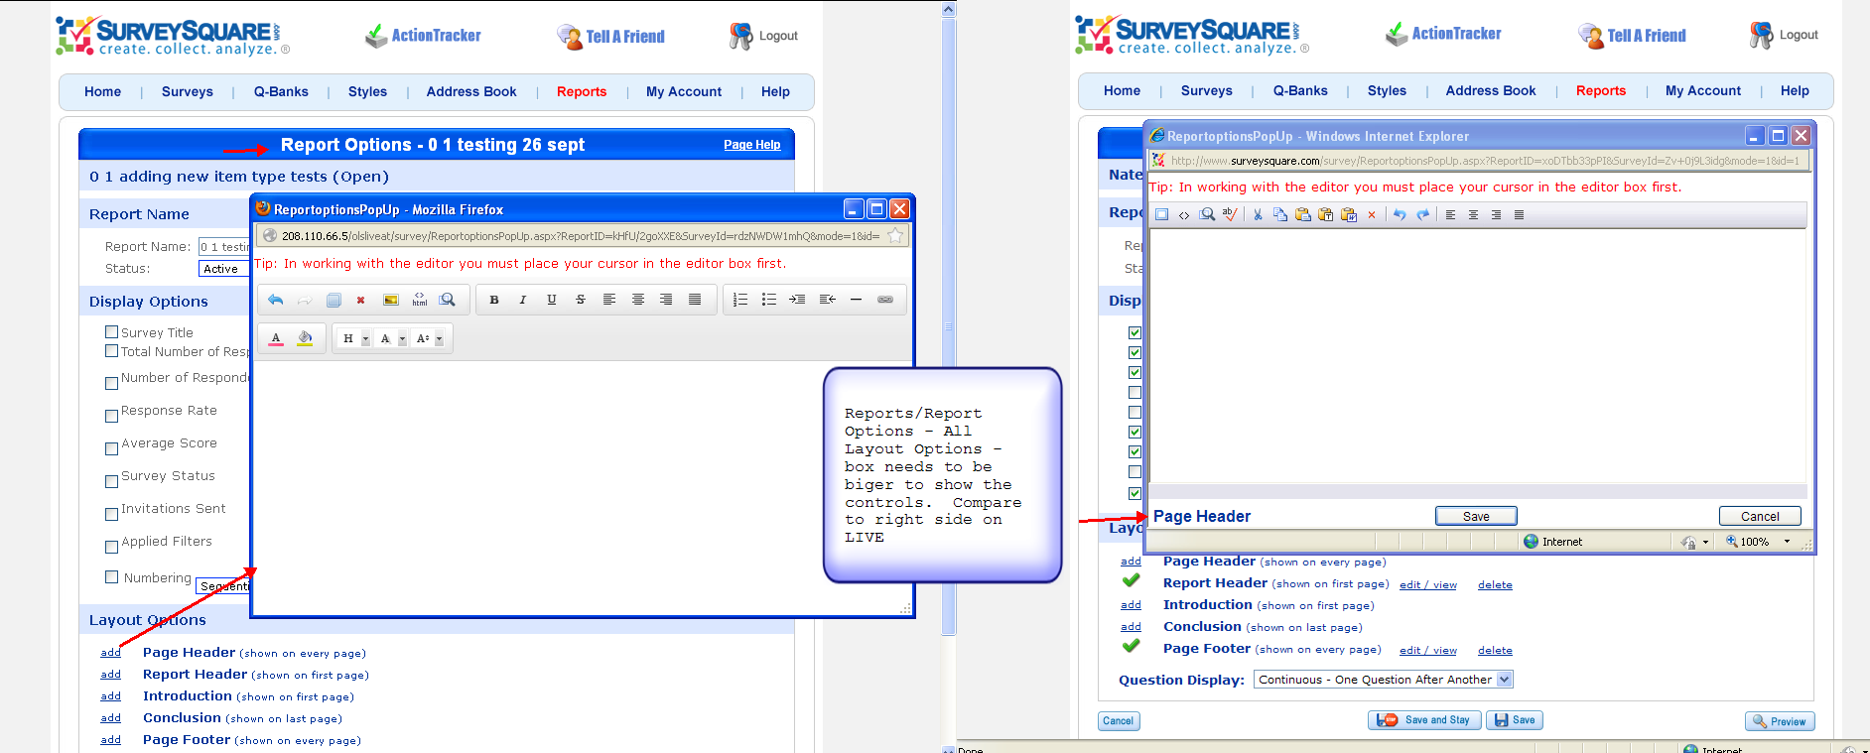

Deploy Survey with Invitation

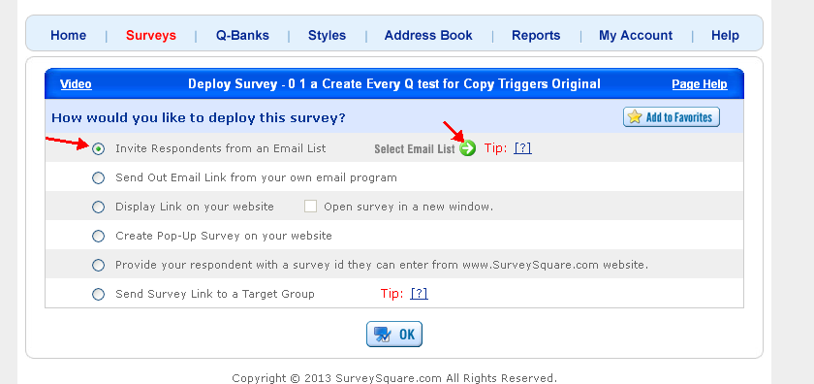

Resend Survey Reminder Invitations – Errors

