**Self-signup process / Chargify API**

We need to give restaurants the option to sign themselves up directly from our website or from reseller’s websites. Chargify will manage the payments so we need to connect their API to EasyWay. When a new customer signs up via one of the chargify hosted payment pages we need to direct them to the easyway ordering control panel and start the “Self Signup wizard so we can capture the necessary information to create their account .

This is an example of a hosted chargify signup page for a product called “EWO Standard Subscription” <https://easywayordering.chargify.com/h/3305634/subscriptions/new>

Each Chargify product has a unique product ID and a unique signup page URL. So each reseller can have their own products and signup pages and we can identify which reseller the customers who sign up belong to by reading the product ID’s that are assigned to that reseller profile.

Also, on your end, you can specify a different “return URL after successful signup” for each reseller if that helps to identify the reseller. I’d also like to use that return URL feature to place the reseller’s logo in the Self Sign Up Wizard that we will be making.

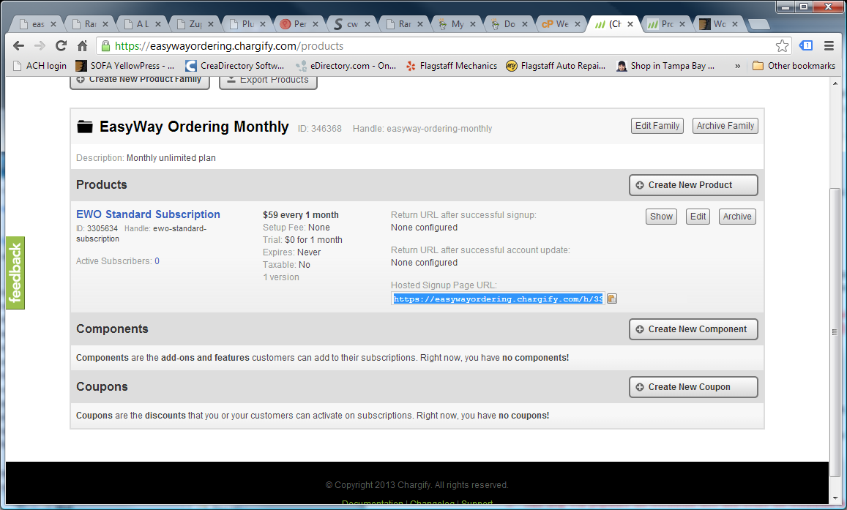

So in the reseller settings we need:

* input fields for admin to add the reseller’s product ID’s
* Display the return URL’s that you want us to enter into chargify for that reseller
* An input field where the EWO admin can enter the hosted signup page URL and the reseller can view the URL (reseller should not be able to edit this field, only admin)

When Chargify sends EWO a successfuly signed upcustomer, EWO should start the Self Signup Wizzard to get the customers information, create and activate their client and restaurant accounts and log them into the admin panel (at the end of the wizard)

The Wizzard will have 6 steps which I outlined in a separate word doc. On the top of the wizard window there should be a progress bar that shows the user which step they are on. The active step should be red, completed steps should be green, skipped steps can be yellow and future steps will be grey. Clicking any step should bring the user back to that step. (their data should not be lost if they go back to a previous step)

Here a couple examples of a sign-up wizards:

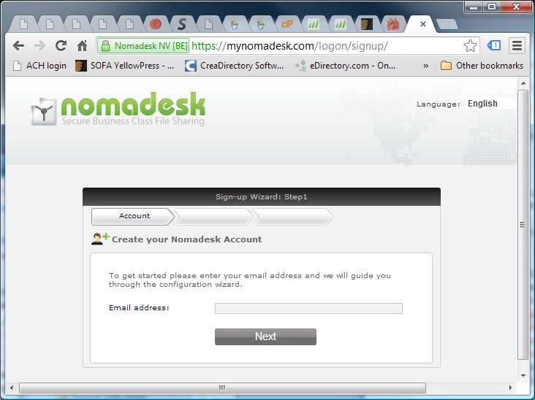

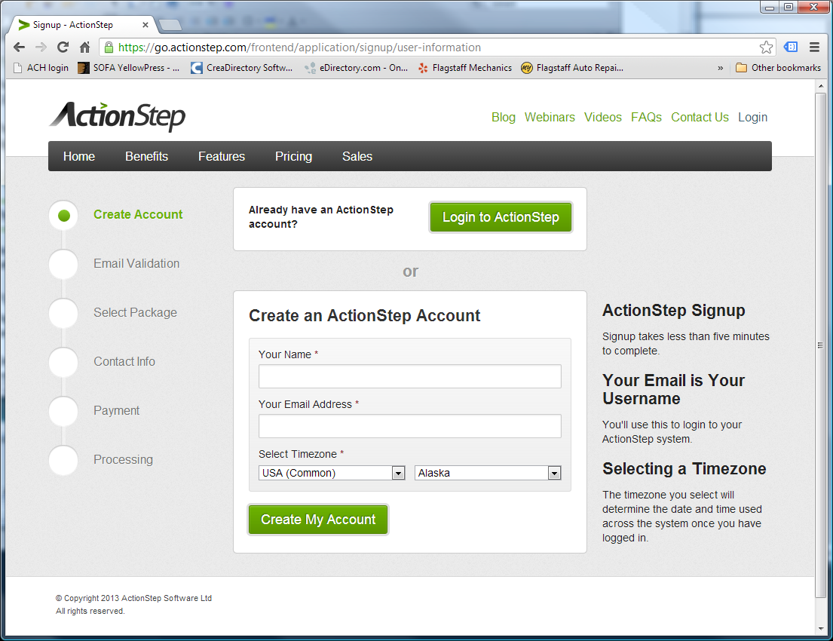

<https://go.actionstep.com/frontend/application/signup/user-information>

You are free to design the look of the wizard but here are some important guidelines

1. Show the steps and show the user where they are in the process
2. Each step should have a Title, description and “help” for more information about a particular field. (in the second example they put the help on the side, but “?” icons work too.
3. The layout should be clean and easy to follow and there should be no other links or distractions and no way to exit the wizard.
4. They can not skip step 1 (logging in or creating an account) but they should be able to skip the other steps if they want to.

When they finish the wizard a license should automatically be assigned to the restaurant against resellers available licenses. If no licenses are available for that reseller, a new one should be assigned to reseller automatically and an email should be sent to cwilliams@easywayordering.com informing me that the reseller added a license via signup wizard.

Also, the form data and attached menu (if applicable) should be emailed to the reseller and to [menus@easywayordering.com](mailto:menus@easywayordering.com)

Chargify will manage the monthly billing. If billing for a restaurant license fails EWO needs to suspend that restaurant license.

To do this, we need to receive a webhook from chargify called [subscription state change] <http://docs.chargify.com/webhooks#subscription-state-change-payload>

When EWO is informed via the chargify webhook that a subscription status has been changed to “cancelled” the license for that restaurant should be suspended in EWO. If the restaurant owner (client) logs into his control panel while one of his licenses is suspended doe to chargify subscription status of “cancelled” he should see a message saying “One or more of your restaurants may be suspended. Click here to update your billing information”

That link should send them to this URL: /update_payment/[subscription.id]/[token]

Documentation on updating payment details on the hosted signup page is available here:

<http://docs.chargify.com/hosted-page-integration>

Once the payment is successfully updated, we need to send them to the “return URL after successful account update” which we can also specify for each product. When Chargify passes them back to that URL EWO should re-activate the license and display a message that their account has been successfully updated and their restaurant has been re-activated.

Metered Usage:

We need the ability to report metered us age to Chargify, to allow resellers to optionally bill their customers for orders taken through EWO

More about metered usage here: <http://docs.chargify.com/api-metered-usage>

There are 5 types of usages they can track:

* Credit card orders (quantity)
  + Number of orders (json should send a quantity of 1 “credit card order” unit each time order is placed
* Credit card orders (dollar amounts)
  + This will let us charge a percentage on each order so json should send the amount of dollars as units (ex: order is for $26.85 – units would be a quantity of 26 units)
* Cash orders (quantity)
  + Number of orders (json should send a quantity of 1 “cash order” unit each time order is placed
* Cash orders (dollar amounts)
  + This will let us charge a percentage on each order so json should send the amount of dollars as units (ex: order is for $26.85 – units would be a quantity of 26 units)
* Rapid reorder text messages
  + Each incoming or outgoing text message = 1 unit

In the reseller control panel the admin should be able to check which metered items will be used for the product ID assigned to that reseller. (remember, resellers can have more than one product ID, so each product ID has to have its own metered usage, return URL and signup page URL settings)

Finally, not all EWO restaurants will use Chargify for billing! Only the restaurants who have a value set for “Chargify Subscription ID” will use chargify. The Admin should be able to set this value or delete it at any time to put a restaurant on chargify billing or take it off.

We should also be able to search restaurants in the CP by Chargify subscription ID number.

If a subscription ID number is already assigned to one restaurant it should not be possible to add the same number to another restaurant.