A Quick CASS Howto
This document gives a quick introduction into setting up and using the CASS (Conceptual Analysis of Software Structure) toolkit. Note that CASS is still work in progress and so is this document.

Download and installation
The most recent version of CASS should be found on the Sourceforge page of the Tockit project: http://sf.net/projects/tockit. The download is a file in ZIP format containing two components:
- an Eclipse plugin to export Java source code into RDF format
- a Java program called “Tupleware” to query the RDF and visualize the results
After downloading the file, just unzip its contents somewhere. The Java program does not need any specific installation, to install the Eclipse plugin, just copy the JAR file from the folder “eclipsePlugin” into the “plugins” directory of your Eclipse installation and restart Eclipse.

Exporting a Java project into RDF
After the Eclipse plugin is installed properly, a new option “CASS->Export Java Source...” should be available in the context menu of a Java project:
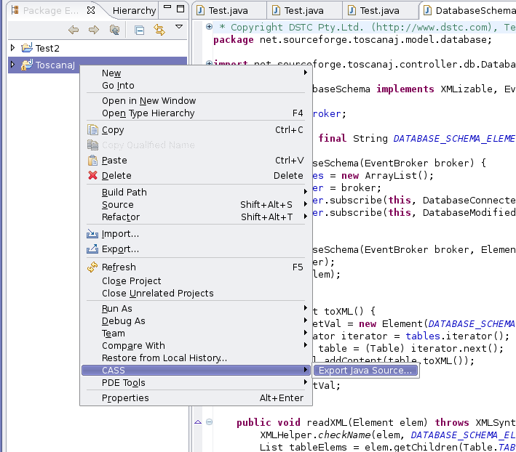
Calling this menu entry opens a file dialog where you can chose the location and the name of the RDF file to save. Files will be saved as RDF/XML unless you specify a filename that ends on “.n3”, in which case Notation3 will be used.
Once the file name and location has been chosen, the export will start. Depending on the project's size this can take a while.

Starting Tupleware as analysis tool
The actual analysis takes place in a program called “Tupleware”. The version of the program in the CASS distribution has already been preconfigured for this purpose. You just start it using the command “java -jar Tupleware.jar” while being in the CASS program folder. If you are analysing a larger source code base you might want to increase the heap space for the JVM, if you are also using the N3 format you might want to increase the stack size. A suitable call for a Sun JVM could look like this:
java -Xmx512M -Xss2048k -jar Tupleware.jar
Smaller analysis tasks can get away without the extra options, though.

Loading the RDF
The RDF file previously exported from Eclipse can now be loaded using the “Tuples->Query RDF model...” menu entry:
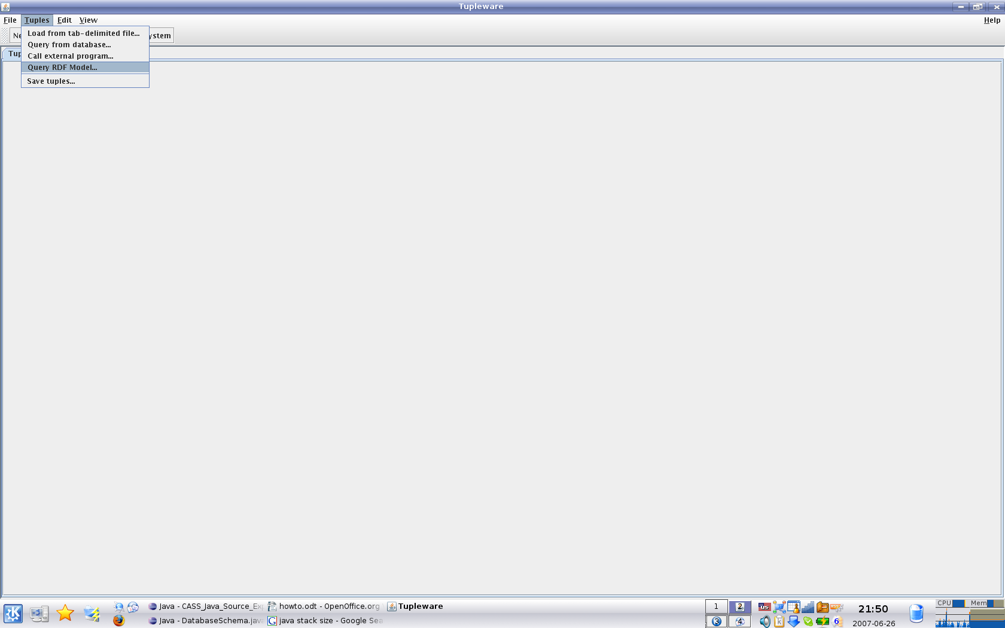
On the next screen you can chose the file to load. Use the “Browse...” button to get a file dialog, chose the file you exported and then hit “Open >>” to open the file. Note that opening the RDF file can take a long time and that the program will not respond in this time.
The next time you open this menu option you will get the option to keep the old model.

Sending a query
The queries are written in a query language called SPARQL (http://www.w3.org/TR/rdf-sparql-query/), or more exactly in the ARQ dialect used by the Jena toolkit (http://jena.sourceforge.net/ARQ/). To get you started try the following query on your project, replacing the highlighted part with the name of your root package:
PREFIX cassProp: <http://tockit.org/cass/properties#>
PREFIX cassType: <http://tockit.org/cass/entityTypes#>
PREFIX package: <http://tockit.org/cass/packages#>

SELECT ?depP ?usedP
WHERE {
?depP cassProp:type cassType:package.
package:net.sourceforge.toscanaj cassProp:contains ?depP.
?usedP cassProp:type cassType:package.
package:net.sourceforge.toscanaj cassProp:contains ?usedP.
?depP cassProp:depends_tr ?usedP.
}
The query language is unfortunately a bit verbose, hopefully later CASS versions will hide that from you. The prefixes declared at the top define the namespaces CASS uses in the RDF file. The full lists of prefixes and other constants can be found at the end of this document.
The actual query can be read as follows:
“Find all pairs (depP,usedP) where both are of the entity type 'package', both are directly under the root package and where depP depends on usedP.”
Or even less formal:
“Show me all dependencies between the toplevel packages, with 'depP' being the dependend and 'usedP' the used package”
Of course the queries can be more complex than this and you are also allowed to query more than two variables at one time, although Tupleware itself can display only diagrams based on pairs – you can create multiple diagrams in one set, though. A ToscanaJ (http://toscanaj.sf.net) can be written to show these in combinations.
Querying less than two variables can be useful for seeing the list of matches, but a diagram needs at least two to be useful.
Once your query is submitted and has been successfully run, Tupleware will ask you which of the variables you want to use as the objects in a diagram. The objects will be the ones appearing in the labels below the nodes, in our example “depP” is a good choice. Chose the entry for that and hit “Ok”.
As a result of this example you should get a table of pairs, each one denoting a particular dependency between packages. Note that these dependencies are based on:
- the callgraph
- type usage as:
  - field type
  - return type
  - parameter type
- the package hierarchy
This means for example that if there is a class in a sub-package of package A that has a method calling a method from a class in a sub-package of package B, then A is considered dependant on B. Similarly for the parameter or return value types or field declarations.

Creating a diagram
To create a diagram you hit the “New Diagram...” button and select a second variable that is used as attributes (the labels above the nodes). Remember that the objects are already chosen, they will be kept fix until you start a new query.
Once you hit “Ok” the new diagram will be created. To see it, chose the “Diagrams” tab in the main window and select the new diagram (it will have the same name as the variable). The result should look like this (apart from the abbreviation for the main package – you would need to edit the file “regExpMappings” in “Tupleware.jar” to get that for your packages):
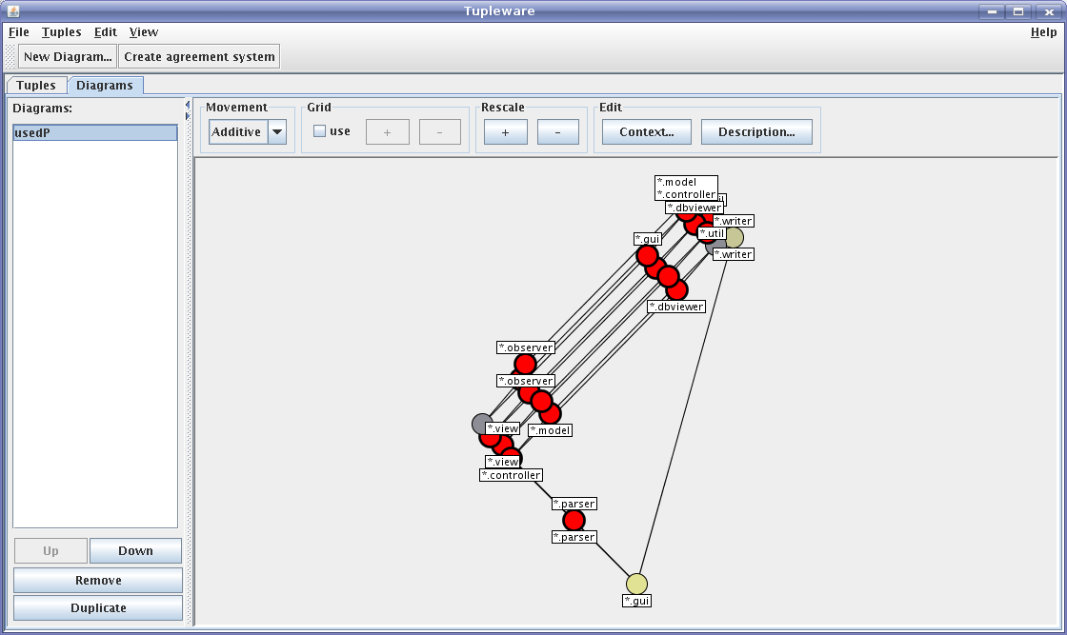
The automated layout is not too good on this example – all the red dots mean that they connect to some edge they don't belong to. As long as the movement option in the upper left is set to “Additive” you can pretty safely drag nodes around. You should be able to get a layout similar to this:
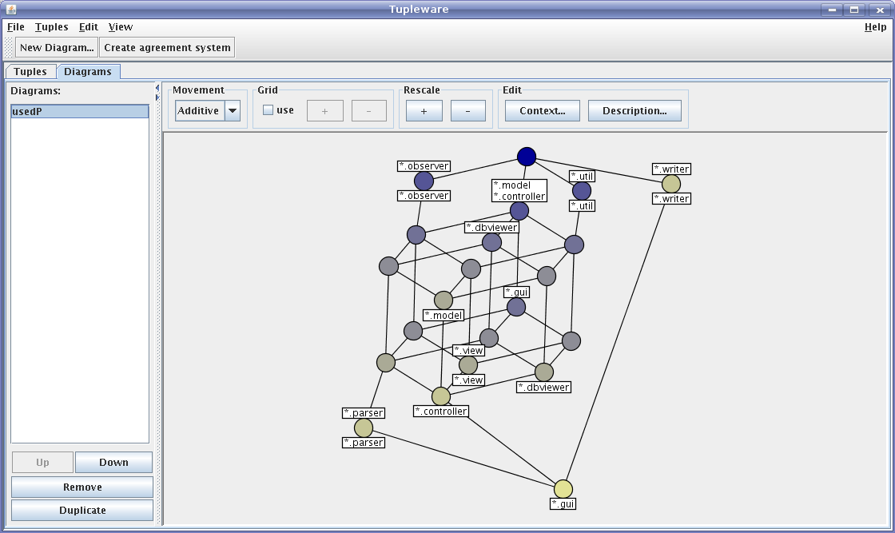
This is actually a good example in that it is not well structured – the big section in the middle is a so-called B4, which means in this case that you can get something that depends on any subset of four different packages. Such structures don't necessarily help understanding the code, although in this case two of the involved packages are “util” and “observer”, which are both small and independent of the rest of the program, which makes things a bit better.
There are also a number of other things noticeable with the explanation based on further investigations in parentheses:
- the writer package is rather independent of the rest (it writes data structures that have been moved into library code, but the package itself wasn't moved)
- the gui package depends on it all (which is fair enough, it contains the main window from which it all starts)
- nearly everyone depends on the model (again that is ok)
- nearly everyone depends on the controller package (that is certainly not ok, particularly the model and the view should not depend on the controller)
To investigate things further, you can phrase new queries. To continue our example we look at the model->controller dependency by issueing this query:
PREFIX cassProp: <http://tockit.org/cass/properties#>
PREFIX package: <http://tockit.org/cass/packages#>

SELECT ?dep ?used
WHERE {
package:net.sourceforge.toscanaj.model cassProp:contains_tr ?dep.
package:net.sourceforge.toscanaj.controller cassProp:contains_tr ?used.
?dep cassProp:depends_tr ?used.
}
Compared to the last query we changed the following:
- dropped the requirement to be a package for both variables
- changed the restriction from being directly in the root package to being somewhere in the model/controller package (notice that we use “contains_tr” now, not “contains”, which changes from direct containment to the transitive and reflexive closure)
The result looks like this after layout:
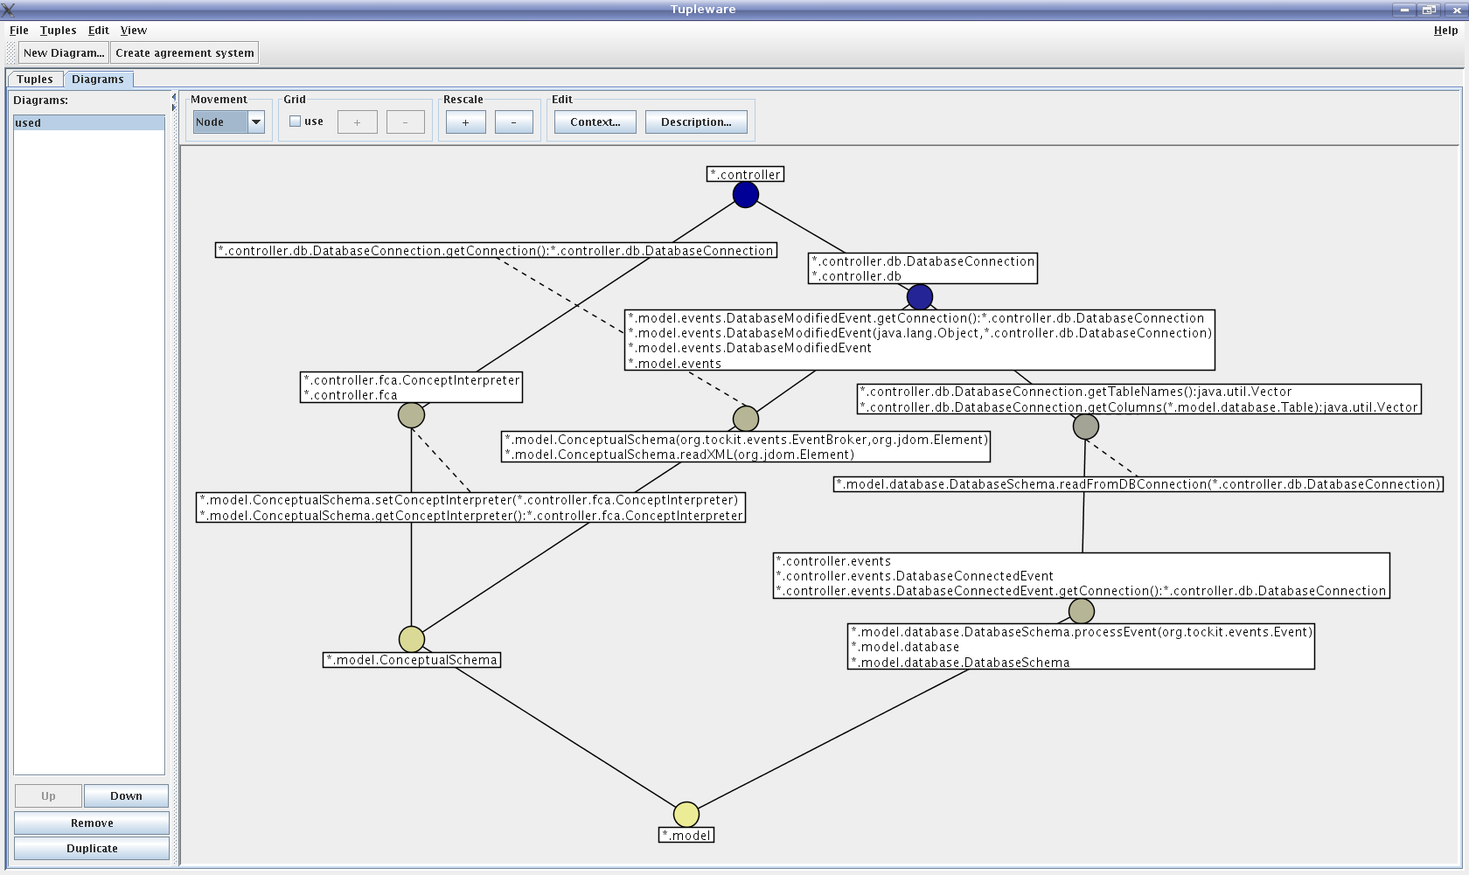
Here we can see the dependencies between the two packages in more detail by having the classes and the methods causing them. In this particular example it turns out that some of the sub-packages in the controller package are not part of the model-view-controller pattern, which might indicate some need for adjusting the package names.
An additional inconsistency that can be seen in this diagram is that there is a “DatabaseModifiedEvent” in the model packages and a “DatabaseConnectedEvent” in the controller packages, which is suspicious – if they are that different that they should be in different packages, they probably should be better distinguished by name (andin fact they are quite the same beasts in this code). This is just an accidental find, but having the bigger picture of a diagram helps with these findings, too.
This concludes our example and the howto. Note that there are many other properties you can query, including the type hierarchy (see the appendix for a list). If you find nice patterns please report them to peter@peterbecker.de – they will be collected in the Tockit wiki on Sourceforge (http://tockit.wiki.sourceforge.net/CASS).

Appendix

CASS namespaces as SPARQL prefix mappings:
PREFIX cassProp: <http://tockit.org/cass/properties#>
PREFIX cassType: <http://tockit.org/cass/entityTypes#>
PREFIX package: <http://tockit.org/cass/packages#>
PREFIX type: <http://tockit.org/cass/types#>
PREFIX method: <http://tockit.org/cass/methods#>

CASS types:
cassType:package A Java package
cassType:interface A Java interface
cassType:class A Java class
cassType:type Any Java type (class, interface, primitive, array)
cassType:method A method

CASS properties:
cassProp:type The CASS type of the entity (package, class, etc.)
cassProp:contains One entity directly contains another, e.g. a package contains a class or a class contains a method
cassProp:contains_tr The transitive and reflexive closure of the contains relation above, i.e. everything that is in an entity and the entity itself
cassProp:calls A method calls another directly
cassProp:calls_tr The transitive and reflexive closure of the calls relation above, i.e. methods that directly or indirectly call another plus themselves
cassProp:calls_ext An extension of the callgraph onto classes and packages using contains_tr. An enitity is considered calling another iff it contains a method that calls a method inside the other.
cassProp:has_parameter
A method uses a Java type as parameter
cassProp:has_parameter_ext
A method uses a Java type as parameter, including occurances as array, i.e. a parameter type String[] creates a link to String
cassProp:has_return_type
A method uses a Java type as return type
cassProp:has_return_type_ext
A method uses a Java type as return type, including occurances as array, i.e. a parameter type String[] creates a link to String
cassProp:has_field_type
A class uses a Java type as type of a field
cassProp:has_field_type_ext
A class uses a Java type as field type, including occurances as array, i.e. a parameter type String[] creates a link to String
cassProp:extends A class extends another class directly
cassProp:extends_tr The transitive and reflexive closure of extends
cassProp:implements A class implements an interface or an interface extends another (note that the latter differs from the usage of the Java keywords)
cassProp:implements_t The transitive closure of the implements relation
cassProp:derivedFrom The union of extends and implements
cassProp:derivedFrom_tr
The transitive and reflexive closure of the derivedFrom relation
cassProp:extends_tr The transitive and reflixive closure of extends
cassProp:depends_tr A transitive and reflexive dependency relation, based on type usage and callgraph. Both type usage relations and the calls relation are extended along the containment closure and then combined as union

The parser recurses for lists and N3 enlists all statements known about a resource in one list. There can be much known about the toplevel packages.
The example here is based on ToscanaJ in revision 1914, you can use that if you want exactly the same results
To be more exact: you can combine multiple variables using a cross-product, but the results can be confusing. Not the material for a quick howto.
We know the Java Language Specification says Java packages are not a hierarchy. Noone else seems to think that way...
This is to keep a set of diagrams all based on the same objects, which allows combining the diagrams in certain ways (as ToscanaJ does).

