

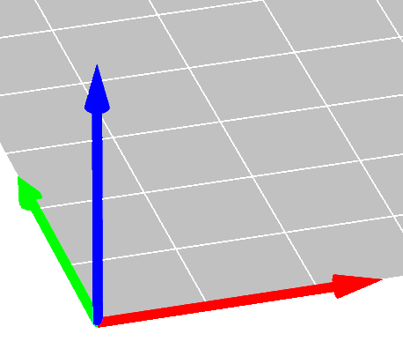
Namn:

3D skrivningskurs lektionskort 1

Q1: I början, skrivaren __________________
_____________________________________
_____________________________________
_____________________________________

Q2: Skrivningen tog ___ minuter och ___ sekunder

Q3: Fingeravtrycksymbolerna påminner oss _____________________________________
_____________________________________
_____________________________________

Q4: Att kyla ner skrivingen tog ___ minuter och ___ sekunder

Q5: Visar kuben till en lärare
Name:

3D printing course lesson card 1

Q1: At first, the printer __________________
_____________________________________
_____________________________________
_____________________________________

Q2: The print took ___ minutes and ___ seconds

Q3: The fingerprint symbols remind us _____ _____________________________________
_____________________________________
_____________________________________

Q4: Cooling down took ___ minutes and ___ seconds

Q5: Show your cube to a teacher

